**DEVELOPMENT OF SARAWAK LAND COVER SYSTEM WITH SPACE TECHNOLOGIES (LIMPAS)**

Hana Mohamed Jamil1, Shahruddin Ahmad1, Nur Amani Yusoff 1, Nurul Suliana Ahmad Hazmi1, Norimaniah Mazelan1, Hazil Sardi Soliano1, Zuraimi Suleiman2, Ramzi Abdillah3, Stephen Ling Jin Huat4, and Tony Octovius Ajol5

1Research Officer, Resource Management Application Division, Malaysian Space Agency (MYSA), Malaysia

2Director, Resource Management Application Division, Malaysian Space Agency (MYSA), Malaysia

3Assistant Director (Survey), Land and Survey Department (LSD), Sarawak, Malaysia

4Cartographer, Land and Survey Department (LSD), Sarawak, Malaysia

5 Assistant Cartographer, Land and Survey Department (LSD), Sarawak, Malaysia

[hana@mysa.gov.my](mailto:hana@mysa.gov.my)

***Abstract:*** *Sarawak Land Cover System (LIMPAS) is an innovative initiative developed by the Malaysian Space Agency (MYSA) and implemented by the Sarawak Land and Survey Department (LSD). The system aims to provide policymakers and land management officials with accurate and updated data on land cover changes by integrating advanced remote sensing techniques. Sarawak, the largest of Malaysia's 13 states, covers a total area of 12,417,000 hectares. Traditionally, land cover mapping in this vast region took more than a decade to complete. To address this, LSD collaborated with MYSA to generate the 2013 1st Edition Land Cover Maps (LCM) using SPOT 5 data, which employed the Rule Set Development method in eCognition software. The 2023 2nd Edition LCM was updated using SPOT 6/7 data.  The results show that between the 1st and 2nd editions, agricultural land use increased by 2.8%, water increased by 0.6%, bare land decreased by 1.1%, urban increased by 0.4%, and forest decreased by 2.7%. The decrease in forest area signifies deforestation for conversion to agriculture, which likely contributed to increased agricultural land. The decrease in bare land is partly associated with urban expansion.  LIMPAS, a web-based Web-GIS smart system for managing Sarawak's land cover, was developed using remote sensing, GIS, and ICT technologies to disseminate this information.  The analysis results demonstrate the system's efficiency in leveraging information delivery.  In conclusion, this paper highlights the proven benefits of the LIMPAS system for LSD and the Sarawak State Government in land management, including the determination of new land ownership titles, assessing compensation costs for the development of the Pan Borneo Highway, conducting suitability analysis for telecommunication tower locations, and performing flood assessment.*

*Keywords: classification, land cover, land management, system.*

1. **Introduction**

Land cover and land cover change are fundamental aspects of environmental and resource management. They provide essential information for understanding the state and dynamics of natural and human-modified landscapes. Understanding landscape patterns, changes, and interactions between human activities and natural phenomena is essential for proper land management and decision-making (Rawat & Kumar, 2015). By monitoring and analyzing land cover and its changes, we can make informed decisions to promote sustainable development, protect natural resources, and enhance the resilience of communities to environmental challenges. Integrating land cover data into planning and policy-making processes is crucial for achieving long-term sustainability and environmental stewardship. Land use and land cover change is an important issue considering global dynamics and their responses to environmental and socio-economic drivers (Akpoti et al., 2016; Bewket, 2002; Hurni et al., 2005). By utilizing advanced remote sensing technologies and incorporating multiple satellite images, these maps provide valuable insights into changing land use patterns.

The Sarawak Land and Survey Department (LSD) is responsible for producing the Land Use/Land Use Map of Sarawak for Sarawak state land management and administration. Previously, the map was produced using aerial photography, which was primarily used to create topographic maps of the state. Although aerial photography offers high-resolution imagery and localized detail, its limitations make it less suitable for the challenging conditions of Sarawak. The process of transferring information from a mosaic aerial photo to a map is very complicated and time-consuming, especially over large areas (Vivekananda, 2021). Remote sensing offers many advantages over traditional data acquisition methods by collecting data over large areas in a relatively short period and providing valuable information in a more efficient, timely, and cost-effective manner (Vivekananda, 2021).

LSD and the Malaysian Space Agency (MYSA) signed and Memorandum of Understanding (MOU) in 2011 for generating land use maps using satellite images. The project started with three (3) pilot areas, which are Matang, Sibu and Kapit, respectively. The 2013 1st Edition LCM using SPOT 5 data (2.5 m spatial resolution) was completed in 2013. The maps were updated using SPOT 6/7 data with 1.5 m spatial resolution for the 2023 2nd Edition LCM.

This paper will later describe the system development process by utilizing remote sensing, machine learning, GIS, ICT, and related technologies. The process consists of four stages: data reception and processing, database design, GIS map preparation, and web development. The cycle starts with remote sensing satellite data reception, as well as supporting data collection such as Digital Surface Models (DSM), Provisional Leases, Topographical Maps, and Old Land Use Maps. The final map output is vector data stored digitally in a database after a quality check procedure to ensure all data is standardized and organized. Subsequently, the LIMPAS system was developed for web publishing. The LIMPAS system was designed for LSD and government officials, providing access to the database and image services with visualization and analytical functionalities according to LSD requirements.

1. **Literature Review**

Remote sensing has become a vital tool for monitoring dynamic changes in natural resources and the environment (Zhao 2003; Chen et al. 2009; Feyisa et al. 2014). It has been extensively used to characterize spatial and temporal land use changes, including the spread of urbanization (Jensen 1981; Yang and Lo 2002). Many studies have employed remote sensing techniques to detect land use changes in land development and management (Tewabe et al, 2020).. Among these techniques, multiresolution segmentation and rule-based classification are commonly applied to classify objects from very high-resolution satellite images of urban areas, such as those captured by SPOT, WorldView, and QuickBird satellites (Haque et. Al., 2016). With the advent of higher-resolution spatial data, object-based image analysis (OBIA) has gained acceptance as an efficient method for analyzing remote sensing data (Blaschke, 2010; Belgiu et al. 2014). OBIA classification has been implemented in software such as Trimble eCognition Developer (Trimble 2013). For instance, Herold et al. (2002), used the OBIA classification method to classify an IKONOS image of an urban area, generating a thematic map of nine classes with an overall accuracy of 79%, demonstrating the effectiveness of this approach for classifying high-resolution images. Similarly, Myint et al. (2011), compared pixel-based classification with OBIA using very high-resolution satellite images in an urban environment. OBIA successfully classified various object classes, including water, buildings, roads, trees, grass, and soil, through the development of specific rule-based classifications based on geometric, texture, and shape information (Mohammad D. Hossain. Et. Al., 2019). OBIA has also been employed to map specific land cover areas across different spatial resolutions and temporal datasets, enabling the detection of land cover changes. By utilizing spectral and spatial information, such as texture, shape, and contextual features, OBIA enhances the discrimination between spectrally similar land cover types, ultimately converting these classifications into a user-friendly vector format for further analysis. Additionally, participatory mapping approaches can be integrated to capture land cover layers and display them in web-based platforms, providing online access, visualization, and analysis of images and ancillary data. This approach has been successfully applied (Zhang C., et. al., 2022), significantly improving online collaborative quality checks, detecting land cover changes, developing solutions, and assessing the effectiveness of actions.

WebGIS has emerged as a robust solution for efficiently managing and utilizing geographic information in today's digital world. It combines the strengths of Geographic Information Systems (GIS) and web technologies to provide global connectivity (ESRI, 2022). This integration allows users to access, interact with, and analyze spatial data via the internet, making geographic information available from anywhere in the world (Randazzo et al., 2023). WebGIS has gained popularity among consumers and the geospatial industry as a more economical and practical method for disseminating geographic data (Dedy Kurniawan et al., 2022), eliminating the need for substantial software investments. In the Land Use and Land Cover (LULC) field, WebGIS has been utilized for visualizing land cover maps, analyzing land use patterns, zoning regulations, and supporting urban growth management (Sandeep V. G, 2021). WebGIS offers significant advantages over traditional desktop GIS, including global accessibility, scalability for numerous users, and cross-platform compatibility through standard web browsers. It is cost-effective, user-friendly, and allows for unified updates across all users, making it versatile and accessible to a broad audience, including the general public and enterprise users (Parihar S. M., 2014).

1. **Study Area**

This project covers the entire area of Sarawak, which consists of 12 divisions: Kuching, Serian, Sibu, Mukah, Sri Aman, Bintulu, Miri, Limbang, Lawas, Kapit, Samarahan, and Betong. The total area encompassed by these divisions is 12,417,000.00 hectares.

Figure 1: The study area

1. **System Development Methodology**
   1. **Data Collection and Processing**

Land Cover Maps produced are under the name of the map series “Sarawak Series 30” (SS30). The 2013 1st Edition LCM was created using 2.5 m SPOT 5 imageries as primary data. Additionally, SPOT 4 and Landsat TM imageries were utilized to overcome data unavailability due to atmospheric effects. A total of 64 scenes dated from the year 2011 – 2013 were used to generate the maps in the first edition. For the upcoming 2023 2nd Edition LCM, a total of 45 scenes dated from the year 2016 – 2022 were used to generate updated land cover maps. This new edition will reflect changes in land cover patterns and help policymakers make informed decisions regarding sustainable development and conservation efforts.

* + 1. **Classification**
       1. **Rule Set Development**

The land cover classification was conducted using a rule-based segmentation method in e-Cognition software. Initially, the rule set was developed using images with minimal atmospheric disturbances. For subsequent images, the rule set was refined by adjusting the thresholds specific to the land cover class depicted in each image.

We began with multi-resolution segmentation, using a scale parameter of 200, and set the shape and compactness criteria to 0.2 and 0.5, respectively. These values were determined through a process of trial and error. After segmentation, the image was classified using an NDVI ruleset. Areas with an NDVI value below 0.4 were categorized as non-vegetation. For these non-vegetated areas, rulesets were developed sequentially for water bodies, shadows, clouds (rule: *brightness > 123*), urban areas, sandbanks (rule: *non-vegetation area with relative border to water*), and cleared land.

Areas with an NDVI value above 0.4 were classified as vegetation. Within the vegetation category, rulesets were created for each vegetation type. For the mangrove class, the SWIR band was utilized due to its sensitivity to the water content in vegetation. Additionally, elevation data from the DSM was incorporated to distinguish between hill forests and dense forest classes.

* + - 1. **Land Cover Updating**

A total of 21 land cover classes mapped throughout Sarawak in 2011-2013 were used as a base layer in the updating process. Changes were updated using ArcGIS 10.4.1 software. A more detailed land cover map was created with a total of 29 land cover classes. This method was opted due to the lack of SWIR band in SPOT 6/ SPOT 7 satellite imageries that is crucial in the rule set development. The SWIR band was used in determination of mangrove and swamp forest classes because of its sensitivities to moisture content in vegetation.

* + 1. **Land Cover Changes Analysis**

Remote sensing and GIS-based change detection approaches are widely used due to their cost-effectiveness and high temporal resolution (Vivekananda *et al.,* 2020). The post-classification comparison technique includes classifying imageries and comparing the relevant classes. The LC Maps for both editions were reclassified into five (5) general classes, namely water bodies, urban, agriculture, barren land, and forest. Land Cover (LC) change analysis was conducted using the reclassified map editions, applying the following equation:

Ci = Li – Bi (1)

The change in class is divided by the covered area base year and multiplied by 100, the computation that was used to calculate the percentage of change (C%) (Vivekananda *et al.,* 2020). This process was conducted in each land cover class.

Pi = Li – Bi × 100 (2)

Bi

The number of classes in the image is indicated by **I**. **Ci** indicates how many classes **I** have changed. **Pi** is the percentage change in class **I** (Vivekananda *et al.,* 2020). **Li** is the 2013 1st Edition LCM, while the 2023 2nd Edition LCM is **Bi** (2023).

* 1. **LIMPAS System Development**

The LIMPAS web application has a three-tier architecture. The application interacts with the end user via the first tier of the architecture. This tier is also known as the user interface tier. Using various internet browser available user are able to access and perform various operations which includes performing queries, print documents and display relevant land use map on using the data provided by the application.

Operations requested from the end user from the first tier is parsed through the second tier where the logical operations will be performed. The second tier consists of a web server and a map server where the map server’s function is to handle requests that is related to spatial data.

The third tier, or the database tier, is where the data for the application is stored and managed. For LIMPAS application, both spatial and non-spatial data are stored and managed using Oracle database management system. Any request and operations carried out by the end user from the first tier will be parsed through the second tier and sequentially the third tier where the required data are retrieved. The LIMPAS system components is presented graphically in Figure 2.

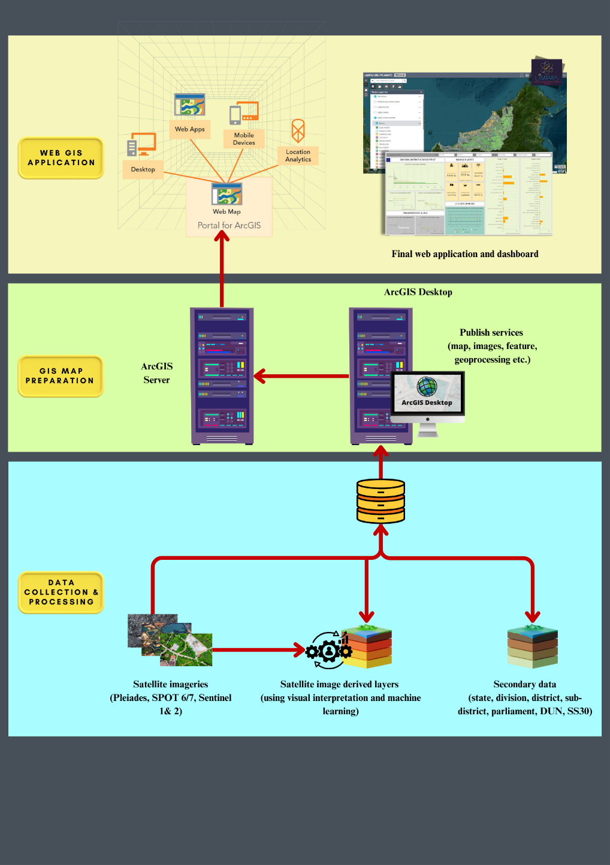

Figure 2: LIMPAS system components.

* + 1. **LIMPAS Database**

Data deployed by LIMPAS application comprises of raster layers (satellite imageries) and feature layers (land cover maps, boundaries, etc.). Attached to the feature layers is its corresponding attribute information stored in spatial tables within the database. Oracle 18c is used to store and manage the data. The logical structure of the database for LIMPAS is designed in accordance to the requirements and specifications gathered from LSD.

* + - 1. **Main Data**
    1. Land Cover - Spatial table that stores all information about land cover including land cover codes and areas in hectares as attributes. There are two editions of land cover layers, the 2013 1st Edition LCM and 2023 2nd Edition LCM. Each land cover editions were displayed by divisions.
    2. Land Cover Changes - Spatial table that stores information on land cover changes including division, 2013 1st Edition LCM and 2023 2nd Edition LCM, and 1st Edition and 2nd Edition generalized land cover as attributes.
    3. MYSA Base Map – SPOT 6 mosaic satellite image base map ranging from 2019-2022.
    4. Satellite Imageries – Collection of satellite imageries from SPOT-6, SPOT-7, Sentinel and Pleiades.
       1. **Secondary Data**

1. Division - Spatial table that stores Sarawak division boundaries containing division name and areas as attributes.
2. District - Spatial table that stores the district boundaries in Sarawak and contains district name and areas as attributes.
3. Sub-district - Spatial table that stores the sub-district boundaries in Sarawak and contains sub-district name and areas as attributes.
4. Parliament – Spatial table that stores Sarawak parliament boundaries containing parliament name, parliament code, criteria and areas as attributes.
5. DUN (State Legislative Assembly) - Spatial table that stores Sarawak state legislative assembly’s boundaries containing DUN name, DUN code, criteria and areas as attributes.
6. SS30 Map Index - Spatial table that stores Sarawak division boundaries containing map name and map index as attributes.
7. CORS (Continuously Operating Reference Station) – Spatial table that stores CORS station containing CORS name and coordinates as attributes.
   1. **GIS Map Preparation**

Using ArcGIS Desktop software, utilizing data stored inside the Oracle database, layers of map are designed accordingly to the styling and symbology specified by LSD. The cartographic map design includes the color for each specific land use class, labels and symbols for every features of the maps. These maps are published to ArcGIS Server as map services. Related satellite images are also published to ArcGIS Server to generate image services. The hosted services will be utilized in the next stage of developing the web application.

* 1. **Web and Web GIS Development**
     1. **Web Development**

The web development for LIMPAS application begins by analysing and gathering information of user requirement. Based on the requirements provided by the user, using the available data gathered, the database is designed. The data includes spatial and non-spatial data has been identified during user requirement specification phase. At this stage, the data is also verified and standardised to remove any redundancies. Using the ArcGIS Desktop and ArcGIS Server the data are published to create APIs that will be employed to generate a web map.

Web map for LIMPAS application combines all the operational layers and a basemap identified using the requirement phase and is created using Portal for ArcGIS. This web map is imported into Web AppBuilder to create GIS application. At this point of the development, functions are added to provide user with operations that can be used to further analyse data when accessing LIMPAS web application LIMPAS web application also consists of an interface where authorised user can log in. The login page is developed using HTML, PHP and Javascript.

LIMPAS can only be accessed by authorized users identified by LSD to ensure effective regulation of its use. The LIMPAS web application is designed with four levels of access. These access levels are established to restrict certain data to only those authorized to view it.

The user are categorised into four levels of access as follows:

|  |  |  |
| --- | --- | --- |
| No. | Access Level | Description |
| 1. | Headquarter 1 (HQ1) | User have access to standard functions with additional functions of dashboard and full queries (division, district, sub-district, parliament, dun) |
| 2. | Headquarter 2 (HQ2) | User have access to standard functions with additional function of full queries |
| 3. | Headquarter 3 (HQ3) | User have access to standard functions with limited queries (division, district, sub-district) |
| 4. | Division | User from division can only access their own division. All user from division have access to standard functions with limited queries. |

* + 1. **Web GIS Modules**

For this application, three (3) primary components were created: a display module, a query and analysis module, and a dashboard module.

* + - 1. **Display Module**

Any web-GIS application needs a display module to be intuitive and user-friendly. Users can pan, zoom, identify landmarks, and print maps. The table of contents displays all GIS data with medium, high, and very-high-resolution satellite images from Pleiades, SPOT6/7, and Sentinel 1 for flood monitoring and detection. This module allows users to visually identify land cover of certain areas and the changes occurred at that area. Figure 3 displays the attribute map using the display pop up function. User also can produce printed maps in this module. Map print layout is shown in Figure 4.

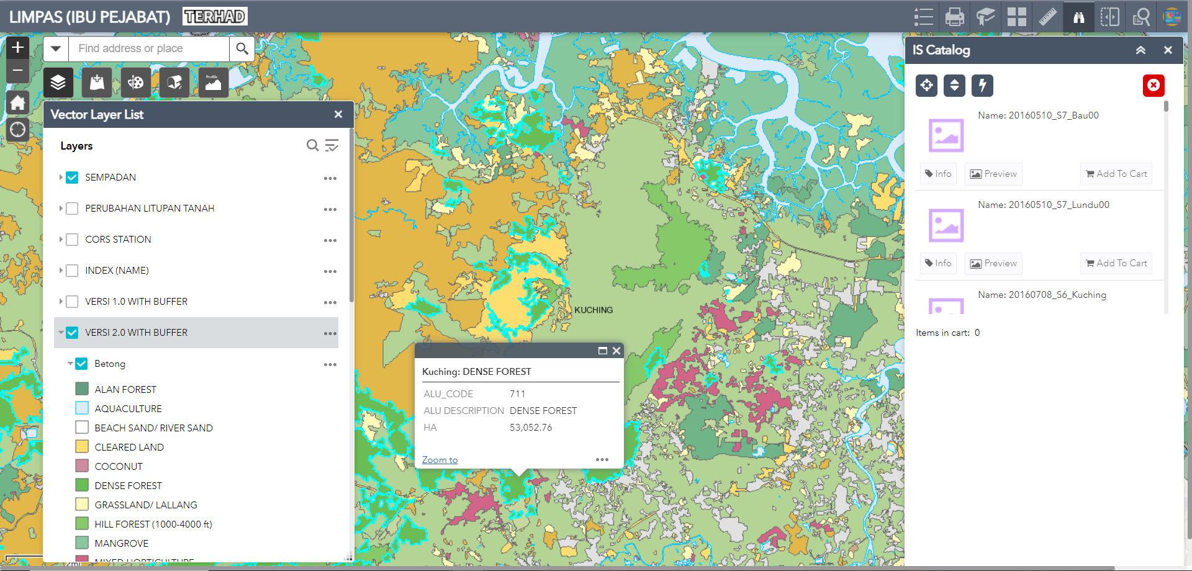

Satellite imageries

Attributes

Vector data

Figure 3: Map with the attribute information using the display pop – up function.

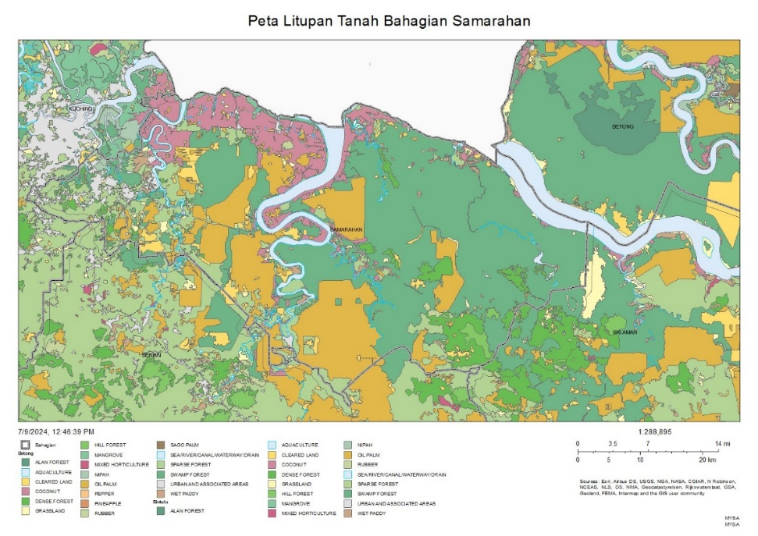

Figure 4: Map in print layout format

* + - 1. **Query and Analysis Module**

The key element of this web-GIS application is the query and analysis module. Registered users can query spatial data based on their needs. The query function for LIMPAS can be done for different administrative level. Land cover maps for both editions can be queried based on division, district, sub-district, parliament and DUN boundaries. Users can also zoom to certain area based on SS30 map sheet index. The query results can be shown in the attribute table, exported to different formats and performed statistical analysis.

The analysis module provide elevation profile and measures distance, and area. Elevation profile is crucial in determining the best location with high quality signal for telecommunications tower. According to Concejal, 2024, Digital Terrain Model (DTM) is essential for calculation vision profiles, and determining the elevation of transmitting and receiving antennas. This can help LSD to take full advantage of the terrain, minimizing interference and maximizing signal range. Furthermore, the area size and distance to nearest settlement areas can also be estimated. Changes between 2 sets of land cover editions were also incorporated into LIMPAS.

* + - 1. **Dashboard Module**

The dashboard module displays multiple visualizations concurrently on a single screen. The dashboard facilitates easy monitoring, decision-making, and viewing of trends in land cover classes and changes, specifically for LSD top management with HQ1 access level. User can view land cover information based on different administrative level (Figure 5).

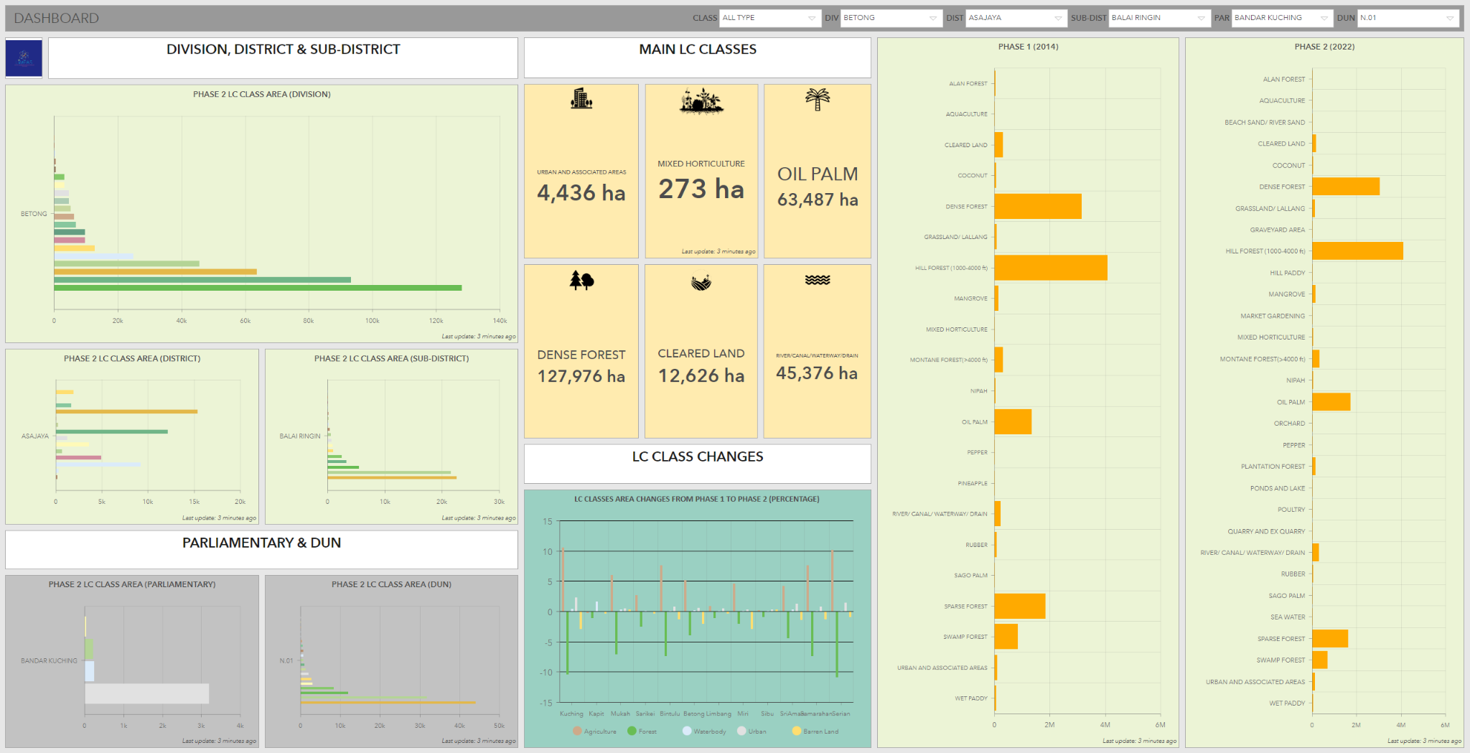

Figure 5: Dashboard showing land cover classes areas and changes information.

1. **Results**

For the 2013 1st Edition LCM, a total of 21 cover classes were mapped. In the 2023 2nd Edition LCM, this number increased to 29 classes. These classes are then generalized into five main categories: *Urban*, *Barren*, *Forest*, *Agriculture*, and *Water bodies*, as shown in Table 1.

Table 1: LC Classes Categories

|  |  |  |
| --- | --- | --- |
| **No.** | **Generalized classes** | **LC Classes** |
| 1. | Urban Land | Urban & Associated Areas |
| Graveyard Area |
| Poultry |
| Mixed Horticulture |
| 2. | Barren Land | Cleared Land |
| Quarry & Ex-Quarry |
| Beach Sand / River Sand |
| 3. | Forest Land | Dense Forest |
| Sparse Forest |
| Hill Forest |
| Montane Forest |
| Alan Forest |
| Mangrove |
| Swamp Forest |
| Nipah |
| 4. | Agriculture Land | Coconut |
| Market Gardening |
| Oil Palm |
| Rubber |
| Paddy |
| Pepper |
| Pineapple |
| Sago |
| Orchard |
| Grassland/Lallang |
| 5. | Water Bodies | Aquaculture |
| River / Canal/ Waterway/ Drain |
| Sea Water |
| Ponds and Lake |

The area information for each class in both years was obtained from Table 2. A post-classification comparison technique was performed, where the LC map from 2013 1st Edition LCM was compared with the 2023 2nd Edition LCM. Based on the comparison, the changes that occurred between both editions are presented quantitatively. As the classification were done based on divisions, the results for all 12 divisions are shown in Figure 8.

Table 2: Area information for 1st and 2nd Edition LCM categories.

|  |  |  |  |  |
| --- | --- | --- | --- | --- |
| Class | LC Map Edition | | | |
| 2013 1st Edition LCM | | 2023 2nd Edition LCM | |
| Hectares (ha) | Percentage (%) | Hectares (ha) | Percentage (%) |
| Agriculture Land | 1,534,791.25 | 12.36 | 1,883,092.51 | 15.17 |
| Barren Land | 280,367.61 | 2.26 | 145,497.81 | 1.17 |
| Forest Land | 10,305,744.46 | 83.00 | 9,974,210.31 | 80.33 |
| Urban Land | 85,988.87 | 0.69 | 132,366.43 | 1.07 |
| Water Bodies | 210,107.82 | 1.69 | 281,832.95 | 2.27 |
| Total area | **12,417,000.00** |  | **12,417,000.00** |  |

* 1. **Sarawak LC Pattern in 2013 1st Edition LCM**

The layout of the 2013 1st Edition LCM is shown in Figure 7a. This edition focuses on priority areas, with classification accuracy as follows: Matang 88%, Sibu 87%, Kapit 92%, Mukah and Halal-hub 86%, Limbang 78%, Nanga Merit 86%, Baram - Murum 86%, Miri 87%, Kuching 84%, Sri Aman 84%, and Lawas 87%.

Initially, field activities are thoroughly conducted in a priority area using stratified random sampling with ERDAS IMAGINE software. The number of samples was determined based on Jensen's theory (1996), which suggests a minimum of 50 samples per pixel per class per scene. Verification locations were then refined based on the project members' experience in image interpretation and the use of supporting data such as orthophotos and multi-temporal images. A total of 1,421 sampling points were collected for field verification, resulting in an overall accuracy of 85.9% for the entire Sarawak region.

The generalized classification categories and their area information are listed in Table 2. Based on the results, the largest category was *forest* (10,305,744.46 ha, 83.0 % of the total area), followed by *agriculture* (1,534,791.25 ha, 12.4% of the total area), *barren land* (280,367.61 ha, 2.3% of the total area), *water bodies* (210,107.82 ha, 1.7% of the total area) and *urban* (85,988.87 ha, 0.7% of the total area).

* 1. **Sarawak LC Pattern in 2023 2nd Edition LCM**

The 2023 2nd Edition LCM layout is displayed in Figure 6b. The generalized version of this map was shown in Figure 7b. According to the map, the Sarawak state area mainly consisted of *forest class* (9,974,210.31 ha, 80.3% of the total area), followed by agriculture (1,883,092.51 ha, 15.2% of the total area). Water bodies rose to the third place, with 2.3% of the total area, covering 281,832.95 ha. Barren land are 145,497.81 ha, 1.2% of the total area. Finally, urban areas are 132,366.43 ha, which makes 1.1% of the total area. From the 2013 1st Edition LCM to the 2023 2nd Edition LCM, the LC patterns changed significantly.

|  |  |
| --- | --- |
|  |  |
| 1. 2013 1st Edition LCM of Sarawak. | 1. 2023 2nd Edition LCM of Sarawak |

Figure 6: 1st and 2nd Edition Sarawak Land Cover Maps

|  |  |
| --- | --- |
|  |  |
| 1. Generalized 1st Edition LC map of Sarawak. | 1. Generalized 2nd Edition LC map of Sarawak |

Figure 7: Generalized 1st and 2nd Edition Sarawak Land Cover Maps

* 1. **Change Detection**

The area for each LC class and its changes from 2013 1st Edition LCM to the 2023 2nd Edition LCM are presented in Table 3. Positive and negative changes were observed between the 2 map editions in the study area. Figure 8 shows the graph depicting the land cover changes in percentage of the study area by divisions. The significant changes for 3 classes (forest, agriculture, and barren land) are elaborated below.

Figure 8: Graph showing the land cover changes percentage of the study area.

Table 3: The area for each LC class in both map editions and the changes occurred.

|  |  |  |  |  |  |
| --- | --- | --- | --- | --- | --- |
|  |  | LC Area (ha) | |  |  |
| No | Class Name | 2013 1st  Edition LCM | 2023 2nd Edition LCM | Area Changed (ha)  (2nd Ed- 1st Ed) | Percent change (%) |
| 1 | Agriculture | 1,534,791.25 | 1,883,092.51 | 348,301.25 | 2.8 |
| 2 | Barren Land | 280,367.61 | 145,497.81 | -134,869.80 | -1.1 |
| 3 | Forest | 10,305,744.46 | 9,974,210.31 | -331,534.145 | -2.7 |
| 4 | Urban | 85,988.87 | 132,366.43 | 46,377.56 | 0.4 |
| 5 | Water Body | 210,107.82 | 281,832.95 | 71,725.13 | 0.6 |

(+) Indicates an increase and (−) indicates a decrease in the area under a LC class for both LCM Editions

* + 1. **Forest**

Forest areas decreased from 10,305,744.46 ha in 2013 1st Edition LCM to 9,974,210.31 ha in 2023 2nd Edition LCM, which represents a net decrease of 348,301.25 ha. This decrease is attributed to the conversion of forest land to other classes, mostly agriculture land. For example, in the Kapit area, forests have been submerged by the rising waters of the river due to the Bakun Dam, causing a 0.6% increase in water bodies.

* + 1. **Agriculture**

Agriculture land areas increased from 1,534,791.25 ha in 2013 1st Edition LCM to 1,883,092.51 ha in 2023 2nd Edition LCM, which represents a net increase of 348,301.25 ha. This is due to an increasing number of areas being explored and developed by individuals or companies for agricultural purposes, including palm oil, rubber, pepper, and more.

* + 1. **Barren Land**

Barren land areas decreased from 280,367.61 ha in the 2013 1st Edition LCM to 145,497.81 ha in 2023 2nd Edition LCM, which represents a net decrease of 134,869.80 ha. The degradation of barren land is attributed to its conversion into urban and agricultural land. The cleared land has been transformed into urban areas with town buildings, shophouses, and more. Some barren land has also been cleared for plantations, resulting in the growth of crops such as oil palm, paddy, and other agricultural produce.

* 1. **Benefit**

LIMPAS provides many benefits to users. It offers systematic and centralized land cover information management, ensuring that all data is organized and easily accessible. The system also monitors land cover class changes using high-resolution and up-to-date satellite images, allowing for accurate and timely updates.

Decision-makers can plan and manage land cover information quickly and accurately with LIMPAS, significantly enhancing their efficiency. Productivity is increased as the survey method planning process is sped up by 50%. Additionally, LIMPAS offers comprehensive mapping coverage for the entire state of Sarawak, ensuring that no area is left uncharted. The system also boasts a classification accuracy of over 80%, providing reliable and precise data for various applications.

The LIMPAS system has proven beneficial to both the LSD and the Sarawak State Government in land management, including determining new land ownership titles, assessing compensation costs for the development of the Pan Borneo Highway, conducting suitability analysis for telecommunication tower locations, and performing flood assessments.

1. **Conclusion**

LIMPAS, a web-based GIS smart system for managing Sarawak's land cover, was developed using remote sensing, GIS, and ICT technologies to disseminate this information.  The analysis results demonstrate the system's efficiency in leveraging information delivery.  In conclusion, the system has been successfully operationalized across all 13 divisions and HQ for Sarawak's land management. Moving forward, the system will be upgraded to Phase 3 using new satellite data to produce the 3rd Edition LCM.

1. **Acknowledgment**

The authors would like to sincerely thank the Department of Land and Survey, Sarawak (LSD) for their collaboration and assistance. We would also like to acknowledge the LIMPAS team from MYSA and LSD for producing the SS30 Land Cover map of Sarawak, which we used as one of the references for this study.

1. **References**

Ahmed, A.A., Kalantar, B., Pradhan, B., Mansor, S., Sameen, M.I. (2019). Land Use and Land Cover Mapping Using Rule-Based Classification in Karbala City, Iraq. In: Pradhan, B. (eds) GCEC 2017. GCEC 2017. Lecture Notes in Civil Engineering, vol 9. Springer, Singapore. https://doi.org/10.1007/978-981-10-8016-6_71

Akpoti, K., Antwi, E. O., & Kabo-Bah, A. T. (2016). Impacts of rainfall variability, land use and land cover change on stream flow of the black Volta Basin, West Africa. *Hydrology*, 3(3), 26. <https://doi.org/10.3390/hydrology3030026>

Belgiu, M., Drǎguţ, L., Strobl, J., 2014. Quantitative evaluation of variations in rule-based classifications of land cover in urban neighbourhoods using WorldView-2 imagery. ISPRS Journal of Photogrammetry and Remote Sensing, 87(0), pp. 205-215

Bewket, W. (2002). Land cover dynamics since the 1950s in Chemoga watershed, Blue Nile basin, Ethiopia. *Mountain Research and Development*, 22(3), 263–269. [https://doi.org/10.1659/0276-4741(2002)022[0263:LCDSTI]2.0.CO;2](https://doi.org/10.1659/0276-4741(2002)022%5b0263:LCDSTI%5d2.0.CO;2)

Blaschke, Thomas. (2010). Object based image analysis for remote sensing. ISPRS J Photogramm Remote Sens. ISPRS Journal of Photogrammetry and Remote Sensing. 65. 2 - 16. 10.1016/j.isprsjprs.2009.06.004.

B Rokni Deilmai et al 2014 IOP Conf. Ser.: Earth Environ. Sci. 20 012052

Bolin Fu, Hang Yao, Feiwu Lan, Sunzhe Li, Yiyin Liang, Hongchang He, Mingming Jia, Yeqiao Wang & Donglin Fan (2023) Collaborative multiple change detection methods for monitoring the spatio-temporal dynamics of mangroves in Beibu Gulf, China, GIScience & Remote Sensing, 60:1, 2202506, DOI: 10.1080/15481603.2023.2202506

Concejal A. (2024, Jan 11). DSM, DTM and DHM Elevation Mapping in Telecommunications: An Essential Tool for Success. <https://www.luxcarta.com/blog/rf-planning/elevation-mapping-telecommunications>

Congalton, R.G. and K. Green. (1999). Assessing the Accuracy of Remotely Sensed Data: Principles and Practices. Lewis Publishers. 137 pp.

Dedy Kurniawan, Dwi Rosa Indah, Purwita Sari, Rahmat Arif Akbari. (2023). Geo-Informatics for the Future: A Systematic Literature Review on the Role of WebGIS in Infrastructure Planning and Development. Indonesian Journal of Computer Science 12(3). 988-1003. DOI:10.33022/ijcs. v12i3.3228

Dires Tewabe & Temesgen Fentahun | (2020) Assessing land use and land cover change detection using remote sensing in the Lake Tana Basin, Northwest Ethiopia, Cogent Environmental Science, 6:1, 1778998, DOI: 10.1080/23311843.2020.1778998

Economic Planning Unit Sarawak. (2021). Post COVID-19 Development Strategy 2030. <https://sarawak.gov.my/media/attachments/PCDS_Compressed_22_July_2021.pdf>

ESRI. (2021). Image Classification using the ArcGIS Spatial Analyst Extension. <https://desktop.arcgis.com/en/arcmap/latest/extensions/spatial-analyst/image-classification/image-classification-using-spatial-analyst.htm>

ESRI. (2022). Get started with Web GIS. ESRI Press. Chapter 1. p. 1-16

GIS Resources. (2015, June 28). Why SWIR Band in Remote Sensing? <https://gisresources.com/why-swir-band-in-remote-sensing/>

GN Vivekananda, R Swathi & AVLN Sujith (2021) Multi-temporal image analysis for LULC classification and change detection, European Journal of Remote Sensing, 54:sup2, 189-199, DOI: 10.1080/22797254.2020.1771215.

Haque, Md Enamul & Al-Ramadan, Baqer & Johnson, Brian. (2016). Rule-based land cover classification from very high-resolution satellite image with multiresolution segmentation. Journal of Applied Remote Sensing. 10. 036004. 10.1117/1.JRS.10.036004.

Herold, M., Scepan, J., Müller, A., Günther, S.: Object-oriented mapping and analysis of urban land use/cover using IKONOS data. In: 22nd Earsel Symposium Geoinformation for European-Wide Integration, pp. 4–6, 2002)

Hurni, H., Tato, K., & Zeleke, G. (2005). The implications of changes in population, land use, and land management for surface runoff in the upper Nile basin area of Ethiopia. *Mountain Research and Development*, 25(2), 147–154. [https://doi.org/10.1659/0276-4741(2005)025[0147:TIOCIP]2.0.CO;2](https://doi.org/10.1659/0276-4741(2005)025%5b0147:TIOCIP%5d2.0.CO;2)

Jean-François Mas, Richard Lemoine-Rodríguez, Rafael González-López, Jairo López-Sánchez, Andrés Piña-Garduño & Evelyn Herrera-Flores (2017) Land use/land cover change detection combining automatic processing and visual interpretation, European Journal of Remote Sensing, 50:1, 626-635, DOI: 10.1080/22797254.2017.1387505

Jenness, J., and J.J. Wynne. 2005. Cohen’s Kappa and classification table metrics 2.0: an ArcView 3x extension for accuracy assessment of spatially explicit models: U.S. Geological Survey Open-File Report OF 2005-1363. U.S. Geological Survey, Southwest Biological Science Center, Flagstaff, AZ.

Jensen, J. R. (2005). “Introductory Digital Image Processing: A Remote Sensing Perspective”. Prentice Hall, NJ: Pearson.

Knudby A.J. (2021). Remote Sensing. <https://ecampusontario.pressbooks.pub/remotesensing/chapter/chapter-7-accuracy-assessment/>

Lillesand, T.M., Kiefer, R.W. and Chipman, J.W., (2004). “Remote Sensing and Image Interpretation”. 5th Edition, John Wiley & Sons Inc., New York.

Ling, J.; Zhang, H.; Lin, Y. Improving Urban Land Cover Classification in Cloud-Prone Areas with Polarimetric SAR Images. Remote Sens. 2021, 13, 4708. https:// doi.org/10.3390/rs13224708

M. M. H. Seyam, M. R. Haque, and M. M. Rahman. (2023). “Identifying the land use land cover (LULC) changes using remote sensing and GIS approach: A case study at Bhaluka in Mymensingh, Bangladesh,” Case Studies in Chemical and Environmental Engineering, p. 100293, doi:<https://doi.org/10.1016/j.cscee.2022.100293>.

Md Mahadi Hasan Seyam, Md Rashedul Haque, Md Mostafizur Rahman, (2023). Identifying the land use land cover (LULC) changes using remote sensing and GIS approach: A case study at Bhaluka in Mymensingh, Bangladesh. Case Studies in Chemical and Environmental Engineering. Volume 7. https://doi.org/10.1016/j.cscee.2022.100293.

Mohammad D. Hossain, Dongmei Chen. Segmentation for Object-Based Image Analysis (OBIA): A review of algorithms and challenges from remote sensing perspective. ISPRS Journal of Photogrammetry and Remote Sensing, Volume 150, 2019, Pages 115-134, ISSN 0924-2716, https://doi.org/10.1016/j.isprsjprs.2019.02.009.

Myint, S.W., Gober, P., Brazel, A., Grossman-Clarke, S., Weng, Q.: Per-pixel versus object-based classification of urban land cover extraction using high spatial resolution imagery. Remote Sens. Environ. **115**(5), 1145–1161 (2011)

Osuna and R Freud (1977). Support Vector Machines: Training and Applications. Massachusetts Institute of Technology Cambridge, USA, p. 1-144.

P. S. Roy and Arijit Roy. (2010). Land use and land cover change in India: A remote sensing & GIS Perspective. Journal of the Indian Institute of Science VOL 90:4 Oct–Dec 2010 journal.library.iisc.ernet.in

Parece T & McGee J. (2023). [Remote Sensing With ArcGIS Pro (Second Edition)](https://pressbooks.lib.vt.edu/remotesensing/). <https://pressbooks.lib.vt.edu/remotesensing/chapter/chapter-25-accuracy-assessment/>

Parihar S. M. (2014). Introduction to Geographic Infromation System (GIS). <https://ebooks.inflibnet.ac.in/geop10/chapter/introduction-to-geographic-information-system-gis/>.

Radhakrishnan, N., Satish Kumar, E., & Kumar, S. (2014). Analysis of urban sprawl pattern in Tiruchirappalli city using applications of remote sensing and GIS. Arabian Journal Science and Engineering, 39(7), 5555–5563. <https://doi.org/10.1007/s13369-014-1099-2>

Randazzo G, Italiano F, Micallef A, Tomasello A, Cassetti FP, Zammit A, D’Amico S, Saliba O, Cascio M, Cavallaro F, et al. (2021). WebGIS Implementation for Dynamic Mapping and Visualization of Coastal Geospatial Data: A Case Study of BESS Project. Applied Sciences. 11(17):8233. <https://doi.org/10.3390/app11178233>

Sandeep V. G., Amol D. V., and Karbhari V. K. (2021). Design and Implementation of a Web-Gis Platform for Monitoring of Vegetation Status. ICTACT Journal On Image and Video Processing February 2021 11 (3) DOI: 10.21917/ijivp.2021.0338

Sarawak Land Survey Department & Malaysian Space Agency. (2023). LIMPAS: Pendigitalan Dimensi Bumi Dari Angkasa. ISBN 978-967-16181-4-1.

Siti Nor Afzan A. H., Noryusdiana M. Y., Siti Muazah M. Z., Hana M. J., Mohd Adha A. M., Mohd. Hakimi A.R., Welly A. N., Nurul Suliana A. H., Bismawaty H., Mohammad Azizi F., Zulfikri I. and Nur Dhuha D. (2023). Establishment of Web-GIS System for Identifying and Monitoring Potential Waste Disposal Site in Malaysia. 44th Asian Conference on Remote Sensing 30 October – 3 November 2023. Taipei, Taiwan.

Tewabe, D., Fentahun, T., & Li, F. (2020). Assessing land use and land cover change detection using remote sensing in the Lake Tana Basin, Northwest Ethiopia. *Cogent Environmental Science*, *6*(1). https://doi.org/10.1080/23311843.2020.1778998

The Official Portal of Sarawak Government. (2020). Sarawak Population (<https://sarawak.gov.my/web/home/article_view/240/175/>)

USGS. (2013, March). Landsat Missions – Landsat 8. <https://www.usgs.gov/core-science-systems/nli/landsat/landsat-8>.

USGS. (n.d). Landsat Missions - Landsat 5. <https://www.usgs.gov/landsat-missions/landsat-5>

USGS. (n.d.). EarthExplorer. <https://earthexplorer.usgs.gov/>

W.M.D.C.Wijesinghe and W.K.N.C. Withanage. (2021). Detection of the changes of land use and land cover using remote sensing and GIS in Thalawa DS Division. Prathimana Journal Volume 14, No.1, 2021, 072 – 086.

Yang, Y.; Yang, D.; Wang, X.; Zhang, Z.; Nawaz, Z. Testing Accuracy of Land Cover Classification Algorithms in the Qilian Mountains Based on GEE Cloud Platform. Remote Sens. 2021, 13, 5064. https://doi.org/10.3390/ rs13245064

Zhang C, Li X. Land Use and Land Cover Mapping in the Era of Big Data. Land. 2022; 11(10):1692. https://doi.org/10.3390/land11101692