**Rice Crop Loss and Damage Estimation Due to Flood Using Remote Sensing Imageries**

Bhogendra Mishra1,2*, Shobha Poudel1,3, Krishna Chandra Devkota4, Bhoj Raj Ghimire1,5

1Senior Scientist, Science Hub, Kathmandu Nepal,

2Institute for Electromagnetic Sensing of the Environment, National Research Council, Milan Italy,

3Fondazione Eni Enrico Mattei, Milan, Italy

4Gandaki Provincial Policy and Planning Commission, Kaski, Nepal,

5Nepal Open University, Lalitpur, Nepal

[*bmishra@sciencehub.org.np](mailto:*bmishra@sciencehub.org.np)

***Abstract:*** *South Asia is predominantly an agrarian society. Agriculture is the main source of livelihood for the majority of the population; with rice being a major staple crop that accounts for more than 25% of the region’s agricultural contribution. The main rice growing season (June to October) is particularly vulnerable to monsoon rainfall-induced flooding damage. Accurate and transparent methods are crucial to assess rice crop damage and support mitigation and disaster response strategies in the country. This study developed a framework for rapid pre- and post-event crop status assessment using optical and microwave remote sensing images and estimate the actual loss based on its timing and intensity. The framework combines Sentinel 2 A/B images with Sentinel 1 SAR images to map rice areas, identify areas at risk, and quantify crop loss due to flooding. The crop status at the moment of flooding is estimated through time series analysis of rice phenology. The inundation area map and its temporal dynamics were developed using Sentinel 1 SAR images during the flooding and post-transplantation months. Statistical analysis was performed on the time-series pre- and post-flooding status of the rice crop to estimate rice yield loss and, finally, automate the method used in the region for yield loss estimation due to flooding in rice-growing areas.*

*Keywords: Agriculture, Disaster, Loss and Damage Estimation, Rice*

Introduction

Natural disasters such as floods, storms, droughts, and earthquakes cause significant loss of assets and life globally. Among these disasters, floods are the most widespread type and cause significant losses. South Asian countries incur higher losses due to inadequate preparedness and lack of timely information dissemination about possible extreme weather conditions. The frequency and intensity of floods have increased due to climate change in recent years. The Food and Agriculture Organization of the United Nations estimates that more than 93 thousand hectares of cropland and 1.6 million tons of crops are damaged by flooding annually (2003–2013), accounting for more than half of the aggregate crops damaged by natural hazards and disasters (FAO, 2015).

Nepal, located in the foothills of the Himalayas, is not an exception. It is particularly vulnerable to climate-induced hazards due to extreme precipitation. Floods are particularly devastating in Nepal, with frequent and severe flooding in recent years made worse by climate change (Y. Mishra et al., 2021a) Recently, Nepal has been frequently experiencing monsoon floods and losing tons of rice but the amount of loss is estimated to be different by different authorities (Poudel et al., 2023). The assumptions could be improved if we could understand the status of crops before and after the flood event precisely. With remote sensing technology, this is possible, though it requires investment in the development of the approach and operable system.

The ability to quickly, affordably and accurately assess crop damage in flood-affected areas is crucial, primarily to provide compensation for crop loss to farmers, future preparedness, as well as for understanding the impact on food security and the economy at both local and national levels (Luintel et al., 2021; B. Mishra et al., 2021). This information is also valuable for decision-makers to plan for rehabilitation and prioritize interventions and communicate the impact of these events in a clear and quantitative way. Additionally, this information has many other uses, such as insurance, trade, food security, and policy development. Traditional survey-based methods are slow and expensive for disaster mapping, making remote sensing a viable alternative. Remote sensing has been shown to be reliable for disaster mapping in the literature and vegetation indices have potential for damage mapping, particularly for flood damage assessment (Phan et al., 2019; Singha et al., 2019).

The degree of crop damage can be quantified by comparing vegetation indices before and after a flood event or by comparing current crop conditions with historical conditions. Several vegetation indices have been developed for crop condition monitoring, including the Normalized Difference Vegetation Index (NDVI), Enhanced Vegetation Index (EVI), Ratio Vegetation Index (RVI), Vegetation Condition Index (VCI), Mean Vegetation Condition Index (MVCI), Ratio to Median Vegetation Condition Index (RMVCI), and Leaf Area Index (LAI) etc. VCI and MVCI are derived from NDVI by further normalizing it with historical maximum and minimum NDVIs or mean NDVI respectively, to capture relative NDVI change with respect to historical NDVI at a given location (Kamthonkiat et al., 2005; Rahman et al., 2021; Yang et al., 2020).

While both mean and median are used to express the central tendency of data, mean is sensitive to outliers. Daily NDVI values may be contaminated by clouds, resulting in unreliable mean NDVI. To avoid the effect of clouds and other noise on NDVI, a modified VCI (mVCI) that uses median NDVI instead of mean NDVI can be used for monitoring vegetation conditions. A novel index called Disaster Vegetation Damage Index (DVDI) has been proposed to measure crop/vegetation damage due to natural hazard-induced disasters, relying on mVCI before and after the disaster event. Recent studies have shown that DVDI is an effective index for rapidly measuring vegetation damage due to natural hazards (Di et al., 2018). This study used DVDI to examine flood crop damage by incorporating three primary information such as crop condition, and flood extents.

Study Area

Figure 1 illustrates the study areas. It lies in the southern part of Nepal. The area is plain flood land with a small part of Chure region in the North. This region is vulnerable to food and flood-induced disasters frequently. The sites for the preliminary study were chosen to represent rice-cultivated regions in Nepal with a history of frequent inundation. The climate of the study area is hot and humid, featuring a hot summer with abundant rainfall and a mild winter. Approximately 80% of the annual rainfall of around 1500 mm occurs between June and September (B. Mishra et al., 2023), with some intense rainfall causing floods and inundation.

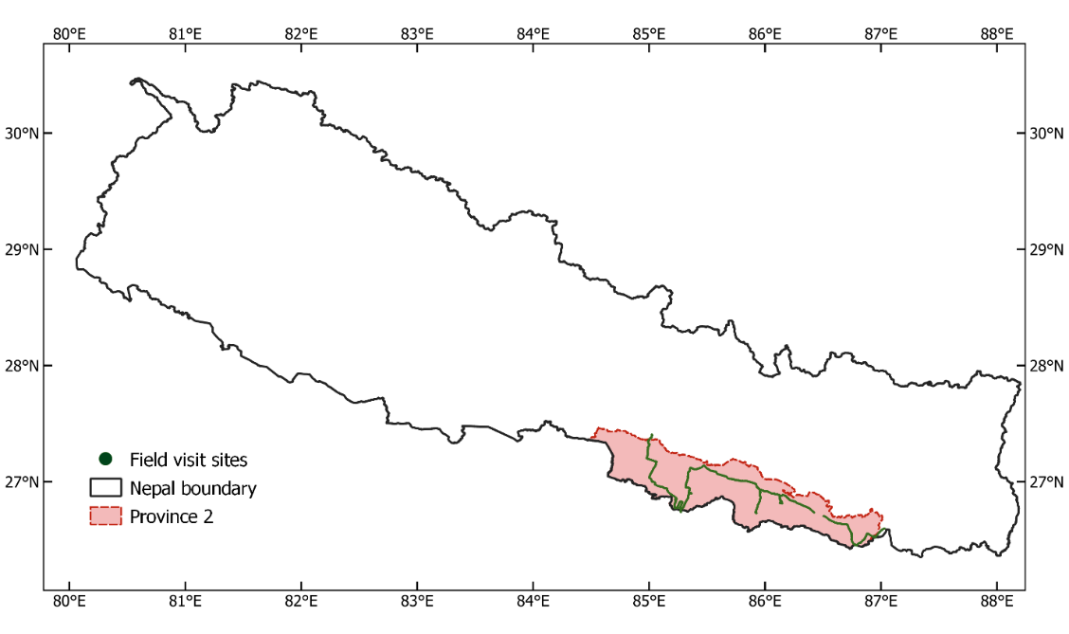

Figure 1 Location of study area and trails of the field visits sites, data from the agricultural fields primarily with the history of flooding and inundation events were acquired.

Data Used

**a. Remote Sensing data**

This research utilized remote sensing data from three satellites: Sentinel-1, Sentinel-2, and Landsat-8. Sentinel-1's SAR data was utilized for detecting water bodies and outlining areas of inundation. Optical imagery was utilized to monitor vegetation growth.

**b. Field Data**

The remote sensing crop map and cropping cycle were validated using ground-based data, which included collecting details about crops on the ground and conducting surveys with farmers in the study area. The ground data included information about both agricultural and non-agricultural land, past cropping patterns, and flood-related disasters in the previous five years. A questionnaire survey was conducted to gather additional information. For remote locations, crop and cropping details were obtained through expert opinion and coordinates were obtained from Google Earth Engine.

**Method**

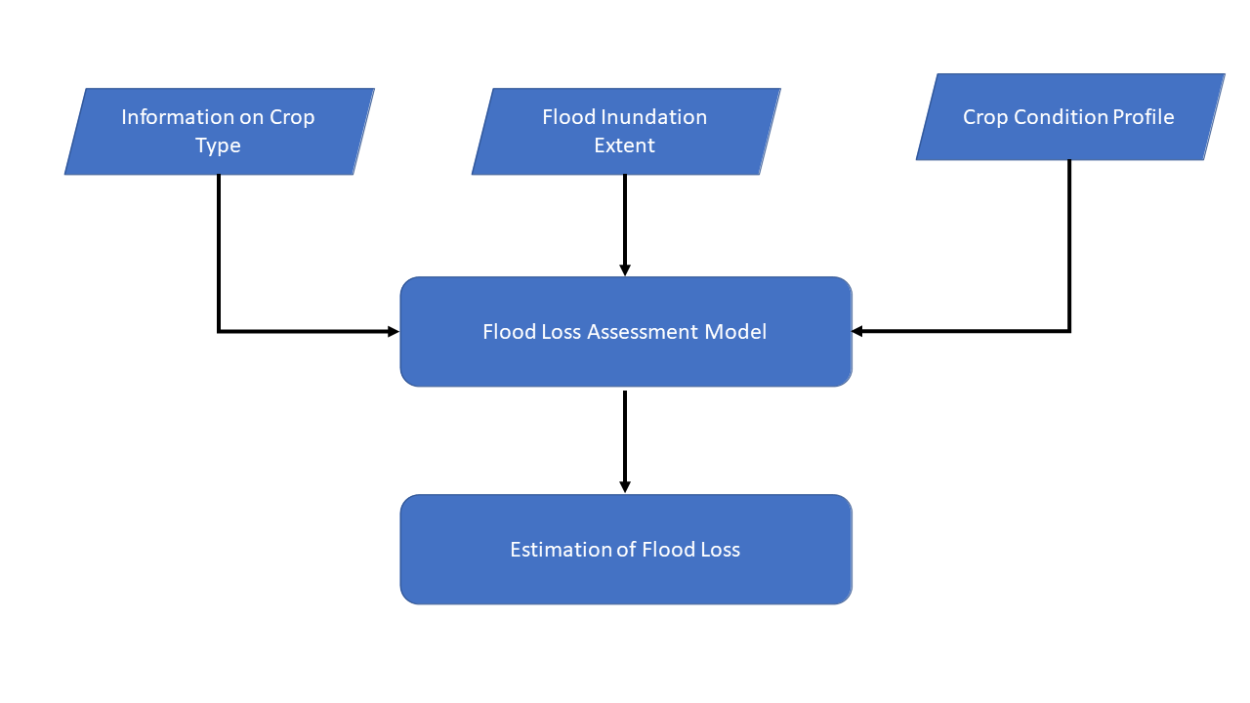A processing chain was developed to detect flooded areas using Sentinel-1 SAR images, map cropping areas and phenology using time series Sentinel 2 optical images, and estimate crop damage using crop condition, crop maps, and flood maps as shown in Figure. 2

Figure 2 The process flow diagram to quantify the loss due to flood or inundation areas.

**a. Crop Area Mapping**

The crop and phenology mapping were performed using a rule-based algorithm on timeseries NDVI data. Cropland follows a general pattern of low NDVI before plantation, consistent increase in NDVI after plantation, maximum NDVI during the heading stage and rapid decrease in NDVI during senescence or harvesting stage. The pixels that match the pattern are labelled as cropland. Once the croplands were identified, the start of season (SoS) and peak of season (PoS) are estimated based on moving window. Rice crops were identified as having the standing water at the time of SoS.

**b. Flooded Area Mapping**

The weekly SAR images (sigma naught) were subjected for the analysis to delineate the weekly inundation area. That was done using the Othu algorithm for sigma naught (Otsu, 1979; Schumann & Moller, 2015). Once water covered area was identified, the deliberate flooding of cropland was confirmed based on inundation maps and phenology maps. The instances in which inundation occurred in proximity to the start of season (SoS), i.e., within two weeks of SOS were considered as the deliberate flooding of cropland for rice transplantation. Such flooding is done to prepare the land for transplantation of rice seedlings. The inundation of crops except such duration is considered as floods that can damage the crops. Such inundation when persists for several weeks, it submerges the seedlings and hinders the normal growth resulting in delayed PoS and reduced yield. Thus, if the water inundation outside transplantation stage persists for a few weeks it was considered as crop damaging flood. Additionally, occupational standing water area in the vegetative crop land is also considered as the flood.

**c. Damage Assessment**

This study combined flood information with crop stage, and crop condition profile for rapid crop damage assessment. The crop condition damage was quantified using DVDI index which is computed as (Di et al., 2018):

*DVDI* = *mVCIa* - *mVCIb*

where mVCIa and mVCIb refers to the median vegetation condition index after and before the event respectively. The mVCI reflects the crop condition of the pixel on the particular day in the given year in comparison with the historical records on that day which is computed as:

$$mVCI=\frac{NDVI-{NDVI}_{med}}{{NDVI}_{max⁡}-{NDVI}_{med}}$$

where NDVI is the NDVI value for the given day in the given year, NDVImed and NDVImax are the median and maximum values of NDVI on that particular day in the historical time. In our study, *mVCI* was calculated with the historical median NDVI of the same age of the crop. The full extent of the study area, that is, beyond the flood affected areas was considered for the reference mVCI. To calculate mVCI before and after a flood event a 7-day window was chosen to calculate mVCI after flood events. Results and analysis.

Results and Discussion

## a. Crop Map

The rice crop area detected in the study area is shown in figure 3. The rice cultivation land is concentrated towards the southern part of the study area (especially in the south of East-West Highway) as forests cover the northern part, with large water bodies and scattered settlements. Table 1 shows that error matrix of the agriculture land against the ground truth samples. The cross validation of the detected agriculture area with the ground truth shows that the rule-based algorithm can satisfactorily delineate the agriculture land with 92.75% accuracy.

Figure 3 Agricultural area in the study area.

Table 1Error Matrix for Agricultural Area Mapping

|  |  |  |  |
| --- | --- | --- | --- |
|  | **Agriculture** | **Other areas** | **Total** |
| **Agriculture** | 198 | 10 | 208 |
| **Other areas** | 19 | 173 | 192 |
| **Total** | 217 | 183 | 371 |

## b. Flood and Inundation Delineation

The figure 4 shows the inundation area detected for 2020 with more than one week of continuous flood apart from the rice transplanted duration. It illustrates the number of consecutive weeks the inundation was detected. The persistent inundation means loss of the crop production in the region, as the crop cannot grow fully under the submerged situation.

Figure 4Inundation duration.

## c. Loss Estimation

The table illustrates the maximum and median NDVI values in the non-inundated and non-flooded area in the spatially extended study at the 10-days interval obtained from the timeseries Sentinel 2 images. The maximum NDVI and Median NDVI values presented in Table 2 were used to compute the median Vegetation Condition Index that indicates the relative vegetation condition of the crop.

Table 2 Maximum and Median NDVI Values for Rice Crops at Various Growth Stages.

|  |  |  |
| --- | --- | --- |
| **Age of crop** | **Max NDVI** | **Median NDVI** |
| Day 1 | 0.1 | 0.02 |
| Day 10 | 0.3 | 0.2 |
| Day 20 | 0.4 | 0.3 |
| Day 30 | 0.5 | 0.4 |
| Day 40 | 0.6 | 0.5 |
| Day 50 | 0.7 | 0.6 |
| Day 60 | 0.75 | 0.65 |
| Day 70 | 0.8 | 0.7 |
| Day 80 | 0.75 | 0.65 |
| Day 90 | 0.7 | 0.6 |
| Day 100 | 0.6 | 0.5 |
| Day 110 | 0.4 | 0.4 |
| Day 120 | 0.3 | 0.2 |

Figure 5 illustrates the severity level of crop loss due to the inundation in 2020 across the study area. The severity level is computed as the function of the duration of the inundation, state of the crop at the time of event and severity level of each incident. The map depicts that the loss occurs primarily in the southern border of Nepal. This can be attributed to the number of dikes in the Indian sides that results in the large amount of the inundation as these areas appear as the most severely affected because of continuous inundation occurring across the monsoon season along the border. Apart from that, a medium level of the damage can be observed near the river corridors, while the loss in the northern parts of the province is rare, except in a very small area of Sarlahi district in the Koshi riverbank.

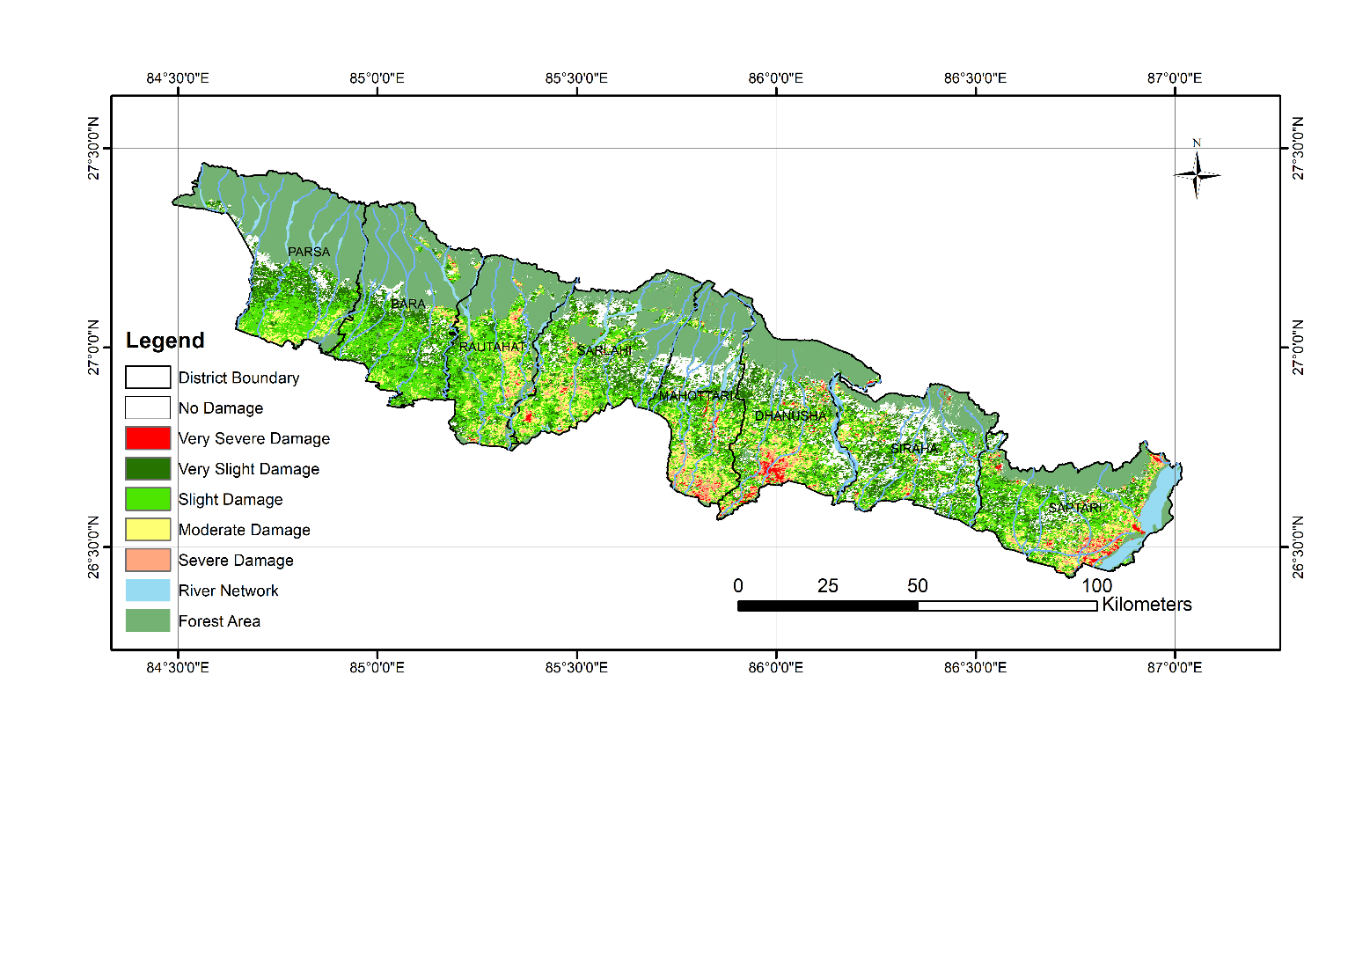

Figure 5Crop loss in Province 2 in 2020 due to the inundation water.

**Conclusion and Recommendation**

In conclusion, the use of DVDI to assess flood impacts on rice crops in Southern Nepal for the year 2020 has proven to be effective in providing rapid qualitative insights into crop damage. While the study shows that large areas of rice were inundated, significant damage was limited to regions where floodwaters persisted for extended periods. The correlation between NDVI drops and damage severity further validates the use of DVDI for assessing crop damage. However, certain limitations remain, such as the influence of factors like flood depth, transplantation timing, and phenological differences. Additionally, uncertainties in remote sensing-based flood and crop mapping may lead to errors in damage estimates, compounded by challenges in validation due to the lack of plot-level loss data.

Despite these challenges, the approach offers key advantages: it relies on freely available remote sensing data, does not require ground surveys, and can be applied rapidly for decision-making in disaster risk reduction. This method is particularly valuable in regions where historical crop data is unavailable, allowing for timely assessments post-flood events. Overall, the DVDI-based approach represents a practical tool for swift crop damage evaluation, offering critical support for policymakers in managing and mitigating flood-related agricultural risks.

Acknowledgement

This study was partly funded by the Asia-Pacific Network for Global Change Research (APN) under the project CRRP2023-05MY-Mishra. We gratefully acknowledge their support in making this research possible.

References

Di, L., Yu, E., Shrestha, R., & Lin, L. (2018). DVDI: A new remotely sensed index for measuring vegetation damage caused by natural disasters. *International Geoscience and Remote Sensing Symposium (IGARSS)*, *2018*-*July*(Dvdi), 9067–9069. https://doi.org/10.1109/IGARSS.2018.8518022

FAO. (2015). *The impact of disasters on agriculture and food security*. https://reliefweb.int/sites/reliefweb.int/files/resources/a-i5128e.pdf

Kamthonkiat, D., Honda, K., Turral, H., Tripathi, N. K., & Wuwongse, V. (2005). Discrimination of irrigated and rainfed rice in a tropical agricultural system using SPOT VEGETATION NDVI and rainfall data. *International Journal of Remote Sensing*, *26*(July 2015), 2527–2547. https://doi.org/10.1080/01431160500104335

Luintel, N., Ma, W., Ma, Y., Wang, B., Xu, J., Dawadi, B., & Mishra, B. (2021). Tracking the dynamics of paddy rice cultivation practice through MODIS time series and PhenoRice algorithm. *Agricultural and Forest Meteorology*, *307*(November 2020), 108538. https://doi.org/10.1016/j.agrformet.2021.108538

Mishra, B., Busetto, L., Boschetti, M., Laborte, A., & Nelson, A. (2021). RICA: A rice crop calendar for Asia based on MODIS multi year data. *International Journal of Applied Earth Observation and Geoinformation*, *103*(September), 102471. https://doi.org/10.1016/j.jag.2021.102471

Mishra, B., Panthi, S., Ghimire, B. R., Poudel, S., Maharjan, B., & Mishra, Y. (2023). Gridded precipitation products on the Hindu Kush-Himalaya: Performance and accuracy of seven precipitation products. *PLOS Water*, *2*(8), e0000145. https://doi.org/10.1371/journal.pwat.0000145

Mishra, Y., Babel, M. S., Nakamura, T., & Mishra, B. (2021a). Impacts of climate change on irrigation water management in the babai river basin, Nepal. *Hydrology*, *8*(2), 1–20. https://doi.org/10.3390/hydrology8020085

Mishra, Y., Babel, M. S., Nakamura, T., & Mishra, B. (2021b). Impacts of climate change on irrigation water management in the babai river basin, Nepal. *Hydrology*, *8*(2), 1–20. https://doi.org/10.3390/hydrology8020085

Otsu, N. (1979). A Tlreshold Selection Method from Gray-Level Histograms. *IEEE Transactions on System Man, and Cybernetics*, *9*, 62–66.

Phan, A., Ha, D. N., Man, C. D., Nguyen, T. T., Bui, H. Q., & Nguyen, T. T. N. (2019). Rapid assessment of flood inundation and damaged rice area in Red River Delta from Sentinel 1A imagery. *Remote Sensing*, *11*(17), 1–24. https://doi.org/10.3390/rs11172034

Poudel, S., Mishra, B., Ghimire, S., Luintel, N., Thapa, P., & Sapkota, R. (2023). Climate change and agroecosystem: impacts, adaption, and mitigation in South Asia. In *Climate Change, Community Response, and Resilience: Insight for Socio-Ecological Sustainability* (pp. 329–344).

Rahman, M. S., Di, L., Yu, E., Lin, L., & Yu, Z. (2021). Remote Sensing Based Rapid Assessment of Flood Crop Damage Using Novel Disaster Vegetation Damage Index (DVDI). *International Journal of Disaster Risk Science*, *12*(1), 90–110. https://doi.org/10.1007/s13753-020-00305-7

Schumann, G. J. P., & Moller, D. K. (2015). Microwave remote sensing of flood inundation. *Physics and Chemistry of the Earth*, *83*–*84*(May), 84–95. https://doi.org/10.1016/j.pce.2015.05.002

Singha, M., Dong, J., Zhang, G., & Xiao, X. (2019). High resolution paddy rice maps in cloud-prone Bangladesh and Northeast India using Sentinel-1 data. *Scientific Data*, *6*(1), 1–10. https://doi.org/10.1038/s41597-019-0036-3

Yang, M. Der, Tseng, H. H., Hsu, Y. C., & Tsai, H. P. (2020). Semantic segmentation using deep learning with vegetation indices for rice lodging identification in multi-date UAV visible images. *Remote Sensing*, *12*(4). https://doi.org/10.3390/rs12040633