**Evaluation of deformation detection performance of highway slope using SAR image simulator**

Iwaki, N.1*, Susaki, J.2, Ishii, Y.3, Oba, T.4

1Student, Graduate School of Engineering, Kyoto University, Japan

2Professor, Graduate School of Engineering, Kyoto University, Japan

3Assistant Professor, Graduate School of Engineering, Kyoto University, Japan

4Professor, Graduate School of Managemnet, Kyoto University, Japan

*iwaki.naoya.33m@st.kyoto-u.ac.jp (*Corresponding author’s email only)

*Abstract*

*Landslides and ground deformation frequently occur around highways, posing significant risks to the stability and safety of infrastructure. Therefore, it is crucial to detect the early signs of these phenomena accurately. Synthetic Aperture Radar (SAR) images have been widely studied for this purpose. However, in actual applications, there are some challenges, such as changes in relative azimuth angles and the occurrence of radar shadows. These issues often make businesses and local governments hesitant to invest in expensive SAR image data. To promote the practical use of SAR technology, it is necessary to better understand the conditions under which slope deformations can be accurately detected. In this study, we developed a pseudo-SAR image simulator that generates SAR images based on satellite orbit data, sensor specifications, and terrain information. Using this simulator, we evaluated how changes in satellite orbit parameters, such as relative azimuth angles, and the direction of surface movement affect the detection of slope deformations using the PSInSAR (Permanent Scatterer Interferometric SAR) method. In addition, the simulator was designed to calculate backscatter coefficients using soil moisture parameters, allowing us to investigate the effect of soil moisture on PSInSAR analysis. Our analysis showed that deformations on slopes facing the satellite's line of sight were detected more accurately, while detection on the opposite slope was less reliable. We also found that even with the same relative azimuth angle, the difficulty in detecting PS points could change depending on the direction of surface movement. Furthermore, changes in soil moisture had a significant impact on the backscatter intensity, which in turn affected the stability of the detection results. These findings emphasize the importance of selecting the appropriate observation conditions to optimize the detection of slope deformations using SAR. Future research will explore the application of this method to more complex terrains, such as mountainous regions, and aim to verify the accuracy of 3D analysis.*

*Keywords: SAR image, simulator, PSInSAR, deformation detection*

1. Introduction

In recent years, aging infrastructure has become a social issue that demands accurate monitoring for its maintenance. Landslides and ground movement often happen near civil engineering structures like highways, and it causes a serious risk to the safety of the infrastructure. So, it is crucial to accurately detect early signs of these phenomena and identify areas that have been affected. Conventional ground-based observation methods are expensive and time-consuming, and it is difficult to monitor a wide area efficiently. Remote sensing technology using satellites has been attracting attention as a solution.

One of the promising tools for this purpose is Synthetic Aperture Radar (SAR), which uses microwave radar on satellites to monitor large areas at a low cost with high precision. SAR is useful for observing changes in the ground's surface. Differential Interferometric SAR (DInSAR) is a method that measures ground movement by using the phase difference of reflected waves in SAR images. This method can capture a wide area of deformation. However, DInSAR's accuracy can be affected by various errors such as atmospheric effects and inaccuracies in the digital elevation model.

To deal with this issue, Ferretti *et al.* [1] proposed a method called Permanent Scatterers InSAR (PSInSAR). This method uses multiple SAR images taken at different times to estimate ground deformation with high accuracy. PSInSAR works by selecting pixels that contain stable reflectors and have low noise, known as Permanent Scatterers (PS). This method improves measurement accuracy by removing errors from the digital elevation model (DEM) and reducing the impact of atmospheric interference. However, when extracting points that contain PS, some areas may have unstable microwave reflections due to issues like radar shadows caused by terrain or observation angle. As a result, PS cannot be detected in these areas, making it hard to accurately estimate ground surface changes. In other words, whether the variation and trend in the area can be correctly measured will only be known after purchasing and analyzing the SAR images. This uncertainty is one of the reasons why businesses and municipalities considering SAR image analysis for managing civil engineering structures may hesitate to adopt the technology. In this study, a pseudo-SAR image simulator is used to create multiple SAR images based on the terrain and variation data of civil engineering structures, especially highway. The objective is to investigate how different factors, such as the direction of variation and the relative azimuth angle, impact the results obtained from PSInSAR. By examining these factors, this study aims to provide insight into how to confirm the accuracy and reliability of SAR image analysis in practical applications.

2. Literature Review

Abo *et al*. [2] conducted a study to compare the results of survey-based and PSInSAR measurements of variability on the slope of a rockfill dam. This study reports that the smaller the angle of incidence, the less deviation there is in the results. It is generally known that areas with low reflection intensity have fewer PS. This makes it harder to estimate variation correctly. However, there are not many studies that analyze and compare results by changing the observation direction and variation direction for a specific terrain. This is because real satellites cannot easily change their azimuth or observation direction, and getting such SAR images is very costly.

Various simulators have been developed for creating pseudo-SAR images, each with a different focus. For example, Ke *et al.* [3] designed Simulator to accurately reproduce a three-dimensional model on a flat surface. Simulator made by Min *et al.* [4] focuses on improving SAR hardware design to meet both technical and economic needs. The simulator used in this study is designed by Teranishi *et al.* [5] and Susaki *et al.* [6]. This simulator can generate the phase images from terrain data and deformation data. It also allows for further analysis with PSInSAR. In addition to this, the reflection intensity is calculated and combined with the phase information to create a SLC for a more realistic simulation in this study. The calculation method of reflection intensity is described in the methodology part.

3. Methodology

In this study, a terrain model that simulates the road surface and slope of a highway (Figure 1) is used to examine how changes in satellite observation direction and ground movement direction affect the PSInSAR analysis results. The highway in the model is set with a road width of 20 meters and a height of 5 meters, while the slope is set to 1:1.8, following the Guidelines for Road Earthworks and Embankment Works from the Japan Highway Association [7]. To verify the ground surface changes, three types of movement—uplift, eastward movement, and northward movement—were tested, each at a rate of 365 mm/year. It's important to note that the variation measured through SAR image analysis is along the satellite's line of sight and may not exactly match the actual ground movement.

(a) (b)

Figure 1: Terrain of highway (a) Referenced highways (b) Terrain model

Figure 2 shows examples of phase and intensity images generated by the pseudo-SAR image simulator. The satellite is in an ascending orbit, and the observation direction is from the right. The flight altitude, spatial resolution, and other parameters are based on the Phased Array L-band Synthetic Aperture Radar-2 (PALSAR-2) on the Advanced Land Observing Satellite 2 (ALOS-2). Since the phase image alone doesn't provide much information, the validity of the SAR image is checked by focusing on the intensity image. Based on the observation conditions, it is confirmed that the intensity is higher on the western slope, where the microwave incident angle is smaller, and lower on the eastern slope, where the incident angle is larger. Since these results match the expected outcome, the generated SAR image can be considered valid. For more information on the pseudo-SAR image simulator, please refer to Teranishi’s article [5] and Susaki *et al.* [6]. However, since Teranishi's simulator only generates phase information, reflection intensity data has been newly added. For the reflection model, we used the IEM model proposed by Fung *et al*. [8]. This model links soil moisture content with the backscattering coefficient. The backscattering coefficient in this model is represented by Equation (1).

$$\begin{aligned}σ^{0}=\frac{k^{2}}{2}\exp\left(-2k_{z}^{2}s^{2}\right)×\sum_{n=1}^{∞}{s^{2n}{\left|I_{qp}^{n}\right|}^{2}\frac{W^{n}\left(-2k_{z},0\right)}{n!}}\#\left(1\right)\end{aligned}$$

$k$ is the wave number, $s$ is the standard deviation of surface height, and for more details on $I_{qp}^{n}$ and $W^{n}$, please refer to Fung’s article [7]. The variable $I_{qp}^{n}$ includes the dielectric constant $ε$, and it depends on the soil moisture content $m_{v}$. Therefore, by providing $m_{v}$ and other parameters, the backscattering coefficient can be calculated. I referred to Neli et al. [9] for specific calculations. Using the obtained backscattering coefficient, we generate a SLC by converting it into amplitude using the calibration formula (2) published by Japan Aerospace Exploration Agency (JAXA).

$$\begin{aligned}σ^{0}=10∙\log_{10}{{\left|d\right|}^{2}+{CF}_{1}-A}\#\left(2\right)\end{aligned}$$

${CF}_{1}$ and $A$ are calibration coefficients, and $d$ represents the digital number of the pixel of interest. According to JAXA's website, ${CF}_{1}$ is -83.0, and $A$ is 32.0 [10].

(a) (b)

Figure 2: Images generated by the simulator. (a)Intensity image (b)Phase image

4. Results and Discussion

Figure 3 shows the results of PSInSAR analysis when the satellite orbit is set to ascending and vertical ground movement is applied. The numbers in the figure show the difference between the theoretical and estimated ground movement; values closer to 0 mean a more accurate estimation. Larger numbers indicate overestimation, and smaller ones mean underestimation. When observing from the west, no PS was detected on the west slope, where the reflection intensity was low, so the ground movement couldn’t be accurately estimated. The same trend was seen with observations from the east side. However, on the slope facing the observation direction, the PS density was higher, leading to more accurate estimation. These results match expectations and show that the simulations are valid. The difference in PS density may be caused by the use of random numbers when simulating orbital errors and noise during SAR image generation.



(a) (b)

Figure 3: Effect of observation direction. (a) From the west (b) From the east

Next, we look at how the analysis results change with different relative azimuth angles. Figure 5 shows the results when the satellite's orbit was ascending, the observation direction was fixed to the right, and the relative azimuth angle θ was set to 30 and 60 degrees for the three types of ground surface changes. For the uplift direction, when θ is 30 degrees, the variation on the west slope is generally captured accurately. On the east slope, PS is found in some spots, but in many areas, the variation is not accurately estimated. In contrast, when θ is 60 degrees, PS is missing in many parts of the west slope, but it is evenly distributed in other areas. This means that even with the same observation direction, the location where variation can be accurately estimated changes as the relative azimuth angle increases. Large errors were found at the edges of the terrain, but these are due to problems in processing the variation data and are not significant. The results for the eastward and northward variations show that there are few PSs on the west slope, whether the relative azimuth angle θ is 30 or 60 degrees, making it hard to accurately estimate the variations. Compared to the uplift direction, the overall PS density is lower and the estimation accuracy is worse. This suggests that PSInSAR analysis can be greatly influenced by both the local terrain and the direction of the variation. Therefore, it's important not to rely on PSInSAR results without considering the terrain and expected changes.

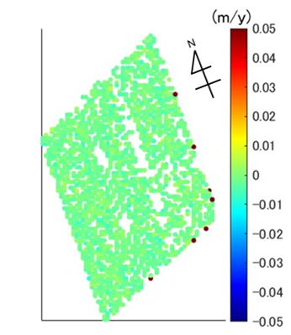

(a) (b)　　　　　　　　　　 　(c)

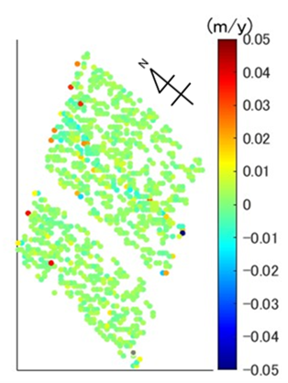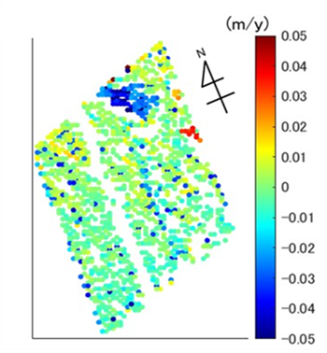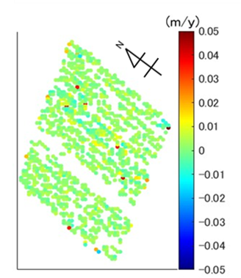

(d) (e) (f)

Figure 4: Effect of relative azimuth angle and variation direction.

(a) Deformation: uplift, angle: 30° (b) Deformation: uplift, angle: 60°

(c) Deformation: east, angle: 30° (d) Deformation: east, angle: 60°

(e) Deformation: north, angle: 30° (f) Deformation: north, angle: 60°

Finally, Figure 6 shows the analysis results when the soil moisture parameter was changed while generating the SAR image with the satellite orbit fixed to ascending and the observation direction to right-side viewing. As the soil moisture increases, the overall reflection intensity becomes stronger, and more PS points are obtained. This leads to more stable estimation accuracy. For paved surfaces like concrete roads, it is unlikely that the moisture content will change significantly, but for bare slopes without pavement, the soil moisture can greatly affect the stability of the estimation. Therefore, when considering the stability of the estimation, it is necessary to also consider the soil conditions of the target area.

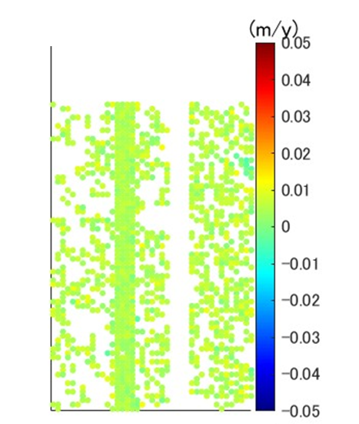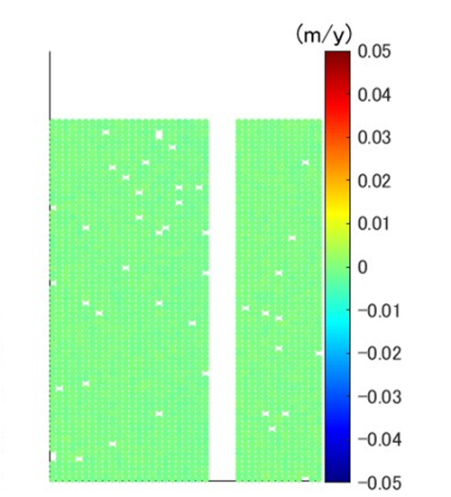

(a) (b)

Figure 5: Effect of soil moisture content (a) $m_{v}=0.2$ (b) $m_{v}=0.6$

**5. Conclusion and Recommendation**

In this study, we used a SAR image simulator to examine how satellite observation conditions and terrain conditions affect PSInSAR analysis results. We specifically analyzed how changes in relative azimuth angle and soil moisture impact reflection intensity, PS density, and estimation accuracy. The results showed that these factors significantly influence the stability of the estimates.

Based on these findings, it is recommended to consider environmental factors such as terrain and soil moisture when applying SAR image analysis to the maintenance of civil engineering structures. Additionally, to improve the accuracy of SAR image analysis, selecting the optimal analysis method based on observation conditions is necessary. In the future, we aim to conduct simulations in areas with more complex terrain, such as mountainous highways, to verify the accuracy of PSInSAR-based change estimation.

Furthermore, when integrating PSInSAR results from different directions and GNSS data for 3D analysis, a common method is to interpolate the variation information for areas without PS using information from surrounding points. However, in areas where PS is not widely available, interpolation has its limits, and it is necessary to conduct simulations based on terrain and observation direction to carefully evaluate the validity of such analyses.

6. References

1. Ferretti, A., Prati, C., and Rocca, F. (2000). Nonliner subsidence rate estimation using permanent scatterers in differential SAR interferometry. *IEEE Trans, Geosci. Remote Sens*, Vol. 38, no. 5, pp.2202-2212.
2. Abo, H., Osawa, T., Ge, P., Takahashi, S., Ymagishi, K., amd Sakurazawa, Y. (2023). *Accuracy validation of external deformation monitoring of rockfill dams using PSInSAR analysis with Sentinel-1 SAR data in the C-band from artificial satellites.* *Japanese Journal of JSCE*, Vol. 79, no. 7.
3. Ke, W., Guowang, J., Xin, X., Hongmin, Z., and Limei, W. (2022). SAR Image Simulation Based on Effective View and Ray Tracing. *Remote Sens*, Vol. 14, no. 5754. https://doi.org/10.3390/rs14225754.
4. Min, W., Diannong, L., Haifeng, H., and Zhen, D. (2007). SBRAS — An Advanced Simulator of Spaceborne Radar. *2007 IEEE International Geoscience and Remote Sensing Symposium. 23-28 July 2007, Barcelona, Spain.*
5. Teranishi, Y., Susaki, J., Oba, T., Ishii, Y., and Hisada, H. (2023) Development and Application of Pseudo-SAR Image Simulator. *2023 8th Asia-Pacific Conference on Synthetic Aperture Radar (APSAR), 23-27 October 2023, Bali, Indonesia.*
6. Susaki, J., and Teranishi, Y. (2024) Unbiased Estimation of Three-Dimensional Deformation from SAR Interferometry and GNSS Observations *IEEE Journal of Selected Topics in Applied Earth Observations and Remote Sensing* Vol. 17, pp.5761-5773.
7. Japan Highway Association, (2010), Guidelines for Road Earthworks and Embankment Works (2010 Edition).
8. Fung, AK., Li, Z., and Chen, K.S. (1992) Backscattering from a randomly rough dielectric surface. *IEEE Trans. on Geosci. and Remote Sensing*, vol. 30, pp.356-369.
9. Neli, R.P., Ulaby, FT., and Dobson, M.C. (1995) Dielectric properties of soils in the 0.3-1.3 GHz range. *IEEE Trans. on Geosci. and Remote Sensing,* vol. 33, no.3, pp.803-807.
10. ALOS-2 Utilization Research Promotion Project. In Japan Aerospace Exploration Agency homepage. Retrieved August 30, 2024,

from https://www.eorc.jaxa.jp/ALOS/jp/alos-2/a2_calval_j.htm.