**AI-Driven Techniques for Night Time Lights Analysis to Assess Socio-Economic Parameters**

Anjani R.N1, Kalyan Deep K1, Nitin M2, Kiranmai P.CH1, Santhoshi T1*, Dr. S.S.Rao1

1Scientist, National Remote Sensing Centre (NRSC), ISRO, Hyderabad, Telangana, India

2Scientist, Space Applications Centre (SAC), ISRO, Ahmedabad, Gujarat, India

[*tsanthoshi3010@gmail.com](mailto:tsanthoshi3010@gmail.com)

***Abstract*:** *Night Time Lights (NTL) represents the intensity of artificial lights which can be related to many dimensions of developmental activities on Earth. There are many indicators available to keep and build economic and ecological resilience. NTL which provides important insights can be considered to monitor these activities and it has been widely used as a proxy for measuring the economic performance of regions. Utilizing NTL data offers greater benefits, due to its timely availability, easy accessibility, and the ability to make comparisons across different regions and countries. The objective of this study is to explore the relationship between NTL and India’s GDP at constant prices along with various economic parameters like Energy-met at national level (Energy-met) and Consumer Price Index (CPI). We aim to gain insights into the complex interplay of factors that influence economic growth and performance over time. In this paper RandomGLM, LASSO regression models are used for understanding the importance of each parameter while various time series models SimpleRNN, GRU, LSTM are employed for forecasting to accurately estimate GDP. The results from the ‘SimpleRNN’ model consistently outperforms over GRU, LSTM, achieving the highest R2-Score of 0.90 and lowest Test Average RMSE of 4.5%. The consistently high R2-score above 0.87 across multiple models indicate a strong ability to explain the variance in the NTL, Energy-met and CPI dataset indicating selected models effectively capturing the underlying patterns in the data, contributing to reliable predictions. Research shows that NTL have a strong and statistically significant relationship with GDP at the national scale, and this correlation can also be applied to regional or sub-national levels.*

*Keywords: CPI, Energy-met, GDP, NTL, Regression*

Introduction

Monitoring and analysing human activities on Earth is vital for building a sustainable future, and it should be done regularly. Night Time Lights (NTL) data collected by satellites has become a key tool for understanding various human activities by linking NTL to factors like land use, socio-economic indicators (such as GDP, poverty, population, electricity use, and crime rates), and environmental variables (like climate change and carbon emissions) (National Remote Sensing Centre, 2022). To effectively analyse these aspects, high-quality NTL data with fine spatial and temporal resolution is needed. Initially, in the late 1960s, the Defense Meteorological Satellite Program’s Operational Line Scanner (DMSP/OLS) captured NTL imagery. While useful at the time, the data lacked onboard calibration, atmospheric corrections, and had a coarse resolution. Later, the Visible Infrared Imaging Radiometer Suite (VIIRS) Day/Night Band (VIIRS/DNB), which evolved from DMSP/OLS, AVHRR, and MODIS, was introduced through a joint mission between NASA and NOAA. VIIRS sensors, aboard the Soumi National Polar-orbiting Partnership (NPP) launched in 2011 and NOAA-20 in 2017, have improved specifications compared to earlier technology. The VIIRS Day/Night Band (DNB) is a broad-spectrum radiometer covering 500-900nm, capable of detecting night light phenomena in both visible and near-infrared regions, with a spatial resolution of 750 meters. Using the data collected by DNB, NASA Earthdata provides derived products at a 15-arc second resolution. VIIRS/DNB has seen major advancements over DMSP/OLS, with NASA's Black Marble Product Suite adding several processing improvements. These include the removal of atmospheric effects such as lunar brightness, stray lights, aurora, and airglow contamination, as well as adjustments for terrain, vegetation, snow, and cloud cover.

The intensity of lights detected through remote sensing is often used as a proxy measure for various socioeconomic indicators. Integrating NTL data with other datasets enables more comprehensive multidisciplinary analysis of NTL observations (Gu et al., 2022). The rapid development of economies demands better monitoring and forecasting approaches. At the national level, GDP is a key tool for policymakers for evaluating economic changes and develop suitable policies, decision making and helping in developing the right sectoral strategies. Conventional approaches to measuring GDP and other economic indicators, based on estimates, surveys, and censuses, are susceptible to biases, delays, inaccuracies, and difficulties in achieving consistent comparisons between and within countries. Significant amount of economic activity takes place in the informal sector, which is often not reflected in GDP calculations (Dasgupta, 2022). It offers a novel foundation for regional economic growth and the creation of a sustainable development strategy, enabling economic forecasting at different scales. Another reason for studying this relationship is that most nighttime consumption and investment activities need lighting. Simply, better economic performance leads to more human activity at night, which increases night light emissions. The use of these data is more helpful than the conventional census approach is due to its timeliness, easy accessibility, and comparability between regions and countries irrespective of statistical capacity, and availability for spatial units below the level at which GDP data are reported. In our study, conducted a comprehensive analysis of NTL data and its correlation with GDP for at National level using the GDP Quarterly data. To ensure the robustness of our study, we utilized datasets spanning 12 years, encompassing the financial years from 2012 to 2023. These datasets were meticulously collected and compiled from reliable sources. In this paper study is carried out at national level quarter-over-quarter (QOQ) changes in the national data. Promising results have given confidence to extend the study for Indian states to derive valuable insights into the economic dynamics of both the nation as a whole and its individual states over a significant timeframe for detailed understanding of their economic performance and variations over the specified period.

Literature Review

Over the past few decades, the utilization of NTL data in socio-economic research has experienced substantial growth, tracing its origins back to the mid-1970, it was shown that NTL could reflect human development and settlement (Lin & Rybnikova, 2023). Initially confined to physical film strips (Elvidge et al., 1997; Elvidge et al., 1999), the accessibility of this valuable data underwent a significant breakthrough in 1992. The National Oceanic and Atmospheric Administration (NOAA) played a pivotal role in digitizing and opening up the archive of nocturnal light data. The DMSP/OLS data, spanning from 1992 to 2013, became a cornerstone for enduring social and economic research due to its extensive temporal coverage (Wang et al., 2018; Zhang et al., 2022). However, recent years have seen a shift in focus towards exploring correlations between NTL scope and intensity and various socioeconomic indicators. This shift has been fuelled by advancements such as VIIRS DNB data, surpassing DMSP/OLS in key aspects like finer spatial resolution, more frequent temporal updates, and a broader radiometric detection range. VIIRS DNB's advantages, including finer spatial resolution (15 arc-seconds), more frequent updates (Daily, Daily Corrected, Monthly, Yearly), and a broader radiometric detection range, have consistently yielded more reliable and comprehensive research outcomes (Abumohsen et al., 2023; Mirzahossein et al., 2022).

Many studies focused on the use of Night Time Lights (NTL) highlight its ability to predict various socio-economic variables, including the estimation of population density, (Elvidge et al., 1999) urbanization, and economic performance at the national and sub-national levels. A strong relationship was identified between Night Time Lights (NTL) and GDP (Elvidge et al., 1997). To analyse the urban night economy and its connection to urbanization using NTL data, a night light economic index was introduced (Gu et al., 2022), another study (Lu & Coops, 2018) evaluated the effectiveness of satellite-based NTL data in predicting national GDP growth, demonstrating that NTL data enhances model accuracy. Sun et al. (2020) proposed a deep learning approach for estimating county-level GDP in the Contiguous United States (CONUS) using time series data from 2012 to 2015. Liang et al. (2019) examined the spatial distribution of Ningbo’s GDP by integrating NPP/VIIRS NTL data with urban GDP statistics. Ma et al. (2019) analysed the spatiotemporal trends of India’s heavy industries using NTL data from 2012 to 2018. As NTL data continues to advance, it has gained significant attention for its objectivity and ease of access make it versatile beyond just estimating social and economic parameters (such as GDP and regional growth). Academic communities also leverage this data for various applications across different domains and there are several proposed models for predicting GDP. Among them, the Autoregressive Integrated Moving Average (ARIMA) model (Gu et al., 2022) is extensively utilized for analyzing the patterns and behaviours in time series data. Kumar and Paramanik (2020) adopted X12-ARIMA to adjust the variables and explored the relationship between financial development and economic growth in India. Previous research efforts (Lin & Shi, 2020; Han et al., 2022; World Bank, 2020) employed regression and machine learning models, incorporating fixed effects, random effects, and trend effects. However, in paper by Abumohsen et al. (2023) to forecast the short-term electrical loads Deep Learning algorithms are used those are RNN (Recurrent Neural Network), LSTM (Long-short term Memory), GRU (Gated Recurrent Unit), based on this we have done SimpleRNN, LSTM, GRU on our Night time data and socio-economic parameters and from all these models, SimpleRNN outperforms GRU and LSTM. According to paper by Abumohsen et al. (2023), different structures of combining two or three deep learning-based algorithms were introduced in neural network forecasting models. In this paper tried one hybrid model which is combining of SimpleRNN and GRU. This hybrid model demonstrated slightly less performance, compared to only simpleRNN. In this study, quarterly nocturnal light data derived from the monthly VIIRS DNB dataset (Prakash et al., 2019) was employed.

For carrying out this study NTL Data, GDP, Gross Value Added (GVA) at constant Prices, Energy-Met, CPI, Per Capita Power Consumption is used and these data sets are downloaded from official web sites.

**a. NTL Data:**

NTL data from VIIRS/DNB a combined mission of NASA and NOAA, acquires Night Time Lights even in poor illumination conditions. Black Marble NTL products derived from VIIRS-DNB at 15 arc-second spatial resolution are available in Daily, Monthly and Annual Composite from January 2012 onwards. VNP46A3 monthly composites NTL for India, spanning from February 2012 to June 2022, were obtained from NASA’s Level 1 Atmosphere Archive and Distribution System Distributed Active Archive Center (LAADS DAAC).

**b. GDP at constant prices:**

GDP quarterly data from the RBI Handbook Statistics of India. This dataset offers a reliable foundation for our economic analysis. We focus on GDP as a crucial economic indicator and use it in a specific form: GDP at constant prices. This choice allows us to eliminate the impact of price changes over time and provides a more accurate representation of changes in the actual volume of goods and services produced.

**c. Energy-Met:**

Energy-met monthly data sourced from the Power System Operation Corporation Limited (POSOCO). A unit of this data is Megawatts (MW). This data allows considering the energy sector's impact on economic performance, this dataset adds depth to our analysis by factoring in energy consumption trends.

**d. GVA at Constant Prices:**

Among the various parameters under GVA at Constant Prices, specifically focus on the sector encompasses Electricity, Gas, Water Supply, and Other Utility Services. This data, again from the RBI Handbook Statistics of India, enables us to assess the contribution of this sector to overall economic performance.

**e. CPI:**

It is used to consider the influence of consumer price changes on economic dynamics, integrated monthly CPI data from the RBI Handbook Statistics of India into our analysis. This factor aids in understanding the purchasing power of consumers and its impact on economic growth.

In essence, our research is underpinned by robust data from reputable sources, enabling us to explore the relationship between NTL and GDP at constant prices along with various economic parameters. By considering these variables, we aim to gain insights into the complex interplay of factors that influence economic growth and performance over time.

Methodology

The overall methodology consists of following 5 processes as given below:

* Data processing to generate Quarterly composites from NTL Radiance monthly data
* Data pre-processing for machine learning algorithms
* Machine learning based algorithms for regression analysis
* Deep Learning based algorithms for forecasting short-term GDP
* Algorithm Comparison and Best Combination Selection Using Performance Metrics

**a. Data processing to generate quarterly composites from monthly NTL data:**

Financial Year of India starts in April of each year up to March of next calendar year. Financial Year Quarters FYQ1 corresponds to April to June, FY Q2 is July – September, FY Q3 is October - December, FY Q4 January – March (next calendar year). GDP, GVA values are available for Financial Year and FY Quarterly at National level. NTL VNP46A3 products monthly composites are used for analysis. To correlate with GDP and other socio-economic parameters financial year and quarterly composites are computed and mapped to financial year wise quarters. Black Marble derived NTL data is available as 10oX10o for entire world, India is covered by 14 tiles and month wise data downloaded for the period January 2012 to June 2023. VNP46A3 dataset is provided in Hierarchical Data Format (HDF5) files, comprising 26 layers. For further processing, "AllAngle_Composite_Snow_Free" and "AllAngle_Composite_Snow_Free_Quality" layers were chosen based on their relevance to the study objectives. Various pre-processing operations were conducted, including layer extraction, TIFF conversion, geo-coding, and mosaicking. These steps are crucial for preparing the data for subsequent analyses.

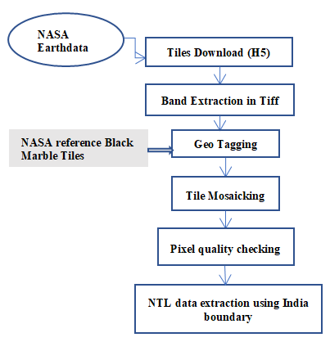

Figure 1: NTL Data Extraction workflow.

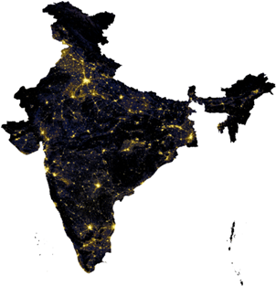

Figure 2: NTL Data for India, 2012.

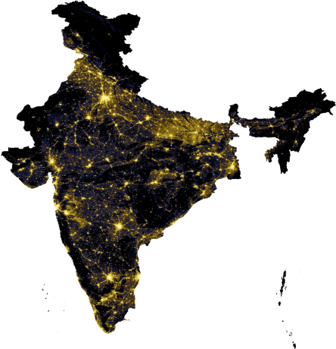

Figure 3: NTL Data for India, 2022.

Figure 1 shows that the NTL data extraction was performed, taking into account the geographical boundaries of India. Month wise mosaics for Indian region are generated (Apr, 2012 – Jun, 2023). Figure 2 and Figure 3 show the NTL data for India in 2012 and 2022, respectively. The pixels with radiance values ranging from 0 to 15 were excluded from the dataset to address the issue of spread, thereby improving the accuracy of subsequent analyses. This step is essential for obtaining reliable NTL radiance values.

An in-house median-max algorithm was developed for generating quarterly NTL composites from the NTL VNP46A3 product. This algorithm addresses even number of samples, selects the maximum median value from to values, ensuring complete control and customization. To enhance data integrity, the algorithm includes a nodata masking step: pixels with a nodata value of 65535 are masked to prevent them from influencing composite calculations. This methodology effectively captures both central tendency and peak intensity, contributing to robust quarterly composites. A distinctive feature of the algorithm is its pixel-wise approach, where values across monthly composites within each quarter are independently analysed for each pixel. This pixel-wise operation enables a more detailed examination of temporal changes in night time light intensity.

To gain confidence in the algorithm, annual composites are also developed using this method to compare with VNP46A4 annual composite products from LAADS DAAC as shown in figure 4. The primary objective was to assess the consistency and accuracy of the generated annual NTL composites. The R2 score obtained from the comparison of the generated annual NTL data with the VNP46A4 annual composite data is exceptionally high, with a value of 0.9996. It indicates an extremely high correlation between the generated and reference annual NTL composites. Such a high score suggests that the in-house algorithm effectively captures the temporal variations in night time light emissions, aligning closely with the dataset from LAADS DAAC.

Figure 4: NTL radiance comparison of VNP46A4 Annual Composites 2022 and Annual Composite generated using VNP46A3 monthly composite product.

**b. Data pre-processing for machine learning algorithms:**

Data normalization serves as a pre-processing method to ensure that features with different scales contribute equally to the analysis. In this study, normalization is necessary because some parameters had significantly larger maximum values compared to others. To address this, we scaled all feature ranges to fall within the [0–1] interval. Various data normalization techniques, such as standardization and max-min normalization, are available (Abumohsen et al., 2023). The linear transformation of the data was achieved through the application of max-min normalization, as determined by the following equation:

$Y’=\frac{Y-Ymin}{Ymax-Ymin}$ (1)

Where *Y* is original data and $Y’$ is normalized data.

Feature selection involves the identification of data attributes that significantly influence the target variable, aiming to enhance model performance. To assess the interdependence of features, a statistical technique was employed to measure how one variable change concerning another. High correlation among features can introduce variance and reduce reliability (Norouzi et al., 2020). To address this, a filter method for feature selection was applied (Abumohsen et al., 2023). This method relies on correlation coefficients, setting a threshold to eliminate features with correlations exceeding 90%. This process isolates highly correlated features and identifies those with minimal correlation to the target variable.

After carefully examining the correlation between different feature combinations, it was observed that there is a remarkably high correlation of 97% between Energy-met and one of the parameters of GVA (Electricity, Gas and Other Utilities). In light of this finding, a decision was made to discard the highly correlated GVA parameter.

**c. Exploring Correlations between parameters Using ML Algorithms:**

Our analysis categorized in to Regression models and Time Series Analysis models for prediction. Under regression RandomGLM and LASSO regression models were used.

Random Generalized Linear Models (RandomGLM) are ML models that combine the flexibility of generalized linear models with the randomness of random effects. Overcomes the limitations of standard generalized linear models by incorporating random effects, capturing unobserved heterogeneity, and providing a more realistic representation of complex data.

LASSO regression (Least Absolute Shrinkage and Selection Operator) is a ML model that utilizes L1 regularization by introducing a penalty term to traditional regression models. Overcomes multicollinearity issues by automatically selecting relevant features, preventing overfitting, and improving model interpretability compared to traditional regression. The L1 regularization term aids in shrinking less relevant coefficients to zero, effectively performing feature selection.

In the literature review most of the papers have emphasized on using Panel, RandomGLM and LASSO. LASSO outperformed other models, in our study also we observed the similar results and following are the tables showing LASSO and RandomGLM metrics.

Regression models are studied to understand the correlation between different parameters used. The comparative analysis of socio-economic parameters with NTL using LASSO 5-fold and RandomGLM 5-fold regression in Table 1, Table 2 shows that LASSO consistently performs better than RandomGLM, by getting lower Root Mean Square Error (RMSE) values across the evaluated parameters. Because it is highly correlated, these attributes are significant for future prediction in time series analysis.

|  |  |  |  |  |
| --- | --- | --- | --- | --- |
| **Feature Combination** | **Avg. Training RMSE**  **[0-1]** | **Avg. Training original RMSE (crore)** | **Avg. Testing RMSE**  **[0-1]** | **Avg. Testing original RMSE (crore)** |
| GDP+NTL | 0.1727 | 373528.34 | 0.1771 | 383040 |
| GDP+NTL+  Energy-met | 0.1268 | 274325.09 | 0.1280 | 276952.7 |
| GDP+NTL+CPI | 0.0951 | 205782.00 | 0.1002 | 216784.8 |
| GDP+NTL+  Energy-met+CPI | 0.1191 | 257590.23 | 0.1239 | 267986.7 |

Table 1: RandomGLM 5-fold regression.

|  |  |  |  |  |
| --- | --- | --- | --- | --- |
| **Feature Combination** | **Avg. Training RMSE**  **[0-1]** | **Avg. Training original RMSE (crore)** | **Avg. Testing RMSE**  **[0-1]** | **Avg. Testing original RMSE (crore)** |
| GDP+NTL | 0.1645 | 355854.26 | 0.1739 | 376141 |
| GDP+NTL+  Energy-met | 0.0947 | 204821.26 | 0.1018 | 220182.9 |
| GDP+NTL+CPI | 0.0940 | 203310.89 | 0.1021 | 220903.4 |
| GDP+NTL+  Energy-met+CPI | 0.0881 | 190538.83 | 0.1059 | 229151.9 |

Table 2: LASSO 5-fold regression.

**d. Deep Learning based algorithms for forecasting short-term GDP:**

Considering the regular intervals and temporal nature of our dataset, as well as recognizing the presence of nonlinear relationships within it, we have planned to use time-series prediction models. Abumohsen et al. (2023) have followed various Deep Learning algorithms for Electrical loads which is short term dependencies. Data used in our analysis is also having short term dependencies as it is quarterly data and these algorithms are suited to predict the GDP.

For Time Series Analysis Simple Recurrent Neural Network (RNN) (Talathi & Vartak, 2015), Long Short-Term Memory (LSTM) (Van Houdt et al., 2020), Gated Recurrent Unit (GRU) (Zakhrouf et al., 2023) models were used.

A Simple Recurrent Neural Network (SimpleRNN) is a type of RNN that processes sequential data by maintaining a hidden state that captures information about previous inputs in the sequence. It is designed to capture dependencies and patterns in sequential data.

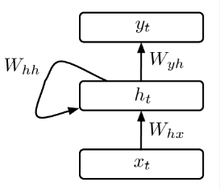

*Source: Proceedings of the International Conference on Learning Representations*

Figure 5: SimpleRNN.

The hidden state *ht* of a SimpleRNN at time step *t* is calculated using the following formula:

*ℎt=activation (Wℎℎ⋅ℎt−1+Whx⋅xt+bℎ)* (2)

*where:*

*ℎt​ is the hidden state at time step t.*

*​xt is the input at time step t.*

*​Wℎℎ is the weight matrix for the recurrent connections.*

*​Wℎx is the weight matrix for the input connections.*

*​ bℎ is the bias term.*

*The output yt​ of the SimpleRNN at time stept can be calculated as:yt​ ​=Wyh​⋅ℎt​+by*

*where:​ Wyhis the weight matrix for the output connections.*

*​ byis the bias term for the output.*

Long Short-Term Memory (LSTM) is a type of RNN designed for sequential data, making it suitable for time-series analysis by capturing long-term dependencies and patterns in NTL data over time. Overcomes the challenge of capturing temporal dependencies in traditional regression models by leveraging memory cells, enabling the model to retain and learn patterns from historical NTL data, particularly useful for time-series forecasting.

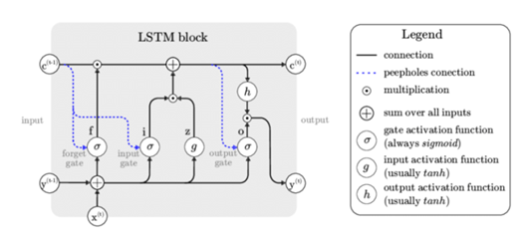

*Source: Artificial Intelligence Review*

Figure 6: LSTM.

Gated Recurrent Unit (GRU) is a type of RNN architecture that incorporates gating mechanisms to regulate the flow of information within the network. GRUs are designed to capture dependencies in sequential data more effectively and address the vanishing gradient problem that can occur in traditional RNNs.

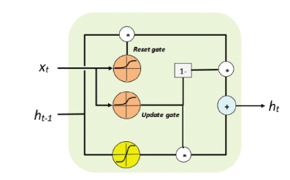

*Source: Physical Geography*

Figure 7: GRU.

Formulae:

The hidden state ht​ of a GRU at time step t is updated using the following formulas:

*Reset gate=σ(Wxr​⋅xt​+Whr​⋅ht−1​+br​)*

*Update gate=σ(Wxz​⋅xt​+Whz​⋅ht−1​+bz​)*

*h~t​=activation (Wxh​⋅xt​+rt​⋅(Whh​⋅ht−1​) +bh​)*

*ht​=(1−zt​) ⋅ht−1​+zt​⋅h~t​*

where:

*ht is the hidden state at time step t.*

*xt​ ​ is the input at time step t.*

*rt ​ is the reset gate, determining how much of the previous state to forget.*

*zt​ is the update gate, controlling how much of the new state to incorporate.*

*h~t is the candidate hidden state.*

*σ is the sigmoid activation function applied element-wise.*

*W and b are weight matrices and bias terms, respectively.*

Furthermore, drawing inspiration from the architecture proposed by Yu et al. (2019), which employed a multi-layer GRU architecture, our study extends the exploration to include multi-layer in SimpleRNN architecture. Additionally, we introduce a hybrid model, combining SimpleRNN and GRU, and aim to evaluate its performance in comparison to traditional RNNs. The overarching objective is to conduct a comprehensive and systematic investigation, analysing whether the introduced multi-layer RNN configurations, including both SimpleRNN and the hybrid model, demonstrate superior performance compared to the conventional RNN model.

**e. Algorithm Comparison and Best Combination Selection Using Performance Metrics:**

Various statistical metrics are employed to assess the performance of data regression (Abumohsen et al., 2023). In the context of deep learning models, this paper will specifically concentrate on evaluating the following metrics: Root Mean Square Error (RMSE), and the Coefficient of Determination (R-squared). The objective is to employ these metrics for testing different models and subsequently selecting the optimal one based on their respective performance evaluations. By exploring this section, we aim to discern the most effective model for predicting GDP.

Root Mean Square Error (RMSE) is a measure of the average magnitude of the errors between predicted and observed values, providing a sense of how well a model is performing.

$RMSE=\sqrt{\left(\frac{1}{N}\sum_{i=1}^{N}{{(y_{i}-ŷ_{i})}^{2}}\right)}$ (3)

Where $y_{i }$ = actual value, $ŷ_{ i}$ = predicted value, N = no. of data points

Coefficient of Determination (R2 score) is a statistical metric that represents the proportion of the variance in the dependent variable that is predictable from the independent variables.

$R^{2}=1-\frac{\sum_{i=1}^{N}{{(y_{i}-ŷ_{i})}^{2}}}{\sum_{i=1}^{N}{{(y_{i}-mean(y))}^{2}}}$ (4)

To assess and compare the outcomes of these models, performance metrics such as RMSE and R2-score are employed. This methodology aims to gauge the efficacy of RNN models in capturing the complexities inherent in our quarterly dataset and subsequently compares their performance against previously utilized linear models.

Results and Discussion

In the initial exploration, as detailed in paper (Lin & Rybnikova, 2023), RandomGLM and LASSO models were applied, revealing LASSO's superiority over the RandomGLM model. However, considering the inherently nonlinear nature of our quarterly data, which departs from a linear form, this paper advocates for the adoption of nonlinear fitting algorithms. Recognizing the effectiveness of RNN in handling sequential and time series data, various RNN algorithms including SimpleRNN, GRU, and LSTM are incorporated.

In this study, the dataset comprises CPI, Energy-met, and a parameter from GVA. The goal is to enhance the performance metrics of the target parameter, GDP, by addressing variance issues and improving reliability. To achieve this, feature selection is employed. During this process, one parameter GVA is excluded due to its high R2-score correlation with Energy-met. Post feature selection, the refined dataset now includes CPI, Energy-met, and NTL radiance as predictor variables for the target variable GDP. This strategic selection aims to optimize the model's performance metrics and foster a more reliable prediction of GDP. Utilizing the selected features (CPI, Energy-met, and NTL data), various combinations were explored to gauge their impact on model performance.

Through a comprehensive analysis of all combinations across different models and employing various metrics, we aimed to discern the combination that outperforms others for each specific model. This systematic evaluation provides insights into the most effective feature combinations, enhancing our understanding of the relationships between the selected features and the target variable (GDP).

In this section, we systematically evaluate the performance of LSTM, RNN, and GRU algorithms across various feature combinations. Our goal is to identify the optimal combination that consistently yields the lowest RMSE across all models. Each model is configured with multiple hidden layers, incorporating a dropout layer with a rate of 0.2. Furthermore, the Adam optimizer is employed for model training.

To ensure robustness and reliability, we apply a 5-fold cross-validation methodology, enhancing the generalization of our results. This approach allows us to obtain more accurate assessments of model performance and facilitates the identification of feature combinations that exhibit superior predictive capabilities. The inclusion of multiple hidden layers, along with the dropout layer, contributes to the models' capacity to capture intricate patterns in the data while mitigating overfitting. Leveraging the Adam optimizer enhances the efficiency of the training process, enabling the models to converge more effectively.

**a. Evaluation of SimpleRNN, GRU, and LSTM for optimal feature combination:**

|  |  |  |  |
| --- | --- | --- | --- |
| **Feature Combination** | **Test Average RMSE (Crore)** | **Test Average RMSE [0-1]** | **Test Average**  **R2 score** |
| GDP+NTL | 124731.32 | 0.0576 | 0.8623 |
| GDP+NTL+Energy-met | 103764.19 | 0.0479 | 0.8962 |
| GDP+NTL+CPI | 115586.75 | 0.0534 | 0.8753 |
| GDP+NTL+  Energy-met+CPI | 97442.75 | 0.0450 | 0.9062 |

Table 3: RMSE, R2-Score for different Feature combination using SimpleRNN.

|  |  |  |  |
| --- | --- | --- | --- |
| **Feature Combination** | **Test Average RMSE (Crore)** | **Test Average RMSE [0-1]** | **Test Average**  **R2 score** |
| GDP+NTL | 146948.77 | 0.0679 | 0.8508 |
| GDP+NTL+Energy-met | 116023.59 | 0.0536 | 0.9025 |
| GDP+NTL+CPI | 121815.60 | 0.0563 | 0.8669 |
| GDP+NTL+  Energy-met+CPI | 115832.18 | 0.0535 | 0.8999 |

Table 4: RMSE, R2-Score for different Feature combination using GRU.

|  |  |  |  |
| --- | --- | --- | --- |
| **Feature Combination** | **Test Average RMSE (Crore)** | **Test Average RMSE [0-1]** | **Test Average**  **R2 score** |
| GDP+NTL | 158110.58 | 0.0731 | 0.8297 |
| GDP+NTL+Energy-met | 125461.61 | 0.0580 | 0.8734 |
| GDP+NTL+CPI | 157164.69 | 0.0726 | 0.8406 |
| GDP+NTL+Energy-met+CPI | 128926.77 | 0.0596 | 0.8728 |

Table 5: RMSE, R2-Score for different Feature combination using LSTM.

Based on the test average RMSE scores across different models and feature combinations shown in Tables 3, 4, and 5, for the SimpleRNN model, the GDP+NTL+Energy-met+CPI combination yields the lowest RMSE of 0.0450 (Table 3). Similarly, the GRU model achieves its lowest RMSE of 0.0535 with the GDP+NTL+Energy-met+CPI combination (Table 4). For the LSTM model with the GDP+NTL+Energy-met combination yields the lowest RMSE of 0.058 (Table 5).

**b. Performance Analysis Using Simple and Hybrid Models:**

Among three models the time-series models (SimpleRNN and GRU) consistently outperformed others when using feature combination GDP+NTL+Energy-met+CPI. To further extend this study, we explored stacked layers and hybrid models using this optimal feature combination.

Based on the results observed in Table 6, SimpleRNN outperforms all other simple and hybrid models for the combination of GDP+NTL+Energy-met+CPI particularly stands out with the lowest Test Average RMSE of 0.0450 among all evaluated combinations, indicating superior predictive accuracy.

Table 6: RMSE, R2-Score of GDP, NTL, Energy-met, CPI combination with Hybrid models.

|  |  |  |  |
| --- | --- | --- | --- |
| **Feature Combination** | **Test Average RMSE (Crore)** | **Test Average RMSE [0-1]** | **Test Average**  **R2 score** |
| SimpleRNN | 97442.75 | 0.0450 | 0.9062 |
| GRU | 115832.18 | 0.0535 | 0.8999 |
| LSTM | 128926.77 | 0.0596 | 0.8728 |
| SimpleRNN+SimpleRNN | 104247.38 | 0.0482 | 0.8986 |
| GRU+GRU | 126617.69 | 0.0585 | 0.8836 |
| SimpleRNN+GRU | 105179.97 | 0.0486 | 0.8890 |

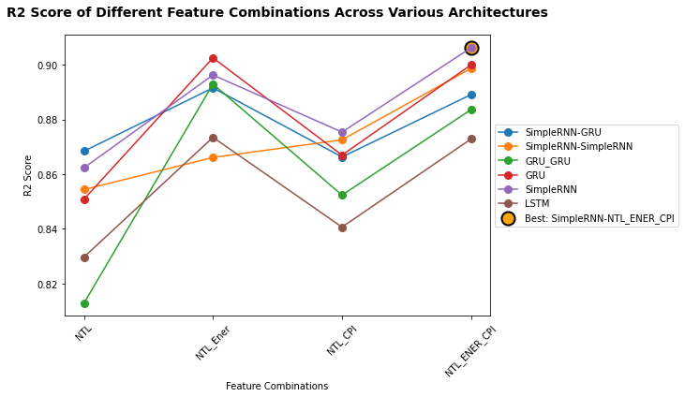

Figure 8: R2 score of different feature combinations across various architectures.

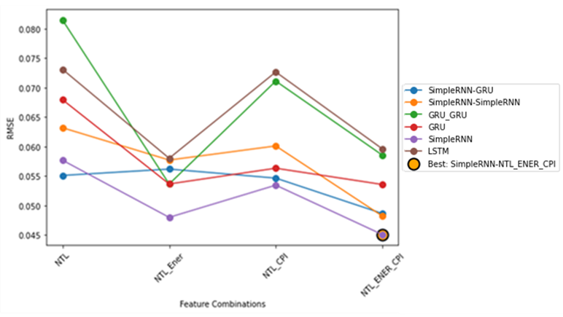

Figure 9: RMSE of different feature combinations across various architectures.

As depicted in the Figure 8 and 9 above, SimpleRNN consistently demonstrates superior performance across all evaluated combinations, achieving the highest R2-score and lowest RMSE values. Notably, the combination of GDP+NTL+Energy-met+CPI has the lowest Test Average RMSE (0.0450), outperforming other combinations. It also achieves a high R2-Score of 0.90, indicating strong predictive performance.

**Conclusion and Recommendation**

Across all models Simple RNN, GRU, and LSTM the GDP+NTL+Energy-met+CPI feature combination consistently outperforms other combinations, delivering the lowest Test Average RMSE and high R2-Scores. Therefore, based on these observations, it can be confidently asserted that GDP+NTL+Energy-met+CPI stands as the preferred and better combination among all tested feature combinations for achieving optimal predictive performance.

In this case SimpleRNN and GRU outperformed when compared with LSTM, it indicates for prediction of GDP of next Quarter has no Long-Term dependencies for prediction of GDP for given set of attributes in time series. Complicated LSTM models (Bi-LSTM, Nested LSTM) are not required. Since in this case of prediction of GDP, it only requires sequential short-term dependencies to predict the next quarter GDP.

The "SimpleRNN" model consistently outperforms individual models (SimpleRNN, GRU, LSTM) and other combinations, achieving the lowest Test Average RMSE of 97442.75 and the highest Test Average R2-Score of 0.90. The consistently high R2-scores above 0.87 across multiple models indicate a strong ability to explain the variance in the GDP+NTL+Energy_met+CPI dataset. This consistency suggests that the selected models effectively capture the underlying patterns in the data, contributing to reliable predictions. Predicted the 2023-24 FY Q2 based on SimpleRNN model, it is 41.58 lakh Crore and compared with the Actual GDP announced 41.74 lakh Crore it is closely matching with RMSE 0.0075. It demonstrates that multitemporal NTL along Energy_Met and CPI data can serve as a good predictor of GDP at the national level. Study will be continued to establish a correlation between Gross State Domestic Product (GSDP) values for Indian states and NTL data leveraging quarterly GSDP data, which is initially reported on an annual basis. In contrast to linear interpolation techniques using unique data augmentation strategy known as quarterly trend interpolation. This innovative approach capitalizes on India's quarterly GDP data to enhance the temporal alignment and precision of the analysis.

References

Abumohsen, M., Owda, A. Y., & Owda, M. (2023). Electrical load forecasting using LSTM, GRU, and RNN algorithms. *Energies, 16*(5), 2283. <https://doi.org/10.3390/en16052283>

Bhuvan, Indian Geoportal of ISRO (n.d.) National Remote Sensing Centre. Retrieved October 24, 2023, from [https:/bhuvan-app1.nrsc.gov.in](https://bhuvan-app1.nrsc.gov.in)

Dasgupta, N. (2022). Using satellite images of nighttime lights to predict the economic impact of COVID-19 in India. *Advances in Space Research,* 70(4), 863-879. <https://doi.org/10.1016/j.asr.2022.05.039>

Elvidge, C. D., Baugh, K. E., Dietz, J. B., Bland, T., Sutton, H. W., & Kroehl, P. C. (1999). Radiance calibration of DMSP-OLS low-light imaging data of human settlements. *Remote Sensing of Environment, 68*(1), 77–88. <https://doi.org/10.1016/S0034-4257(98)00098-4>

Elvidge, C. D., Baugh, K. E., Kihn, E. A., Kroehl, H. W., Davis, E. R., & Davis, C. W. (1997). Relation between satellite observed visible-near infrared emissions, population, economic activity, and electric power consumption. *International Journal of Remote Sensing, 18*(6), 1373–1379. <https://doi.org/10.1080/014311697218485>

Gu, Y., Shao, Z., Huang, X., & Cai, B. (2022). GDP forecasting model for China’s provinces using nighttime light remote sensing data. *Remote Sensing, 14*(15), 3671. <https://doi.org/10.3390/rs14153671>

Han, G., Zhou, T., Sun, Y., & Zhu, S. (2022). The relationship between night-time light and socioeconomic factors in China and India. *PLOS ONE, 17*(1), e0262503. <https://doi.org/10.1371/journal.pone.0262503>

Kumar, K., & Paramanik, R. (2020). Nexus between Indian economic growth and financial development: A non-linear ARDL approach. *Journal of Asian Finance, Economics and Business, 7*(6), 109-117. https:// doi.org/10.13106/jafeb.2020.vol7.no6.109

Liang, H., Guo, Z., Wu, J., & Chen, Z. (2019). GDP spatialization in Ningbo City based on NPP/VIIRS night-time light and auxiliary data using random forest regression. *Advances in Space Research,* 65(1), 481-493. <https://doi.org/10.1016/j.asr.2019.09.035>

Lin, T., & Rybnikova, N. (2023). Changes in the association between GDP and night-time lights during the COVID-19 pandemic: A subnational-level analysis for the US. *Geomatics, 3*(1), 156–173. <https://doi.org/10.3390/geomatics3010008>

Lin, J., & Shi, W. (2020). Statistical correlation between monthly electric power consumption and VIIRS nighttime light. *ISPRS International Journal of Geo-Information, 9*(1), 32. <https://doi.org/10.3390/ijgi9010032>

Lu, Y., & Coops, N. C. (2018). Bright lights, big city: Causal effects of population and GDP on urban brightness. *PloS One, 13*(7), e0199545. <https://doi.org/10.1371/journal.pone.0199545>

Ma, C., Niu, Z., Ma, Y., Chen, F., Yang, J., & Liu, J. (2019). Assessing the distribution of heavy industrial heat sources in India between 2012 and 2018. *ISPRS International Journal of Geo-Information, 8*(12), Article 568. <https://doi.org/10.3390/ijgi8120568>

Mirzahossein, H., Gholampour, I., Sajadi, S. R., & Zamani, A. H. (2022). A hybrid deep and machine learning model for short-term traffic volume forecasting of adjacent intersections. *IET Intelligent Transport Systems,* 16(11),1648-1663. <https://doi.org/10.1049/itr2.12224>

Norouzi, A., Aliramezani, M., & Koch, C. R. (2020). A correlation-based model order reduction approach for a diesel engine NOx and brake mean effective pressure dynamic model using machine learning. *International Journal of Engine Research, 22,* 2654–2672. <https://doi.org/10.1177/1468087420936949>

Prakash, A., Shukla, A., Bhowmick, C., & Beyer, R. (2019). Night-time luminosity: Does it brighten understanding of economic activity in India? ResearchGate. <https://www.researchgate.net/publication/334811462_Night-time_Luminosity_Does_it_Brighten_Understanding_of_Economic_Activity_in_India>

Sun, J., Di, L., Sun, Z., Wang, J., & Wu, Y. (2020). Estimation of GDP using deep learning with NPP-VIIRS imagery and land cover data at the county level in CONUS. *IEEE Journal of Selected Topics in Applied Earth Observations and Remote Sensing, 13,* 1400-1415. <https://doi.org/10.1109/JSTARS.2020.2983331>

Wang, Y., Shen, Y., Mao, S., Chen, X., & Zou, H. (2018). LASSO & LSTM integrated temporal model for short-term solar intensity forecasting. *IEEE Internet of Things Journal,* 6(2), 2933-2944. <https://doi.org/10.1109/JIOT.2018.2877510>

World Bank. (2020). Examining the economic impact of COVID-19 in India through daily electricity consumption and nighttime light intensity. Retrieved from <http://hdl.handle.net/10986/33986>

Yu, Z., Niu, Z., & Tang, W. H. (2019). Deep learning for daily peak load forecasting - A novel Gated Recurrent Neural Network combining dynamic time warping. *IEEE Access,*7,17184-17194. <http://doi.org/10.1109/access.2019.2895604>

Zhang, J., Wen, J., & Yang, Z. (2022). China’s GDP forecasting using Long Short-Term Memory Recurrent Neural Network and Hidden Markov Model. *PLOS ONE, 17*(6), e0269529. <https://doi.org/10.1371/journal.pone.0269529>