**Synchronized Data-Based Back-Projection Algorithm for Stationary Receiver & Moving Transmitter SAR Imaging**

Ji-Hwan Hwang1, Jung-Hwan Song2, Kwang Ho Coi3 and Chul H. Jung4*

1Radar Research Center, EchoSensing Inc: Principal Research Engineer, Korea

2 Radar Research Center, EchoSensing Inc: CTO, Korea

3 Radar Research Center, EchoSensing Inc: Senior Reseearch Engineer, Korea

4 EchoSensing Inc: CEO, Korea

[chjung@echosensing.com](mailto:chjung@echosensing.com)

***Abstract*:** *A synchronized data-based back-projection algorithm(BPA) is presented in this study for reconstructing an image of the SAR system, which consists of a stationary receiver and a moving transmitter. In this BPA imaging process, the data synchronization performs time-, position- and frequency synchronization sequentially on the position information and two channels received data collected from the stationary receiver and moving transmitter, respectively. The BPA geometry for SAR imaging can be reconstructed using the time- and position-synchronized data. Then, the frequency synchronization corrects a linear phase error caused by using an individual receiver and transceiver. Residual phase errors that remain after correcting the linear phase error term can be mitigated by phase gradient autofocus(PGA), which is applied to the direct-path channel data of the stationary receiver, not the imaging-path channel data. Because two-channel data are simultaneously received under the same condition, any residual phase errors may equally come into both channel data. Thus, it can be analyzed with the direct-path data, which has a single trajectory in the range compressed domain. The residual phase errors analyzed using the PGA method on the direct-path data can be utilized to correct the input data for the proposed BPA process, resulting in a well-focused SAR image. The performance of the proposed BPA process has been validated using the raw data measured through the field campaign. In particular, a comparative result obtained by applying the PGA method on the direct-path data, rather than the imaging-path data is shown in the manuscript.*

*Keywords: back-projection algorithm, data synchronization, stationary Rx & moving Tx SAR, phase gradient autofocus, phase error correction*

Introduction

A bistatic SAR system, in which the transmitter and receiver are spatially separated, allows for configuration under various incident angle conditions for target detection & analysis. It is also possible to extend into a multistatic SAR system. However, to be implemented, a time-synchronization for bistatic SAR operation and raw data acquisition is necessary and it may be complicated or tedious work[Behner, 2015; Walterscheid, 2006; Anghel, 2017; Silva Filho, 2022]. Moreover, to reconstruct the SAR image, synchronizing the raw data measured at the transmitter- & receiver sides is definitely essential, too. So, this study proposes the synchronized data-based back-projection algorithm to combine and optimize the SAR signal processing for the SAR image reconstruction.

SAR geometry with stationary Rx & moving Tx

A system configuration for validation of the SAR system consisting of the stationary receiver and moving transmitter is as shown in Figure 1.

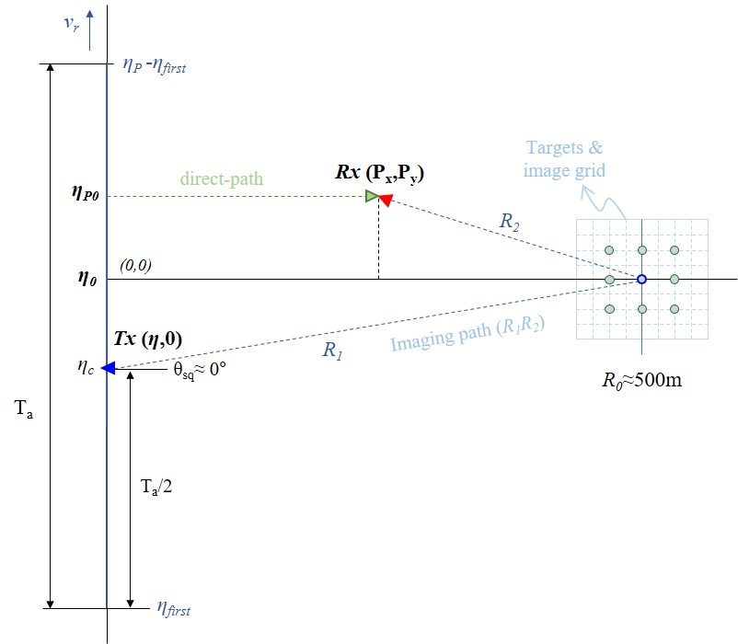

Figure 1: SAR geometry consisting of the stationary Rx & moving Tx

Table 1: Parameters of the SAR system consisting of the stationary Rx & moving Tx

|  |  |  |
| --- | --- | --- |
| **Variables** | **Description** | **Remark** |
| ηP | Sampling time |  |
| **ηP0** | Closest approach time for BSAR#2 |  |
| η0 ,ηc | Closest approach time for target | (When θsq=0°, η0 =ηc) |
| **ηfirst** | Sync. Start time |  |
| **Px, Py** | Position of BSAR#2 |  |

The primary parameters for synchronizing raw data in Figure 1 are *ηp0* and (Px, Py). These represent the closest approach time for the stationary receiver and the relative position between a moving trajectory and a scene center, respectively. To focus the SAR image, conducting a geometrical reconstruction of this SAR system is important as the first step. The relative position of the stationary receiver is crucial because it serves as a reference point in this SAR configuration. Moreover, the process of finding the closest approach time(*ηp0*) and relative position (Px, Py) of the stationary receiver is the same as the procedure of raw data synchronization.

Synchronized data-based Back-projection algorithm

Three types of input data were utilized for SAR imaging. The initial input consists of raw data collected from the moving transmitter as monostatic SAR raw data. The second and third inputs are raw data obtained from the stationary receiver as bistatic SAR raw data. They are received from the direct-path and imaging-path channels, respectively. These datasets contain important parameters for reconstructing the bistatic SAR image, which can be analyzed and extracted through the raw data synchronization process.

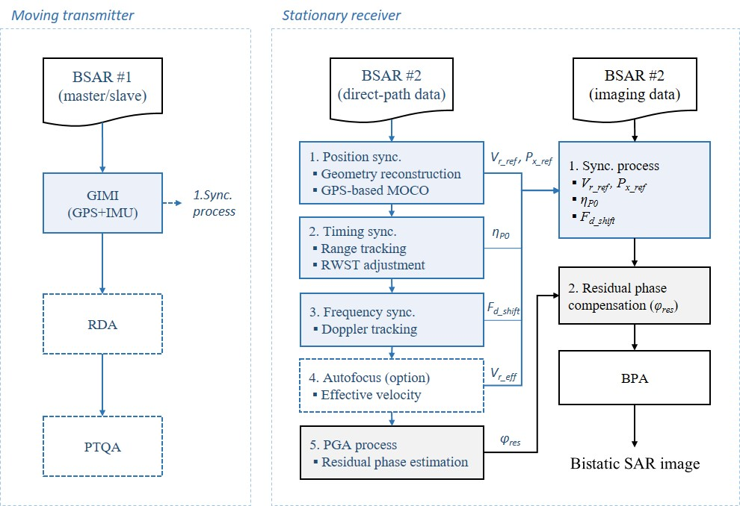

Figure 2: Blockdiagram of the synchronized data-based back-projection algorithm

The procedure for synchronizing the raw data can be summarized as shown in Figure 2. First, the monostatic SAR raw data collected by the moving transmitter is processed to analyze the platform’s relative velocity(*vr*) and crosscheck the SAR system. Then, two types of bistatic SAR raw data collected by the stationary receiver are processed to analyze the data synchronization and extract the residual phase errors.

The raw data collected from the direct-path channel of the stationary receiver was reconstructed to create the bistatic SAR image through the synchronization process. This synchronization process consists of three steps: position-, timing- and frequency synchronization. In the position synchronization step, the closest approach point(*Px*) and the relative velocity(*vr*) were analyzed from the range cell migration (RCM) curve of the direct-path data. The sampling time(*ηp0*) at the closest approach point(*Px*) was determined through the range tracking, which is part of the timing synchronization process. The final step is the frequency synchronization process, which corrects the linear phase error component caused by the GPS time synchronization module. This is necessary due to the accumulation of a non-negligible tiny difference between transmitter and receiver over the sensing time.

**a. Data synchronization:**

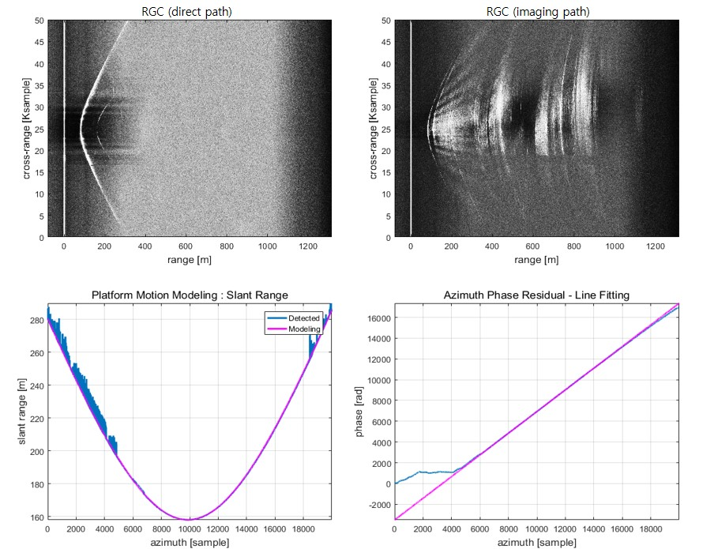

Figure 3: Example of the raw data synchronization analysis process (e.g., direct- & imaging-path data, analysis data of the distance & phase error of receiver)

Figure 3 shows the raw data sets(e.g., direct- & imaging-path data) collected by the stationary receiver and the analysis results of range tracking and linear phase error component in the direct-path data.

**b. Residual phase correction:**

The fourth & fifth steps in the center column of Figure 2 are optional processes to reconstruct an optimum SAR image. Contrast maximizing autofocus and PGA(phase gradient autofocus) methods were applied to estimate the optimal relative velocity and residual phases. Of them, the PGA process is generally adopted for optimal SAR focusing however in this case, it was applied for the residual phase analysis in the direct-path data of the stationary receiver. The residual phase analyzed by the PGA is used to compensate for the phase errors of the imaging-path data. This is possible because both channel data of the receiver were received simultaneously and have the same phase errors.

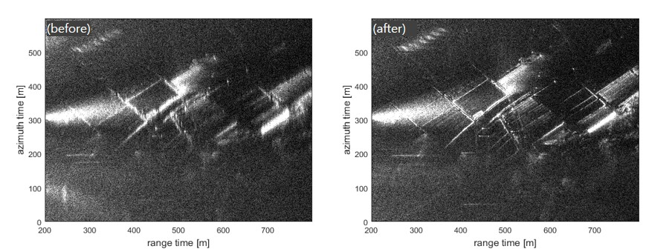 Figure 4: Comparison result of the SAR images before & after correcting the residual phase errors by PGA.

Figure 4 shows the comparison result before & after correcting the residual phase. The residual phase that exists even after the linear phase error correction can be optimized more through the PGA process.

SAR imaging by the proposed back-projection algorithm

Finally, the synchronization parameters extracted from the direct-path data are applied to the input data of the back-projection algorithm for reconstructing the bistatic SAR image, as shown in the last column of Figure 2. The synchronization parameters were utilized to improve the bistatic SAR geometry for the back-projection algorithm. The residual phase error component, analyzed by the PGA process, was used to compensate for the phase component of the BPA input data. This BPA has an advantage that allows focusing on most cases of bistatic & multistatic SAR. However, it has a critical weakness, taking a long processing time.[Soumekh, 1999; Ribalta, 2010; Walterscheid, 2006; Ender 2004; Neo, 2008]

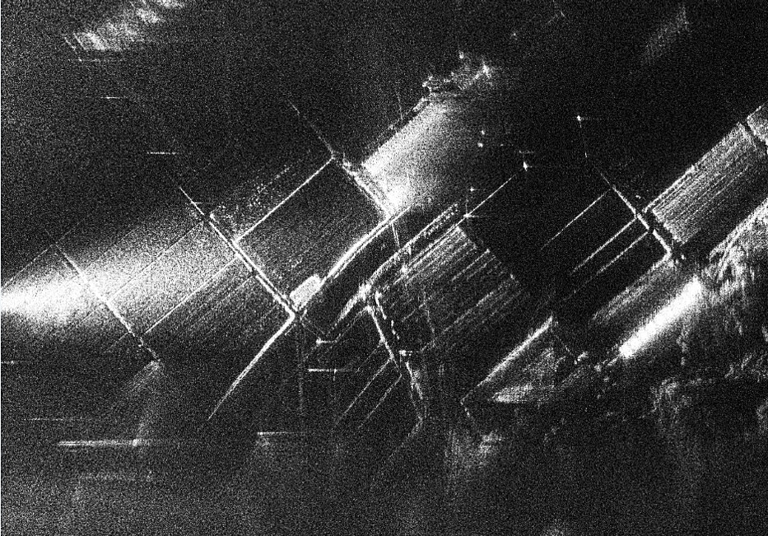

Figure 5: The final result of the SAR image reconstructed by the synchronized data-based back-projection algorithm.

Figure 5 shows the outcome of the proposed synchronized data-based back-projection algorithm. The SAR imaging algorithm and transceivers for data acquisition were developed internally by EchoSensing Inc. in Korea. The whole process such as data acquisition, synchronization process, and bistatic SAR imaging was verified through field experiments.

**Conclusion**

The synchronized data-based back-projection algorithm was developed to reconstruct SAR images with the stationary receiver and moving transmitter. Additionally, an optimized SAR signal processing method, which includes three steps of data synchronization and PGA, was suggested to improve the performance of the back-projection algorithm and enhance SAR image quality. EchoSensing Inc. confirmed the effectiveness of the back-projection algorithm through field experiments and SAR data processing. It is anticipated that this algorithm could be applied to other systems, such as multistatic SAR, because there are no restrictions on SAR imaging with multiple receivers and a transmitter.

**Acknowledgement**

This research was financially supported by the Institute of Civil Military Technology Cooperation funded by the Defense Acquisition Program Administration and Ministry of Trade, Industry and Energy of Korean government under grant No. 22-CM-16

References

Behner, F., Reuter, S., Nies, H., & Loffeld, O. (2015). Synchronization and processing in the HITCHHIKER bistatic SAR experiment. *IEEE Journal of Selected Topics in Applied Earth Observations and Remote Sensing*, *9*(3), 1028-1035.

Walterscheid, I., Ender, J. H., Brenner, A. R., & Loffeld, O. (2006). Bistatic SAR processing and experiments. *IEEE Transactions on Geoscience and Remote Sensing*, *44*(10), 2710-2717.

Anghel, A., Cacoveanu, R., Moldovan, A. S., Savlovschi, C., Rommen, B., & Datcu, M. (2017, May). Bistatic SAR imaging with Sentinel-1 operating in TOPSAR mode. In *2017 IEEE Radar Conference (RadarConf)* (pp. 0601-0605). IEEE.

Silva Filho, E. R., & Cassola, M. R. (2022, July). Experimental evaluation of GNSS-based frequency synchronization for SAR applications. In *IGARSS 2022-2022 IEEE International Geoscience and Remote Sensing Symposium* (pp. 7164-7167). IEEE.

Soumekh, M. (1999). *Synthetic aperture radar signal processing* (Vol. 7, No. 1999). New York: Wiley.

Ribalta, A. (2010). Time-domain reconstruction algorithms for FMCW-SAR. *IEEE Geoscience and Remote Sensing Letters*, *8*(3), 396-400.

Walterscheid, I., Ender, J. H., Brenner, A. R., & Loffeld, O. (2006). Bistatic SAR processing and experiments. *IEEE Transactions on Geoscience and Remote Sensing*, *44*(10), 2710-2717.

Ender, J. H., Walterscheid, I., & Brenner, A. R. (2004, September). New aspects of bistatic SAR: Processing and experiments. In *IGARSS 2004. 2004 IEEE International Geoscience and Remote Sensing Symposium* (Vol. 3, pp. 1758-1762). IEEE.

Neo, Y. L., Wong, F. H., & Cumming, I. G. (2008). A comparison of point target spectra derived for bistatic SAR processing. *IEEE Transactions on Geoscience and Remote Sensing*, *46*(9), 2481-2492.