**Flood Assessment Method for Heritage Conservation at the Site Scale: A Case Study of PuZhou Ancient City Site, China**

Zhu Z.X. 1, Dong Y.Q.1*, and Hou M.L.1

1 School of Geomatics and Urban Spatial Informatics, Beijing University of Civil Engineering and Architecture, China

[*](mailto:*author@gmail.com) dongyouqiang@bucea.edu.cn

***ABSTRACT：****The concept of "preventive conservation" has become the focus of heritage conservation worldwide, risk assessment is one of the important elements of preventive conservation. Current flood risk assessments tend to focus on larger scales such as cities or river basins and fail to adequately refine the risk to individual buildings. This paper presents a flood risk assessment methodology tailored to the scale of cultural heritage units, to enhance the accuracy of identifying site-specific risks. The method couples hazard with vulnerability to assess flood risk. Regarding hazard, to solve the issue of the minimal contribution of slight geographical variations in water and environmental indicators at the scale of cultural heritage units to the classification of storm flood danger， we employ the Storm Water Management Model (SWMM). This model is utilized to establish rainfall scenarios and conduct numerical simulations, translating these into intuitive risk parameters like depth and extent of inundation. Additionally, a vulnerability assessment procedure for cultural heritage was designed. This procedure analyzes structural stability using finite element simulations, quantifies the sensitivity of cultural objects to floods, evaluates exposure based on potential value loss, and assesses disaster prevention and mitigation capacity considering protective measures and restoration possibilities. Flood risk can be obtained by weighing the results of hazard and vulnerability analyses. The case study of the ancient city site of Puzhou verifies the feasibility of the risk assessment methodology adopted and reveals the risk level of different areas. The results of the assessment show that the Xicheng District, except for the southern city wall, has a low flood risk and good resilience to flooding. The Drum Tower area has a damaged foundation but is on higher ground and has a lower flood risk. The Eastern District has important cultural relics, the low-lying topography makes it highly vulnerable to the double threat of flooding and human damage. Considering natural hazards and cultural heritage specifics, this integrated approach offers a targeted framework for assessing flood risks and developing prevention and mitigation strategies for heritage sites. Apply it to additional sites to further validate its effectiveness in the future.*

*Keywords: ancient sites*, *cultural heritage, flood disaster risk assessment, hazard, vulnerability*

# **1. Introduction**

The impact of meteorological and hydrological disasters on cultural heritage tops the list of threats from natural disasters (Luo,Wang, & Song, 2020; Liang, Gong, Sun, & Chen, 2023). Natural disasters like floods have a certain regularity and predictability, preventive conservation increases the thinking about the uncertainty of disasters, predicting and assessing the flood risk that may affect cultural heritage, which becomes a key task in the protection of non-renewable cultural heritage (Garrote, Díez-Herrero, Escudero, & García, 2020). Heritage sites are crucial cultural assets, often exposed to flood threats due to their open or semi-open environments. Thus, flood risk assessment is key to their protection. Flood disaster is a complex system that integrates natural and human factors. Risk assessment involves analyzing the spatial distribution and the synergistic relationships among four key components: disaster-causing factors, disaster-conceiving environments, disaster-bearing bodies, and regulating factors. This analysis then facilitates the classification of the risk level (Wu, Hu, Zhang, Lin, Li, & Huang,  2016; Dai, 2018; Liu, 2019; Qiao & Wang, 2020).

Based on the definition of risk, scholars at home and abroad have conducted a lot of research on how to carry out flood risk assessment, and different scales require different methods when assessing flood risk. Current flood risk assessments focus on larger scales such as cities and watersheds, focusing on those impacts that can be quantified in financial terms, while often ignoring those impacts that are difficult (or impossible) to express in non-monetary terms, such as loss of cultural values (Giuliani, De Falco, Cutini, & Di Sivo, 2021). The subject of the impact of natural disasters, including floods, on cultural heritage has received considerable scientific attention (Maierhofer et al, 2008; Sabbioni et al, 2006; Drdácký, 2010; Li, Zhang, Sun, & Wang, 2017; Lee, Kim, & Jung, 2014). A generalized model assesses disaster risk to immovable cultural heritage, considering both time and space. It factors in seasonal rainstorm frequency and intensity to gauge disaster risk and evaluates environmental sensitivity through elevation, slope, land use, and vegetation. The model also measures the cultural relics' vulnerability based on their value, exposure, and damageability, effectively highlighting seasonal variations in floods (Liang, Gong, Sun, & Chen, 2023). Dai Weijia (2018) addressed spatial disparities in precipitation at the township scale in small regions by using cumulative catchment volumes as an indirect disaster factor. The environmental sensitivity for breeding disasters was analyzed through tertiary indicators like river network density, terrain variation, and vegetation cover. Vulnerability was assessed qualitatively by the site's value and protection level. By overlaying hazard and value levels, the risk sites within the Longwan Site were identified. A simplified method for qualitative risk assessment established a risk assessment framework considering heritage value and authenticity, used the Nara Authenticity Grid to assess the loss of heritage value under different disaster scenarios, and qualitatively assessed the expected damages, repairable capacity, and the loss of value after restoration based on the responsiveness of the heritage categories, providing new ideas for risk management of world heritage (Giuliani, De Falco, Cutini, & Di Sivo, 2021).

These studies show that disaster risk assessment of cultural heritage requires a systematic consideration of disaster characteristics, environmental conditions and the vulnerability of the heritage itself, especially an approach oriented towards irreplaceable heritage values.

This study, taking the Puzhou ancient city site as a case, develops an integrated flood risk assessment method for immovable cultural heritage. The method combines quantitative simulation with qualitative analysis, allowing the risk to be specifically identified for each cultural relic. Specifically, the hazard uniformly represents the impact of the environment and rainfall, and the flood risk is quantitatively assessed using the results of hydrological modelling. Perform qualitative vulnerability assessments that are more centered on the reaction of the cultural heritage items themselves, taking into account exposure, sensitivity, and the capability for disaster prevention and mitigation. Lastly determination of flood risk which represents a synthesis of flood hazard and vulnerability of the model area.

# Data and Methods

Ancient site flood risk can be calculated by the following equation:

$R=H\left(Df,Es\right)+V\left(Se,Ex,Pm\right)$ (1)

In equation (1), R is the flood risk level of the heritage site, H,V represent hazard and vulnerability, respectively; Df and Es represent the hazard of disaster-causing factors and the sensitivity of the environment, respectively; Se, Ex, Pm correspond to the sensitivity, exposure, and disaster prevention and mitigation capacity, respectively.

At the scale of cultural heritage units, elements of cultural heritage are generally distributed in a point-like pattern, with the areas of cultural heritage being relatively concentrated and collectively belonging to a single geomorphological environment. Variations in environmental indicators are not pronounced over small distances. The spatial distribution of individual cultural relics shows minimal differences, directly applying traditional meteorological and hydrological indicators, such as rainfall amount and duration, to evaluate disaster-causing factors may not adequately reflect and quantify the subtle micro-variations among heritage sites. Therefore, we consider the use of hazard indicators to express both the disaster-causing factors and the disaster-inducing environment of a heritage site. Vulnerability is mainly expressed in terms of the heritage site itself and the cultural values it contains. Vulnerability is assessed in terms of the structural stability of the site proper, the loss of value before and after the disaster, and the ability to recover. This study proposes a vulnerability assessment framework, as depicted in Figure 1, which considers exposure, sensitivity and disaster prevention and mitigation capacity, resulting in five vulnerability (V) categories, ranging from V1 (low) to V5 (high).

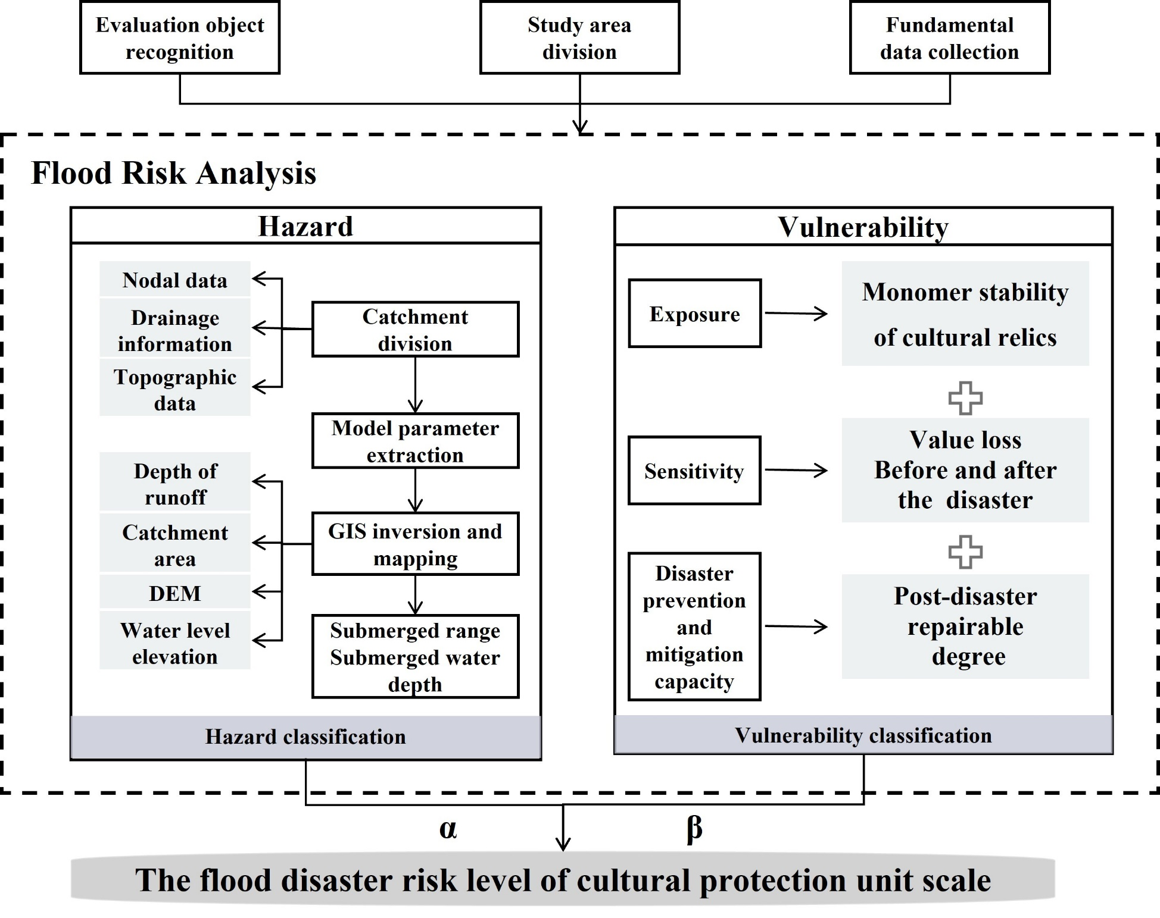

*Source: Drawn by the author*

Figure 1: The risk assessment framework proposed in this paper.

## 2.1Hazard

Hazard assessment reflects more natural attributes, which can be quantitatively predicted through physical, hydrological and other parameters. The SWMM model takes into account a variety of influencing factors such as rainfall, topography and land use. Meteorological and hydrological indicators are created by designing different rainfall scenarios for different recurrence periods and numerical simulation, and the Chicago rain type is applied to the short-calendar-time storm type design to generate the required recurrence period rainfall sequences in the SWMM model of the ancient city. The storm intensity formula is shown below:

 (2)

Where *q* is the design storm intensity, The unit is L（s·ha）-1; *p* is the rainstorm recurrence period; *t* is the rainfall duration (min); *A, c, b* and *n* are local parameters.

For a given area, the *A,clg,p* in its storm intensity equation is the deterministic value α, yielding an average storm intensity $i$ of

 (3)

Where *i* is average storm intensity (mm min-1); *T* is rainfall duration in mm; *b, n* are parameters. Since there is a link between rainfall intensity and time, it can be also expressed as:

 (4)

Joining the two equations and introducing the rainfall coefficient, *r*, results in:

 (5)  (6)

where *ta* represents the post-peak time series and *tb* represents the here-peak time series, *r* denotes the integrated rain peak location coefficient.

After obtaining the comprehensive rain peak position coefficient r from the joint Equation 3 and Equation 4, the rainfall data for the rainfall calendar were finally obtained by using Equation 5 and Equation 6 through the rainfall amount, the average rainfall amount, and the average rainfall intensity during the time interval. The design rainfall was used as an input for the hydrological simulation of the study area using the SWMM model, and based on the runoff results from the SWMM simulation, the local isovolumetric method was used to calculate the hazard parameters such as depth of inundation and extent and to assess different levels of hazard.

## 2.2Vulnerability

Vulnerability is a state in which a disaster body is susceptible to damage from disaster-causing factors due to its structure or proximity to hazardous areas and is an attribute of the disaster body itself (Zhang, Zhao, & Jiang, 2010). Vulnerability analyses of a disaster-bearing body from the perspective of risk include three aspects: "exposure", "sensitivity" and "disaster prevention and mitigation capacity".

### 2.2.1Sensitivity assessment of cultural relics based on numerical analysis

"Sensitivity" reflects the susceptibility of a hazard-bearing body to its vulnerability to damage caused by hazard-causing agents. Three categories—mild, moderate, and severe—define the anticipated damage to cultural heritage in the event of a disaster(Giuliani, De Falco, Cutini, & Di Sivo, 2021). These categories are determined by the effects on the structure's general stability, human life, and the security of immovable cultural material. However, the single stability assessment of immovable cultural relics does not involve human or movable cultural heritage. Therefore, its sensitivity can be converted into slope stability analysis theory in geotechnical engineering to study structural stability problems (Zheng & Zhao, 2004; Wang & Zhao, 2013), the method is quantitative and objective, and the stability and damage of the cultural heritage structure can be assessed.

### 2.2.2 Exposure assessment of cultural relics based on value analysis

"Exposure" refers to the number or value of disaster bodies (e.g., people, houses, roads, indoor property, etc.) exposed to the effects of hazard-causing factors(Zhang, Zhao, & Jiang, 2010). A single cultural heritage object is assessed within the parameters of a cultural heritage unit, and the exposure primarily addresses the cultural heritage's value. Exposure of immovable cultural assets can thus be described as the loss of cultural heritage value in pre- and post-disaster situations, taking into account the influence of disaster-causing causes. This study evaluates the value loss of relics in before and after disaster scenarios using the Nara Grid technique. Seven evaluation dimensions are determined based on the concrete and intangible aspects of cultural heritage: Form and structure; substance and materiality; usage and purpose; technology and history; setting and location; spirit and sentiment; and other internal and external variables(Yang, Zhang, Sun, & Li, 2010).

$I_{N_{i}}^{S_{j}}=\frac{N_{i}^{0}−N_{i}^{Sj}}{N_{i}^{0}}， 0≤I_{N_{i}}^{S_{j}}≤1$ (7)

Eq. (5), compares the changes in the scores of each assessment aspect in the pre-disaster $N_{i}^{0}$ and different post-disaster scenarios $N_{i}^{Sj}$. The loss of value index $I_{N_{i}}^{S_{j}}$ is defined to indicate that a higher value of the index indicates a more severe loss of cultural heritage values.

### 2.2.3Assessment of disaster prevention and mitigation capacity

"Disaster prevention and mitigation capacity" describes humankind's ability to use engineering and non-engineering measures, such as emergency rescue, defense, post-disaster recovery and reconstruction, and disaster monitoring and forecasting systems, to prevent the value of the disaster-bearing body from being damaged by the disaster-causing factors (Zhang et al, 2024). The ability of cultural heritage to prevent and mitigate disasters is embodied in the ability of cultural heritage itself and external protective measures to resist disasters, as well as the ability of post-disaster restoration.

$Pm=β_{31}Dc+β_{32}Mr+β_{33}Tf+β_{34}Fa+β_{35}Ml$ (8)

$β_{31}+β_{32}+β_{33}+β_{34}+β_{35}=1$ (9)

In the formula, $β_{31}，β_{32}，β_{33}，β_{34}，β_{35}$ is the weight coefficient, $Pm$ is the prevention and mitigation capacity, **is the damage condition, is the material repairability, is the technical feasibility,  is the capital adequacy, and  is the management level.

### 2.2.4 Vulnerability assessment flowchart

The framework created by Giuliani (2021), which can more accurately and objectively distinguish the degree of vulnerability of various cultural relics and achieve a differentiated evaluation of the vulnerability of cultural relics, is used to improve the vulnerability assessment process that is proposed in this paper. To sum up, Figure 2 illustrates the procedure of the vulnerability assessment.

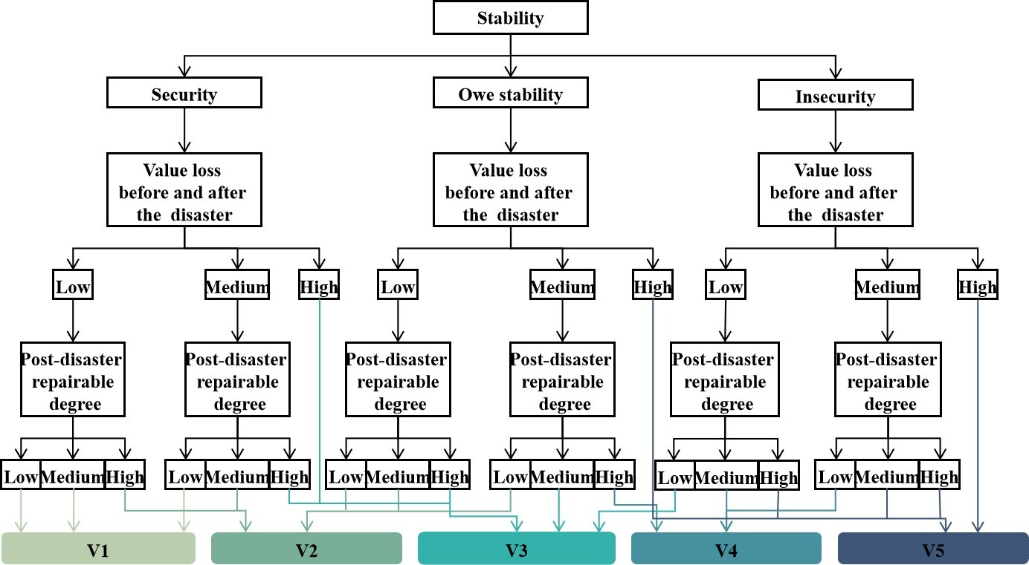

*Source: Drawn by the author*

Figure 2: Improved vulnerability assessment procedure.

## 2.3 Coupling of hazard and vulnerability

The risk depends on both external disasters and internal vulnerability. The higher the hazard assessment level, the greater the likelihood and severity of the disaster. The greater the vulnerability assessment level, the lower the heritage's ability to withstand calamities and external protection. the coupling of the two reflects the comprehensiveness of the disaster impact.

Set a score of 1-5 to indicate the rating of hazard and vulnerability, with 1 being the lowest and 5 the highest. According to the actual situation, determine the hazard weight $α$ and vulnerability weight $β$. According to the formula, calculate the weighted average score that is the final risk value (Table 1).

$α+β=1$ (10)

$Risk=αH+βV$ (11)

Table 1: Classification standard of flood risk grade.

|  |  |  |  |  |  |
| --- | --- | --- | --- | --- | --- |
| **Weighted average** | **1≦x＜2** | **2≦x＜3** | **3≦x＜4** | **4≦x＜5** | **x=5** |
| Risk level | Low Risk | Relative Low Risk | Medium Risk | Relatively High Risk | High Risk |

*Source:Drawn by the author*

# 3.Result and analysis

## 3.1Overview of the study area

The PuZhou Ancient City Site, which spans 4.375 square meters and is 2.5 km long by 1.7 km wide from north to south, is one of China's numerous cultural heritage sites. The entire area is split into two cities: the Tang Dynasty's remnants are primarily found in the East city, while the Ming Dynasty's remnants are primarily found in the West city. There are remnants of the old city wall, city gate, Drum-tower, Jar city, etc. inside the inner city. The location of the site (Figure 3a), Yongji City, is part of the Yellow River Basin and has historically faced numerous flood threats (Li, 1999; Yang, 2015; Li, 2013; Han, 2002). In the history of the ancient city of Puzhou, several flood control engineering facilities were built to protect the structure of the city wall(Yang, Zhang, Sun, & Li, 2010), as shown in Figure 3b.

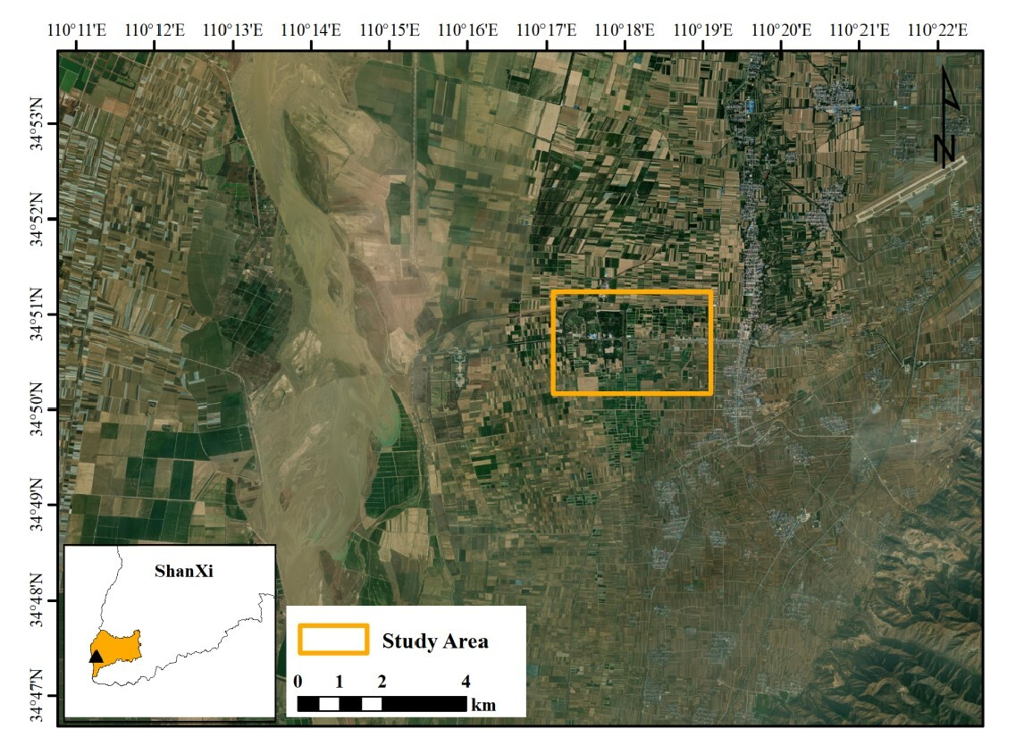

(a)

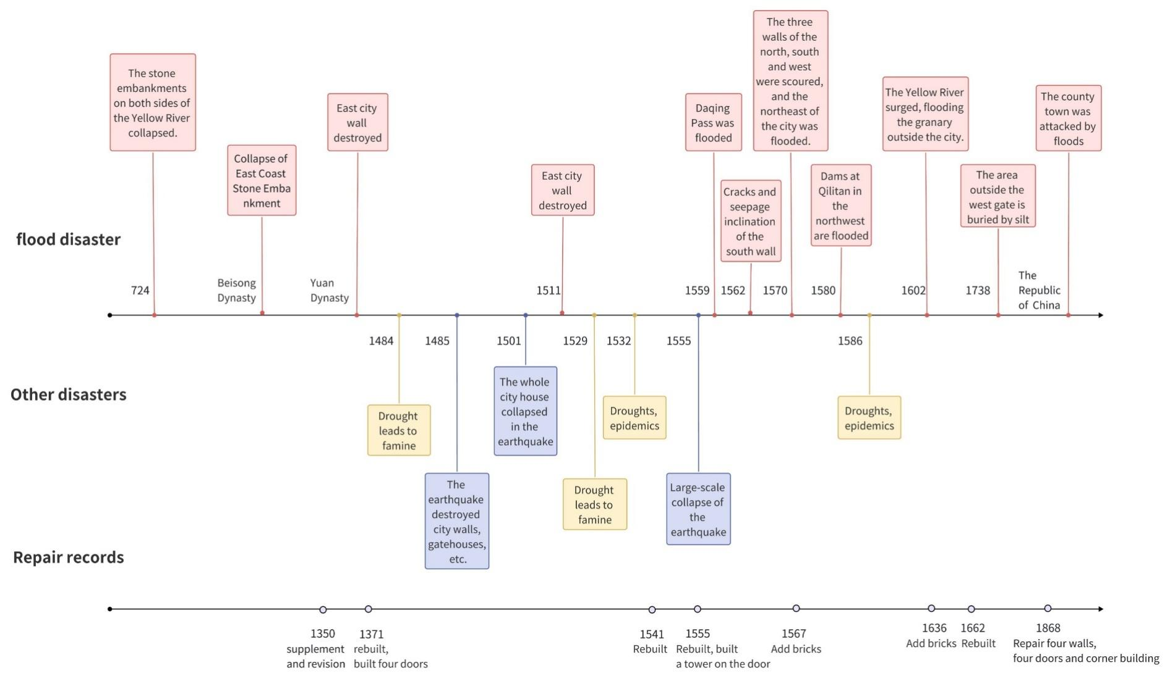

(b)

*Source: Drawn by the author*

Figure 3: (a) is the PuZhou ancient city site, (b) is a historical disaster and restoration history.

## 3.2 Data

During the comprehensive assessment of Puzhou Ancient City, we collected and processed three major categories of data to ensure the accuracy and utility of drainage engineering, meteorological and hydrological analyses, and spatial geographic information. The manual collection encompassed data on drainage networks and outfalls, while rainfall data, a key component of meteorological and hydrological data, was obtained through a meteorological simulator. Spatial geographic data included domain elevation, slope, and land use planning information. We utilized UAV equipment to capture high-precision imagery of the ancient city area. This imagery was then processed with ContextCapture software to generate a 3D model, orthophotos, and a high-density image point cloud (DIM). Furthermore, we imported the point cloud data into the ArcGIS platform, where LAS data and raster conversion tools were employed to create a digital elevation model with a 10-meter resolution, from which contour maps were derived.

## **3.3 Results**

### 3.3.1Hazard assessment of PuZhou ancient city site

The rainfall duration is set to 3 hours, and the peak coefficient is set to 0.3, based on the Chicago rain type generator and the Yongji City rainstorm intensity Equation 12, which is used to determine the recurrence period for various rainstorm scenarios. With a rainfall amount of 144.28 mm and an average rainfall intensity of 48.619 mm h-1, the rainfall eigenvalues for the recurrence period of 1 in 1000 years are calculated.

 (12)

Where *q* is the storm intensity; *T* is the return period; *t* is the rainfall duration (min);

Finally, the inundation area of the PuZhou ancient city site was determined by integrating with DEM. The ideal water level value for each sub-catchment was obtained by continuously providing the flood water level value in GIS. The water depth value of each inundation area under the relevant scenario can be calculated by subtracting the water surface elevation value under the millennium return time from the ground elevation value of the PuZhou ancient city site using Arc-map's raster calculator tool. As the runoff continues to converge on the lower slope, as Figure 4 illustrates, the water depth within the inundation zone of the PuZhou ancient city site reaches a maximum of around 75 cm and a minimum of approximately 25 cm.

Concerning the PuZhou ancient city site conservation planning information, and the topographic features of the ancient city, the flood risk classification criteria for the PuZhou ancient city site have been developed for the time of the emergence of the inundation zone and the size of the distance from the inundation zone to the heritage elements, where distance refers to the distance from the cultural heritage to the inundation zone. The results were compared with Table 2 to classify the hazard level of PuZhou ancient city site heritage elements.

Table 2: Relic hazard rating classification criteria .

|  |  |  |  |  |  |
| --- | --- | --- | --- | --- | --- |
| **Distance(m)** | **x≦10** | **10＜x≦20** | **20＜x≦30** | **30＜x≦40** | **40＜x** |
| Risk level | Low Risk | Relative  Low Risk | Medium Risk | Relatively High Risk | High Risk |

*Source:Drawn by the author*

Based on the raster map of inundation extent and the vector map of heritage distribution, the distance values of heritage attributes are set. The distance is set directly for point elements, and the midpoint distance is taken for line elements. Then neighborhood analysis is carried out to determine whether there is a flooded area within the set distance. According to the results of the analysis, the flood risk level of each heritage is determined with reference to the risk rating criteria as shown in Figure 4 .

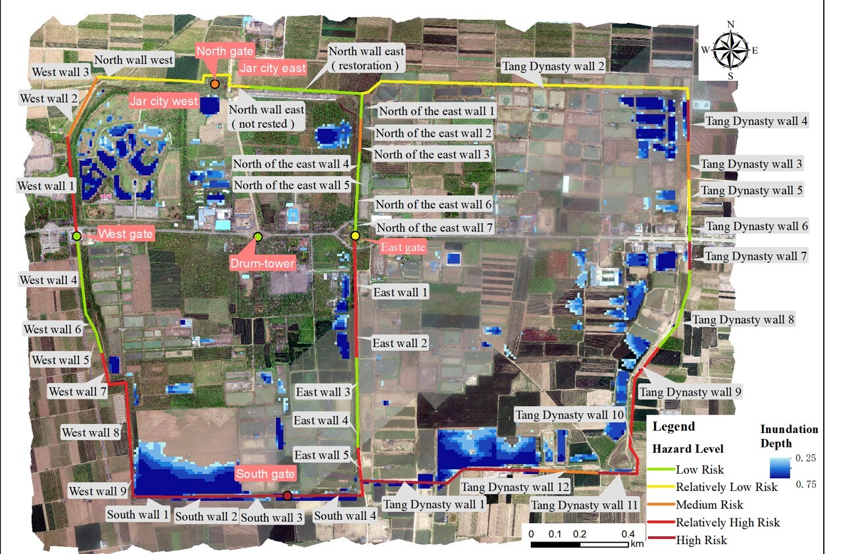

*Source: Drawn by the author*

Figure 4: Results of Hazard Assessment of PuZhou ancient city site.

### 3.3.2 Vulnerability assessment of PuZhou ancient city site

#### 3.3.2.1Stability evaluation of cultural relics

The sliding displacement of the slope is mainly concentrated in the section direction, and the change with the normal direction is small, which can be regarded as a two-dimensional problem. MIDAS TES GX is used to establish a two-dimensional calculation model. The three-dimensional point cloud data is used to extract the section for the key structural positions, such as wall body, column, etc., and fit to generate a two-dimensional model. Considering the mechanical properties of the soil, reasonable initial and boundary conditions are set for simulation analysis. The displacement response and stress distribution of the cultural relics are visually displayed through cloud images to judge the structural stability.

In the study area, soil samples from the northeast corner of the city wall were taken for testing and analysis, and the values of each strength parameter of the soil body in the modelling process of the site were obtained concerning the following: The rock and soil type is brown yellow silt, the natural moisture content is 5.3 %, the natural density is 1.7 g cm³-1, the liquid limit is 25.1 %, the plastic limit is 16.9 %, the plastic index is 8.2, and the liquid limit index is-1.41. The compression modulus obtained from the compression consolidation test is 6.3 MPa. Through the shear test, the cohesion is 21.9 MPa and the internal friction angle is 23.4 °. The elastic modulus of the soil is obtained, the cohesion is 21.9KPa, the internal friction angle is 23.4 °and the compression modulus is 6.3MPa from the compression consolidation test.

The stability assessment of the ancient building is divided into five levels based on the engineering characteristics of the project, its actual operability, the slope of the existing engineering experience, and other factors, generally can be divided into the coefficient of safety K ≦ 1.0 for the state of instability, 1 < K ≤ 1.2 for the state of limit equilibrium, 1.2 < K ≤ 1.5, for the state of marginally safe, 1.5< K ≤ 1.8 for the state of basic safety, K > 1.8 for the state of safety. Take the north gate soil collapse as an example, and do the stability analysis in detail.

|  |
| --- |
|  |
| (a) |
|  |
| (b) |

*Source: Drawn by the author*

Figure 5: Experimental results of stability indicators at the North gate collapse: (a) is the distribution of total translation displacements; (b) is the distribution of equivalent strains.

Numerical analysis helps predict damage to ancient city walls (Figure 5). After 3 hours of rain, there's soil peeling and, at 48.619mm h-1 rainfall, a sharp increase in displacement threatens the site's safety. The safety factor is 1.1, which is unstable.

At the same time, our attention should turn to areas that may have structural problems (Figure 6). Stability analyses on ancient city walls should focus on areas most susceptible to structural damage, particularly corners and height changes where stress concentration is likely to cause cracks and instability. The relatively weak structure of the city gate is susceptible to cracks and displacement, material variances can also lead to weak joints. Areas where obvious cracks, tilts and other damages have occurred, which can directly affect the overall stability should be included as a key object of analysis.

|  |  |
| --- | --- |
| (a) | (b) |
| (c) | (d) |
| (e) | (f) |

*Source: Drawn by the author*

Figure 6: The experimental results of several other key parts: (a),(c)and(e)are the distribution of total translation displacements; (b),(d)and (f) are the distribution of equivalent strains

#### 3.3.2.2Evaluation of cultural relics exposure level

Cultural heritage's "dimensions" and "aspects" are scored to determine each attribute (Giuliani, De Falco, Cutini, & Di Sivo, 2021) In particular, the PuZhou ancient city site's city walls and gates, which are significant historical artifacts, received scores of 55 and 50, respectively, maintaining the closed layout of the old city and demonstrating the scope and quality of the city's construction. One of PuZhou's most significant landmarks is the Drum-tower. It received 47 points for moving the Drum-tower from the Cross Street entrance to the middle of the street, which shows the development and progression of China's historic city planning. The Jar city received 45 points. Demonstration of pre-disaster and post-disaster Nara grid scores using the city gate as an example (Table 3 and Table 4).

Table 3: Completed Pre-disaster Nara grid for the “city gate” attribute in the PuZhou ancient city site.

|  |  |  |  |  |
| --- | --- | --- | --- | --- |
| **Aspects** | **Artistic** | **Historic** | **Scientific** | **Social** |
| Form and  design | The typical characteristics of the gates of the Han nationality are elegant and solemn in shape.  **Score: 2** | In line with the style of the Ming Dynasty gates.  **Score:3** | It embodies the style and skills of architectural art in the Ming Dynasty.  **Score:2** | Compliance with the urban layout plan.  **Score:3** |
| Material and  substance | Main building materials remain in their original state.  **Score:2** | Building materials reflect different historical periods.  **Score:3** | Available for research application of building materials.  **Score:1** | In line with the surrounding environment and local characteristics.  **Score:2** |
| Tradition,  technique  and  workmanship | Retain the Ming Dynasty wood structure.  **Score:2** | Show the superb construction process of the gates of the Ming Dynasty.  **Score:3** | Study of ancient stone and wood structures.  **Score:1** | Inherit the wisdom of craftsmen and inherit architectural skills.  **Score:2** |
| Location and  setting | **Score:0** | Follow the principle of feng shui.  **Score:2** | At the traffic hub, the location is scientific and reasonable.  **Score:1** | Integrate into urban life and become a social place in the city.  **Score:3** |
| Use and  function | They no longer play a defensive and flood control role.  **Score:1** | Witness the historical evolution of the city.  **Score:3** | Examining the function of ancient times.  **Score:2** | Provide public activity space.  **Score:2** |
| Spirit and  feeling | Fit PuZhou ancient city site style.  **Score:2** | Reflects the vicissitudes of rise and fall.  **Score:3** | Reflect on the cultural characteristics of the times.  **Score:2** | Carrying the collective memory of history.  **Score:3** |

*Source:Drawn by the author*

After the flood, all aspects of the gate's value were damaged to a certain extent, mainly in terms of artistic value, but most of the core values were still preserved. The post-disaster value score is 41.

Table 4: Completed Post-disaster Nara grid for the “city gate” attribute in the PuZhou ancient city site.

|  |  |  |  |  |
| --- | --- | --- | --- | --- |
| **Aspects** | **Artistic** | **Historic** | **Scientific** | **Social** |
| Form and  design | The overall majestic shape is preserved, but some parts are damaged and missing.  **Score: 1** | The overall style of the gates of the Ming Dynasty can be identified.  **Score:1** | **Score:2** | **Score:3** |
| Material and  substance | Some ancient building materials are damaged and lost.  **Score:1** | **Score:3** | **Score:1** | **Score:2** |
| Tradition,  technique  and  workmanship | The wood structure technology of the Ming Dynasty was partially damaged, but the whole can be identified.  **Score:1** | The overall process technology level can still be understood.  **Score:2** | Some stone and wood structure techniques are difficult to repair.  **Score:1** | Inherit the wisdom of craftsmen and inherit architectural skills.  **Score:2** |
| Location and  setting | **Score:0** | **Score:2** | **Score:1** | **Score:3** |
| Use and  function | **Score:1** | **Score:3** | **Score:2** | The use function of public space is impaired.  **Score:0** |
| Spirit and  feeling | The cityscape has an impact, but the overall retention score.  **Score:1** | **Score:3** | **Score:2** | **Score:3** |

*Source:Drawn by the author*

#### 3.3.2.3Level of disaster prevention and mitigation capacity of cultural relics

The PuZhou ancient city site after experiencing the flood disaster, each part of the restorability evaluation is as follows. Apart from the relatively well-preserved western city wall, the other three sides have largely become uneven ruins and fragmented walls. The overall expectation for repair is low and requires a high level of technically sophisticated capital. The West gate is the only part of the existing city gate that has not been severely damaged. The other city gates' red brick doorway, stone, and wood components have soaked under the strength and resistance to erosion reduction over time, and the wooden parts have decayed and deformed. Jar city repair capacity is low. The current Jar city has significant deterioration, and prolonged submersion following significant harm makes it challenging to repair the wooden portion of the larger stone building; Other than the base and the surrounding doorway, which are more intact, the Drum-tower has various degrees of destruction; in particular, the wooden components are nearly impossible to restore.

When looking at things holistically, the restoration of the PuZhou ancient city site is very difficult. The hardest parts of the restoration process are the East city ruins and Jar city. Important elements like the city walls and gates are more challenging to return to their original state. Maintaining historical authenticity is an extremely challenging endeavor that calls for increased technological and financial resources, as well as focused reinforcement and corrective actions.The result of the vulnerability assessment of the PuZhou ancient city site, after taking into account all relevant factors, has been presented in full in Figure 7.

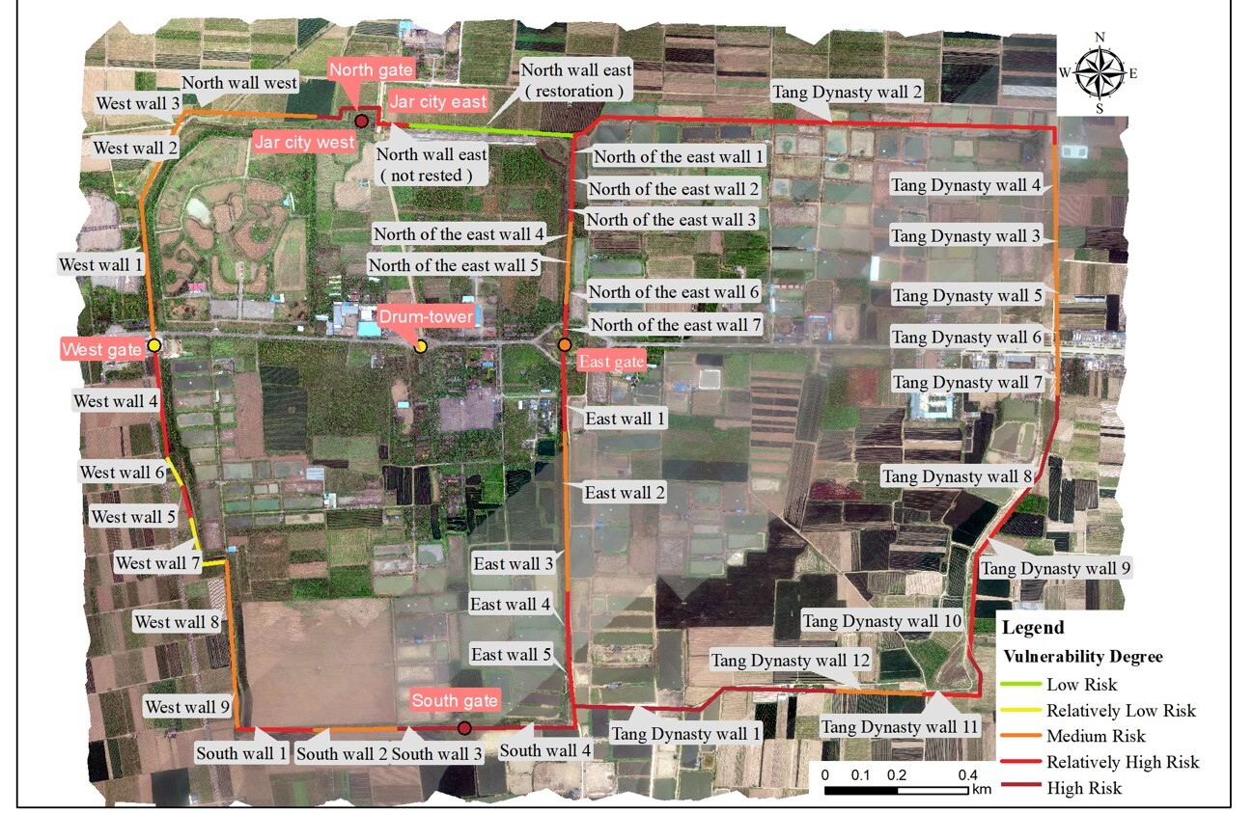

*Source: Drawn by the author*

Figure 7: Results of the vulnerability assessment of the PuZhou ancient city site.

### 3.3.3 Relics flood risk rating results and discussion

The primary natural catastrophe risk that the PuZhou ancient city site faces is flooding, which can be prevented in part by careful planning. Still, the preservation of cultural artifacts from water erosion is of greater importance. The site's cultural relics are vulnerable due to their soil, stone, and wood composition, which have limited resistance to scouring and corrosion. Even if not fully submerged, the relics can still be damaged by the force of water flow. The site's vulnerability to flood-related harm is weighted at 80%, reflecting the high sensitivity and instability of the relics. The remaining 20% is weighted towards the immediate hazard of flooding, highlighting the need for careful planning and preservation efforts to protect these artifacts from erosion.

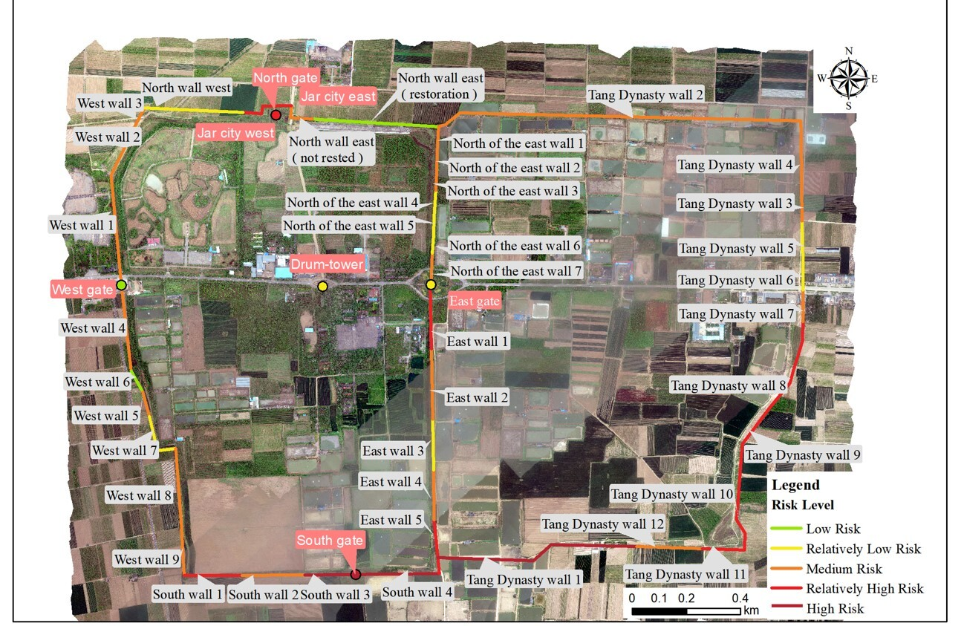

*Source: Drawn by the author*

Figure 8: The risk level of each artifact under flood disaster at the PuZhou Ancient City Site.

The flood risk assessment of the PuZhou ancient city site reveals the following: The site's southern portion is at the lowest point; the Southern wall and the Tang wall have seen the most flooding. The earthen Tang wall remains susceptible to scour damage, especially in the vicinity of Tang 11. The South gate and the entire part of the South wall are nearly completely drenched. The wall's vulnerability is further increased by the fact that it has been in poor condition for a long time and that the bricks have severe shedding and alkalization issues. The South wall and the South gate are in a high-risk state. South wall 2 and Tang wall 12 are less prone to structural problems, and their stability is slightly better, so their risk level is lower than other sections. There is some damage to the foundations of the East gate and the Drum-tower in the center of the city, but the risk is relatively low due to the high elevation, flatness and distance from the inundation zone, which makes prolonged inundation virtually impossible, and therefore reduces the risk to them.There are a large number of important relics of the Tang Dynasty in the East City, which have high historical and cultural value. However, many relics have been submerged or seriously damaged, and the simulation results show that there is still a high risk of submergence in this area. The East City relics are vulnerable to natural disasters and man-made destruction, their risk is high. In contrast, due to the long-term experience of many reinforcement and repairs in West City, the preservation of the brick wall is relatively good and remains continuous and complete, which enhances its disaster resistance, so the risk of the West City is relatively low.

Overall, the risk status of the site shows a general distribution of geographical space, and the risk level shows an increasing trend from north to south and from west to east. In line with the south due to the low altitude, facing a higher flood threat; the eastern part is highly valuable and fragile because of the preservation of a large number of important relics. The findings support the scientifically sound practice of giving vulnerability 80% weight and hazard 20% weight. This allocation is more in line with the actual circumstances at the PuZhou ancient city site and can better balance the two distinct disaster types of inundation and scouring.

# 4.Conclusion

This paper presents a framework for evaluating the flood risk to ancient heritage sites. The framework integrates hazard and vulnerability assessments, considering both natural disaster impacts and the intrinsic qualities of cultural relics, offering a more nuanced understanding of heritage risk. Utilizing the SWMM model, the study simulates surface runoff under rainfall scenarios to predict potential flood risks. The vulnerability assessment framework emphasizes the protection of cultural value, focusing not only on economic loss but also on quantifying structural stability and acknowledging the maintenance values of these sites. The assessment process not only quantifies the stability of the cultural heritage under the action of disasters from the engineering structure level, but also fully considers the unique cultural connotation and maintenance value of the cultural heritage, and more comprehensively depicts the real risks faced by the immovable cultural heritage. The method is applied to the flood hazard assessment of the PuZhou ancient city site, and the results show that the method is valid and reliable, consistent with the connotation of cultural heritage risk, and provides a comprehensive and in-depth risk perspective.The framework proposed in this paper is designed for flood assessment at the scale of cultural heritage units. However, its generalizability should be confirmed through additional case studies in various regions. The article concentrates on flood risk assessment, future research should explore the framework's adaptability for other disaster risk assessments and validate its applicability.

# **Funding**

This research was funded by National Key Research and Development Program of China, grant number 2022YFF0904300, National Natural Science Foundation of China, grant number 42171356, 42171444, and 42301516, Beijing Municipal Education Commission- Municipal Education Commission Joint Fund Project, grant number KZ202110016021, research Project of Beijing Municipal Education Commission - General Project of Science and Technology Plan, grant number KM202110016005 and Beijing University of Civil Engineering and Architecture Special funds for basic scientific research business expenses of municipal universities, grant number X20043.

# **References**

Chai, X., Dong, Y., & Li, Y. (2022). Waterlogging Assessment of Chinese Ancient City Sites Considering Microtopography: A Case Study of the PuZhou Ancient City Site, China. Remote Sensing, 14(17), 4417.

Dai,W., (2018). Protection strategy of LongWan site in Hanriver basin to deal with the rainstorm waterlogging disaster risk. Wu Han: Huazhong Agricultural University.

De Moel, H., Jongman, B., Kreibich, H., Merz, B., Penning-Rowsell, E., & Ward, P. J. (2015). Flood risk assessments at different spatial scales. Mitigation and Adaptation Strategies for Global Change, 20, 865-890.

Drdácký, M. F. (2010). Flood damage to historic buildings and structures. Journal of Performance of Constructed Facilities, 24(5), 439-445.

Garrote, J., Díez-Herrero, A., Escudero, C., & García, I. (2020). A framework proposal for regional-scale flood-risk assessment of cultural heritage sites and application to the Castile and León Region (Central Spain). Water, 12(2), 329.

Giuliani, F., De Falco, A., Cutini, V., & Di Sivo, M. (2021). A simplified methodology for risk analysis of historic centers: the world heritage site of San Gimignano, Italy. International Journal of Disaster Resilience in the Built Environment, 12(3), 336-354.

Han, Y., (2002). On the historical status and development and protection of PuZhou ancient city site. Journal of History and Chorography (05), 71-72.

Huijbregts, Z., van Schijndel, J. W., Schellen, H. L., & Blades, N. (2014). Hygrothermal modelling of flooding events within historic buildings. Journal of Building Physics, 38(2), 170-187.

Liang, L., Gong, A., SUN, Y., & CHEN, Y. (2023). Seasonal Rainstorm and Flood Risk Assessment Method for Immovable Cultural Relics. Geomatics and Information Science of Wuhan University, 48(12), 1978-1989.

Lee, H., Kim, J. S., & Jung, S. (2014). Flood risk analysis of cultural heritage sites: Changgyeong Palace, Korea. Arabian Journal for Science and Engineering, 39, 3617-3631.

Li, H., Zhang, J., Sun, J., & Wang, J. (2017). A visual analytics approach for flood risk analysis and decision-making in cultural heritage. Journal of Visual Languages & Computing, 41, 89-99.

Li, M. ,(1999). The PuZhou ancient city site examination. Historical Monthly (Z1), 88-92.

Li, Z. (2013). The life history of a historic city: Puzhou Old City History. Shanxi University (Dissertation, Shanxi University). Master's Degree https://kns.cnki.net/kcms2/article/abstract?v=cp4X_-KT6XPjDAKrkpR7SX5W4g1BDmnMlX2Cdgq61NVTBaSVHQuDMmDCt6GlxfNo7kcBn2HZTZXx_3dsjqtuOZ08PcDfScNefj-quz_Avnsbc2IZ5J1w7SIW9zzocBcl3c1rIJcA4txmUpOxrjyycAdn2QhMcUTEzxtVY3pd0MjSYMlhiu1KRtrRqsQJl2NcWY6CbQd_FRM=&uniplatform=NZKPT&language=CHS

Liu,J.,(2019) .A Comprehensive Study on the Risks of World Cultural Heritage Based on Remote Sensing and GIS Ph.D. (Dissertation, University of Chinese Academy of Sciences (Chinese Academy of Sciences, Institute of Space and Astronautical Information Innovation)). Ph. https://link.cnki.net/doi/10.44231/d.cnki.gktxc.2019.000007 doi:10.44231/d.cnki.gktxc.2019.000007.

Luo, Y., Wang, F. &  Song, X. (2019). Analysis of the Protection and Management Status and Trends of China's World Heritage Sites - China's World Heritage Sites 2018 Annual General Report. China Cultural Heritage (06), 4-26.

Maierhofer, C., Köpp, C., Kruschwitz, S., Drdacky, M., Hennen, C., Lanza, S., ... & Askew, P. (2008). Cultural Heritage protection against flood–A European FP6 research project. In Structural Analysis of Historic Construction: Preserving Safety and Significance, Two Volume Set (pp. 129-138). CRC Press.

Sabbioni, C., Cassar, M., Brimblecombe, P., Tidblad, J., Kozlowski, R., Drdácký, M., ... & Ariño, X. (2006). Global climate change impact on built heritage and cultural landscapes. In International Conference on Heritage, Weathering and Conservation, HWC 2006 (pp. 395-401).

Sun, D., Yang, T., Li, S., Goldberg, M., Kalluri, S., Helfrich, S., ... & Miralles, F. R. (2024). Hazard or non-hazard flood: Post analysis for paddy rice, wetland, and other potential non-hazard flood extraction from the VIIRS flood products. ISPRS Journal of Photogrammetry and Remote Sensing, 209, 415-431.

Ten Veldhuis, J. A. E. (2011). How the choice of flood damage metrics influences urban flood risk assessment. Journal of Flood Risk Management, 4(4), 281-287.

Vojtek, M., & Vojteková, J. (2016). Flood hazard and flood risk assessment at the local spatial scale: a case study. Geomatics, Natural Hazards and Risk, 7(6), 1973-1992.

Wang,Y., Zhao, D. &  Dai,S. (2013). Landslide stability analysis of Mingiingtai of Big Buddhist Temple in Binxian County.Building Structure. Building Structure (13), 84-90. doi:10.19701/j.jzjg.2013.13.019.

Wenhui, Q., & Qiang, W. (2020). Flood Risk Assessment model for urban cultural heritage: A case study of Guangzhou city. Areal Research and Develop⁃ ment, 39(2), 127-131.

Wu, Z., Hu ,Y., Zhang ,M., Lin, G., Li ,Q.& Huang ,Y. (2016). Assessing Fire Risk in Historical and Cultural Blocks Based on GlS: A Case Study in the fuzhou Three Alleys and Seven Lanes. Journal of Catastrophology (04), 205-209+223.

Yang, G., Zhang, L., Sun, C. &  Li, B. (2010). Stability Analysis and Evaluation about the Old Rampart Builded with Tamped Soil in Pingyao. Special Structures (04), 102-106+89.

Yang, X,. (2015). Changes in the Urban Landscape of Pochu before and after the Jin-Yuan War in the Thirteenth Century. Journal of History and Chorography (02), 54-62+73. doi:10.13514/j.cnki.cn14-1186/k.2015.02.010.

Zhang, B,, Zhao, Q., Jiang, Y.(2010).Research on Indexes System about Regional Vulnerability of Hazard-affected Bodies and FineSpatial Quantitative Model. Journal of Catastrophology,25(02),36-40.

Zhang ,J., Bao, G., Liu, W., Yang, C,. Yan ,Z., Dai, Q. &  Fu ,Y. (2024). Characteristics and model of rainstorm and flood disaster risk index along Qinghai Highway. Arid Land Geography(01), 28-37. doi:10.12118/j.issn.1000-6060.2023.283.

Zheng, Y.,Zhao, S. (2004). Application of strength reduction method for soil and rock slope. Application of strength reduction method for soil and rock slope (19), 3381-3388.