**Analysis of Spatial Bias of Precipitation Estimated from Weather Radar Data During Storm Dissipation with Geographic Information System in Central Thailand**

Apichaya Kangerd1*, Nattapon Mahavik1,2, Fatah Masthawee1,3, Sarawut Arthayakun1,4,

Rangsan Ket-Ord1, Ukrit Samaksaman1, Chanin Umponstira1, Jamorn kunwilai1, Wirachart Promta3,

Charatdao Kongmuang1,2, Sarintip Tantanee2,5

*1Department of Natural Resources and Environment,* *Faculty of Agriculture Natural Resources and Environment, Naresuan University, Phitsanulok 65000, Thailand*

*2Water Resources Research Center, Faculty of Engineering, Naresuan University, Phitsanulok 65000, Thailand*

*3Thai Meteorological Department, Bangkok 10260, Thailand*

*4Department of Royal Rainmaking and Agricultural Aviation, Bangkok, 10900, Thailand*

*5Department of Civil Engineering, Faculty of Engineering, Naresuan University, Phitsanulok 65000, Thailand*

*Email: apichaya.ice7835@gmail.com

***Abstract***

*Meteorological weather radar is a vital instrument in the study of atmospheric conditions and weather forecasting. It plays a particularly significant role in spatial rainfall estimation, especially in areas lacking ground-based rain gauge stations. However, radar-derived rainfall estimates often exhibit discrepancies when compared to measurements from ground stations, a phenomenon referred to as bias. The variability of this bias is influenced by several factors, including the Z-R relationship, topography, storm characteristics, and seasonality. Additionally, the complexity of radar data processing, which requires advanced programming skills, poses a challenge to the spatial analysis of radar data. This research utilized C-band weather radar data from the Thai Meteorological Department, focusing on the central region of Thailand during the 2018 monsoon season, which was affected by Tropical Storm SON-TINH. The preliminary data processing was conducted using open-source radar libraries. The study aimed to compare spatial bias using the Marshall-Palmer Z-R relationship (Z = 200R1.6) against ground-based rainfall data at hourly intervals. The methodology for processing and analyzing spatial bias was implemented using Geographic Information System (GIS) software. Furthermore, the study tested spatial bias correction using the Inverse Distance Weighting (IDW) method. The corrected data were then analyzed using statistical measures such as RMSE, MAE, and MFB to assess the effectiveness of the bias correction methods over different time intervals. The results indicated that MFB correction effectively reduced the discrepancies between radar and ground-based rainfall estimates across all time periods, particularly in shorter intervals. In contrast, the IDW method was found to significantly reduce the bias in radar-derived cumulative rainfall over longer periods. Validation using RMSE and MAE statistics confirmed that both methods enhanced the accuracy of radar-based rainfall estimates.*

*Keywords: Ground-based weather radar, Spatial Bias, Spatial Statistics, Thailand, Z-R Relationship*

# **Introduction**

Water is the most important resource for human life and social development worldwide. It is not only the source of life but also a critical component in both consumption and production. Water usage in agriculture is a key factor in economic development and human well-being. The amount of water used in cultivation and animal husbandry significantly influences the quality and quantity of yield. Therefore, increasing agricultural productivity sustainably relies on efficient water resource management and innovative approaches to enhance water use efficiency. However, climate change has exacerbated issues such as more frequent and severe floods, droughts, mudslides, and soil erosion. Additionally, the growth of urban communities and the expansion of industry have worsened water quality problems (National Water Resources Agency, 2018). In Thailand, multiple agencies are involved in water resource management and disaster prevention, making it essential to accurately forecast rainfall in specific areas and times. Currently, rainfall measurement in Thailand is conducted using both automatic and manual ground-based rain gauges across the country. However, these may be insufficient, particularly in mountainous, hilly, and hard-to-reach areas. Sucharit et al. (2007) noted that ground rain gauges measure rainfall at a specific location in units such as millimeters per hour (mm/hr) or inches per hour. While this method can be highly accurate, it is not without flaws. Equipment may be incomplete or damaged, the installation site may be obstructed by trees or buildings, and the cost of measuring equipment can be high. Furthermore, since these gauges measure rainfall only at specific locations, they do not provide information about actual rainfall in surrounding areas where there are no measuring stations. Therefore, while the rainfall data obtained from these gauges is generally reliable, it has limitations compared to other measurement methods.

In addition to measuring rainfall using ground rain gauges, various tools are available for weather monitoring, including meteorological satellites and ground-based weather radar stations. These tools have gained widespread use. However, they also come with limitations. For example, satellite-based weather monitoring requires multiple satellites to cover specific areas, and the frequency of data collection can be limited. As a result, rainfall data obtained from satellite estimates are often higher than those measured by ground rain gauges (Nattapon Mahavik, 2019). Rainfall data can also be estimated from reflectivity values captured by ground-based weather radars, which offer both spatial and temporal resolutions suitable for small and medium-sized areas. This method provides reliable and relatively efficient rainfall estimates. Despite these advantages, there are limitations associated with estimating rainfall from radar reflectivity values. For instance, ground clutter, such as buildings, trees, noise from transmission towers, aircraft, and terrain features, can interfere with data accuracy. Additionally, data obtained from satellites and ground-based radars often overestimate actual rainfall compared to measurements from ground-based rain gauges. Therefore, it is essential to adjust these discrepancies to ensure the data aligns more closely with reality.

The objective of this research is to utilize precipitation estimates from the Meteorological Department's ground-based weather radar, specifically from the Phitsanulok Radar Station, to study and correct the spatial differences between radar-estimated rainfall and ground-measured rainfall. The Z-R correlation developed by Marshall et al. (1955) will be applied to compare radar estimates with ground rain data provided by the Institute of Water Resources Information (Public Organization) during Tropical Storm SON-TINH. The analysis will be conducted using geographic knowledge to identify a spatial estimation method that reduces the spatial difference in radar rainfall estimates. The Inverse Distance Weighted (IDW) method will be employed, and the results will be verified using statistical metrics such as Mean Field Bias (MFB), Root Mean Squared Error (RMSE), and Mean Absolute Error (MAE). Quality improvements to the radar data will be done using an open-source radar library.

# **2. Study and Information Area**

The radar is located in the lower northern region of Thailand at geographical coordinates 16°46'30.358" N latitude and 100°13'4.312" E longitude, at an altitude of 47 meters. The area covered by the radar includes a diverse range of terrains, from the central and southern floodplains to the surrounding mountainous regions in the west, north, and east. The radar coverage area also encompasses several significant river basins within the Chao Phraya River basin, including the Ping River basin and the Wang River basin. According to Mahavik & Tantanee (2019), during the southwest monsoon season, which spans from May to mid-October, the region experiences a substantial increase in rainfall. The southwest monsoon brings moisture from the ocean to the land, resulting in storms and heavy rains throughout Southeast Asia, including Thailand. This study utilizes radar data from Tropical Storm "SON-TINH" in 2018. The data in our study area have been processed and analyzed, as shown in Figure 1.

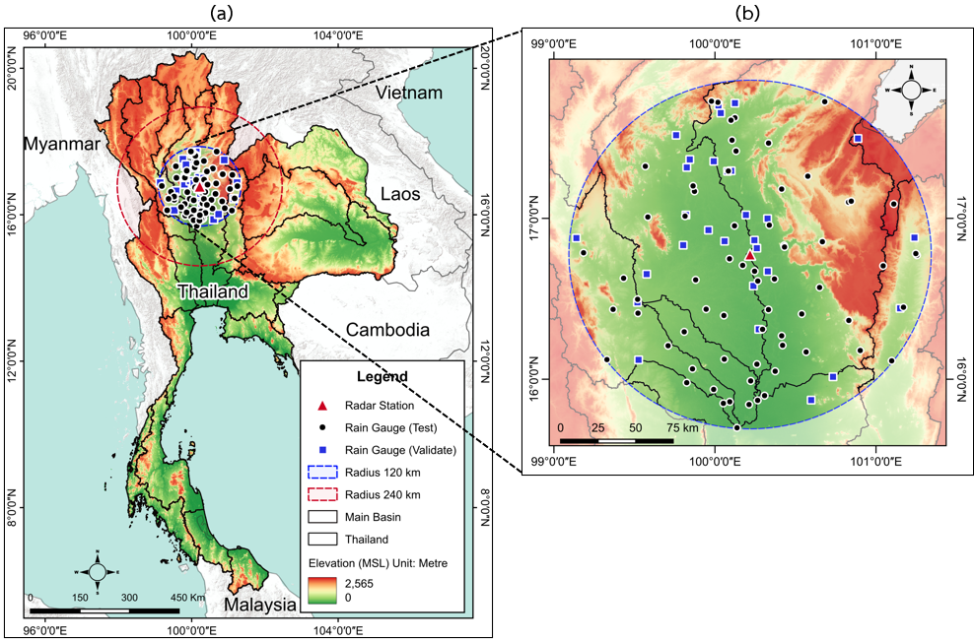

Figure 1: Map of study area(a) Map of Thailand (b) Map of the Observation Area of the Phitsanulok Weather Radar Station. The map displays the observation area of the Phitsanulok Weather Radar Station, which has a radius of 120 kilometers.

# **3. Tools and data used in the study**

## **3.1 Tools Used**

Table 1: Tools and software used in the research

|  |  |
| --- | --- |
| **Tools & Software** | **meaning** |
| 1. QGIS Geographic Information Program V.3.32 Lima | Open-source software used to analyze and visualize geographic data. |
| 2. Miniconda3 Program | Python Open-Source Software and Packages Install the necessary libraries for analyzing radar data. |
| 3. Integrated Data Viewer (IDV) V.6.0u1 | It uses two-dimensional display of radar and climate data. 3D & Animation |
| 4. Python language and open-code radar libraries Py-Art, Wradlib and other libraries such as Numpy, geopandas, Scipy, Wradlib, seaborn, rasterio cartopy and matplotlib | Radar Library Radar Data Analysis and Libraries for Spatial Data Management and Analysis Math calculations, graphs and maps. |

# **3.2 data**

The data utilized for this analysis consisted of meteorological radar data from the Phitsanulok Weather Radar Station, managed by the Department of Meteorology. The radar has a coverage radius of 240 kilometers and operates with a first elevation angle of 0.5 degrees. All analyses were performed using data in Universal Time Coordinate (UTC), with rainfall and location data obtained from the auto-telemetry stations of the Water Resources Information Institute (Public Organization). The data was retrieved via an API from the following link: <https://tiservice.hii.or.th/opendata/> data_catalog/0station_metadata.csv, in CSV format. The study focused on data collected during Tropical Storm SON-TINH on July 17, 2018, adjusted to Thailand local time. Additionally, a numerical elevation model from the United States Geological Survey (USGS) was used, featuring a spatial resolution of 90 meters.

# **4. Study methods**

## **4.1 Operating Procedure**

As seen in Figure 2, gathering data was the process's initial stage. The TMD-operated Phitsanulok Weather Radar Station provided the meteorological radar data. Every 15 minutes, the station collected four consecutive observations at a 0.5-degree elevation angle. Data were recorded in Universal Format (UF) format in UTC. The research team developed a Python script to retrieve this data via an API and store it in CSV format, adjusted to Thailand local time. To ensure accurate alignment with other datasets, the radar file timestamps were converted from UTC to local time. Additionally, Digital Elevation Model (DEM) data with a spatial resolution of 90 meters was downloaded from the USGS. This DEM data was imported into a Geographic Information System (GIS) and clipped to match the coverage area of the weather radar.

Data processing was done in the second step. To assess terrain-induced radar beam occlusion, the Wradlib open-source radar package (Heistermann et al., 2013) was utilized in conjunction with the DEM data. The radar data was then transformed from the polar coordinate system to the Cartesian coordinate system. Constant Altitude Plan Position Indicator (CAPPI) radar data was generated at an altitude of 2 kilometers, with a 0.5-degree elevation angle, at 15-minute intervals, resulting in four files (00, 15, 30, and 45 minutes) for the duration of Tropical Storm SON-TINH. These files were exported in GeoTIFF format for further analysis using open-source geospatial software.

Data analysis was done in the third step. To enable comparison with rainfall data derived from ground observations, reflectivity data has been converted into rainfall rates by applying the Z-R relationship, which was first developed by Marshall et al. (1955). This ground-based data was then used in a bias correction process to refine the estimated rainfall rates. Lastly, spatial estimation was conducted using the bias-corrected rainfall data.

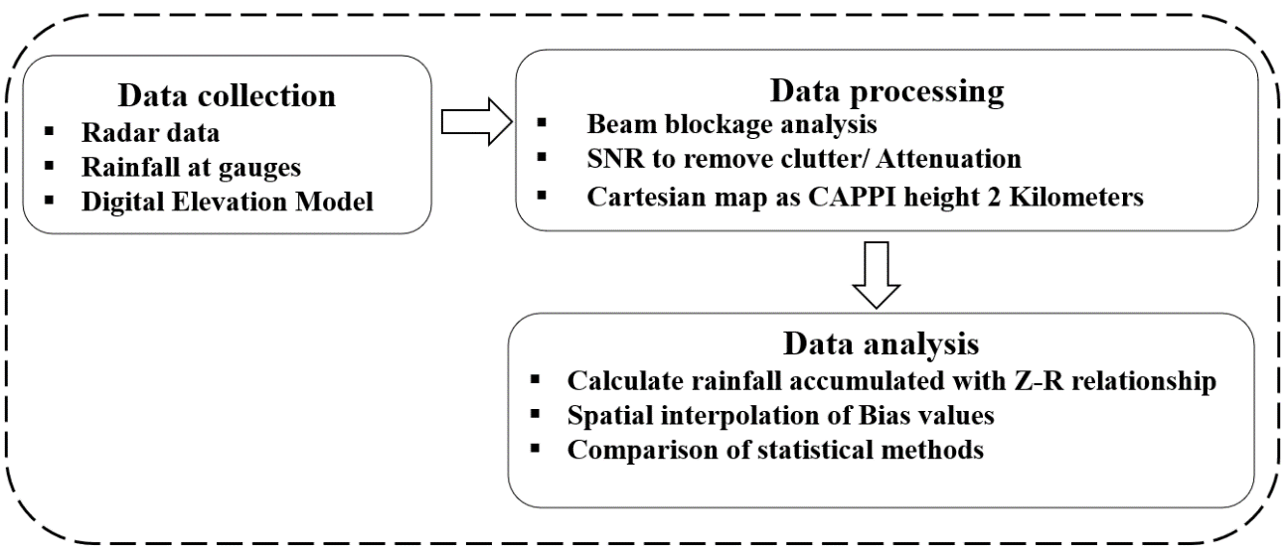

Figure 2: Research Conceptual Framework

**4.2 Radar Data Correction with Open Code Library**

Beam Blockage Analysis: This analysis utilizes DEM in combination with an open-source radar library. Mahavik & Tantanee (2019) employed the Wradlib software to investigate the physical properties of convective clouds. By analyzing radar data from the Phetchabun Station during the southwest monsoon season, they generated CAPPI radar map at an altitude of 3 kilometers. Furthermore, they developed a tracking method to gather physical statistics on convective clouds. This approach is essential for assessing radar quality, as terrain-induced beam blockage can significantly affect the accuracy of radar measurements. For instance, Figure 3 demonstrates how terrain in the northwest, particularly the area surrounding Ramkhamhaeng National Park in Sukhothai Province, completely obstructs the radar beam.

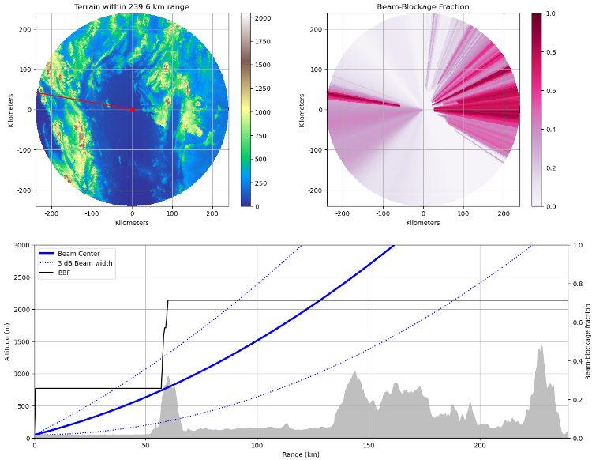

Figure 3:Proportion of the obscuration of the first lift angle radar beam of the Phitsanulok radar station considered together with Digital Elevation Model (DEM)

Ground Clutter Removal: Ground clutter refers to signal contamination from non-meteorological objects, such as buildings and other structures, that interfere with radar reflectivity data. This contamination can introduce bias into reflectivity measurements, leading to inaccurate data. To mitigate this, it is essential to filter out contaminated signals (Mahavik, 2022). The Py-ART library is employed to remove ground noise and unwanted data (Helmus & Collis, 2016). In experiments, Signal to Noise Ratio (SNR) of less than 1 indicates low signal quality, while an SNR above 70 may still be affected by noise or errors. Figure 4 illustrates how creating a new field for comparison allows Py-ART to evaluate data before and after filtering. The use of doorstep filters effectively removes low-quality data from the dataset. Assessing the SNR value is a widely accepted method for determining signal quality.

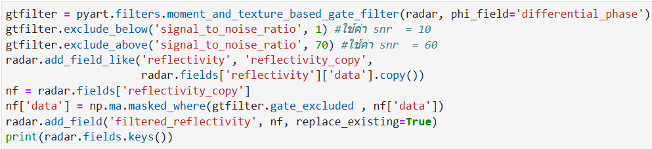

Figure 4: Example code from SNR

Attenuation Correction: The attenuation of radar signals caused by atmospheric gases is a critical factor affecting the accuracy of meteorological measurements. This attenuation depends on the radar wavelength and the altitude of the measurement, as atmospheric components such as gases, cloud water droplets, raindrops, snow, and hail can absorb and scatter radar energy (Mahavik, 2022). To address this issue, it is essential to apply a correction process based on standard atmospheric refraction assumptions. For this study, the open-source radar library Py-ART was used to perform attenuation correction, as shown in Figure 5. C-band radar systems are particularly prone to signal attenuation over distance and through meteorological objects, which can degrade signal strength. If attenuation is not corrected before estimating rainfall using the Z-R relationship, the resulting rainfall estimate may be lower than the actual value, leading to an underestimation of precipitation (Mahavik, 2022).

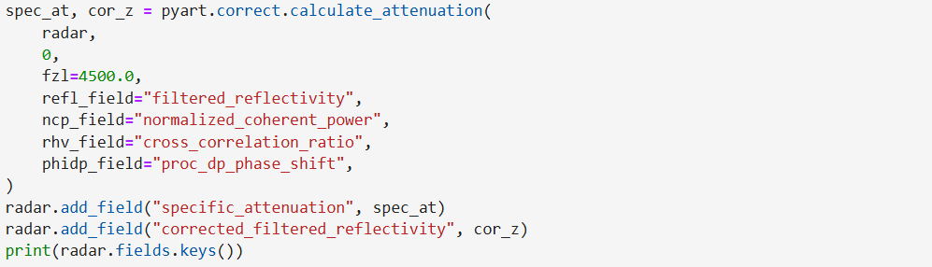

Figure 5: Example of noise filtering code using SNR

## **4.3 Data Analysis**

***Calculate the Z-R Correlation:*** The Z-R correlation is used to relate the radar reflectivity factor (Z) to rainfall intensity (R). Radar reflectivity measures the intensity of waves reflected from raindrops in the air, but this does not directly translate to the amount of rain falling to the ground, unlike measurements from ground-based rainfall stations. Therefore, the radar reflectivity values (measured in dBZ) need to be converted to rainfall intensity using the Z-R relationship. This relationship describes how the radar reflectivity factor correlates with the distribution of rainfall. The Z-R relationship can be expressed as follows (Nattapon Mahavik, 2022).

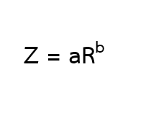

*Where* Z represents the radar reflectivity factor in units of mm⁶/m³, and R denotes the rainfall intensity in mm/hr. The constants a and b are coefficients that depend on the distribution of raindrop sizes and vary based on factors such as the type of rainfall, geographic location, time of day, and season.

***Mean field bias (MFB)*** ratio of the average of the measured rainfall from radar to the average value of rainfall measured by rain meters. Determining the multiplier factor is used to evaluate and improve the accuracy of rainfall measurements from radar compared to measurements from rain meters, allowing for better calibration and bias reduction (Makmi & Mapiam, P. P., 2020).

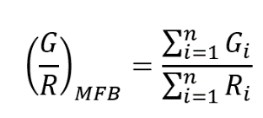

***Root Mean Square Error (RMSE)*** is a measure of the difference between predicted values and observed values by calculating the difference between the predicted value and the actual value and finding the average of that difference (Mahavik, 2017).

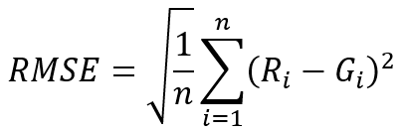

***Mean Absolute Error (MAE)*** means that it is the average of the absolute difference between a predicted or predicted value and an actual value.

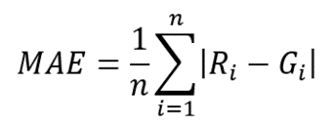

*Where* Given that Gi is the actual measured rainfall value in the sample at i (mm), Ri is the estimated rain value of the radar (mm) n is the total number of measuring stations.

***Spatial interpolation*** in meteorological data is used to correct the bias in radar rainfall estimates. In areas where data are insufficient or unavailable, nearby values are used to estimate missing data through mathematical equations. In this study, the local interpolation method, as described by Chang (2002), was applied. This method places greater weight on nearby data points, allowing them to exert more influence on the estimated values.

# **5. Results**

## **5.1 Radar Data Correction**

With the Py-ART open-source radar library, we provide the preliminary results of radar data correction. The radar data shown in Figure 6a shows the station's surroundings to be significantly affected by ground noise before it was filtered out. As Figure 3 illustrates, 100% beam blockage at Ramkhamhaeng National Park (Sukhothai province) also results in high reflectivity values in the northwest.

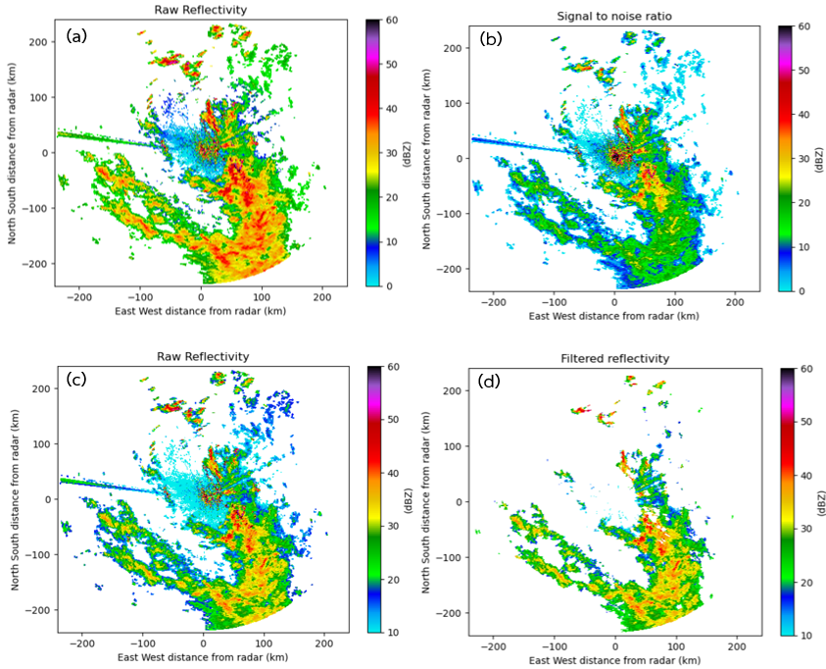

Figure 6: Pre-processing radar data results (a) Raw reflectivity image (b) Proportional value between signal value and noise value) (c) Image before filtering with SNR (d) Image after filtering with SNR

To address these issues, SNR was used to differentiate high signal values originating from the Earth's surface, up to an altitude of 15,000 meters. Figure 6b provides an example during Tropical Storm SON-TINH on July 17, 2018, from 07:00 to 07:45 UTC (14:00 to 14:45 local time in Thailand). The analysis revealed significant contamination at both the lowest and highest reflectivity levels. As depicted in Figure 5, Python scripts were employed to filter out ground noise and remove unwanted data. The results indicated that an SNR below 1 signifies low signal quality, while an SNR above 70 is optimal for radar data filtering during the Tropical Storm SON-TINH event, ensuring the preservation of the maximum rainfall area. Figure 6d shows that, after applying these filters, the ratio of signal to noise around the radar station was substantially reduced, and the abnormal reflectivity values were eliminated. Additionally, reflectivity values that were higher than actual observations were removed, improving the accuracy of the radar reflectivity data.

Adjusting Signal Attenuation Using the Py-ART Open-Source Library: Figure 7a presents the collected radar parameters, including azimuth angle, elevation angle, range, and tilt angle, as well as radar reflectivity values in dBZ. These factors contribute to signal attenuation, resulting in a weaker signal than the actual reflectivity. Thus, it is necessary to correct for signal attenuation before proceeding with further analysis. After applying attenuation correction, as shown in Figure 7b, areas affected by signal attenuation, particularly those farther from the radar station, exhibit increased reflectivity values, providing more accurate data for subsequent analysis.

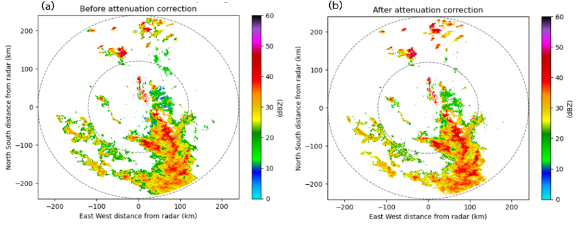

Figure 7: Adjusting Signal Attenuation (a) before attenuation correction (b) after Attenuation correction

Next, the radar data are converted from the polar coordinate system to the Cartesian grid coordinate system. The coordinates are subsequently adjusted and exported into a format compatible with spatial analysis in GIS. The output from the Wradlib function is used to transform the data into Cartesian grid coordinates, utilizing the WGS84 datum, an international standard for geographic coordinates, as illustrated in Figure 8.

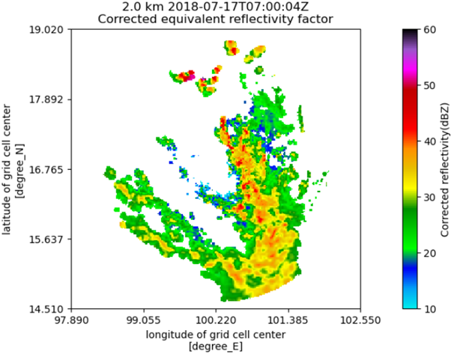

Figure 8: Results of Conversion of Coordinates from Polar Coordinate System to Cartesian Coordinate System

## **5.2 Development of Radar Analysis Process in GIS System**

Calculation of Hourly Accumulated Rainfall: A model was developed using QGIS, an free and open-source software, to process radar data for calculating accumulated rainfall. This model was chosen due to the large volume of data involved, as shown in Figure 9. Rainfall intensity (Z) is derived from the Z-R Marshall-Palmer relationship, represented by the equation Z = aRb, with default parameters set to a = 200 and b=1.6 CAPPI data at a height of 2 kilometers were used, and calculations were performed every 15 minutes (00, 15, 30, and 45 minutes) using the Raster Calculator command. The 15-minute rainfall values were summed to compute the hourly accumulated rainfall, and the Cell Statistics command was used to calculate daily accumulated rainfall. To ensure accurate daily accumulation, at least 80% of the data (equivalent to 19 hours) was required for the calculation.

A set of maps in Figure 10 show the conversion of rainfall intensity (R) to radar reflectivity (Z) on July 17, 2018. At (a) 07:00 UTC, (b) 07:15 UTC, (c) 07:30 UTC, and (d) 07:45 UTC, the maps show the intensity of the rainfall. Rain clusters with a southeasterly origin started to move into the 120-kilometer study region, according to observations obtained by the Phitsanulok weather radar station.

The accumulated rainfall calculations for Tropical Storm SON-TINH on July 17, 2018, are shown in Figure 11. It is evident from the data in Figure 11 that the 120-kilometer radius around the watershed is not completely covered by the 1-hour accumulation of rainfall.

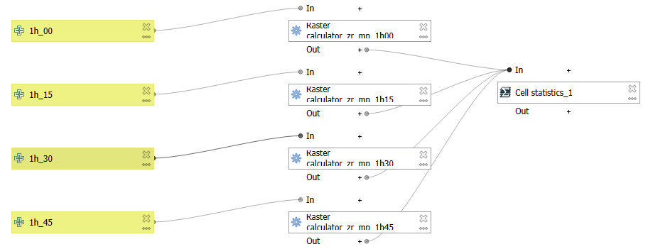

Figure 9: Hour accumulate rainfall calculation model using Z-R relationship

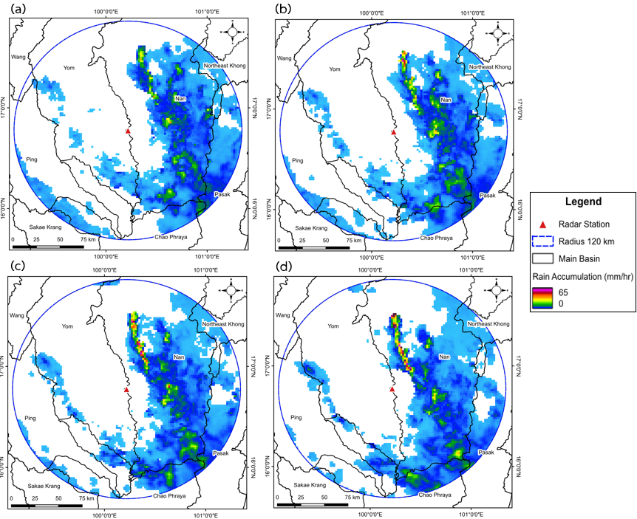

Figure 10: Results of Radar Reflection (Z) Conversion to Rainfall Intensity (R) of Tropical Storm SON-TINH On July 17, 2018, Phitsanulok Weather Radar Station (A) Rainfall intensity at 07:00 UTC (b) Rainfall intensity at 07:15 UTC (c) Rainfall intensity at 07:30 UTC (d) Rainfall intensity at 07:45 UTC

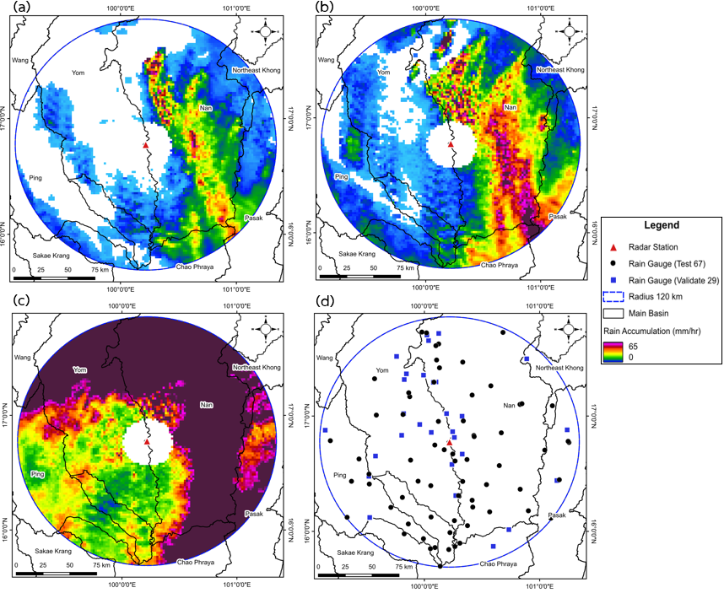

Figure 11: Map of hourly rainfall accumulation from the Z-R relationship of Tropical Storm SON-TINH. On July 17, 2018, Phitsanulok Weather Radar Station (a) 1-hour cumulative rain map from 07.00-07.45 UTC (b) 3-hour cumulative rain map from 06.00-08.45 UTC (c) 24-hour cumulative rain map from 00.00-23.45 UTC (c) location map of 67 test stations and 29 monitoring stations

## **5.3 Spatial Differences Correction**

Using data from Tropical Storm SON-TINH on July 17, 2018, during its tropical storm phase with strengthened conditions and wind speeds ranging from 35 to 40 kilometers per hour, hourly bias correction was carried out. Spatial variation analysis was conducted for this particular time frame. At intervals of 1, 3, 6, 9, 12, and 24 hours, ground-based rainfall data and estimations derived from radar were compared. For this correction process, automatic weather stations from a total of 96 locations within a 120-kilometer radius of the Phitsanulok radar station were randomly selected using QGIS software. These stations were divided into test stations (70% of the total, represented by black circles in Figure 11c, comprising 67 stations) and validation stations (30% of the total, represented by blue squares in Figure 11c, comprising 29 stations). Rainfall data from the test stations were extracted for the same time intervals: 1, 3, 6, 9, 12, and 24 hours. Ground-based rainfall data, formatted in CSV files for Thailand's local time, was matched with radar-based rainfall estimates. A criterion was set to include only rainfall measurements greater than 0, ensuring consistency between radar and ground-based data. Figure 12a provides an example of the 24-hour accumulated rainfall results, while Table 2 presents the calculated bias between radar and ground-based measurements.

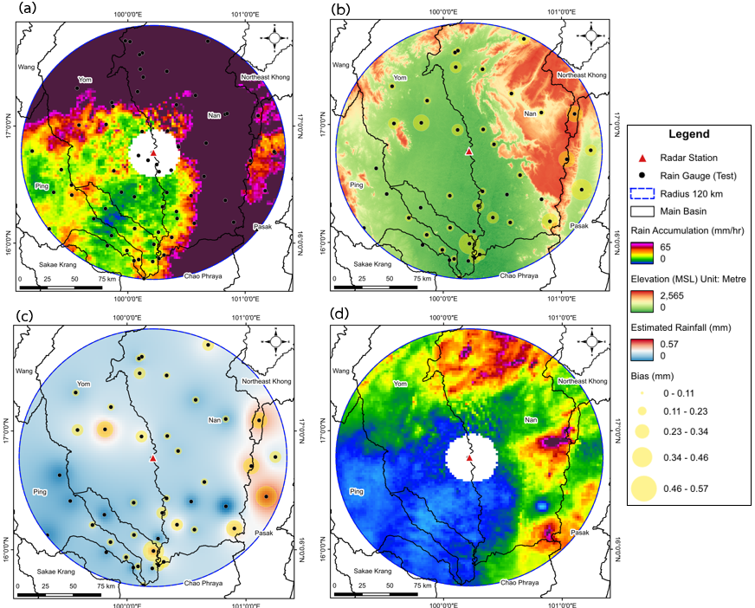

Figure 12: Map of the Spatial Differences Correction Process (a) 24-hour accumulated rainfall map for the period from 00:00 to 23:45 UTC. (b) Extracted results and differences at the test station locations. (c) Spatial interpolation results using Inverse Distance Weighting (IDW). (d) Results of the spatial differences correction.

Radar rainfall measurements from some stations produce values higher than ground-based measurements, while others produce lower values, resulting in station-specific biases. To address this, it is necessary to adjust the radar data to align with ground-based observations. This adjustment was performed using spatial interpolation with the Inverse Distance Weighting (IDW) method, as illustrated in Figure 12c. The spatial interpolation results, derived from the bias values, were then used to correct MFB. Radar rainfall data were multiplied by the values obtained from the spatial interpolation, as depicted in Figure 12d, to make the radar measurements consistent with ground-based rainfall observations. As shown in Table 2, radar rainfall estimates at intervals of 1, 3, 6, 9, 12, and 24 hours were consistently higher than ground-based measurements. The bias values, derived from comparing radar and ground-based rainfall, varied by time interval, with the highest bias of 0.32 occurring at the 1-hour interval (07:00 UTC) and the lowest bias of 0.21 at the 24-hour interval (00:00–23:45 UTC). This discrepancy suggests that radar-derived rainfall estimates over shorter time intervals tend to be less accurate compared to longer intervals. After correction using MFB method, radar rainfall values more closely matched ground-based measurements across all intervals, demonstrating the effectiveness of MFB correction in reducing discrepancies in radar data.

Table 2:Adjustment of Mean Field Bias (MFB)

|  |  |  |  |  |  |
| --- | --- | --- | --- | --- | --- |
| **Accumulated rainfall** | **Time (UTC)** | **Rain radar (mm)** | **Rain gauge (mm)** | **Bias**  **(mm)** | **MFB**  **(mm)** |
| 1 hour | 07.00 | 106.03 | 33.60 | 0.32 | 33.60 |
| 3 hours | 06.00 – 08.45 | 533.02 | 118.00 | 0.22 | 118.00 |
| 6 hours | 06.00 – 11.45 | 998.92 | 248.80 | 0.25 | 248.80 |
| 9 hours | 06.00 – 14.45 | 1,306.84 | 300.60 | 0.23 | 300.60 |
| 12 hours | 06.00 – 17.45 | 1,696.92 | 372.40 | 0.22 | 372.40 |
| 24 hours | 00.00 – 23.45 | 2,917.70 | 604.40 | 0.21 | 604.40 |

To verify our method, we have employed evaluation metrics. To extract values at locations both before and after bias correction, a total of 29 stations, or 30% of the stations, were used in the validation process. The bias correction's results are shown in Figures 12c and 12d. As shown in Table 3, the differences between ground-based rainfall measurements from the validation stations and radar-estimated rainfall, both before and after correction, were analyzed for time intervals of 1, 3, 6, 9, 12, and 24 hours. Before correction, bias values ranged from 2.10 mm for the 3-hour interval to 5.12 mm for the 6-hour interval, indicating significant deviations in rainfall estimates from uncorrected radar data. After applying the bias correction, the calculated rainfall values more closely aligned with ground-based measurements. Post-correction bias ranged from 24.63 mm for the 1-hour interval to 252.26 mm for the 24-hour interval, reflecting improved accuracy following correction. The largest pre-correction bias occurred at the 6-hour interval (5.12 mm), while the smallest occurred at the 3-hour interval (2.10 mm).

The accuracy of the correction was further validated using RMSE and MAE, as shown in Table 4. It was observed that for the 1-hour interval, RMSE and MAE increased after correction, with RMSE rising from 1.03 to 9.22 and MAE increasing from 3.69 to 4.61. However, for longer intervals (3 to 24 hours), the IDW correction method significantly reduced RMSE and MAE. For example, at the 24-hour interval, RMSE decreased from 68.50 to 0.57, and MAE dropped from 19.00 to 0.16. These results indicate that the IDW method effectively corrects discrepancies between radar and ground-based rainfall measurements, particularly over extended time periods.

Table 3: Results Before and After Bias Correction Using Validation Stations

|  |  |  |  |  |
| --- | --- | --- | --- | --- |
| **Accumulated rain** | **Time (UTC)** | **Rain gauge (mm)** | **Bias Before Correction**  **(mm)** | **Bias After Correction**  **(mm)** |
| 1 hour | 07.00 | 6.20 | 4.13 | 24.63 |
| 3 hours | 06.00 – 08.45 | 45.00 | 2.10 | 26.68 |
| 6 hours | 06.00 – 11.45 | 127.60 | 5.12 | 160.90 |
| 9 hours | 06.00 – 14.45 | 144.20 | 4.15 | 208.29 |
| 12 hours | 06.00 – 17.45 | 200.80 | 3.92 | 251.45 |
| 24 hours | 00.00 – 23.45 | 250.20 | 3.23 | 252.26 |
|  | |  |  |  |

Table 4: Statistic Values Before and After Adjustment Using the IDW Spatial Interpolation Method

|  |  |  |  |  |
| --- | --- | --- | --- | --- |
| **Z-R Relationship**  **Marshall-Palmer** **(Z=200R1.6)** | **Before Correction** | | **After correction** | |
| **RMSE** | **MAE** | **RMSE** | **MAE** |
| 1 hour | 1.03 | 3.69 | 9.22 | 4.61 |
| 3 hours | 19.18 | 8.58 | 8.19 | 3.66 |
| 6 hours | 32.74 | 8.75 | 8.90 | 2.38 |
| 9 hours | 37.43 | 10.00 | 17.13 | 4.58 |
| 12 hours | 54.60 | 15.14 | 14.05 | 3.90 |
| 24 hours | 68.50 | 19.00 | 0.57 | 0.16 |

# **6. Conclusion**

During the SON-TINH storm over the middle of Thailand, we investigated into bias correction. Accurate radar data can be obtained by using open-source radar libraries that reduce ground clutter and adjust for signal attenuation. By eliminating non-meteorological targets, such as aircraft, buildings, and terrain features, and correcting measurement errors, the quality and reliability of radar data are significantly enhanced, ensuring a more accurate representation of meteorological conditions. MFB correction is an effective approach for reducing bias in radar data compared to ground-based rainfall measurements. MFB has been shown to significantly decrease bias across various time intervals, bringing radar-based rainfall estimates closer to those of ground measurements. The reduction in bias after applying MFB demonstrates its effectiveness in refining radar rainfall estimates. IDW method is used for spatial interpolation, where values from nearby locations are weighted based on their distance to unsampled points. This method has been shown to significantly reduce RMSE and MAE, especially over longer time intervals. The reduction in these error metrics indicates that IDW effectively improves radar data accuracy when compared to ground-based rainfall measurements. The future work should involve increasing the number of events and experimenting with other spatial bias correction methods, such as Kriging, by comparing variations in topography.

**Acknowledgments**

We would like to express our appreciation to the Thai Meteorological Department for their contribution of radar data, which was utilized in the course of this research. We thank the Hydro-Informatics Institute for their high-level support in providing ground-level rainfall data. The figures in this study were mostly produced using Python scripts, together with the open radar library, namely Py-Art and Wradlib. This work (Grant No. N25A660467) was partially supported by the National Research Council of Thailand (NRCT), Ministry of Higher Education, Science, Research, and Innovation.

# **References**

Areeratchakul, N., et al. (2020). A study of spatial rainfall estimation using meteorological radar in the Chi River Basin (Research Report). Suan Sunandha Rajabhat University (in Thai).

Chang, K.-T. (2002). Introduction to geographic information systems. McGraw-Hill Higher Education.

Heistermann, M., Jacobi, S., & Pfaff, T. (2013). Technical note: An open-source library for processing weather radar data (wradlib). Hydrology and Earth System Sciences, 17(4), 863–871. https://doi.org/10.5194/hess-17-863-2013

Helmus, J. J., & Collis, S. M. (2016). The Python ARM Radar Toolkit (Py-ART), a library for working with weather radar data in the Python programming language. Journal of Open Research Software, 4(1), e25.

Lower Northeastern Meteorological Center. (2017). Knowledge about weather radar for the public. Ubon Ratchathani. Retrieved from <http://www.ubonmet.tmd.go> .th/files/KM-base/KM-2560-3.pdf *(in Thai)*.

Mahavik, N. (2017). Bias adjustments of radar rainfall during seasonal march of the summer monsoon in the middle of Thailand. International Journal of Applied Environmental Sciences, 12(4), 577-594.

Mahavik, N. (2019). Development of a mosaic rainfall mapping method using ground-based weather radar data in the Chao Phraya River Basin (Final Research Report). Contract No. R2561B063 (*in Thai*).

Mahavik, N. (2022). Meteorological weather radar. Chulalongkorn University Press (*in Thai*).

Mahavik, N. (2024). Research and development project on hailstorm detection using meteorological radar based on open-source geoinformatics systems during summer in northern Thailand (Final Research Report). Contract No. RGNS 63 – 136 (*in Thai*).

Mahavik, N., & Tantanee, S. (2019). Convective systems observed by ground-based radar during seasonal march of Asian summer monsoon in the middle of Indochina Peninsula. Engineering and Applied Science Research, 46(4), 318–330.

Mahavik, N., & Tantanee, S. (2021). Seasonal characteristics of precipitating cloud properties and structure derived from TRMM: 16 years over the inland of the Indochina Peninsula. Geographia Technica, 16(1), 48–66.

Makmee, C., & Buddhaksa Mapiam, P. (2020). The impact of spatial variability bias analysis on radar rainfall accuracy. Proceedings of the 25th National Civil Engineering Conference, July 15-17, 2020 *(in Thai).*

Marshall, J. S., Hitschfeld, W., & Gunn, K. L. S. (1955). Advances in radar weather. Advances in Geophysics, 2, 1–56. Academic Press.

National Water Resources Office. (2018). 20-year master plan for water resource management (2018-2037) (*in Thai*).

Suwannawarakathorn, R. (2000). Comparison of spatial rainfall estimation methods using GIS: A case study of the Cheon River Basin. Journal of Remote Sensing and GIS, 1(1), 35–48.

Wangwongwiroj, N. (2008). Hydrology. King Mongkut’s University of Technology Thonburi (*in Thai*).