**The study of the physical characteristics of thunderstorms clouds that cause hailstorms during the summer season using weather radar data in northern Thailand with geographic information systems**

Jamorn Kunwilai1*, Nattapon Mahavik1, Fatah Masthawee1,2, Sarawut Arthayakun1,3, Rangsan Ket-Ord1, Ukrit Samaksaman1, Apichaya Kangerd1, Wirachart Promta2,   
Chanin Umponstira1, Charatdao Kongmuang1,5, Sarintip Tantanee4,5

*1 Department of Natural Resources and Environment Faculty of Agriculture Natural Resources and Environment, Naresuan University Phitsanulok 65000, Thailand

2 Thai Meteorological Department Bangkok 10260, Thailand

3 Department of Royal Rainmaking and Agricultural Aviation, Bangkok 10900, Thailand

4 Department of Civil Engineering, Faculty of Engineering, Naresuan University, Phitsanulok 65000, Thailand

5 Water Resources Research Center, Faculty of Engineering, Naresuan University, Phitsanulok 65000

*Email : [jamornk63@nu.ac.th](mailto:jamornk63@nu.ac.th)

**Abstract :** *This study investigates the physical characteristics of severe thunderstorm clouds responsible for hailstorms in the Chiang Khong District, Chiang Rai Province, northern Thailand. On April 23, 2020, an evening hailstorm lasting approximately two hours damaged around 500 houses. Despite this, spatial analysis of such data using Geographic Information Systems (GIS) has not yet been conducted, likely due to the complexities of handling high-resolution radar data. To address this gap, the research team developed a data processing methodology using an open-source radar library in Python, utilizing C-band radar data from the Thai Meteorological Department (TMD). Prior to the experiment, a methodology was designed for analyzing key physical characteristics, such as location, size, radar signal strength, and the movement speed of thunderstorm clouds, using GIS. The results show that, on the observed date, the clouds moved from northwest to southeast. The analysis of the storm's physical characteristics such as direction, origin, severity, and area can be applied to investigate hailstorm events in other times and locations. The TMD can adopt this GIS-based method for analyzing severe weather events.*

*Keywords :* *Hailstorms, Severe Thunderstorm Clouds, Ground-based Weather Radar, Chiang Rai, Thailand*

**1. Introduction**

Thailand, located in the humid tropics, typically does not experience natural events associated with very low air temperatures, such as snow or ice formation. However, hail and hailstorms do occur, particularly during the summer and rainy seasons. These hailstorms often cause significant damage to agriculture, housing, and property, especially in northern and northeastern regions, where the terrain favors the development of severe thunderstorms capable of producing hail. Hailstorms are driven by thunderstorm development, where moist and cool air is uplifted within the clouds, leading to the swirling of cold air that forms hail. Once the hailstones fall to the ground, they can cause substantial damage (Prein and Holland , 2018).

Understanding the physical characteristics of hail such as size, shape, density, and internal structure is essential for assessing damage risk. The use of meteorological radar to detect hailstorms has advanced over time, allowing for the identification of storm intensities that may indicate hail formation. However, there are three key challenges in accurately estimating hail. First, radar reflectance alone cannot determine the size and concentration of hail, as these parameters also depend on the size and intensity of the reflection value. Consequently, relying solely on polarimetric radar is insufficient for precise hail detection (Mirmozafar & Zhang, 2018). To improve radar-based hail size estimation, additional observations related to precipitation size, shape, and direction are necessary (Ortega et al., 2016). Other challenges include inaccurate radar calibration and radar beam interference. Over the years, radar users have made significant efforts to develop algorithms that mitigate these sources of error and improve rainfall and hail estimations derived from radar data. (Kumjian, 2013). This has created a continuous need for further advancements in radar data processing and analysis. In response, several open-source Python libraries have been developed to facilitate the processing and analysis of radar data. A prominent example is Py-ART (Python ARM Radar Toolkit, Helmus & Collis, 2016), which provides essential tools for reading and analyzing radar data.

The integration of Python with QGIS further enhances the ability to conduct spatial analysis and geospatial modeling. Through PyQGIS, Python scripts can access QGIS functions, while libraries such as Rasterio and GeoPandas allow for the saving of processed data as .tif files, simplifying data import into QGIS. Radar data can then be utilized to create maps, supporting more accurate spatial analysis and efficient management of large and complex datasets. However, challenges remain in using radar technology for hail detection and integrating Python with QGIS. These include contamination from noise sources such as dust and smaller water droplets, which can reduce the accuracy of radar data and the reliability of hail detection. Additionally, interpreting radar and Geographic Information System (GIS) data requires specialized expertise, and the accuracy of predictions depends heavily on the correct interpretation of the data.

This research proposes a data processing workflow using an open-source radar library in Python. By utilizing C-band radar data from the Thai Meteorological Department (TMD), the research aims to develop a methodology for analyzing the physical characteristics of thunderstorms within a GIS framework. This includes examining the location, size, radar signal strength, and movement speed of thunderstorm clouds, among other factors. The results will contribute to a better understanding of hailstorm events in Thailand and provide a foundation for further advancements in hail detection and analysis.

**2. Study Area**

The Chiang Rai Meteorological Radar Station is one of the stations operated by the TMD. It is located in northern Thailand, in Mueang District, Chiang Rai Province, at approximately 19.90°N latitude and 99.83°E longitude, at an altitude of about 390 meters (Northern Meteorological, 2017)above sea level as shown in Figure 1.

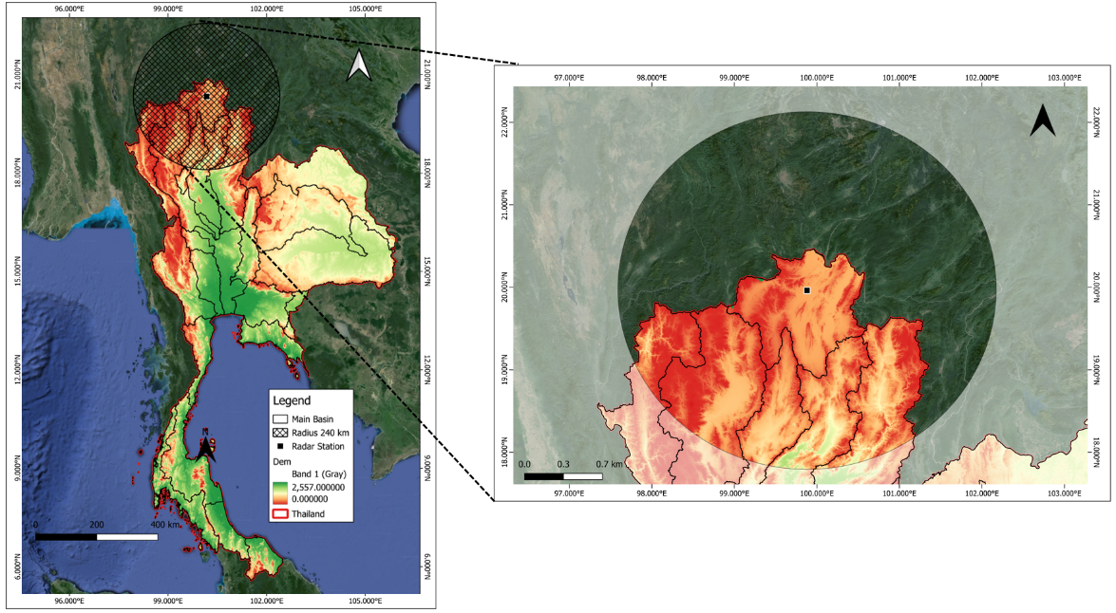

Figure 1 :Study area of the meteorological weather radar station. The black dot indicates the location of the radar station. The blue circle represents a radius of 240 kilometers from the monitoring station, while the black circle delineates the division of the watershed boundary in Thailand. The red line outlines the boundaries of Thailand**.**

The station is equipped with a dual-polarimetric weather radar operating in the C-band frequency range, with a coverage radius of 240 kilometers. The radar conducts scan four times per hour, or every 15 minutes, utilizing four elevation angles. Its observation area covers several northern provinces, including Chiang Rai, Phayao, Nan, Phrae, Lampang, Lamphun, Chiang Mai, Mae Hong Son, Tak, Phitsanulok, Sukhothai, Uttaradit, and Kamphaeng Phet.

**3. Tools and information**

**3.1 Tools Used**

Table 1 Tools and Software Used in Education

|  |  |
| --- | --- |
| **Tools & Software** | **Description** |
| 1. QGIS Geoinformatics Program v.3.36.3 | Geographic Information System Software |
| 2. Miniconda 3 | A popular tool for managing packages and environments in Python. |
| 3. Python language and open code radar library | Libraries used for radar data processing, along with the associated source code, are freely available for use and modification as needed. |

**3.2 Radar data**

The data used for the analysis consisted of meteorological radar data from the Chiang Rai Meteorological Department Radar Station. Observations were conducted four times in succession every 15 minutes, within a radar operating radius of 240 kilometers. The first elevation angle was set at 1.0 degrees. The data collected ranged from 9:00 to 14:00 Universal Time Coordinated (UTC), resulting in a total of 36 files.

**4. Study Methods**

**4.1 Pre-processing step**

Our research methodology has been shown in Figure 2. The first step involves collecting meteorological radar data from the Chiang Rai Weather Radar Station, operated by the Thai Meteorological Department. The radar station conducts four consecutive observations per hour, at 15-minute intervals, with the first elevation angle set at 0.5 degrees. Data is recorded in UTC format, covering the period from 09:00 UTC to 14:00 UTC, which coincides with the formation and progression of rain clouds into Chiang Khong District, Chiang Rai Province.

The second step focuses on processing the radar data using the Python programming language. This phase utilizes the Wradlib open-source radar library (Heistermann et al., 2013) and the Py-ART open-source radar library to eliminate ground clutter and correct for the weakening of radar beam signals over distance. The radar data is then transformed from the polar coordinate system to the Cartesian coordinate system. A Constant Altitude Plan Position Indicator (CAPPI) is generated at a height of 2 kilometers for the first elevation angle (1.00 degrees) at 15-minute intervals from 09:00 UTC to 14:00 UTC, resulting in four sub-files (00, 15, 30, and 45 minutes) in GeoTIFF format, which are prepared for further analysis using geospatial software.

The third step involves performing a physical analysis of hail by importing the CAPPI radar data at an altitude of 2 kilometers (from step 2) in GeoTIFF format. The data is reclassified to compare radar reflectivity values at various levels, using sensitivity tests at thresholds of 20, 25, 30, and 35 dBZ. The resulting raster sensitivity test files are converted into shapefiles, allowing for the identification of rain clouds likely to produce hail, based on their formation and movement characteristics during each time interval.

รูปภาพประกอบด้วย ข้อความ, ภาพหน้าจอ, ตัวอักษร, ไลน์

คำอธิบายที่สร้างโดยอัตโนมัติ

Figure 2 :ResearchConceptual Framework

The fourth step entails calculating statistical values for the clouds using the shapefiles generated in step three, through the Zonal Statistics tool. Key statistical measures include Sum, Mean, Median, Minimum, and Maximum reflectivity values. The area of each cloud is also calculated using the Field Calculator tool, with results converted to square kilometers.

The fifth step involves determining the velocity of the clouds by calculating the centroids of each cloud. The distance between the centroids of consecutive clouds is measured using the "Measure Area" tool, and the velocity is then calculated using the formula V=S/T=*TS*​, where V represents the velocity in meters per second, S is the distance in meters, and T is the time taken in seconds. In this case, the time taken for the clouds to move is 15 minutes, which is equivalent to 900 seconds.

**4.2 Radar Data Correction with Open Code Library**

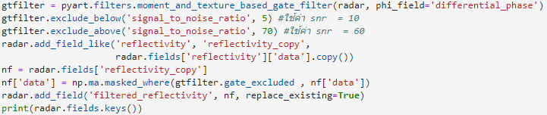 Ground clutter and signal-to-noise ratio (SNR) removal are critical processes in radar data analysis, particularly when examining reflectivity data. Reflectivity can be contaminated by signal clutter and noise, which may introduce bias in the reflectivity measurements. As such, it is essential to filter out contaminated signals (Mahavik, 2022). The Py-ART open-source library is used to remove signals that fall below a specified threshold, ensuring more accurate analysis. Radar filtering is a crucial step in preparing data, particularly when high accuracy is required for estimating rainfall. In this study, the filter is set to eliminate data with SNR values below 5 dBZ and above 70 dBZ.

Figure 3 :Code from Signal and Noise Decontamination (SNR)

Using the Py-ART library, radar data is transformed into a Cartesian coordinate system by creating a data grid. This process involves converting radar data from its original format, such as Plan Position Indicator (PPI), into a 3D Cartesian grid format, enabling more detailed analysis and 3D visualization. As shown in Figure 4 the grid_from_radars function is executed to generate the grid. The grid dimensions are defined as (41, 241, 241), representing 41 vertical layers (z-axis) and 241 grid points along both horizontal axes (x and y). The z-axis spans from 0 to 20,000 meters (20 kilometers), while the x and y axes range from -240,000 to 240,000 meters (or -240 to 240 kilometers), covering a total area of 480 x 480 kilometers.

The CAPPI results are exported for hail detection by generating a GeoTIFF file using the Py-ART library. After exporting the GeoTIFF file, it is essential to verify that the file has been correctly generated at the specified location and that its size is appropriate. This verification can be performed by opening the file in QGIS and confirming that it meets the expected parameters.

**5. Results**

**5.1 Radar Data Adjustment and Export**

Radar data correction is carried out using the Py-ART open-source radar library. As shown in Figure 4a, the radar data before filtering contains a substantial amount of ground clutter.

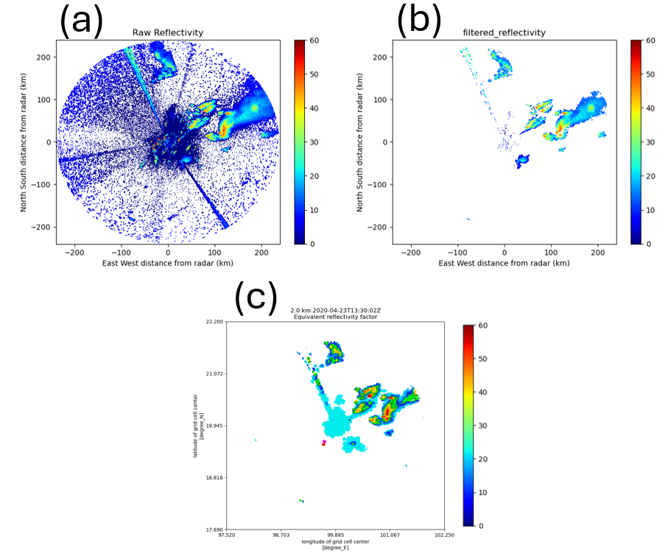

Figure 4 :Adjustment and Export of Radar Data (a) Reflection value before correction, (b) Reflection value after correction, (c) Radar data ready for export

In contrast, Figure 4b displays the data after noise reduction, resulting in more accurate readings. This correction minimizes misinterpretation and improves the overall accuracy of the analysis. Additionally, the process facilitates smoother data export to various formats and systems, as demonstrated in Figure 4c.

* 1. **Development of Radar Analysis Process in GIS System**

An experiment was conducted to adjust the sensitivity test for clouds expected to produce hail and to develop a model in the QGIS program for processing radar data in the calculation of accumulated rainfall. The model described below is designed to handle large datasets efficiently, significantly reducing the processing time for radar data with complex procedures. Prior to model creation, several experiments were necessary to identify key processes that contribute effectively to the development of the model steps. Figure 5 illustrates the model used for analyzing the physical characteristics of hail formation as part of the sensitivity test process. Sensitivity tests were performed at reflectivity levels of 20, 25, 30, and 35 dBZ. Following these tests, the data is converted from Raster to Vector format to facilitate estimation in subsequent steps.

**รูปภาพประกอบด้วย ข้อความ, แผนภาพ, ไลน์, ตัวอักษร

คำอธิบายที่สร้างโดยอัตโนมัติ**

Figure 5 : Experimental model of sensitivity test adjustment at 20, 25, 30 and 35 dBZ levels.

Statistical values were analyzed using the QGIS program through modeling, based on data from the sensitivity test adjustments and vector data obtained from the transformation process. The statistical values analyzed using the Zonal Statistics tool include Mean, Median, Maximum, and Minimum. To determine the area of the cloud where hail is expected, field attributes were added to the table, and the *$area* function was employed to calculate the area. This process is illustrated in Figure 6.

As can be seen in Figure 6, the cloud area is significantly smaller at 16.00 (local time UTC+7) or 4 p.m. than it is at other times. Furthermore, between 5 and 6 p.m., there is minimal change in the cloud area's size across various reflectivity values. But in contrast to previous periods, the cloud area grows dramatically during this time. By 8 p.m., when the thunderstorm that devastated Chiang Khong occurred, the cloud area has grown significantly. Subsequently, the cloud area gets smaller and heads northeast.

The analysis of physical characteristics also includes determining the speed of clouds expected to produce hail. The *Measure Area* tool is used to calculate the distance the cloud moves by generating centroids for each cloud and measuring the distance between consecutive centroids. The speed of cloud movement is then calculated based on these measurements. Calculate the speed of movement.

**รูปภาพประกอบด้วย ข้อความ, ภาพหน้าจอ, จำนวน, ตัวอักษร

คำอธิบายที่สร้างโดยอัตโนมัติ**Figure 6 :Comparison of the area size of each reflection value.

Rain clouds are shown moving at intervals of fifteen minutes in Figure 7. A rain cloud was observed developing over Lam Nam Kok National Park, which is situated in Mueang District west of the radar close to Doi Hang, at 4 p.m. local time. Then the cloud mass headed northeast. The rain cloud moved into Chiang Khong District, Chiang Rai Province, about 7 p.m. (as demonstrated by the orange area), and by 8 p.m., it started to leave Chiang Khong. After that, it left Thailand about 9:00 p.m. local time. The velocity at which thunderstorm clouds that produce hailstorms move is shown in Figure 8. This speed is determined by calculating the distance traveled and the time elapsed. It was found that at 4.00 p.m local time, the cloud at the reflection level of 25 dBz had an average speed of cloud movement of 9 m/s.

**รูปภาพประกอบด้วย ข้อความ, แผนที่

คำอธิบายที่สร้างโดยอัตโนมัติ**

Figure 7:Rain clouds moving through Chiang Khong District: (a) Reflection value at 20 dbz (b) Reflection value at 25 dbz (c) Reflection value at 30 dbz (d) Reflection value at 35 dbz

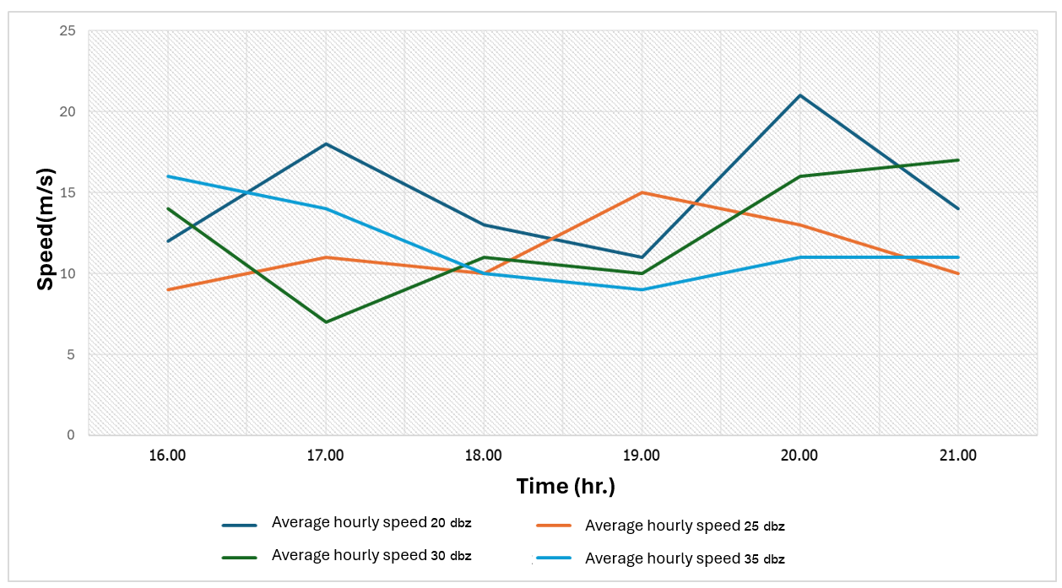

Figure 8.The movement speed of clouds during the period from 4:00 p.m. to 8:00 p.m. local time (16.00-20.00 local time UTC+7).

**6. Discussions**

Radar data contains valuable information, but it is often affected by ground clutter unwanted signals caused by buildings, trees, and other objects that reflect radar waves, leading to misinterpretation. Removing these signals significantly enhances the accuracy of radar data. The analysis of hail-producing thunderstorms in a GIS system revealed the movement patterns of thunderstorm clouds in northern Thailand, which generally travel from northwest to southeast or west to east. Cumulus clouds form in the late afternoon (Mahavik et al., 2023), developing into thunderstorms later in the day as they are carried by wind currents. The speed of cloud movement is also a critical indicator. Rapid cloud movement suggests strong winds, often associated with severe thunderstorms. Fast-moving clouds can also transport cold air from the atmosphere, mixing with warmer air near the surface, which may lead to atmospheric instability and increase the likelihood of lightning or hail. (Alessandro Tiesi et al. ,2023) This study is important for enhancing the understanding of hailstorms in northern Thailand, with potential applications for developing early warning systems to mitigate hailstorm damage. Furthermore, the radar data processing techniques developed in Python and GIS systems can be applied in future studies to effectively analyze the physical characteristics of thunderstorms in various events.

**7. Conclusion and Recommendation**

The application of weather radar data is invaluable for detecting the characteristics of thunderstorm clouds, including storm intensity, rainwater density, and potential hailstorm occurrences. In this research, a hailstorm analysis system was developed in conjunction with a Geographic Information System (GIS). The physical analysis of hail within GIS allows for a detailed understanding of storm characteristics, including direction, origin, severity, and area size. Future research should explore the integration of dual-polarimetric radar data with GIS to analyze multiple hailstorm events in northern Thailand.

**Acknowledgments**

We would like to express our appreciation to the Thai Meteorological Department for their contribution of radar data, which was utilized in the course of this research. The figures in this study were mostly produced using Python scripts, together with the open radar library, namely Py-Art and Wradlib. This work was supported by Naresuan University (Grant No. R2567B072) and National Science, Research and Innovation Fund (NSRF).

**References**

Inyukhin, V. S., Kushchev, S. A., Liev, K. B., & Makitov, V. S. (2016). Radar studies of the distribution of the formation zones of the first radar echo of hail clouds. Izvestiya, Atmospheric and Oceanic Physics, 52(6), 615–621. https://doi.org/10.1134/S0001433816060063

Kumjian, M. R. (2013). Principles and applications of dual-polarization weather radar. Part I: Description of the polarimetric radar variables. Journal of Operational Meteorology, 1(19), 226–242. https://doi.org/10.15191/nwajom.2013.0119

Mahavik, N. (2022). Weather radar in meteorology. Bangkok: Chulalongkorn University Press (*in Thai*).

Mahavik, N. (2024). Research and development project for hail detection using meteorological radar data based on open source geoinformatics systems during the summer in Northern Thailand (Final research report).

Mahavik, N., Tantanee, S., & Masthawee, F. (2023). Dual-polarimetric radar applications for investigating severe thunderstorms in Northern Thailand during the pre-monsoon season. Applied Environmental Research, 45(4), Article 026. https://doi.org/10.35762/AER.2023026

Mirmozafar, M., & Zhang, G. (2018). Dual-polarization antennas with high isolation and polarization purity: A review and comparison of cross-coupling mechanisms. IEEE Antennas and Propagation Magazine, 60(6), 58–67. https://doi.org/10.1109/MAP.2018.2883032

Northern Meteorological Center. (2017). Knowledge of Chiang Rai weather radar and weather forecast results. Retrieved from http://climate.tmd.go.th/content/category/25

Ortega, K. L., Krause, J. M., & Ryzhkov, A. V. (2016). Polarimetric radar characteristics of melting hail. Part III: Validation of the algorithm for hail size discrimination. Journal of Applied Meteorology and Climatology, 55(4), 829–848. https://doi.org/10.1175/JAMC-D-15-0203.1

Prein, A. F., & Holland, G. J. (2019). Global estimates of damaging hail hazard. Weather and Climate Extremes, 24, 100197. https://doi.org/10.1016/j.wace.2018.10.004

Tiesi, A., Mazza, S., Conte, D., Ricchi, A., Baldini, L., Monopolti, M., Picciotti, E., Vulpiani, G., Ferretti, R., & Miglietta, M. M. (2022). Numerical simulation of a giant-hail bearing Mediterranean supercell in the Adriatic Sea. Atmosphere, 13(8), 1219. https://doi.org/10.3390/atmos13081219