Monitoring the Mount Ruang (Indonesia) volcanic eruption of April 2024 using satellite thermal imagery and numerical simulation

Rohit Mangla^{1*}, Kurniawan Tjendra¹, Santo V. Salinas¹
¹Centre for Remote Imaging, Sensing and Processing, National University of Singapore
*manglar@nus.edu.sg (*Corresponding author’s email only)
Abstract
The present study investigates the most intense volcanic eruption (level 4 category) over Mount Ruang in Indonesia using Himawari-9 AHI satellite thermal images and RTTOV radiative transfer model. The RGB images are produced to visually distinguish volcanic ash, SO₂ and water clouds and used a modified split window technique to extract ash pixels. As a first step for ash optical and physical quantification, we simulate the ash affected pixels by generating synthetic AHI radiances using the RTTOV radiative transfer model. An ash profile is constructed as a function of cloud top height, depth of cloud, and ash concentration and given as an input to the RTTOV model. In one selected scenario (top height: 15 km, depth: 0.8 km, concentration: 1 mg/m3), we observed that the simulated top of the atmosphere radiation field matches well with AHI’s radiance observations. These initial results are encouraging, and the next step is to prepare a database of ash affected AHI radiances and use the optimization techniques or optimal retrieval algorithms to quantify critical ash parameters (eg. plume height, ash concentration etc).
Keywords: Volcanic ash, Himawari-9/AHI, RTTOV, Mount Ruang

Introduction
Indonesia has the largest number of active volcanoes (~127, according to some estimates) in the world (Hidayat et al., 2020). Mount Ruang, located in the Sangihe volcanic arc off the coast of Sulawesi Island (Morrice’ et al., 1983), is one of Indonesia’s active volcanoes. On 17th April 2024, an intense volcanic explosion (level 4 category) was reported over Mount Ruang, one of the largest in the last 50 years. The eruption continues till 19th April 2024, and then again eruptions happened between 29th and 30th April 2024 (according to the Volcano Observatory Notice for Aviation (VONA). Volcanic ashes are aerosol particles made of fine and coarse rocks and dust, crystalized minerals surrounded by several gases (such as HCl, SO₂, CO₂, H₂O). Ashes actively spread to the neighboring areas severely affecting the air quality, forcing hundreds of people to evacuate their homes. These ashes are also a major threat to the aviation industry as the ash exposure damages the airframe and engines and causes economic harm owing to the shutdown of airport activities (F. Prata & Rose, 2015). Crucial monitoring is of utmost importance to minimize the risk and economic losses.
Satellite remote sensing has been proven to be a very useful tool for the monitoring and detection of volcanic ashes and SO₂ clouds (Hidehiko et al., 2015; Piontek et al., 2021). National weather agencies rely on geostationary satellite imagery for the volcanic ash detection and retrievals because of high spatial and temporal resolution. For example, German weather service is using Spinning Enhanced Visible and Infrared Imager (SEVIRI) images onboard Meteosat Second Generation (Bugliaro et al., 2022). Similarly, Japan meteorological agency is using Himarwari-8/9 Advanced Himawari Imager (AHI) observations operationally for real-time monitoring of volcanic ashes over larger areas (Ishii et al., 2023a). Satellite based ash detection methods are based on thermal infrared channels of 8-12 $μm$, because of their strong correlation with ash clouds as first observed by Prata, (1989). The Volcanic Ash Advisory Centre (VAAC) is using a reverse absorption method to examine the ash region. This method computes the difference between ash and water/ice absorption signal. The negative difference indicates ash (Bugliaro et al., 2022; Francis et al., 2012).
In past years, several research works have been done towards quantification of ash retrievals (eg. Plume height, cloud effective radius) from satellite imagery (Bugliaro et al., 2022; Ishii et al., 2023b; A. T. Prata et al., 2022). Most of the retrieval methods required a radiative transfer model or a forward operator (eg. RTTOV) that transforms atmospheric model profiles into satellite observed radiances. Such simulations are useful for the quantification of ash parameters. For instance, Piontek et al., (2021) run a large set of radiative transfer calculations for various atmospheric conditions (with and without ash) to create the training dataset for an artificial neural network algorithm for ash retrievals. In another study by Bugliaro et al., (2022) proposed a Volcanic Ash Detection using Geostationary Satellites (VADUGS) algorithm which is based on neural network trained with simulated satellite thermal images. The VADUGS algorithm is operational at German weather service since 2015. Motivated by the above studies, a multi-institutional project is underway at Centre for Remote Imaging, Sensing and Processing, National University Singapore (NUS), in collaboration with Nanyang Technological University (NTU), and Meteorological Service Singapore (MSS) to develop an automated framework to detect and quantify volcanic ash retrievals using satellite imagery, in-situ observations and numerical models over Southeast Asia.
Southeast Asia is known for the heavy cloudiness in the world (Jin et al., 2009). Accurate prediction is a challenge because volcanic ashes are hidden under water and ice clouds. Existing ash retrieval algorithms are not as accurate over Southeast region as are in cloud-free region. Therefore, as a first step, this study attempted to demonstrate the potential of combined satellite thermal imagery and radiative transfer simulations for a reliable quantification of Mount Ruang’s eruption over Indonesia.
Data and Model
Himawari-9 AHI observations
The Himawari-9 satellite was launched by Japan Aerospace Exploration Agency (JAXA) on 2nd November 2016 with an AHI imager situated at ${140.7}^{0} E$. The AHI imager provides full scans of Earth every 10 minutes in 16 spectral channels from visible to infrared (i.e. 0.46-13.3 $μm$). The imager resolution is 1 km for 0.47, 0.51 and 0.61 $μm$, while 0.5 km for 0.64 $μm$, and 2 km for 1.6-13.3 $μm$. Volcanic ash is detectable in thermal IR channels. Therefore, Level 2 products of IR brightness temperatures (hereafter, Tb) of channels 11-16 (see Table 1) are used for this study.
Table 1: Details of Himawari-9 AHI thermal Channels (Bessho et al., 2016)
Channels | Wavelength ($μm$) | Spatial Resolution | Sensitivity
11 | 8.6 | 2 km | Cloud phase, SO₂
12 | 9.6 |  | Ozone content
13 | 10.4 |  | Cloud Imagery, Cloud top temperature
14 | 11.2 |  | Cloud Imagery, Sea surface temperature
15 | 12.4
16 | 13.3 |  | Cloud top height

RTTOV Radiative Transfer Model
This study used the Radiative transfer for TOVS (RTTOV) v13.2 model for the simulations of ash affected Tbs (Saunders et al., 2018). In this research, the inputs of the RTTOV model are taken from ERA-5 reanalysis dataset, which consists of atmospheric and surface parameters available at hourly interval, ${0.25}^{o}$ spatial resolution, and 37 model levels (model top is at 1 hPa) (Hersbach et al., 2020). The inputs of the RTTOV model are profile of temperature, pressure, specific humidity, hydrometeor contents, ozone mixing ratio, cloud fractions, volcanic ash mixing ratio, surface variables (temperature at 2m, dew point temperature, specific humidity at 2m, u-v wind component at 10m, skin temperature, surface pressure), and sensor parameters (Wavelength, grid location, and viewing angle). The volcanic ash mixing ratio profile is computed by the user defined ash eruption parameters including ash top height, ash bottom height and ash concentration (Vidot et al., 2022).
The optical properties (absorption and scattering) of cloud and ash particles (per ${cm }^{-3}$) are pre-computed using Mie theory. For this study, we selected the ‘New Volcanic ash (VAPO)’ aerosol type from the OPAC (Optical properties of aerosols and cloud) database, available within the RTTOV model. The VAPO model assume ash particles as ‘spherical’ and uses a log-normal particle size distribution to calculate the optical properties for a range of particle radius between 0.005 and 20 $μm$. The refractive indices used in VAPO model are from Poelack et al., (1973).
Methodology
Figure 1 describe the methodology adopted for this study. First step is to prepare an RGB composite image using AHI observations for visualization of ash spread near the volcanic site. The RGB composite is a method to extract cloud and associated phenomenon based on the assignment of red, green, and blue to multi spectral images. This RGB colour scheme is described in Akihiro, (2020), specifically for AHI satellite images. As mentioned in Table 2, the red colour is assigned to the brightness temperature difference (BTD) of channel 13 and 14 (${BTD}_{13-14}$). The green colour is assigned to the BTD of channel 11 and 13 (${BTD}_{11-13}$). Lastly, the blue colour is assigned to the channel 13. Second step is to extract the ash affected pixels using split window technique. Traditionally, the split window method computes the BTD between 10.8 $μm$ and 12.0 $μm$ wavelength. For this study, we used the Ishii et al., (2023) recommended modified split window technique which uses ${BTD}_{13-14}<-0.1$ K for volcanic ash detection using AHI images. The next step is to set up a RTTOV radiative transfer model to perform ash simulations. Past studies (e.g. Piontek et al., 2021) consider a range of ash parameters for radiative transfer simulations (e.g. ash top height € [100m, 20 km]), which is also an extension of this study, but not discussed here. In this study, a homogenous profile of ash is assumed (cloud top height: 15 km, bottom height: 13 km, concentration: 1 mg/m3) based on the parameters reported for Mount Ruang eruption by VAAC centres. After that, the simulated ash Tbs are compared with the observed Tb and the differences are analysed. By successfully generating ash images closer to observations, the simulated images could be a valuable source of information for predicting volcanic eruption source parameters.

Table 2 shows the details of RGB composite for volcanic ash using AHI observations
Beam | Channel | Threshold
Red | IR (13) 10.4 – (14) 11.2 $μm$ | -4 to 2 K
Green | IR (11) 8.6 – (13)10.4 $μm$ | -4 to 5 K
Blue | IR (13) 10.4 $μm$ | +243 to +303 K

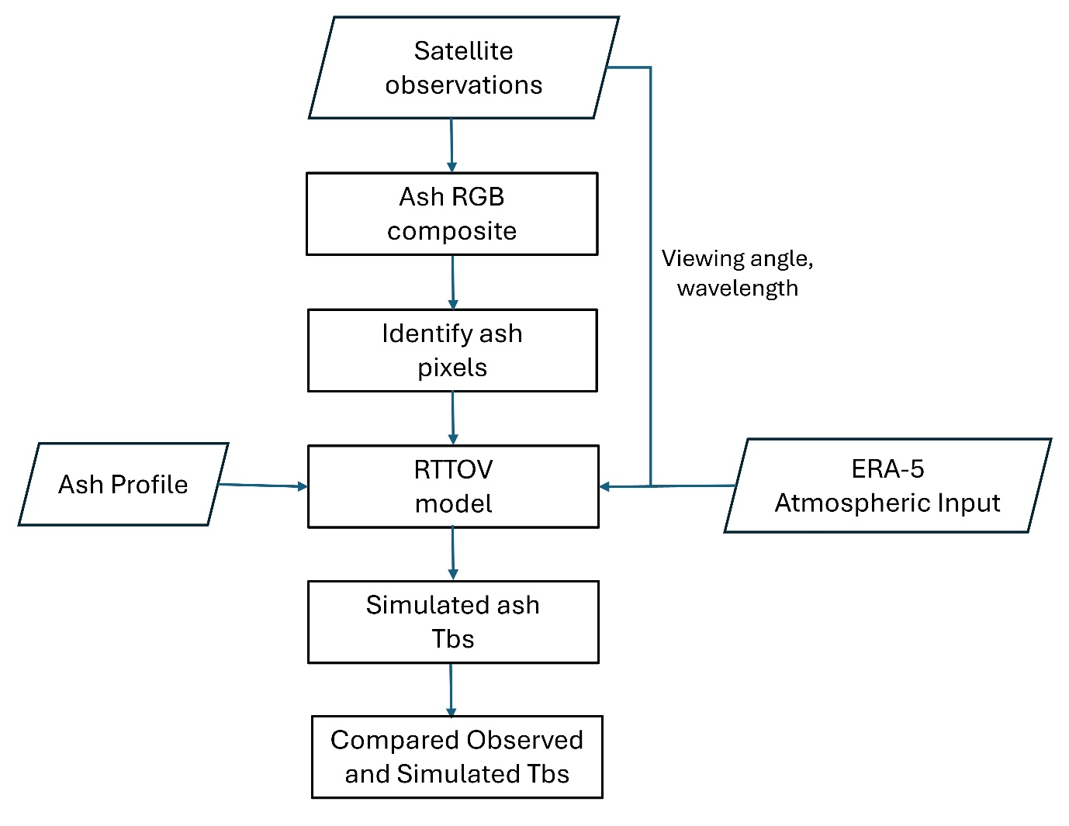
Figure 1: Flow diagram of methodology to describe the synergy of satellite observations and RTTOV radiative transfer model for predicting the ash signal.
Results and Discussions
Ash RGB Composites
Each channel of AHI observations carries physical information of atmospheric and surface properties. An example of AHI RGB image is shown in Figure 2a for the Mount Ruang eruption on 17th April 2024 at 1700 UTC. Following Akihiro, (2020), the volcanic ash is highlighted by the red color and appears as reddish and pinkish (see towards left of Mount Ruang site). The green color represents SO₂ clouds and a big SO₂ gas plumes can be seen next to the volcanic site; however, the color variation depends upon SO₂ concentration. The blue colour is a function of surface and cloud top temperature. A strong blue color represents warm surface that provides high contrast for ash detection. In this case, blue region is warm ocean. The yellowish region is where volcanic ash is accompanied by SO₂ and other gases. A mixture of thick ash and ice clouds are represented by the brownish colour, whereas the black region surrounded near the peak represent the thin ash cloud mix with ice. The mixed colours largely depend on viewing angle, ash concentration, temperature, surface emissivity and water content. This RGB scheme is based on recommendations of World Meteorological Organization (WMO) and vastly used by operational forecasters and researchers globally.
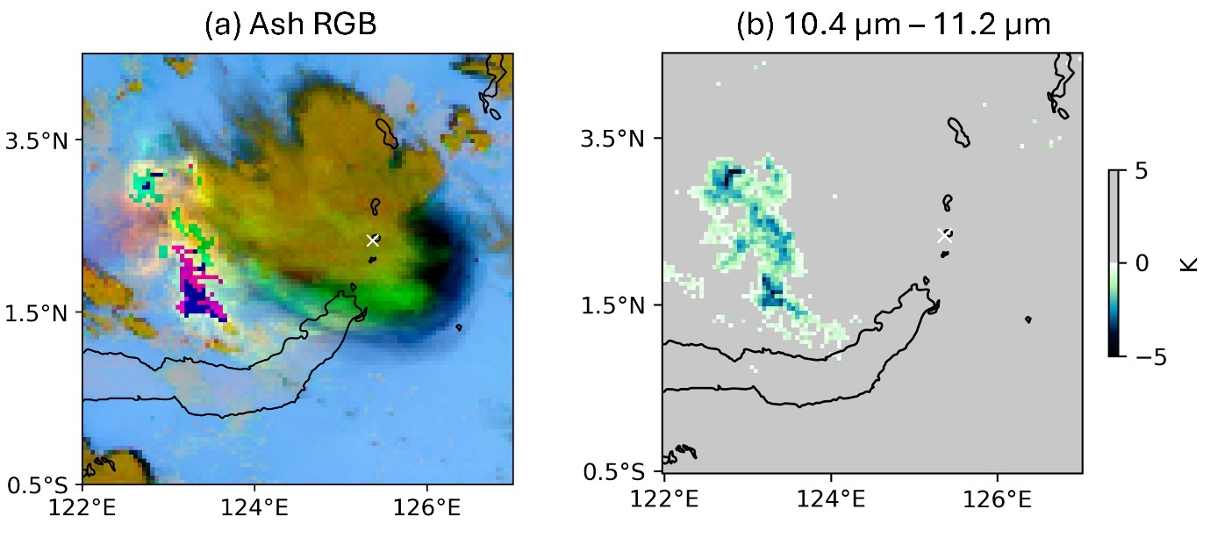
Figure 2 (a) An Ash RGB composites of AHI observations on 17th April 2024, 1700 UTC over the Mount Ruang region (marked by white cross) is shown. (b) showing the AHI brightness temperature differences (${BTD}_{13-14}$) image and the ash pixels are identified using the modified split window technique and highlighted by colors.
Selection of Ash pixels
Figure 2b display the AHI ${BTD}_{13-14}$image for the same Ruang eruption discussed in the Figure 2a. The coloured pixels are highlighted as volcanic ash pixels. In the context of AHI images, the volcanic ash is more absorbing at 10.4 $μm$ (channel 13), and the liquid water/ice absorbs higher at 12.4 $μm$ (channel 15). Therefore, ${BTD}_{13-15}$ of AHI images are used for ash detection in many past studies (eg. Ishii et al., 2018). However, Ishii et al., (2023) observed that ${BTD}_{13-15}$ doesn’t account for thin ash clouds because of relatively larger water absorption at channel 15 than the traditional 12.0 $μm$ (Hidehiko et al., 2015). In addition, channel 14 (11.2 $μm$) is relatively less affected by stronger water vapour absorption (Lindsey et al., 2012) and ${BTD}_{13-14}$ shows a higher potential to detect thin volcanic ash. Hence, Ishii et al., (2023) recommended to use ${BTD}_{13-14}<0.1$ K for volcanic ash detection, and therefore, applied in this study. Note that the larger negative pixel in the ${BTD}_{13-14}$image does not mean higher ash concentration but could be from smaller ash particles. In general, the strength of ash signal in satellite image is dependent on several factors such as the optical and physical properties of ash clouds (cloud optical depth, shape, size distribution and refractive indices), the satellite viewing angle, and the thermal contrast between ash cloud top and surface properties and the presence of water and ice particles. Another limitation of split window method is that the negative signal may occur due to low level inversion and desert dust but identified as volcanic ash (Pavolonis et al., 2006; Prata & Grant, 2001). However, desert dust would not significantly contribute to Mount Ruang (Indonesia) emissions as no desert dust source exist in Southeast Asia. Despite the several challenges, the split window is very reliable and still used in operational volcano prediction centres.
Simulation of ash images using RTTOV model
The volcanic ash clouds are highly transient in nature as dispersion and sedimentation process lead to thinning of ash cloud with time. Therefore, it’s complicated to measure the actual vertical distribution of ash as it rapidly changes with meteorological conditions. For the simplicity, we consider the homogenous ash cloud for the radiative transfer simulation. Figure 3 shows the (a) observed Tb, (b) simulated Tb and the (c) observed minus simulated Tb differences for the ash classified pixels at 10.4 µm. One can notice that simulated ash Tbs are in good agreement with observations. A few pixels in Figure 3c observes large negative differences. One possible reason could be the large cloud cover in observation due to thick meteorological cloud, which was not in the simulation at the same location. The large pixel-to-pixel differences are common and can be observed up to 80 K as in Piontek et al., (2021). Therefore, statistical investigation is required for a robust conclusion. However, the combining satellite imagery with RTTOV radiative transfer computations for ash retrieval is especially encouraging. However, this is a single case study and in order to fully characterize the various ranges of ash physical and optical properties we need to perform retrievals over a larger number of samples and obtain a representative range of variability of these physical and optical parameters.
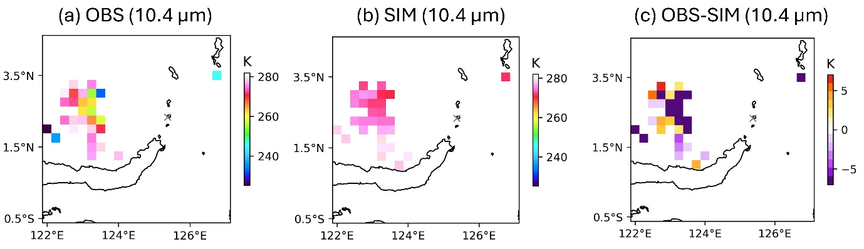Figure 3 (a) Observed and (b) simulated AHI ash affected brightness temperature for the Mount Ruang eruption on 17th April 2024 at 17h UTC. (c) shows the differences between observed and simulation.
Conclusions
This study demonstrates the potential of synergy between Himawari-9 AHI observations and RTTOV radiative transfer simulations for the retrieval of ash parameters of Mount Ruang’s eruption on 17th April 2024. We generated the RGB composite images to distinguish volcanic ash, SO₂ and water/ice clouds. After that, we applied a modified split window technique to classify only ash pixels. Those ash pixels are simulated using RTTOV model for one selected scenario (top height: 15 km, depth: 0.8 km, concentration: 1 mg/m3) and compared with observations. Our work shows that the spatial distribution of observed and simulated ash Tbs fairly agree on the cases we studied. However, statistical investigation is required for a robust conclusion. The initial results are encouraging. Furthermore, the future plan is to prepare a database of radiative transfer simulations for all past volcano events, so that this database can provide more useful insights of eruption source parameters (e.g. Plume height, particle effective radius etc.) and could be potentially used to train machine learning models for the accurate projection of real-time volcanic eruption parameters.
References
Akihiro, S. (2020). Introduction to Himawari-8 RGB composite imagery. In Meteorological Satellite Center Technical Note (Vol. 65).
Bessho, K., Date, K., Hayashi, M., Ikeda, A., Imai, T., Inoue, H., Kumagai, Y., Miyakawa, T., Murata, H., Ohno, T., Okuyama, A., Oyama, R., Sasaki, Y., Shimazu, Y., Shimoji, K., Sumida, Y., Suzuki, M., Taniguchi, H., Tsuchiyama, H., … Yoshida, R. (2016). An introduction to Himawari-8/9 — Japan’s new-generation geostationary meteorological satellites. Journal of the Meteorological Society of Japan, 94(2), 151–183. https://doi.org/10.2151/jmsj.2016-009
Bugliaro, L., Piontek, D., Kox, S., Schmidl, M., Mayer, B., Müller, R., Vázquez-Navarro, M., Peters, D. M., Grainger, R. G., Gasteiger, J., & Kar, J. (2022). VADUGS: a neural network for the remote sensing of volcanic ash with MSG/SEVIRI trained with synthetic thermal satellite observations simulated with a radiative transfer model. Natural Hazards and Earth System Sciences, 22(3), 1029–1054. https://doi.org/10.5194/nhess-22-1029-2022
Francis, P. N., Cooke, M. C., & Saunders, R. W. (2012). Retrieval of physical properties of volcanic ash using Meteosat: A case study from the 2010 Eyjafjallajkull eruption. Journal of Geophysical Research Atmospheres, 117(2). https://doi.org/10.1029/2011JD016788
Hersbach, H., Bell, B., Berrisford, P., Hirahara, S., Horányi, A., Muñoz-Sabater, J., Nicolas, J., Peubey, C., Radu, R., Schepers, D., Simmons, A., Soci, C., Abdalla, S., Abellan, X., Balsamo, G., Bechtold, P., Biavati, G., Bidlot, J., Bonavita, M., … Thépaut, J. N. (2020). The ERA5 global reanalysis. Quarterly Journal of the Royal Meteorological Society, 146(730), 1999–2049. https://doi.org/10.1002/qj.3803
Hidayat, A., Marfai, M. A., & Hadmoko, D. S. (2020). Eruption on Indonesia’s volcanic islands: A review of potential hazards, fatalities, and management. IOP Conference Series: Earth and Environmental Science, 485(1). https://doi.org/10.1088/1755-1315/485/1/012061
Hidehiko, M., Masaya, T., & Yuki, K. (2015). VIS and IR bands of Himawari-8/AHI compatible with those of MTSAT-2/Imager. In Meteorological Satellite Center Technical Note (Vol. 60).
Ishii, K., Hayashi, M., Ishimoto, H., & Shimbori, T. (2023a). Prediction of volcanic ash concentrations in ash clouds from explosive eruptions based on an atmospheric transport model and the Japanese meteorological satellite Himawari-8: a case study for the Kirishima-Shinmoedake eruption on April 4th 2018. Earth, Planets and Space, 75(1). https://doi.org/10.1186/s40623-023-01790-y
Ishii, K., Hayashi, M., Ishimoto, H., & Shimbori, T. (2023b). Prediction of volcanic ash concentrations in ash clouds from explosive eruptions based on an atmospheric transport model and the Japanese meteorological satellite Himawari-8: a case study for the Kirishima-Shinmoedake eruption on April 4th 2018. Earth, Planets and Space, 75(1). https://doi.org/10.1186/s40623-023-01790-y
Ishii, K., Hayashi, Y., & Shimbori, T. (2018). Using Himawari-8, estimation of SO2 cloud altitude at Aso volcano eruption, on October 8, 2016. In Earth, Planets and Space (Vol. 70, Issue 1). Springer Berlin Heidelberg. https://doi.org/10.1186/s40623-018-0793-9
Jin, X., Wu, T., Li, L., & Shi, C. (2009). Cloudiness characteristics over Southeast Asia from satellite FY-2C and their comparison to three other cloud data sets. Journal of Geophysical Research Atmospheres, 114(17). https://doi.org/10.1029/2008JD011422
Lindsey, D., Schmit, T. J., MacKenzie, W. M., Jewitt, C. P., Gunshor, M. M., & Grasso, L. (2012). 10.35 μm: atmospheric window on the GOES-R Advanced Baseline Imager with less moisture attenuation. Journal of Applied Remote Sensing, 6(01), 1. https://doi.org/10.1117/1.jrs.6.063598
Morrice ’, M. G., Jezek ’, P. A., Gill’, J. B., Whitford, D. J., & Monoarfa, M. (1983). AN INTRODUCTION TO THE SANGIHE ARC: VOLCANISM ACCOMPANYING ARC-ARC COLLISION IN THE MOLUCCA SEA, INDONESIA. In Journal of Volcanology and Geothermal Research (Vol. 19).
Pavolonis, M. J., Feltz, W. F., Heidinger, A. K., & Gallina, G. M. (2006). A Daytime Complement to the Reverse Absorption Technique for Improved Automated Detection of Volcanic Ash.
Piontek, D., Bugliaro, L., Schmidl, M., Zhou, D. K., & Voigt, C. (2021). The new volcanic ash satellite retrieval vacos using msg/seviri and artificial neural networks: 1. development. Remote Sensing, 13(16). https://doi.org/10.3390/rs13163112
Pollack, J. B., Toon And, O. B., & Khare J, B. N. (1973). Optical Properties of Some Terrestrial Rocks and Glasses. In ICARUS (Vol. 19).
Prata, A. (1989). Observations of volcanic ash clouds in the 10-12 μm window using AVHRR/2 data. International Journal of Remote Sensing, 10(4–5), 751–761. https://doi.org/10.1080/01431168908903916
Prata, A., & Grant, I. F. (2001). Retrieval of microphysical and morphological properties of volcanic ash plumes from satellite data: Application to Mt Ruapehu, New Zealand. Quarterly Journal of the Royal Meteorological Society, 127(576), 2153–2179. https://doi.org/10.1002/qj.49712757615
Prata, A. T., Grainger, R. G., Taylor, I. A., Povey, A. C., Proud, S. R., & Poulsen, C. A. (2022). Uncertainty-bounded estimates of ash cloud properties using the ORAC algorithm: Application to the 2019 Raikoke eruption. Atmospheric Measurement Techniques, 15(20), 5985–6010. https://doi.org/10.5194/amt-15-5985-2022
Prata, F., & Rose, B. (2015). Volcanic Ash Hazards to Aviation. In The Encyclopedia of Volcanoes (pp. 911–934). Elsevier. https://doi.org/10.1016/B978-0-12-385938-9.00052-3
Saunders, R., Hocking, J., Turner, E., Rayer, P., Rundle, D., Brunel, P., Vidot, J., Roquet, P., Matricardi, M., Geer, A., Bormann, N., & Lupu, C. (2018). An update on the RTTOV fast radiative transfer model (currently at version 12). Geoscientific Model Development, 11(7), 2717–2737. https://doi.org/10.5194/gmd-11-2717-2018
Vidot, J., France, M., & Hocking, J. (2022). Note on RTTOV unit conversions for gases, clouds and aerosols.

