Object-based multi-scale recognition approach for residential landscape classification

Zhang Lei* ·Wu Bingfang ·Liu Yu · Li Xiaosong· Yuan Quanzhi

Key Laboratory of Digital Earth Science, Institute of Remote Sensing and Digital Earth, Chinese Academy of Sciences, P. O. Box 9718, Beijing 100101, China. *Corrispodent author, Tel.: +86 10 64842376, E-mail: [zhang@irsa.ac.cn](mailto:zhang@irsa.ac.cn)

**Abstract:** In using object-based classifier for land cover classification, analysts typically encounter serious issues of producing segmented objects to fit the boundary of real land cover types, they usually occupy different scale levels. This study concentrates on the multi-scale segmentation to reduce errors for object identification. The result reveals that geographic object-based image analysis (GEOBIA) for residential dwellings identification outperforms pixel-based approach, and multi-scale GEOBIA improves recognition accuracy than single-scale GEOBIA. The multi-scale approach produced a significantly higher overall accuracy of 91%, whereas single-scale GEOBIA produced 84% and pixel-based classifier produced 73%. The traditional per-pixel approach is not very efficient in identifying residential dwellings; the dark roofs of residential dwellings have extremely spectral similarity with ploughed but bare cropland, mining mound and brick sites. The segmentation experiment demonstrated that the ratio of shape to spectrum 0.3:0.7 is optimal parameter setting, the weighted adjustment of smoothness and compactness presented no an obvious difference in effect, weight of compactness 0.6 and smoothness 0.4 indicated acceptable selection that regularly shaped segments better match the general form of houses. The shape features including object size, ratio of length to width, and compactness effectively improved spectral identification. The confused types of residential dwellings, industrial zone, and fallow field have best boundary fit at scale level of 20, 30, and 100, respectively. The industrial zone classified at scale level 30 and fallow field identified at scale level of 100 successfully removed the misclassified candidate residential dwellings at scale level of 20. Multi-scale GEOBIA approach has less spectral and shape mixed effects than approach employing single-scale GEOBIA and pixel-based classifier.

**Keywords:** Object-based; ·Residential dwellings; ·Rule-based classification; ·Multi-scale

**1. Introduction**

With the projected global increase of urbanization, pressure on land availability for urban use will increase. These land cover conversions usually compete with agricultural activities. In areas where urbanization is not controlled, the concentration of human presence in residential and industrial settings may lead to an alteration of ecosystems patterns and processes (Anne, 2008). Urbanization and the impact of human settlements are two of the main causes of global environmental degradation. Urban sprawl is cited as a factor in air pollution, since the car-dependent lifestyle imposed by sprawl leads to increases in fossil fuel consumption and emissions of greenhouse gases (Wilson et al. 2003). The high dynamism of urban areas produces a continuous alteration of land-cover and use, and consequently, cartographic information is quickly outdated. Therefore, the availability of accurate estimation of up-to-date cartographic and geographic information in a timely and accurate manner is imperative for adequate management and planning of urban areas and for monitoring global environmental change (Ban, 2010; Weifeng, 2011; Hermosilla, 2012).

Extraction of impervious surfaces is still a challenge because of the heterogeneity of urban landscapes. From a spectral point of view, buildings are seen as roof surfaces of different materials such as brick, copper, aluminum, zinc, slate, bitumen, stone, etc. with a certain slope. Such a complex mix of roof construction and materials leads to difficulties for automatic spectral building extraction (Lemp and Weidner, 2005). Recognition of impervious surfaces has also been performed by the combination of high-albedo and low-albedo fraction images (Wu, 2004). Because a low-albedo fraction image is associated to the kinds of features, including water, canopy shadows, building shadows, moisture in grass or crops, and dark impervious surface materials, it is critical to remove other types of covers from the low-albedo fraction image before it is used for the extraction of impervious surfaces (Lu and Weng, 2006). For large area recognition, it is difficult to discriminate between houses with orange tile roof and orange bare soil from tennis court or between water and shadow (Bert et al., 2004). However, by using semantic object approach taking into account the spatial attributes such as area, shape, pattern and other elements of scientific visualization, the impervious surface may be separated from other types and categorized into residential, industrial or commercial building (Sunil et al., 2010).

The spectral heterogeneity severely limits the application of traditional pixel-based approach in which the so called salt-and-pepper effect and the limitation to spectral information are handicaps for the recognition of semantic classes (Yu et al., 2006). The same classes have different spectral properties and different classes show similar spectral reflectance. Consequently, the increase of intra-class variance and decrease of inter-class variance lead to the inadequacy of traditional pixel-based classification approaches (Huang and Zhang, 2012). The pixel-based and GEOBIA classifications each have their own strengths and weaknesses. The pixel-based classification provides maximum spatial detail but is susceptible to class confusion due to spectral mixing (Baatz et al., 2004). Some ground targets, such as urban areas and golf courses, contain complicated elements that show obvious differences in character on very high resolution imagery (Chungan et al., 2012).

The basic idea of GEOBIA is to group the spatially adjacent pixels into spectrally homogeneous objects and then perform classification on objects as the minimum processing unit. It extracts textural, structural or contextual features or topological information from images in addition to spectral features. GEOBIA has the advantages over pixel-based analysis, where context is limited to the local interaction of individual pixels within a window of a specific size (Ardila et al., 2012 ) and address objects characteristics through sub-objects allowing the explicitly treat of various ‘within-patch heterogeneity’ (Blaschke, 2010). GEOBIA classification is considered to be more accurate than the pixel-based approach which is especially appropriate for categorizing land-use and land cover from high spatial resolution imagery (Cleve et al., 2008).

The segmentation technique for object creation has the advantage of being able to produce segments of various sizes within one step as it is based on equal within-object homogeneity rather than size. The elements from the two main groups of segmentation algorithms (boundary-based and region-based) applied on very high spatial resolution images for different landscapes. Comparatively, region-growing algorithm gives the best results (Wang et al., 2010). It groups pixels or sub-regions into larger regions based on two categories of heterogeneity parameters, the spectral and shape properties of objects. Weighting between both the two categories of these parameters enables an adjusting of segmentation results to the considered application. Then the maximum allowed overall heterogeneity of the segments is fixed with the ‘scale’ parameter (Carleer et al., 2005). The shape factor is composed of smoothness and compactness. It is important to notice that the two shape criteria are not antagonistic. This means that an object optimized for compactness might have very well smooth borders.

Increasing spatial resolution does not necessary increase classification quality as it introduces more details and so increase noise and spectral fidelity. Based on this assumption, it is important to use the optimal spatial resolution as it has a particular bearing on the result quality (Anne et al., 2008). GEOBIA is inextricably linked to multi-scale analysis concepts (Hay and Castilla, 2008), even if single levels are targeted for specific applications (Weinke et al., 2008). The land cover characteristics are sensitive to and depended on the scales of image or segmented image, of which the selection is very important and is a hot research topic in GEOBIA. The appropriate scale of observation is a function of the type of environment and the type of information that is being sought (Hay et al., 2001). However, there is no standardized or widely accepted guideline to optimize the homogeneity setting (scale parameter) of the segmentation (Kim et al., 2011). There is not a unique scale for the analysis of geographic elements in remote sensing (Ardila et al., 2012). In many cases significant objects appear at different scales of analysis of the same image (Arbiol et al., 2006).

Knowledge rule-based systems are becoming more and more important in various domains despite the fact that they are still complex to produce (Gomez &Segami, 2007). It is a hierarchical, rule-based classifier following a coarse-to-fine strategy. In work on coarse-to-fine classification, attributes are employed to recursively partition the set of hypotheses into ever finer and more homogeneous subsets (Gangaputra and Geman, 2006). Indeed, acquiring and representing the knowledge of a domain is often a tedious process and the multiple steps involved in the creation of the knowledge-base can be very different according to the studied domain. This heterogeneity led to an abundance of propositions and the expert is often lost when the time comes to choose a solution. However, the advantages of representing and storing domain knowledge are undeniable. Indeed, it is then possible to produce intelligent systems based on the use of the acquired knowledge and to better explain and understand the domain under-consideration (Forestier, et al., 2012).

This paper study: (1) to describes the parameters derived from the image object to characterize residential dwellings, and develop a multiple scale dataset with contextual and spectral GEOBIA methods using very high resolution (VHR) imagery; (2) to establish rule-based systems of the classification and to present results; (3) to compare this approach with single-scale GEOBIA and pixel-based classifier, as well as to assess the accuracy and suitability of this approach for residential identification.

**2. The study area and Data processing**

2.1. The study area

This study site is located in a suburban area (northwest corner: 33°03′17″N, 107°14′00″W; southeast corner: 33°02′28″N, 107°15′13″W) in Hanzhong, China. Land cover is dominated by cropland and forest with low to medium density residential development, and industrial zone in small proportions. Impervious surface are typical land cover in suburban environment, which includes detached and cluster houses, concrete or asphalt highway, expressway and country roads. Vegetation cover, such as needle leaf forest, broad leaf forest and grass, mosaics with impervious surface. During growth season, cropland is mixed with growth crop and fallow field. The variety of land use/land cover in the study site makes it an ideal area for this study.

2.2. Data source and pre-processing

Two cloud-free ortho-rectified Worldview-2 VHR images of panchromatic and multispectral mode were acquired for the present study (Table 1). It is the availability of two spatial resolutions (multiple mode 1.8m, pan mode 0.45m), that may allow to identify simultaneously residential object of local scale (single farms or houses) and at regional scale (urban area context including all the urban land cover objects), the image was acquired in the seeding season when the spectral feature of cropland was mixed with gray roofs of residential dwellings. This option was to attempt the shape identification rather than spectral features alone. Image pre-processing was primarily performed in Erdas9.0 (ERDAS Inc., Georgia, USA). The procedures include image geo-registration, radiation calibration, atmospheric correction and terrain caused spectral correction (Degui and Alan, 1998). Geo-registration was delivered on DEM-based ortho-rectification with a processing model of IKONOS using a nearest neighborhood re-sampling method with 1 m by 1 m grid DEM. Atmospheric correction is conducted using the Atcor3.0 module applying the Motran4.0 approach. Terrain correction is performed in Atcor3.0 to reduce the topographic distortion on the spectral reflectance.

Table 1 Characteristics of Worldview images used for GEOBIA identification of rural settlement

|  |  |
| --- | --- |
| Parameters | Features |
| Acquisition time (UTC) | 3:50 am (local time: 11:35 am), 29-April-2010 |
| Off-nadir angle (◦) | 0.2 |
| Sun elevation (◦) | 67.2 |
| Sun azimuth (◦) | 140.6 |
| Resolution (m) | 0.45 (Multispectral mode); 1.8 (pan mode) |
| Bands | Blue (0.4–0.5); green (0.5–0.6); red (0.6–0.7); NIR (0.7–0.9) |
| Test site area (ha) | 40000 |

**3. GEOBIA approach for residential recognition**

3.1. Multiple-scale segmentation of VHR images

The segmentation routine is based on a fractal net evolution algorithm. It was operated in package of Definiens Professional 8.7 (Trimble Germany GmbH, Munich, Germany) using a region growing approach (Yu et al. 2006). The purpose of segmentation fit object boundary on the target types that not only the house roof, but also other spectrally similar targets, such as fallow fields, bare area, industrial zones and transportation lines. Segmentation is controlled by scale threshold (extents of spectral heterogeneity and geometric similarity), weights for spectrum and shape, weights for compactness and smoothness characteristics of objects, and weights for auxiliary data such as DEM. The spectral heterogeneity refers to standard deviation of the reflectance of an imagery band within an object boundary. It indirectly controls the size of objects by specifying the maximum heterogeneity of objects. The greater the scale threshold, the larger the average size of the objects. The smoothness of the segment boundary is defined as the ratio of the number of boundary pixels of a object to the square root of its area, and the compactness is the ratio of segment boundary length to the perimeter of the minimum bounding rectangle that encompasses the object.

The scale of segmentation was adjusted in an interactive, trial-and-error fashion for optimal fit of relevant class recognition. The work started with segmentation using Worldview-2 image. All bands (4 multiple and 1 pan) are equally weighted at a basic scale of 10. Each object is a part of land cover type. Generally, the optimal fit of segmentation was in a vague range, not a unique value, so the scale interval was defined as 5. So, the scale threshold series was defined as 10, 15, 20, 25, 30, 100 and 200. The weight of shape was set as 0.1, 0.2, 0.3, 0.4, 0.5 (shape normally providing less information than spectrum, range: 0-1, the sum of the two weights equals 1). The compactness weight was set as 0.3, 0.4, 0.5, 0.6, and 0.7 (both compactness and smoothness are description of shape, weight is better around 0.5, range: 0-1). In correspondence to the interaction of three factors, the other two factors kept constant values when analyzing effect of changes of a factor on segmentation.

3.2. Definition of image object features

Though it is a time consuming work for selection of classification criteria and thresholds, the knowledge-based or rule-based approach has many advantages for classification. The prior knowledge is required to construct hierarchical rules before executing classification. The features with physical meaning and derived from image bands are auxiliary to identify the classes. Nine features covering spectrum, geometric shapes and texture are chosen (Table 2). NDVI was applied for distinguishing vegetation from impervious surface; NDWI was employed for water detection; and impervious surface brightness (IB) and impervious surface index (II) were used for impervious extraction. For residential dwellings identification, object geometric features including L/W ratio, object size and compactness were used. StdDev and Gray-level difference vector entropy (GLDV_entroy) took the recognition of object internal features.

Table 2 Spectral and geometric features for residential object identification.

|  |  |  |
| --- | --- | --- |
| ID | Formula | Description |
| 1 |  | Normalized Difference Vegetation Index, it is sensitive to vegetation |
| 2 |  | Normalized Difference Water Index, it is an indicator to water |
| 3 |  | Impervious surface brightness, characterizes the settlement in high reflectance |
| 4 |  | Impervious surface index, characterizes the settlement in high reflectance |
| 5 |  | Ratio of length to width of out object rectangle |
| 6 | S | Size of object (area) |
| 7 |  | Total number of pixels contained in object area, a kind of roundness |
| 8 |  | Standard deviation calculated from the layer values of all n pixels forming an image object, represents texture of inner object |
| 9 |  | Gray-level difference vector for all direction entropy, a kind of object inner pattern |

3.3. Recognition and quantification of residential surface

The rule-based classifier was employed to classify residential dwellings. A class hierarchy and its associated knowledge base of classification rules are developed by adapting the knowledge base created by Zhou & Troy (2008). It is depended on prior knowledge or sample feature analysis on in-situ data. We proposed the following two basic principles of hierarchical rules setting: 1) Obvious discrimination features or maximum inter-class variance factors were set in upper hierarchical rules to reduce error transfer downward; 2) Maximum classes were removed each separation to shorten the nodes of hierarchical rules. The multiple scale approach was organized for fitting different land cover boundary and type recognition. The basic hierarchical rule was set at segmentation scale level of 20 for candidate residential dwellings identification. The segmentation scale level of 30 and 100 were generated for identification of spectral confused industrial area and fallow field, then to overlay multi-scale layers to refine residential dwellings (Figure 1).

We first separated non-vegetation from vegetation objects using NDVI, with the threshold less than value of 0.047 determined by the histogram thresholding method. The non-vegetation objects were then subdivided into non-water surface and water using NDWI, those objects with NDWI values of more than -0.4 were classified as bare surface. In this case, some shallow water were mixed with dark bare object and shady objects, threshold set as wide range as possible so as to include entire bare surface. The bare surface was further separated into dark object and bright object. The criteria of IB and II are set as values more than187 and less than 0.16 to remove the bright objects respectively. Dark object normally represented residential dwellings because of the tile composition on roof in this rural area, and some fallow field with ploughed bare or moist cropland. The cement and metal roof of industrial area and road surface, and other dry bare surface took high reflectance. The further improvement were using shape index of size value more than 1125 and Length/width value more than 4.2 to remove large object and long object that could be commercial site, roads or even some narrow rivers. The followed step was to detect the complex industrial zones. GLDV_Entropy more than 4 was to extract the objects with high inner spectral variance, such as brick site, open mineral mound. Nevertheless, there still were many complex industrial zones and fallow fields mixed with residential dwellings at scale level 20. The next step employed multi-scale approach, the optimal segmentation of scale level 100 was set to divide fallow field using StdDev of Band 1 of a value less than 3.9. The fallow field was then masked on the candidate residential objects classified at scale level 20, otherwise some fallow field are designated to residential surface at scale 20, because of inadequate scale effect. The same approach was applied to the industrial zone and brick site that were segmented at the best fit of scale level at 30. Compactness value more than 2.72 was selected to discriminate linear or curve pattern while there were many patches of them appeared at scale level of 20.



Figure 1. Flow chart of multi-scale identification of residential dwellings based on objects.

**4. Results and discussions**

4.1. Segmentation effect analysis

The result of experiment showed the optimal scale level 20 for the residential dwellings detection was better than other scales (Figure 2(a), 2(b), 2(c)). The roof objects were identified, without other types included in. The ratios of shape to spectrum weights were set to 0.3:0.7, other ratio demonstrated as less segmented or over segmented (Figure 2(d), 2(e), 2(f)). The adjustment of smoothness to compactness presented no an obvious difference (Figure 2(g), 2(h), 2(i)). Weight of compactness 0.6 revealed acceptable option that regularly shaped segments better match the general form of houses (e.g. rectangular-shaped components). So as to segmentation for fallow field, the best fit was obtained when scale level is set at 100, shape weight set as 0.5,and compactness weight as 0.5. For industrial zone, the optimal fit acquired when scale level is set at 30, shape weight as 0.5 and weight of compactness as 0.5.

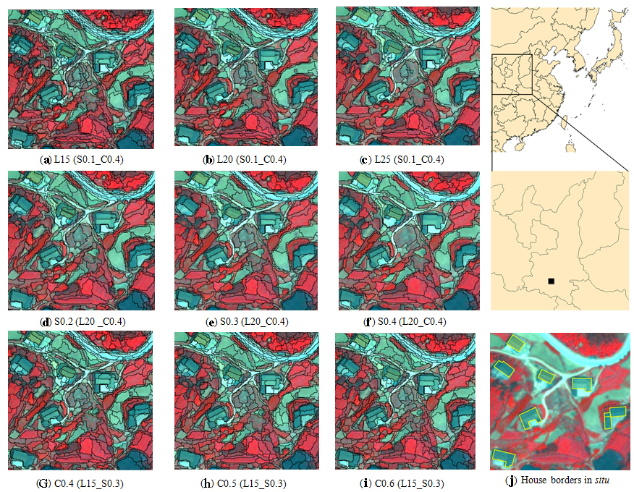Figure 2 Effects of scale, smoothness and compactness factors on segmentation. L: scale level; S: shape weight; C: compactness weight; (a), (b) and (c) reveal the scale change while shape and compact keep no change; (d),(e),(f) display the shape change while scale and compactness keep no change; (g), (h), (i) show the compactness change while shape and scale keep no change; (j) represents truth data of the roofs.

4.2. Results and error analysis on residential identification

Figure 3 reveals the results of residential dwelling identification. An accuracy assessment was performed on the samples generated randomly from the Worldview-2 imagery by visual interpretation. A grid of 30×30 m was superimposed the imagery, resulting in entire 2000 point sampling locations,. These samples were overlain with the classified land cover map to extract 168 samples of relevant residential dwellings. As the ground targets were easily distinguishable on the imagery by vision, visual interpretation was used to check over the sampling points. The type of land use/cover at each sampling point is determined within the domain of 1 pixel. Only pure/typical pixels were employed to build error confusion matrices to calculate the classification accuracy.

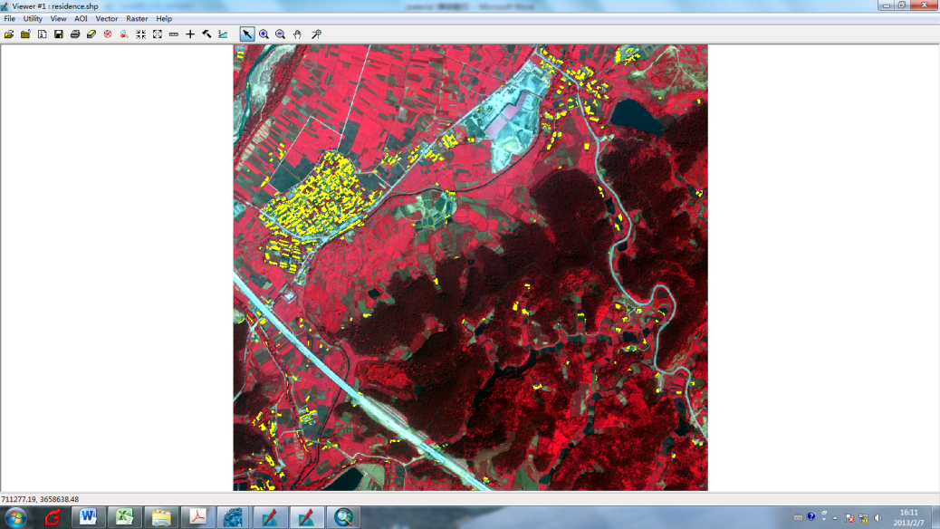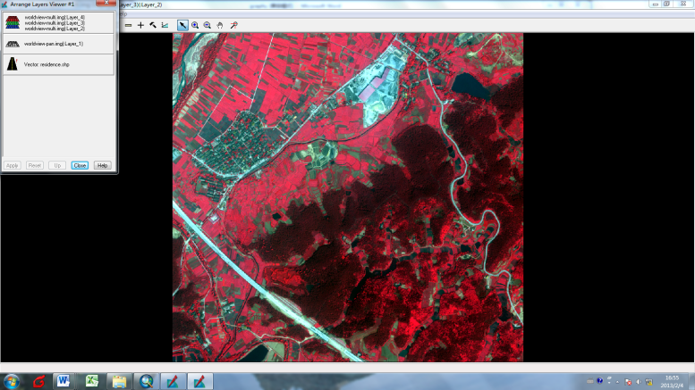

(a) RawWorldview-2 image. (b) Result of the identification (yellow).

Figure 3 Results of residential dwellings for the Hanzhong area using knowledge-bases

The result statistics illustrates that the overall accuracy of residential dwelling classification is 91.4%. The producer’s and user’s accuracy values reach 94.5% and 96.4%, respectively (Table 3). The implemented GEOBIA approach identifies most of the residential dwellings throughout the study area. It includes the cluster villages and scatter rural houses. The impervious surfaces of industry and roads are completely separated. Some errors occurred in the categorization of fallow field in small patch , as a result of limitation associated with the spectral and shape similarity, where these cropland objects are ploughed or located on low elevation with reflectance of moist soil that is typically similar to the tile roof. Another error appears in the village or town in the case of conjunction of residential dwellings. Classifier fails to detect them with the shape features, especially when houses in cross intersection. Some houses with straw roof show the yellow color that is typically mixed with bare soil, and was misclassified to bright impervious surface.

Table 3 Accuracy assessment of multiple object residential classification based on 168 samples

|  |  |  |  |  |  |  |  |
| --- | --- | --- | --- | --- | --- | --- | --- |
| user class\ sample | Water | Bright impervious | Fallow field | Vegetation | Others | Residence | Sum |
| Water |  |  |  |  |  | 2 | 2 |
| Bright impervious |  |  |  |  |  | 1 | 1 |
| Fallow field |  |  |  |  |  | 0 | 0 |
| Vegetation |  |  |  |  |  | 0 | 0 |
| Others |  |  |  |  |  | 6 | 6 |
| Residence | 2 | 1 | 3 | 0 | 0 | 159 | 165 |
| Sum | 2 | 1 | 3 | 0 | 0 | 168 | 174 |
| Producer accuracy | 0.945 |  |  |  |  |  |  |
| User accuracy | 0.964 |  |  |  |  |  |  |
| Overall accuracy | 0.914 |  |  |  |  |  |  |

4.3. Comparison of object-based versus pixel-based approach

We compared multi-scale GEOBIA approach with single-scale GEOBIA and pixel-based approaches, analyzed the identification effects on residential surface. The single-scale GEOBIA recognition was performed on image objects at segmentation scale of 20. The knowledge rule is as the same as identification at above multi-scale, but without use of the last two steps of compactness and STD_b1 factors. The pixel-base classification was directly classified on image by rule-based classifier of the same hierarchical structure, the threshold changed slightly.

GEOBIA for residential dwelling identification outperforms pixel-based classifier, and multi-scale GEOBIA improves recognition accuracy of single-scale GEOBIA. Three approaches all figure out the single houses from block settlement of village or town, where yards and bare area surround residential surfaces. They classify the same total area of residential dwellings, the difference is that pixel-based approach omits a part of residential dwellings and includes other classes. Multi-scale GEOBIA generates the highest accuracy among three approaches (Table 4). In the case of pixel-based approach, the dark roof tiles of rural residential surface has spectral similarity with ploughed bare cropland, mining mound, brick site, in spite of their slight texture difference. Especially, most of the dark parts of brick site are identified as the residential surface. This shortage heavily reduces accuracy of identification (Figure 4 (k)). It is a reason that brick site has the same element material as the tile roof. Therefore, the result of pixel-based classification shows a mixture of targets (Figure 4 (c), Figure 4 (g) and (k)). The pixel-based approach produces “pepper and salt” effect. It extracts more patches than GEOBIA (Table 4). Moreover, it lacks of capability in detecting objects with shape feature that human usually recognizes. However, the GEOBIA approach overcomes this weakness. The segmentation is a procedure of merging spectral homogeneous pixels to generate the semantic shape. The identification bases on the features of entire or part of target domain, rather than of each element. Geometric features can be applied to improve unreasonable spectral classification, such as identification of brick site (Figure 4 (j) and Figure 4 (k)). However, the GEOBIA also leads to reduction of inter-classes spectral variety due to average effects of inner object feature. This negative effect miss some residential dwellings compared to pixel-based approach (Figure 4 (b) and Figure 4 (c)). The multi-scale GEOBIA approach improves the single-scale GEOBIA. Using this approach, each land cover type occupies certain segmentation scale level in terms of shape features and boundary match. The segmentation scale level of 20 is appropriate fit of residential object, but not an acceptable scale for the identification of fallow field or brick site that are divided to many patches (Figure 4 (b), Figure 4 (j)). Some small patches of fallow field have similar rectangular shape and spectral feature with residential dwellings at scale level of 20 that lead to generation of single-scale error. Using the multi-scale approach, most of the fallow field are effectively distinguished and removed from the candidate residential dwellings classified in single scale. Complicated shape features of industrial zones and brick sites are merged by object upscaling, and extracted using compactness criteria. These non-residential dwelling imperious surfaces are then employed as a mask to refine the candidate residential dwellings at scale level of 20.

Table 4 Accuracy derived by pixel-based, single-scale and multi-scale GEOBIA approaches

|  |  |  |  |
| --- | --- | --- | --- |
| Features | Pixel-based | Single-scale GEOBIA | Multi-scale GEOBIA |
| *Area* (m2) | 106570 | 129405 | 94297 |
| *Patch number* | 25438 | 1356 | 1016 |
| *Overall accuracy* | 73% | 84% | 91% |

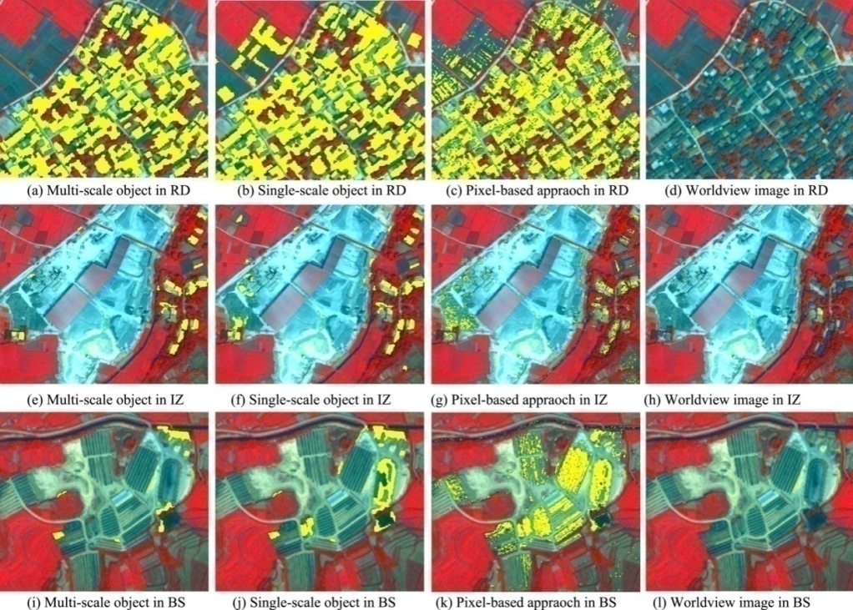

Figure 4. Comparison of approaches applied in residential identification of multiple scale object, single scale object and pixel-based approach. RD: residential dwellings, IZ: industrial zone; BS: brick site. (a), (e), and (i) are performed on the combination with segmentation scale at 20, 30, 100, respectively; (b), (f), (j) are recognized on segmentation scale level 20; (c), (g), (k) are identified on pixel approach and rule-based algorithm; (d),(h), (l) are original images.

4.4. Multi-scale identification

The segmentation scaling is based on homogeneous spectral merging. It is different from pixel-based scaling of spatial merging. The segmentation scaling lead to two effects: object geometric modification and spectral change. Upscaling usually increases the size of object but not always. Figure 5 shows the scaling procedure, objects do not change original shape and size until a threshold is met. The fallow field has similar shape feature with residential dwellings at scale of 20. Fallow field keep rectangular shape through scaling. However, the shape feature of residential dwellings changes at scale of 100 because other irregular yards join the objects. In this case, the shape indices are capable to separate these two classes, though they are not robust features for universal use. Mean feature of object are stable for both fallow field and residential dwellings through scaling, but StdDev of them increases while upscaling. StdDev of residential dwellings increases more than fallow field (Figure 5). The segmentation scale level of 100 generates a StdDev of 3.5 between fallow field and the residential dwellings for identification because of their merging of many bare yard and vegetation. But fallow field objects still keep pure inner composition at scale level 100 (Figure 5 (d), Figure 6). The dominant slanting roof of house in this study area separates the two-side effect with varied spectral features. It is difficult to merge two-side roofs of single house without merging neighbor houses or other types (Figure 5 (a), 5 (b), 5 (c)). The segmentation scale level of 20, 25, and 30 are possible options for residential dwellings discrimination. However, the scale level 20 has more consistent features of shape and spectrum on half side roof.

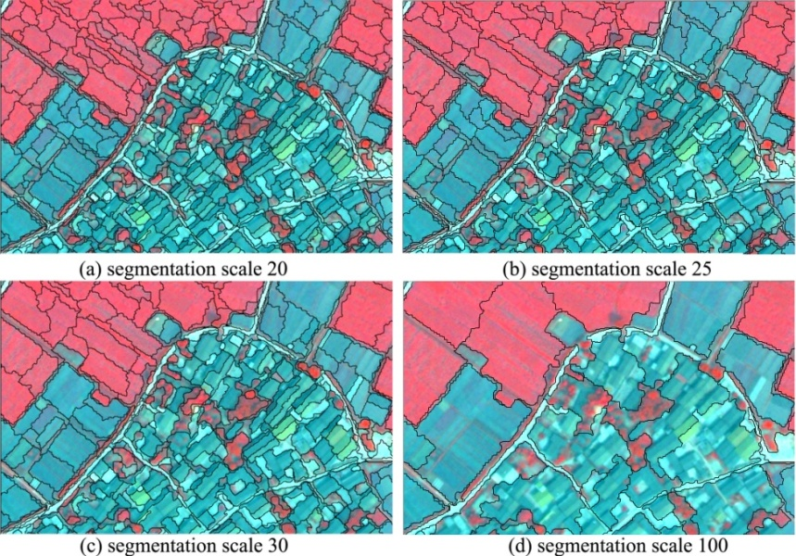The acceptable segmentation efficiency for land cover type identification is depended on the selection of parameters. These parameters include scaling threshold, weight for spectrum and shape, weight for smoothness and compactness, weight for each multispectral band. It is assessed by trial-and-error method or empirical approach that is time consumption for consideration of a variety of parameter combinations. There is no effective and automatic definition of these parameters. Moreover, single scale level may not be suitable for identifying all classes in an image. Multi-scale identification solves the problem but makes the classification procedure complicated with rule-based classifier.

Figure 5. Scaling effect for residential dwellings and fallow field on object boundary. (a) is suitable scale for residential dwellings of two-side roof; (b) and (c) are also suitable but not acceptable scale with a variety of shape characters; (d) is optimal scale for fallow field detection while residential dwellings mixed with other types.

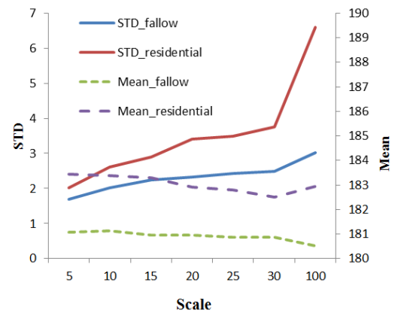

Figure 6.Scaling effect of residential dwellings and fallow field on object features

**5. Conclusions and outlook**

This study reveals that GEOBIA for residential dwellings identification outperforms pixel-based approach, and multi-scale GEOBIA approach improves recognition accuracy of single-scale GEOBIA. The multi-scale GEOBIA classifier produces a significantly higher overall accuracy of 91% for residential dwelling identification, whereas single-scale GEOBIA classifier produced 84% and pixel-based approach produced 73%. The traditional per-pixel approaches were not very effective in identifying residential land cover classes. In pixel-based classification, the dark roofs of residential dwellings have extremely spectral similarity with ploughed but bare cropland, mining mound, and brick site. The GEOBIA approach performs the segmentation procedure to generate semantic objects and employs both shape and spectral features to identify the targets. In this case, we demonstrated that the weight of shape to spectrum 0.3:0.7 is optimal parameter ratios. The adjust of smoothness to compactness presents no an obvious difference. Weight of compactness 0.6 and smoothness 0.4 show better option that regularly shaped segments better match the general form of urban development. The shape features including object size, L/W and compactness effectively improved spectral identification. The segmentation scaling of GEOBIA has a function of object merging to match boundary of target objects. The mixture of residential dwellings, industrial zones, and fallow fields occupies optimal classification scale level at 20, 30 and100, respectively. Other scales lead to less segmented or over segmented effects. The segmentation scaling modifies the shape relevant features and spectral features of land cover classes. The industrial zones classified at scale level of 30 and fallow field identified at scale level of 100 remove the misclassified candidate residential dwellings at scale of 20. Multi-scale GEOBIA approach has less spectral and shape mixing effects than employing single-scale GEOBIA and pixel-base classifier.

The GEOBIA is recently developed approach that has many advantages of land cover identification, but it still exists many problems that are required to solve. The segmentation effects typically impact the recognition results, the next work will concentrate on study of the segmentation scaling, to find effective the parameter and methods to extract the best scales of each land cover classes. Multi-scale is a valuable approach, but complicate work, therefore, the scale transferred method will be developed to concert the multiple scale objects projected to single level scale that makes identification easy.

**Acknowledgments**

This research was funded by the "Strategic Priority Research Program — Climate Change: Carbon Budget and Related Issues" of the Chinese Academy of Sciences (No. XDA05050109); Inventory and Assessment of National Ecological Environment 10 years Changes（2000-2010）using Remote sensing.

**References**

Anne Jacquin, Lucie Misakova, Michel Gay 2008. A hybrid object-based classification approach for mapping urban sprawl in periurban environment. Landscape and Urban Planning 84, pp. 152–165.

Ardila Juan P., Wietske Bijker, Valentyn A. Tolpekin, Alfred Stein 2012. Context-sensitive extraction of tree crown objects in urban areas using VHR satellite images. International Journal of Applied Earth Observation and Geoinformation 15, pp. 57–69.

Arbiol, R., Zhang, Y., Palá 2006. Advanced classification techniques: a review. ISPRS Commission VII Mid-term Symposium “From Pixel to Processes”, Enschede, NL, 8–11 May.

Ban Yifang , Hu Hongtao & I. M. Rangel 2010. Fusion of Quickbird MS and RADARSAT SAR data for urban land-cover mapping: object-based and knowledge-based approach. International Journal of Remote Sensing. Vol. 31, No. 6, 20, pp. 1391–1410.

Bert Guindon, Ying Zhang, Craig Dillabaugh 2004. Landsat urban mapping based on a combined spectral–spatial methodology. Remote Sensing of Environment 92, pp. 218–232.

Blaschke T. 2010. Object based image analysis for remote sensing. ISPRS Journal of Photogrammetry and Remote Sensing 65, pp. 2–16.

Carleer, A.P., Debeir, O., Wolff, E. 2005. Assessment of very high spatial resolution satellite image segmentations. Photogramm. Eng. Remote Sens. 71, pp. 1285–1294.

Cleve, C., Kelly, M., Kearns, F.R., Mortiz, M. 2008. Classification of the wildland-urban interface: a comparison of pixel- and object-based classifications using high resolution aerial photography. Computers, Environmental and Urban Systems 32, pp. 317–326.

Degui, G., Alan, G. 1998. Topographic normalization of landsat TM images of forest based on subpixel Sun–Canopy–Sensor Geometry. Remote Sens. Environ 64, pp. 166–175.

Forestier, G., Puissant, A., Wemmert, C. Gancaski, P. 2012. Knowledge-based region labeling for remote sensing image interpretation, Computers, Environment and Urban Systems. [Volume 36, Issue 5](http://www.sciencedirect.com/science/journal/01989715/36/5), pp. 470–480.

Gangaputra, S., Geman, D. 2006. A design principle for coarse-to-fine classification. In: Proc. IEEE Conference on Computer Vision and Pattern Recognition, New York, June 17_22. pp. 1877_1884.

Gomez, F., & Segami, C. 2007. Semantic interpretation and knowledge extraction. Knowledge-Based Systems, 20, pp. 51–60.

Hay, G.J., Marceau, D.J., Dube, P., Bouchard, A. 2001. A multiscale framework for landscape analysis: Object-specific analysis and upscaling. Landscape Ecology16 (6), pp. 471–490.

Hay, G.J., Castilla, G. 2008. Geographic Object-Based Image Analysis (GEOBIA): A new name for a new discipline. In: Blaschke, T., Lang, S., Hay, G. (Eds.), Object Based Image Analysis. Springer, Heidelberg, Berlin, New York, pp. 93–112.

Hermosilla T., Ruiz L.A., Recio J.A., Cambra-López M. 2012. Assessing contextual descriptive features for plot-based classification of urban areas. Landscape and Urban Planning 106, pp. 124–137.

Kim, M., Warner, T., et al. 2011. Multi-scale GEOBIA with very high spatial resolution digital aerial imagery: scale, texture and image objects. Int. J. of Remote Sensing 32, pp. 2825–2850.

Lang, S., Schöpfer, E., Langanke, T. 2008. Combined object-based classification and manual interpretation_Synergies for a quantitative assessment of parcels and biotopes. Geocarto International 23 (4), pp. 1–16.

Lemp, D., Weidner, U. 2005. Segment-Based characterization of roof surfaces using hyperspectral and laser scanning data. In: Proc. IGARSS 2005 Symposium, Seoul, Korea, 25–29 July. 4 p.

Li Chungan and Shao Guofan 2012. Object-oriented classification of land use/cover using digital aerial Orthophotography. International Journal of Remote Sensing Vol. 33, No. 4, 20 February, pp. 922–938.

Lu Dengsheng, Weng Qihao 2006. Use of impervious surface in urban land-use classification. Remote Sensing of Environment 102, pp. 146–160.

Sunil Bhaskaran, Shanka Paramananda, Maria Ramnarayan 2010. Per-pixel and object-oriented classification methods for mapping urban features using Ikonos satellite data. Applied Geography 30, pp. 650–665.

Wang Zhongwu, John R. Jensen, JunghoIm 2010. An automatic region-based image segmentation algorithm for remote sensing applications. Environmental Modelling & Software 25, pp. 1149–1165.

Weifeng Li, Zhiyun Ouyang, Weiqi Zhou, Qiuwen 2011. Chen Effects of spatial resolution of remotely sensed data on estimating urban impervious surfaces. Journal of Environmental Sciences, 23(8), pp. 1375–1383.

Weinke, E., Lang, S., Preiner, M. 2008. Strategies for semi-automated habitat delineation and spatial change assessment in an Alpine environment. In: Blaschke, T., Lang, S., Hay, G.J. (Eds.), Object Based Image Analysis. Springer,Heidelberg, Berlin, New York, pp. 711–732.

Wilson, E.H., Hurd, J.D., Civco, D.L., Prisloe, M.P. and Arnold, C. 2003. Development of a geospatial model to quantify, describe and map urban growth. Remote Sensing of Environment, 86, pp. 275–285.

Wu, C. 2004. Normalized spectral mixture analysis for monitoring urban composition using ETM+ imagery. Remote Sensing of Environment 93, pp. 480–492.

Yu, Q., Gong, P., Clinton, N., Biging, G., Kelly, M., Schirokauer, D. 2006. Object based detailed vegetation classification with airborne high spatial resolution remote sensing imagery. Photogrammetric Engineering and Remote Sensing 72(7), pp. 799–811.

Zhou, W., & Troy, A. 2008. An object-oriented approach for analyzing and characterizing urban landscape at the parcel level. International Journal of Remote Sensing 29 (11), pp. 3119−3135.