**Geographic Information Database Platform to Support Decision Making on Forest Fire Extinguishing in Wildlife Sanctuary Thailand**

Supaphorn Phumdee1*, Kunlaporn Kunlayapo1, Nattapon Mahavik1,2

1Department of Natural Resources and Environment, Faculty of Agriculture Natural Resources and Environment, Naresuan University, Phitsanulok 65000, Thailand

2Water Resources Research Center, Faculty of Engineering, Naresuan University, Phitsanulok 65000, Thailand

*Email: [supaphorn66@nu.ac.th](mailto:supaphorn66@nu.ac.th)

***Abstract :*** *Forest fires are an important problem for humanity that must be urgently addressed. Most forest fires in Thailand are caused by accidental or unintentional human activity. During the dry season each year, forest fires spread regularly, causing damage to natural resources, wildlife, the environment, economy, and the quality of life of the population. It has been observed that mistakes in planning to suppress forest fires occur frequently, leading to the loss of lives of officers almost every year. This is partly due to the lack of important information for planning and managing areas affected by forest fires, as well as the absence of a spatial visualization platform that can aid in effective management of forest fire areas. For this reason, the research team aims to develop a platform to support decision-making in extinguishing forest fires and to aid in planning to prevent their spread. With the development of a spatial database, including hotspot data obtained from MODIS and VIIRS satellites, the platform can retrieve such data in real-time. Background images from Sentinel-2 satellite data can be utilized to analyze areas at risk of forest fires and assess areas damaged by forest fires. The test results of the developed platform in Thailand revealed that it could support decision-making by authorities in planning forest fire extinguishing operations effectively. In 2024, the number of hotspots decreased by 79.85% from the previous year, and the display platform can also support the display and processing of spatial data layers in various aspects that will be added in the future.*

*Keywords: Forest Fire, Platform, Wildfire, Hotspot*

**1.Introduction**

Wildfires can cause significant damage to natural resources, wildlife, the environment, the economy, and the quality of life of populations, whether ignited by human activity or natural causes (Vásquez et al. 2021). In Thailand, wildfires are more frequently caused by human activities than by natural factors, with the primary cause being forest resource collection, accounting for 62.94% (Forest Fire Prevention and Control Bureau, 2019). When wildfires become uncontrollable, they can rapidly spread and encroach upon community areas. Without proper preparedness and prevention measures, this can lead to severe negative impacts on lives and property. Therefore, effective wildfire risk management is critically important. However, wildfire prevention planning is a complex task that requires comprehensive and timely decision-making information. Without adequate and timely support data, the effectiveness of the planning process may be compromised (Jiraphas, 2021).

Fire is a physical phenomenon characterized by the presence of flames, light, and heat in a complex interplay. The essential components for fire are fuel, oxygen, and heat. When all three elements are present, a fire can ignite and sustain itself in an uncontrolled chain reaction. Wildfires are classified into three types based on the nature of the fuel being burned: Ground Fire, Surface Fire, and Crown Fire (Bureau of protecting forests and forest fire control, 2019). In the suppression efforts by authorities and relevant agencies, errors and losses still occur, such as attempting to extinguish fires on the ground without understanding the overall fire behavior. Incorrect approaches can lead to dangerous situations, including threats to life.

In the United States, the Wildland Fire Decision Support System (WFDSS) (Noonan- Wright et al., 2011) supports experts in wildfire prevention decision-making. Similarly, Canada has the Canadian Forest Fire Danger Rating System (CFFDRS) (Lee et al., 2002), which aims to achieve the same goal. Many other countries likely have similar systems in place to support decision-making. However, such a system has not yet been developed for Thailand. Importantly, countries with different terrains and climates experience varying wildfire behaviors, and differences in policies, equipment, staffing levels, and expertise among officials also exist. Therefore, any system implemented must be tailored to the specific context in which it will be used (Jiraphas, 2021).

The Nam Pat Wildlife Sanctuary, covered with a diverse range of forests including deciduous forests, dry dipterocarp forests, dry evergreen forests, and moist evergreen forests, maintains its rich natural resources and environment (Department of National parks Wildlife and Plant Conservation, 1984). However, the area faces various issues such as poaching, illegal logging, forest product collection, agricultural encroachment, and ongoing wildfire problems. Reports indicate that in 2023, the sanctuary experienced wildfire damage to 239,332.04 rai out of a total area of 317,500 rai (Protected Area Administration Office 11 (Phitsanulok), 2023). Implementing a spatial decision support system combined with modern geographic survey technologies could significantly enhance officials' ability to analyze, plan, and manage wildfire suppression and monitoring effectively during crises.

This study aims to develop a decision support system for wildfire suppression missions to assist officials in planning to prevent the spread of wildfires. The system will create a geographic information system (GIS) platform that supports weather data and hotspot information. Analyzing burned areas and assessing fire severity is crucial for effective wildfire monitoring and preparedness. Additionally, integrating high-precision unmanned aerial vehicles (UAVs) into operations can enhance management accuracy, reduce risks to personnel, and provide valuable data for forestry and geology. Terrain characteristics and forest temperature data are also vital for future forest condition assessments.

1. **Study area 2.1**

**2.1 Background**

The Nam Pat National Forest Reserve is part of the Protected Area Administration Office 11 (Phitsanulok). It remains a lush, biodiverse forest with water sources and food supplies that serve as habitats for various wildlife. The Forest Department, recognizing its ecological value, instructed forestry experts to survey and manage the area, leading to its designation as the Nam Pha Wildlife Sanctuary on September 5, 2001.

**2.2 Characteristic**

The terrain is characterized by a series of high, complex mountain ranges stretching from the northeast to the southwest. Notable peaks include Khao Daen, Phu Nong Don, Phu Hud, and Phu Luang, with elevations of 1,041 meters, 1,027 meters, 1,043 meters, and 1,044 meters above sea level, respectively. The area’s main watercourse is the Pad River, a tributary of the Nan River, originating from the western part of the region. The climate is characterized by three distinct seasons: the hot season, which lasts from February to April with an average temperature of 37°C; the rainy season, spanning from May to October; and the cold season, from November to January, with an average temperature of 27°C. The highest recorded temperature is 42°C, while the lowest is 13°C, and the average annual rainfall is approximately 1,100 millimeters

**2.3 Location and territory**

The study area is located within the Nam Pad Wildlife Sanctuary, covering a total area of 317,500 rai (508 square kilometers), with a perimeter length of 193 kilometers. The sanctuary spans the regions of Ban Khok Subdistrict, Na Khum Subdistrict in Ban Khok District, Fak Tha Subdistrict, Song Khon Subdistrict, Ban Sieo Subdistrict, and Song Hong Subdistrict in Fak Tha District, as well as Den Lek Subdistrict, Huai Mun Subdistrict, Ban Fai Subdistrict, and Nam Phai Subdistrict in Nam Pad District, Uttaradit Province. The sanctuary lies between latitudes 17°41' to 18°6' N and longitudes 100°43' to 101°5' E. The boundaries of the study area are as show in (**Figure 1**)

To the north, the area is bordered by the Phu San Khiao Wildlife Non-Hunting Area in Ban Khok District, Uttaradit Province. To the south, it borders the Phu Miang-Phu Thong Wildlife Sanctuary in Chat Trakan District, Phitsanulok Province. On the east, it is bordered by the Mae Charim Wildlife Sanctuary in Ban Khok and Fak Tha Districts, as well as the Huai Phueng-Wang Yao Non-Hunting Area in Nam Pad District, Uttaradit Province. To the west, it shares a border with Phu Soi Dao National Park, covering Ban Khok, Huai Mun, and Nam Pad Districts in Uttaradit Province West: Bordered by Phu Soi Dao National Park, Ban Khok, Huai Mun, and Nam Pad Districts, Uttaradit Province.

Figure 1 : Study area.

1. **Tools and Data Used in the Study**

**3.1 Tools Used**

Table 1: Tools and Software Used in the Study.

|  |  |
| --- | --- |
| **Tools and software** | **details** |
| ArcGIS Pro | Supports spatial and tabular data representation, capable of managing both 2D and 3D data formats. It integrates with ArcGIS Online and is properly licensed for use by staff and students of Naresuan University. |
| ArcGIS Platform | A mapping and spatial analysis system capable of creating data in the Geo Dashboard platform. It allows for publishing interactive maps on websites and is licensed for internal use by Bar9SE Co., Ltd. |
| QGIS v.3.36.3 | A geographic information system (GIS) software that is continuously developed to support specialized applications. It is used for the analysis and visualization of geographic data. |
| Drone DJI Mavic 3 Thermal | Drones equipped with infrared (IR) or thermal sensors can access difficult-to-reach areas to measure and monitor the temperature of various objects or regions. They display thermal imagery and video of objects or areas. This technology is supported by DJI 13 Store Co., Ltd. |

# **3.2 DATA**

Table 2: Information.

|  |  |  |
| --- | --- | --- |
| **Data** | **Source** | **Details** |
| Hotspot | NASA Firms | Updated every 3 hours, the MODIS and VIIRS satellites detect fire locations within a 1 square kilometer area. The MODIS sensor (with a spatial resolution of 1 kilometer) processes detected fire locations into a single heat point. If there are multiple fire locations within the same 1 square kilometer area, they are counted as one heat point. In contrast, the VIIRS sensor (with a spatial resolution of 375 meters, providing greater detail than MODIS) can detect fire locations more precisely. It counts fires occurring within a 375 x 375 meter area as a single heat point, regardless of the number of fire locations within that area.Consequently, for the same area, the number of heat points detected by the VIIRS sensor is greater than that detected by the MODIS sensor. |
| Hotspot,Weather, Aspect, Slope | ArcGIS Online | Updated every 3 hours, the website livingatlas. arcgis.com features a prominent search bar on the homepage. Users can search for various contents through this bar and filter data by time period or industry of interest. After selecting the desired data, a brief description, including the source of the data, will be provided. Users can then activate the selected data layer immediately. |
| Satellite imagery from Sentinel-2, with a spatial resolution of 20 meters. | free download on the website. | Downloaded from Copernicus: Imagery of the Nam Pad Wildlife Sanctuary in Uttaradit Province, with 12 bands. Data was recorded on March 31, 2024, to represent pre-fire conditions, and on April 5, 2024, to represent post-fire conditions. The spatial resolution is 20 meters for Band 8a and 20 meters for Band 12. The temporal resolution is 5 days, and the radiometric resolution is 16 bits.Downloaded Hotspot Data: For March 31, 2024, and April 5, 2024, from the Suomi NPP, NOAA-20, and NOAA-21satellites using the VIIRS (Visible Infrared Imaging Radiometer Suite). The sensor resolution is 375 meters. |
| Relevant Base map Information | collect, research | Including: Water sources, rivers, roads, and maps showing the boundaries of sub- districts and districts within the province. |

# **Methodology**

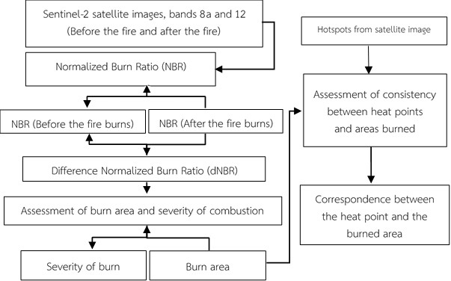The initial step involved analyzing burned areas using NDVI and NBR indices. The procedure consists of five steps (1) Downloading Satellite Imagery (2) Calculating the Normalized Burn Ratio (NBR) (3) Calculating the Burn Severity Index (BSI) (4) Assessing Burned Area and Burn Severity. (5) Evaluating the Consistency Between Burned Areas and Hotspots The assessment of burned areas is conducted in conjunction with field verification of the actual burned areas.

Figure 2: Steps in Analyzing Burned Areas Using NDVI and NBR Indices.

1. Sentinel-2 Satellite Imagery: The Sentinel-2 system captures multispectral optical images, allowing for data collection across visible light wavelengths to near-infrared wavelengths. This results in imagery with a spatial resolution of 20 meters, which is useful for detecting differences in vegetation. Sentinel-2 images from March 31, 2024, and April 5, 2024, were downloaded from the Copernicus Open Access Hub.
2. Calculating the Normalized Burn Ratio (NBR): The NBR index was computed for pre- fire (March 31, 2024) and post-fire (April 5, 2024) conditions. Sentinel-2 imagery was used, specifically in the near-infrared (NIR) and shortwave infrared (SWIR) bands, to calculate the NBR index using Equation 1. The NBR index ranges from -1 to 1, where higher values indicate healthier vegetation and lower values indicate bare soil and recently burned areas. Areas not burned typically have NBR values close to zero (Space Technology Development Agency (Public Organization), 2022).

NBR=(NIR - SWIR) / (NIR + SWIR) Equation 1

Where: NBR stands for Normalized Burn Ratio, an index used to assess burned areas.

NIR refers to Near Infrared reflectance.

SWIR denotes Shortwave Infrared reflectance.

1. Calculating the Difference Normalized Burn Ratio (dNBR): The dNBR is computed by finding the difference between the Normalized Burn Ratio values before the wildfire (NBR-Pre) and after the wildfire (NBR-Post), as shown in Equation 2. A higher dNBR value indicates more severe damage, while a negative dNBR value suggests regrowth following the burn.

dNBR = (NBRPre) - (NBRPost) Equation 2

where: dNBR stands for Difference Normalized Burn Ratio, which represents the difference in burn index values.

NBR-Pre refers to the Normalized Burn Ratio value from satellite imagery before the wildfire.

NBR-Post denotes the Normalized Burn Ratio value from satellite imagery after the wildfire.

1. Assessing Burned Area and Burn Severity Using dNBR: The burned area and severity are evaluated using the Difference Normalized Burn Ratio (dNBR), and the severity is classified into five levels. The classification criteria are detailed in Table 3 and are based on the guidelines from the United States Forest Service (2006).

Table 3: Criteria for Classifying Burn Severity Levels.

|  |  |
| --- | --- |
| **Severity level of burn** | **dNBR value range** |
| 1. Unburned | -0.100 to 0.099 |
| 2. Low Severity Burn | 0.100 to 0.269 |
| 3. Moderate-low Severity Burn | 0.270 to 0.439 |
| 4. Moderate-high Severity Burn | 0.440 to 0.659 |
| 5. High Severity Burn | * 1. 1.300 |

(5) Evaluating the Consistency Between Burned Areas and Hotspots: Hotspot data from the Suomi NPP, NOAA-20, and NOAA-21 satellites, comprising 75 points, were used for verification. The analysis involved checking whether the hotspots fell within the burned areas identified through the burn severity classification

The next step in analyzing risk areas within the Nam Pad Wildlife Sanctuary focuses on assessing the risk of illegal logging within the national park. This analysis adheres to guidelines set by the Department of National Parks, Wildlife, and Plant Conservation, utilizing geospatial data overlays of relevant factors, as outlined below

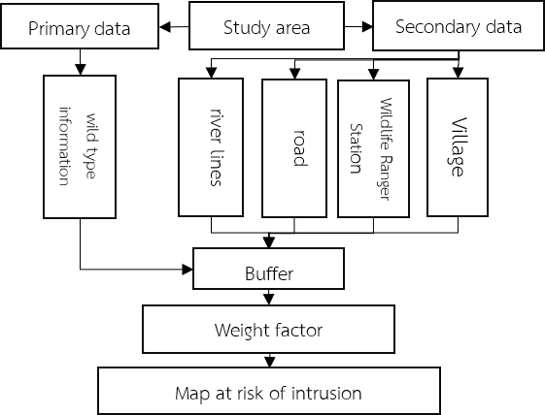 Figure 3: Steps in Analyzing Risk Areas in the Nam Pad Wildlife Sanctuary.

Step Three involves creating a 2.5 km² grid to cover the area for drone support during field

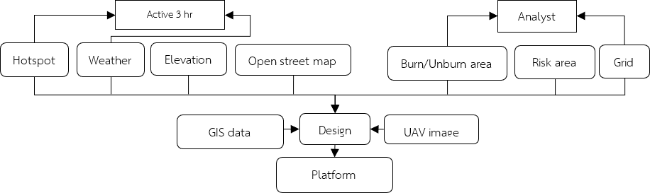operations and to establish flight points. In Step Four, a web-based platform is developed, hosted via Arc Online and utilizing a Cloud GIS system for practical application. This platform enables organizational sharing and management of access rights. It integrates various datasets, including historical hotspot density over the past five years, burn area analysis using NDVI and NBR indices, encroachment risk assessment in the Nam Pad Wildlife Sanctuary, the 2.5 km² grid for drone support, and additional data such as hotspot locations, wind speed, wind direction, aspect, and slope sourced from arcgis.com.

Figure 4: Workflow Steps.

# **5. Results**

**5.1 Calculation Results of the Normalized Burn Ratio (NBR)**

The analysis of the Normalized Burn Ratio (NBR) prior to the wildfire in the Nam Pad Wildlife Sanctuary indicated that NBR values ranged from a maximum of 0.536 to a minimum of -0.731, with the highest and lowest values observed in Fak Tha District (Table 4). Post-fire analysis in the same area revealed NBR values ranging from a maximum of 0.520 to a minimum of -0.656, with the highest and lowest values again recorded in Fak Tha District.

Table 4: Normalized Burn Ratio (NBR) Index in the Nam Pad Wildlife Sanctuary

|  |  |  |  |  |  |
| --- | --- | --- | --- | --- | --- |
| **Normal burn area index** | | | | | |
| **Time** | **Lowest Value** | **Maximum Value** | **Average** | **Standard Deviation** |
| Before the fire | -0.7319 | 0.5365 | 0.1684 | 0.0918 |
| After the fire | -0.6564 | 0.5207 | 0.1568 | 0.0992 |

The calculation of the Difference Normalized Burn Ratio (dNBR) in the Nam Pad Wildlife Sanctuary revealed that the dNBR values ranged from a maximum of 0.886 to a minimum of -0.820, with an average value of 0.011. Higher NBR values indicate areas where no fire occurred, while lower NBR values indicate fire-affected areas. Conversely, higher dNBR values indicate greater fire impact, while lower dNBR values suggest minimal or no fire impact. Although both NBR and dNBR are used to assess wildfire damage, they serve different purposes: NBR provides a general assessment of wildfire impact, while dNBR measures the severity of damage by comparing pre- and post-fire conditions.

The assessment of burn areas in the Nam Pad Wildlife Sanctuary revealed that 515.43 km² (322,144.62 rai) of the area remained unburned, representing 99.21% of the total area. In contrast, 4.05 km² (2,535.42 rai), or 0.78%, was affected by fire. The burn severity was categorized as follows: low severity (3.8429 km², 0.7397%), moderate-low severity (0.1603 km², 0.0308%), moderate-high severity (0.0438 km², 0.0084%), and high severity (0.0096 km², 0.0018%) (Table 5). The distribution of burned areas was concentrated in Ban Khok District within the Nam Pad Wildlife Sanctuary. (**Figure 5**)

Table 5: Burned Area and Severity Levels

|  |  |  |  |
| --- | --- | --- | --- |
| **Severity of Burn** | **Square Kilometer** | **Area Rai** | **Percent** |
| 1. Unburned | 515.4313 | 322,144.6209 | 99.2190 |
| 2. Low Severity Burn | 3.8429 | 2,401.8288 | 0.7397 |
| 3. Moderate-low Severity Burn | 0.1603 | 100.2136 | 0.0308 |
| 4. Moderate-high Severity Burn | 0.0438 | 27.3858 | 0.0084 |
| 5. High Severity Burn | 0.0096 | 6.0000 | 0.0018 |

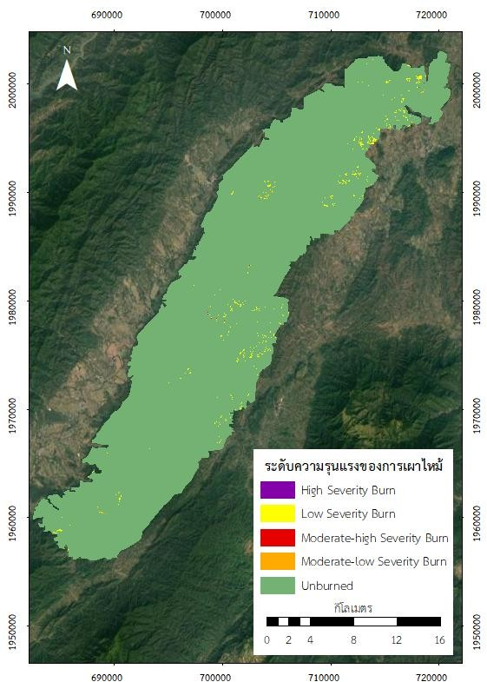

Figure 5: Burned Area and Severity Levels

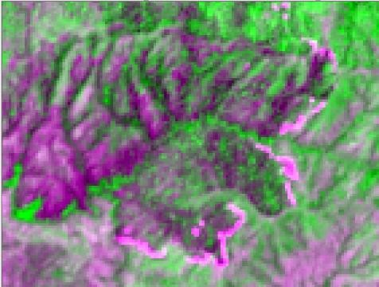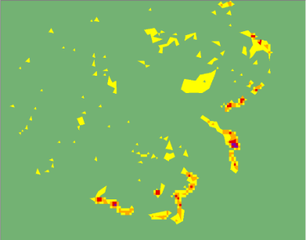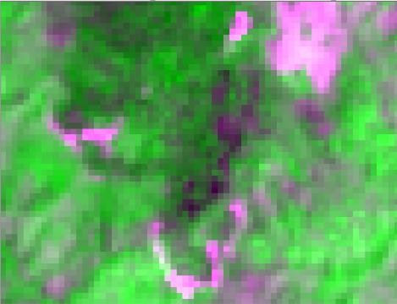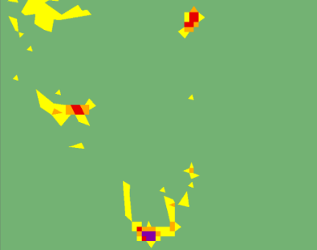

Figure 6: An example image that enlarges the burned area with satellite images.

The assessment of the correlation between burned areas and hotspots revealed that 32 hotspots corresponded to burned areas, while 43 hotspots were in areas that were not burned. This indicates a correlation of 42.66% for hotspots within burned areas and 57.33% for hotspots in non-burned areas.

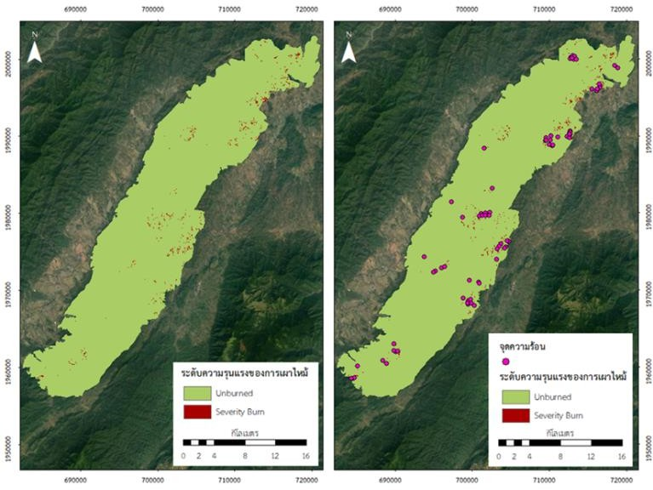Table 6: Correlation Between Burned Areas and Hotspots

|  |  |  |
| --- | --- | --- |
| **Area** | **Hotspot** | **Percentage of consistency** |
| Unburn | 43 | 57.33 |
| Burn | 32 | 42.66 |
| Total | 75 | 100 |

Figure 7: Burned areas and hotspots.

## **5.2 Results of Platform Development**

The developed system, once operational, initially displays the protected wildlife sanctuary area. Users can specify their area of interest by selecting districts, and the system uses data from Living Atlas to identify the location based on keywords entered in the search box, zooming in on an area of 1-5 square kilometers. Users can activate or deactivate various base map layers, including hotspot locations from MODIS and VIIRS satellites, by toggling icons on the map. These layers include analyses of burned versus unburned areas, aiding in predicting potential impact zones.

An analysis of the Burn Index (NBR) and false-color composite images from Sentinel-2 satellites, captured on March 31, 2024, with a 20-meter resolution, indicated that the area is at risk of future fires. On April 3, 2024, satellite data revealed the emergence of hotspots in the reviously identified risk zone. As of April 4, 2024, the system's Platform continues to display an increase in hotspots in this area, as shown in **Figure 10**.

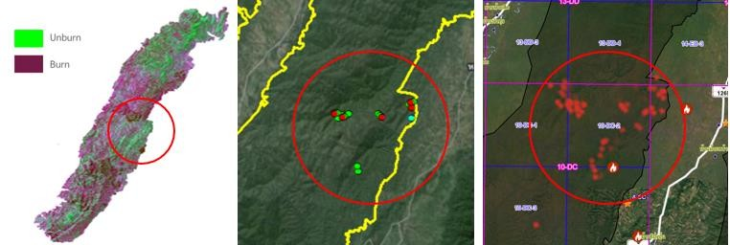

Figure 10: Results of Platform Development

# **6.Conclusion**

The analysis of burned areas in Nam Pat Wildlife Sanctuary, Uttaradit Province, using Sentinel-2 satellite imagery to calculate the Normalized Burn Ratio (NBR) has proven effective for assessing and monitoring fire severity. The study found that the NBR index can accurately track the extent and intensity of fire damage. Additionally, spatial accuracy assessments revealed a significant correlation between burned areas and hotspot data, which can be used to validate fire analysis results. These findings highlight the value of using NBR and hotspot data to improve fire assessment and verification.

Regarding platform development, although still in progress, the system effectively meets the research objectives. It has demonstrated utility in planning and managing conservation areas to mitigate surface fire spread. However, the platform has limitations: it currently does not support fire spread prediction or account for other fire-related impacts, such as smoke. Additionally, weather data should be collected directly from the field for improved accuracy. Despite these limitations, the platform provides valuable tools for analyzing fire- affected areas and supporting conservation efforts, though further development is needed to enhance its capabilities.

In conclusion, while the system is still under development, it successfully meets the research objectives. The researchers identified several limitations regarding its current functionality, such as the lack of fire spread prediction and the absence of considerations for smoke and other fire impacts. For more precise analysis, weather data should be sourced directly from the field. Despite these challenges, the system remains a useful tool for planning and managing conservation areas to prevent surface fires from spreading.

# **References**

Bureau of protecting forests and forest fire control. (2019). Knowledge about Wildfires. Retrieved from <https://www.dnp.go.th/forestfire/web/frame/lesson1.html>.

Department of National parks Wildlife and Plant Conservation. (1984). The Nam Pat Wildlife Sanctuary. Retrieved from [https://portal.dnp.go.th/DNP/FileSystem/download?uuid](https://portal.dnp.go.th/DNP/FileSystem/download?uuid%20=55a9bf3b-9502-4137-9ea8-cb4c66afe1ea.pdf)

[=55a9bf3b-9502-4137-9ea8-cb4c66afe1ea.pdf](https://portal.dnp.go.th/DNP/FileSystem/download?uuid%20=55a9bf3b-9502-4137-9ea8-cb4c66afe1ea.pdf)

Developing the US wildland fire decision support system. Journal of Combustion, Article ID 168473. 14 p.

Jiraphas, B. (2021). Development of a decision support system for wildfire prevention in residential areas (Proceedings of the 26th National Conference on Civil Engineering). June 23-25, 2021.

Lee, B. S., Alexander, M. E., Hawkes, B. C., Lynham, T. J., Stocks, B. J., & Englefield, P. (2002). Information systems in support of wildland fire management decision making in Canada. Computers and Electronics in Agriculture, 37(1-3), 185-198. <https://doi.org/10.1016/S0168-1699(02)00120-5>

Nickson Perera, M.G.H (2021). Sample thesis name. Sri Lanka: Doctoral dissertation, University of Peradeniya

Noonan-Wright, E., Opperman, T. S., Finney, M. A., Zimmerman, G. T., Seli, R. C., Elenz,

L. M., Calkin, D. E., & Fiedler, J. R. (2011). Developing the U.S. wildland fire decision support system. Journal of Combustion, Article ID 168473, 14 pages. https://doi.org/10.1155/2011/168473Developing the US wildland fire decision support system. Journal of Combustion, Article ID 168473. 14 p.

Office of Fire Prevention, Suppression, and Control. (2019). Knowledge about Wildfires. Retrieved from <https://www.dnp.go.th/forestfire/web/frame/lesson1.html>.

Vásquez, F., Cravero, A., Castro, M., & Acevedo, P. (2021). Decision support system development of wildland fire: A systematic mapping. Forests, 12(7), 943. https://doi.org/10.3390/f12070943