Detection, Collection and Management Of Marine Garbage through the Development of an Automated Collector
Jovina Virgin^{1*}, Shivaani Suseendran¹, Charanya Manivannan¹, Dr. Vani K.¹, Dr. Balaganesan G.²
¹Department of Information Science and Technology, College of Engineering, Guindy, Chennai, India ²Central Skill Training & Fabrication Facility, Indian Institute of Technology - Madras, India
*jowee2303@gmail.com

Abstract Garbage dumping and accumulation in water bodies have seemingly increased exponentially in the past few decades. This created the need for implementing a garbage collector that is cheap and can effectively collect garbage floating on the surface of the water. The collector is equipped with a camera that performs object detection using a trained You Only Look Once (YOLOv8) model with a mean average precision of 0.974. Upon detection of marine debris, signals will be sent to the Arduino microcontroller. The collector will collect debris using a robotic arm that is equipped with a net extension. The robotic arm is mounted onto a rotating base. Arduino controls the power supply and direction control of the base through the connection of 2 relays. This enables the arm to drop the collected garbage into the fiber-reinforced polymer vessel it is mounted on. Navigation is done using two motors that work on the principle of Differential Steering. It aims to achieve turning by creating a difference in speed between both motors. Once the garbage is collected, the best methods of disposal are ranked using the Analytical Hierarchical process algorithm by making use of Multi-Criteria decision analysis. The criteria for assessing the methods are found to be cost, count, feasibility and recyclability, and the information related to this is obtained from data taken from public domain. Pairwise importance matrices are defined for these factors and the most weighted method is considered to be the most suitable of all which can be implemented for disposal.
Keywords: Arduino, Differential Steering, Analytical Hierarchical Process, Yoloc8, Pairwise Importance Matrices

Introduction
According to the World Water Assessment Program (WWAP) by UNESCO around 90% of the total waste in developing countries is diverted to sources like rivers and lakes. These unsustainable waste disposal methods pose a significant threat to water quality and exacerbate water pollution. Currently, manual cleaning methods are employed to address this issue, which are both undesirable and hazardous. Manual cleaning not only jeopardizes the health of individuals involved in the act but is also inefficient, time-consuming and unpleasant. For these reasons, this paper proposes an alternate solution for the detection, collection and management of marine debris by the usage of a specialized garbage collector capable of detecting and collecting plastic waste and fishing nets from water bodies. This sustainable alternative gives us a chance to mitigate water pollution and preserve marine ecosystems. The collected garbage is then processed to decide the best method of disposal using multi-criteria analysis. It’s a decision-making methodology used when decisions involve multiple criteria or objectives that need to be considered simultaneously. MCDA helps in systematically evaluating alternative options based on these criteria, allowing decision-makers to make informed choices. It considers factors such as cost, feasibility, recyclability, and count of occurrences for each method. By evaluating these criteria, we can assess the effectiveness and practicality of different waste disposal techniques, helping stakeholders make informed decisions about waste management strategies.

Literature Review
With the increase in water pollution, there was a crippling need for the design and development of an automated way to collect and dispose of marine debris. Several of these approaches have been discussed below.
Masood et al (2022) in his work describes the design and development of an Automated Marine Trash Collector for collecting trash from water bodies. The prototype, designed for narrow water bodies, was successfully tested in the Bandar Canal, Vijayawada. It collected nearly 500g of floating solid trash in one trip. It utilized cost-effective components, including an Arduino Uno controller, a partitioned conveyor belt, and various collecting hardware and was entirely designed and 3D printed using Blender. The system employs ultrasonic sensors, remote controllers, and multiple motors for trash collection. However, this work did not incorporate any object detection models for the detection of floating debris and entirely relied on sensors for the same. This was disadvantageous as it would collect any floating object in its path including organic matter like leaves and bark. This would be a waste of resources as it could have been used to collect other environmentally hazardous debris.
Another similar work is Kannav et al (2021) paper where he designed a collector like a boat with a cedar wood base, equipped with propellers for movement, a collection tray made of aluminium alloy, and a garbage collection tub made of low-density polymer. It uses DC motors and an Arduino Uno microcontroller for control. It was designed on SolidWorks and Proteus was used for circuitry design. It was virtually simulated and tested using Unity which was a success. The robot can collect garbage from the water surface and dump it into a tub. It is remotely controlled and capable of carrying a maximum load of 7 kg. However, it operates on batteries which significantly reduces the operation time.
Shamsuddin et al (2020) describe a completely different design for this garbage collector. Their main goal was to design a highly stable waste trash collector that would be able to collect a decent amount of debris with minimal trips back to the coast. Based on the catamaran hull model a 3D design was developed using Siemens NX10 software, incorporating elements like a trash bin collector and a waterwheel for garbage collection and movement. They chose square hollow mild stainless steel as their construction material for its cheap prices, high corrosion resistance and sturdiness. The design allows for the vehicle to be remotely controlled and effectively collect trash from the water surface. This model can further be enhanced by making the entire process, from detection to collection, completely automated.
Another hardware-centric marine debris collector is discussed in Singh et al (2022) work. The drone is semi-autonomous, using six ultrasonic sensors for environmental mapping. These sensors send data to an Arduino microcontroller, which assists the operator in navigating and avoiding obstacles. The drone uses various mechatronics components, including an Arduino Uno microcontroller, modified electronic ducted fans (EDFs) for propulsion, and a humanoid robotic arm with heavy-duty metal gear servos for debris collection. The paper suggests that with further modifications and optimizations, the drone's applications could be expanded, making it a multifunctional tool for various water-related tasks.
Unlike other papers, Parvez et al (2022) suggest a unique robotic system for an automated marine debris collector. It combines the benefits of both hardware and software components for its functioning. It uses Raspberry Pi as its microcontroller to control its operations. A camera module is used to track and detect garbage following which the deployed robotic arm is used to collect floating garbage and when the collection chamber is full an alert is sent to the operator via an Android application. This is done using an ultrasonic sensor which also plays a dual role in helping the collector avoid obstacles as well. Even water quality is monitored using turbidity, conductivity and temperature sensors. This data is continually monitored in real time through a web server. Navigation is done by a propeller unit driven by DC motors, which are controlled by a motor driver module. The only disadvantage of the suggested model is that it needs periodic charging.
Once the waste is detected and collected, its management/disposal has to be done in a suitable way. This has to be done by considering various criterias such as cost, feasibility, etc. One such methodology is used in the paper proposed by Murilo et al. (2022) is a systematic literature review. The study provides an overview of multicriteria decision methods for managing plastic waste in a plastic-intensive context. About 20 relevant papers were identified by a literature search. This was done using content analysis methodology, wherein there was an overall review of abstracts, although in some cases the entire manuscript was considered to include the study. Also presented are the preferred recycling methods of various types of plastic wastes, wherein High-density polyethylene and polyethylene terephthalate would be mechanically recycled, while feedstock recycling is preferred for Poly Vinyl Chloride and Polystyrene, and Low-Density Polyethylene will be incinerated with energy recovery.

Methodology
Implementation of the marine debris collector and disposal methods are described in detail below.

Marine Debris Collector
The Marine Debris Collector has both hardware and software components to it. The software aspect focuses on detecting the presence of marine debris while the hardware aspect focuses on collecting it.
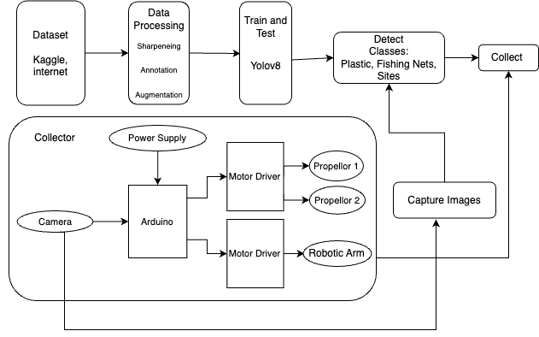
Figure 1: Architecture for Marine Debris Collector

Data: A dataset comprising 600 images was meticulously curated from the internet and Kaggle. Through manual verification and elimination of duplicates, the dataset was refined. Augmentation techniques such as colour jittering, random Gaussian noise, and Piecewise Affine Transformation was then applied, enriching the dataset for robustness and diversity. Annotation was done using labelImg, categorizing images into five distinct classes: Plastic, Fish, Fishing Nets, Site, and Ships

Model: YOLOv8 and Real-Time Detection Transformer (RT-DETR) are cutting-edge models used for garbage detection in this module. YOLOv8 stands out for its efficiency in predicting bounding boxes and class probabilities directly, allowing it to excel in various applications with its single neural network architecture. On the other hand, RT-DETR represents a breakthrough in real-time object detection and tracking by leveraging Transformer architecture. This enables seamless end-to-end processing of video streams, facilitating precise and efficient detection and tracking of objects in dynamic real-world environments. Object detection and tracking are done using Bytetrack.yaml. It is an object-tracking system that not only identifies the location and class of objects within frames but also assigns a unique ID to each detected object, ensuring accurate tracking throughout the duration of the video.

Robotic Arm: To control the arm of the collector Arduino Mega has been used in place of MakeBlock’s Mega PI. Therefore the pins of Mega PI have been mapped accordingly with the Arduino Mega. The wiring of the arm has been modified to make it compatible with the Arduino. In place of MegaPi Encoder/DC Driver V1 the L298N dual h-bridge motor driver to get the direction and speed of the motors. It also protects the microcontroller from damage. The robotic arm is shown in Figure 2 and its corresponding circuit in Figure 3.
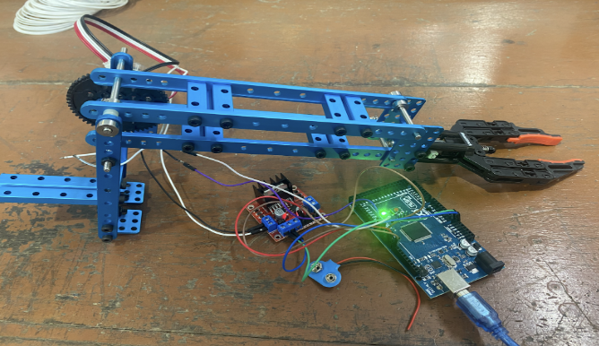
Figure 2: Robotic Arm
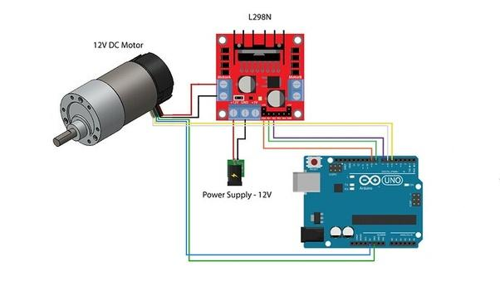
Source: howtomechantronics.com
Figure 3: Circuit Diagram for Motor in Robotic Arm

Net Extension: To collect garbage, a servo motor has been used. It is mounted onto the robotic arm using a structure that was designed and 3D printed. A thin rod of diameter 2mm has been threaded onto the servo motor. Then, a modified fishing net is attached to the rod using a metal cable. The circuitry is shown in Figure 4 and its setup is shown in Figure 5.
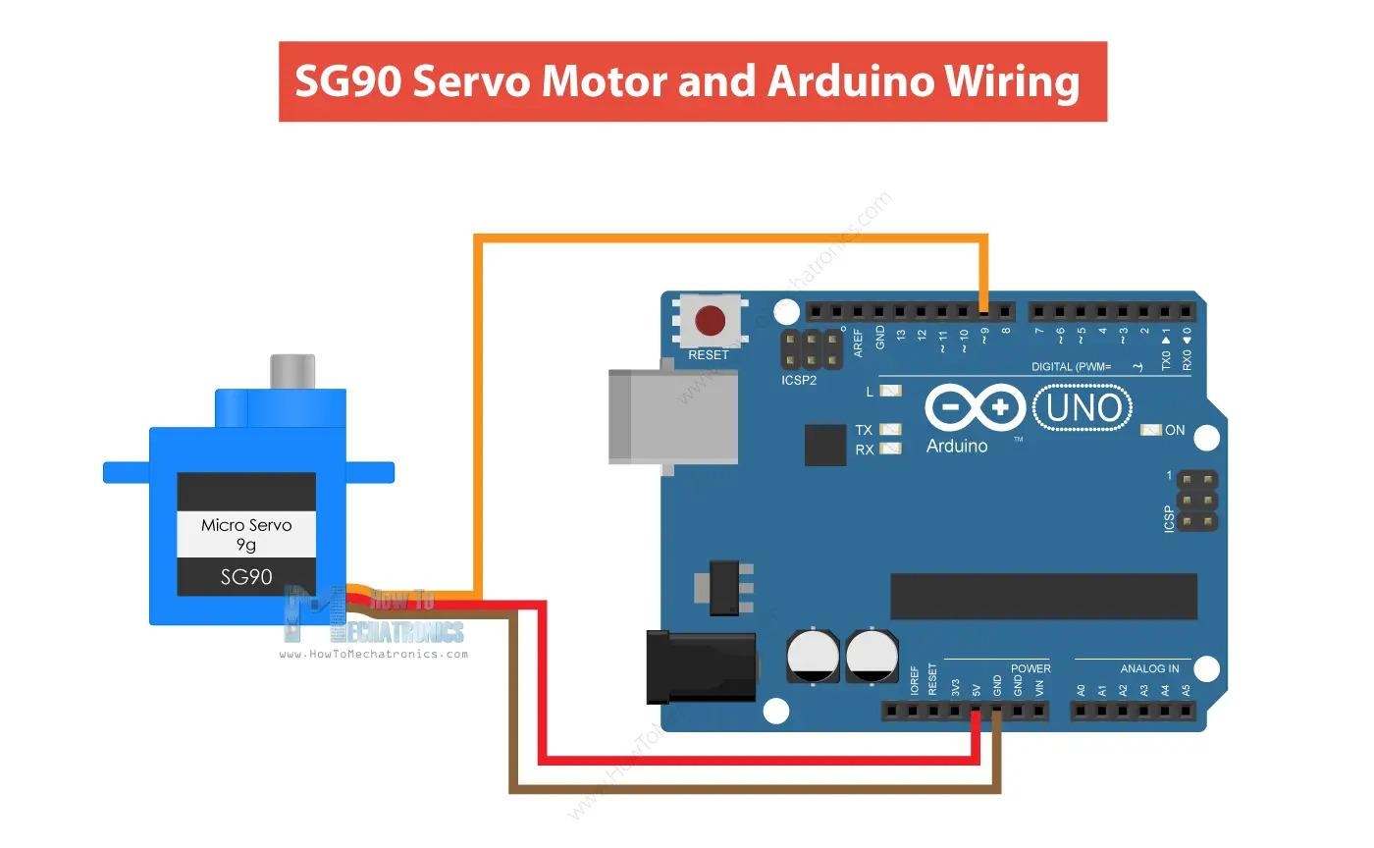
Source: howtomechantronics.com
Figure 4: Circuit Diagram for Servo Motor
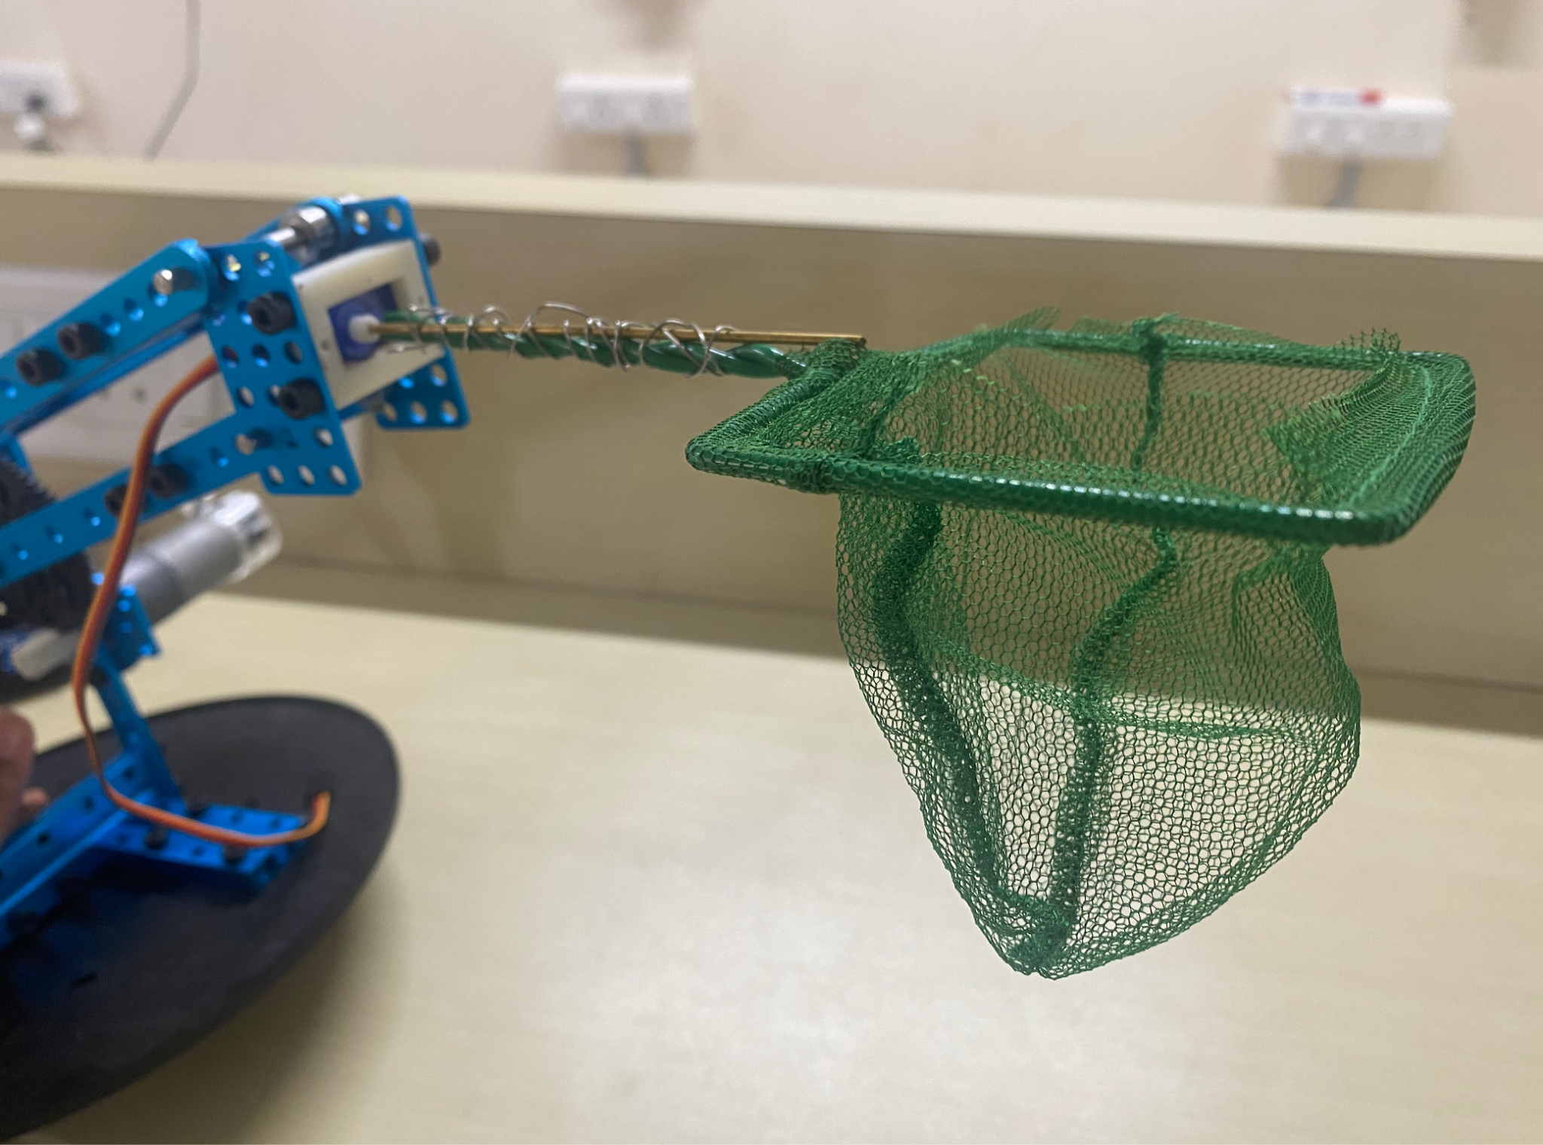
Figure 5: Net Extension

Rotating Base: The arm is mounted on a rotating base bought on Amazon. It looks like Figure 6. This base was dismantled and all its constituent parts were removed. Holes were drilled onto the rotating base and the arm was attached to it using L-shaped brackets. It had direction, speed and angle control programmed on the board that came along with it. The base was switch-controlled which was then modified by removing the switches and soldering new wires to it. These wires were then attached to Arduino via 2 different relays. Relays were used to control the power supply and direction. In one pulse generated for power supply two pulses for direction control were generated. This enabled the arm to turn, drop the collected garbage into the vessel and come back to its original position.
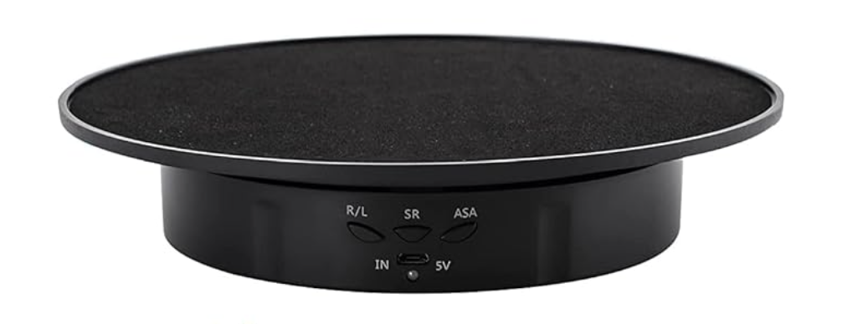
Source: Amazon.com
Figure 6: Rotating Base

Live Video Stream: Live video streaming for object detection is done using an Android smartphone. IP Webcam application is first installed on the mobile phone. Both PC and phone are connected to the same network. The server is started on the webcam application, which will generate an IPv4 address. In the Python code, this IPv4 address is given to establish a connection and to access the live video feed. Once connected, the Python code is run, and a window will pop up displaying the live video footage from the phone’s camera. Then integration of the already trained YOLO model is done into the code to perform object detection on the live stream, enabling real-time analysis of the video feed for identifying objects of interest

Vessel: A FRP model of a boat as shown in Figure 7 is used as the body of the collector. The robotic arm is clamped onto the front of the collector. Drafting is performed so that the boat does not roll or topple. The draft or draught of a ship is a determined depth of the vessel below the waterline, measured vertically to its hull’s lowest—its propellers, or keel, or other reference point. This is done to ensure the ship can navigate safely, without grounding.
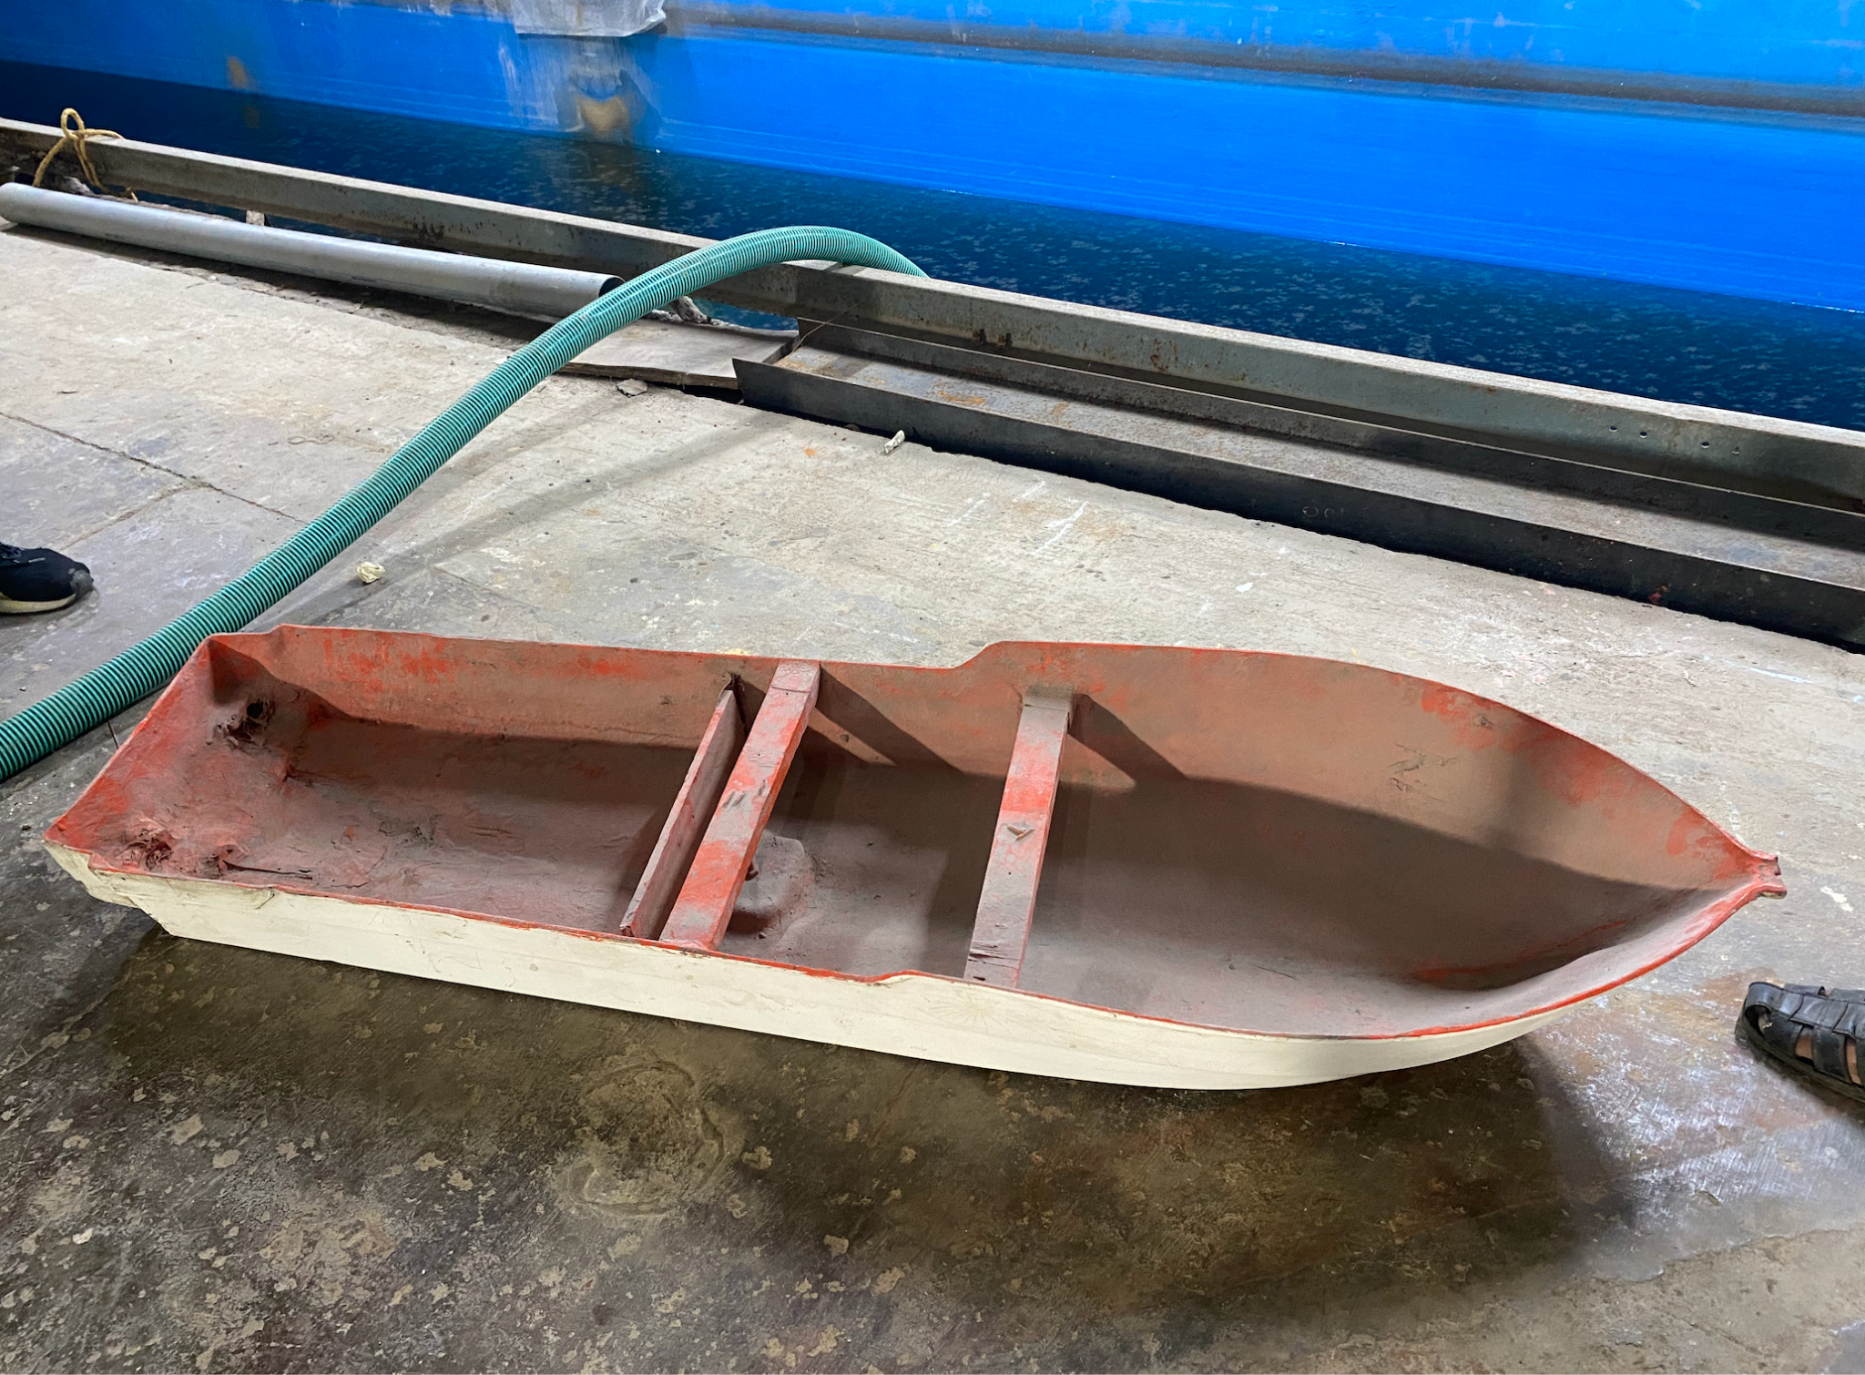
Figure 7: FRP Vessel

Motor - Propeller system: To achieve left turns, a system with two motors connected to an L298N motor driver is utilized, enabling control over speed and direction. When turning left, the left motor halts its rotation for 2 seconds, allowing the right motor to continue rotating at full speed. Conversely, to execute right turns, the right motor pauses while the left motor maintains full speed. This differential control strategy enables precise navigation, enhancing the maneuverability and versatility of the system. The setup and connection diagram are shown in Figures 8 and 9.
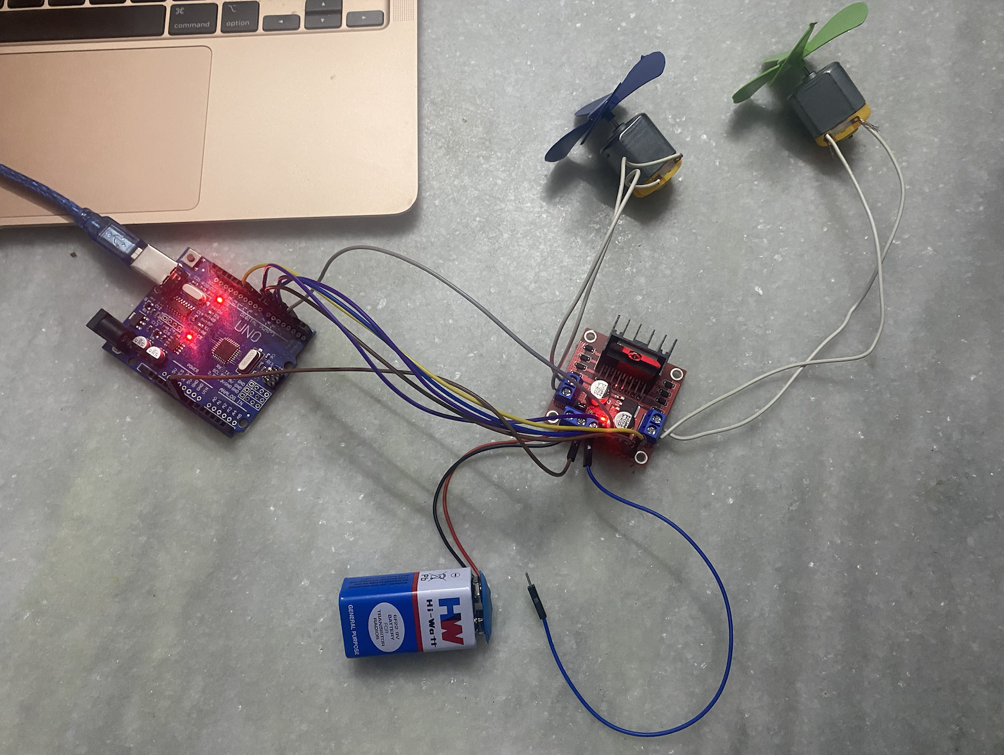
Figure 8: Motor - Propeller System
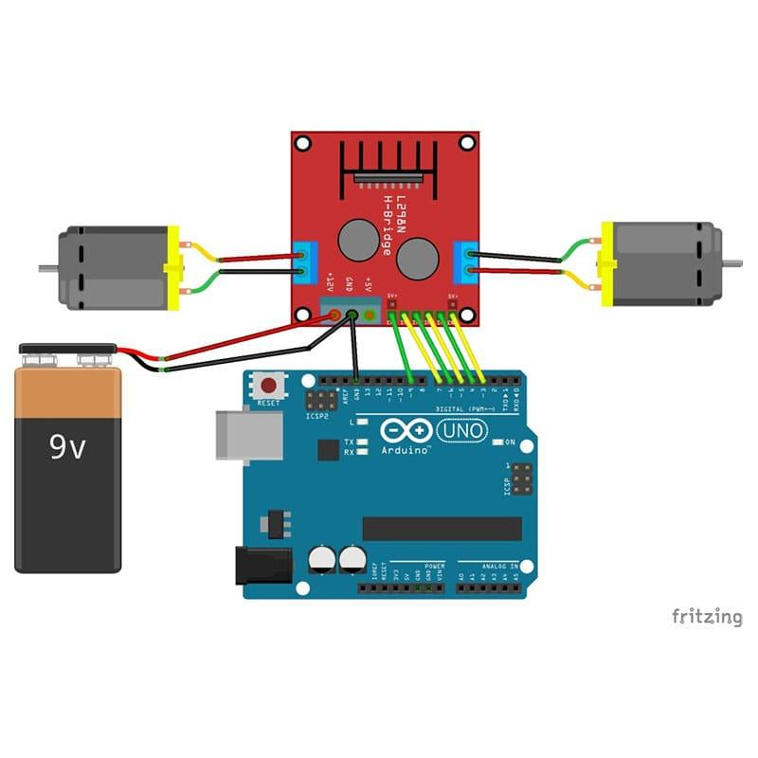
Source: fritzing.org
Figure 9: Circuit Diagram for motors

Waste Disposal Methods Using Multi-Criteria Analysis
This module employs Multi-Criteria Decision Analysis (MCDA) to evaluate waste disposal methods based on criteria such as cost, feasibility, recyclability, and occurrence frequency. It also integrates Analytic Hierarchy Process (AHP) to break down decisions into hierarchical criteria, aiding in assigning weights and prioritizing waste management options effectively. Figure 10 shows the architecture diagram for methods of disposal using AHP.
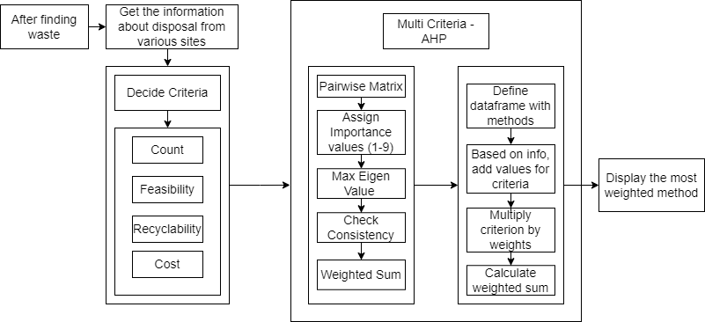
Figure 10: Architecture Diagram for methods disposal using AHP

Data: The data for finding the best method for disposal is gathered from a lot of papers and sites online. For each of the types of waste the methods, cost, feasibility etc. are documented.

Algorithm: Multi-Criteria Decision Analysis (MCDA) is used to evaluate waste disposal methods based on certain criteria. Analytic Hierarchy Process (AHP) algorithm is employed for this analysis. Firstly the pairwise matrix is created by setting the importance values from 1-9 (as shown beside Table 1). The criteria or factors used to assess each method are count, cost, feasibility and recyclability. The cost, feasibility and details of methods of disposal for each class - plastic, fish nets, metal cans and wood pieces are obtained from various sites in the internet and the comparative range for each method is saved. AHP derives the relative weights of criteria and alternatives through pairwise comparisons, calculating the principal eigenvector of the comparison matrix. Then, a weighted sum for each alternative is computed based on criteria weights and performance.

Table 1: Pairwise comparison matrix with importance values
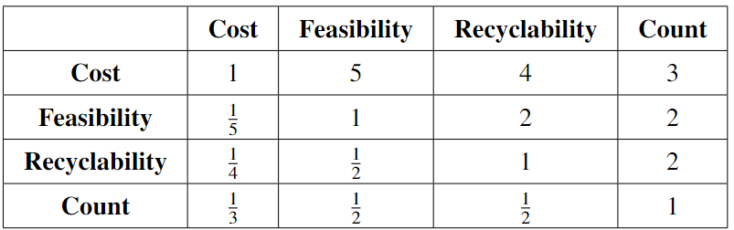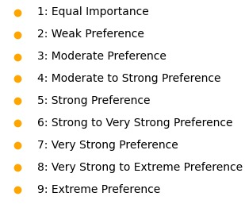

Importance Matrix: Table 1 displays the importance pairwise matrix. When cost and feasibility are considered, cost gets more importance as if it's lesser or affordable then it'll be more feasible. Feasibility is considered more important than Recyclability and Count and so on. In this case, the relative importance assigned to the Count criterion will likely be lower compared to other criteria, as it doesn't directly affect the substantive aspects of each waste management method. When the vice versa is considered it'll be the inverse. The diagonal elements are all 1s. Since a criterion is inherently equal to itself, it is considered to be as important as itself.

Consistency index: Consistency of judgments is checked using the consistency index, consistency ratio and then the eigen vectors are normalized. The same process is repeated for alternatives this entire analysis is performed for each type of waste detected and the method with the highest weight is considered to be chosen.

$$Consistency Index = \frac{λ_{m}-n}{n-1}$$
$Consistency Ratio = \frac{Consistency Index}{Random Index}$
$Criteria/Alternative weights=\frac{1}{n}\sum_{j=1}^{n}{}w$_{j}

Results and Discussion
The procedures performed and results obtained are discussed in detail below.

Marine Debris Collector
The marine debris collector floats down the water current and live video footage is received on the server from the camera mounted on the vessel of the collector. YOLO and RTDETR models were used for object detection. Metrics for both models are calculated and shown in Table 2. Evaluation metrics form a core procedure in machine learning, through which accurate object detection models are built which provide the most reliable results. Precision measures the prediction accuracy, whereas recall measures the total number of predictions with respect to the ground truth. mAP encapsulates the tradeoff between precision and recall and maximizes the effect of both metrics.
Table 2: Evaluation Metrics - Object Detection
Model | Precision | Recall | mAP
Yolov8 | 0.944 | 0.943 | 0.974
RTDETR | 0.972 | 0.978 | 0.992

Since the YOLO model outperforms the RTDETR model it has been solely used for object detection in the collector. A sample detection is shown in Figure 11.

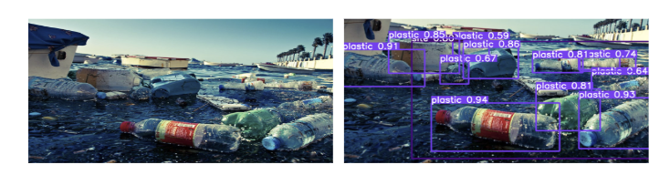
Figure 11: Detection of Waste

In the development of the robotic garbage collector system, first, the control system for manoeuvring the robotic arm was modified by replacing the MakeBlock Mega PI with an Arduino Mega by adhering to the pin mapping schema of the MakeBlock Mega PI and Arduino Mega. Additionally, the motor driver was upgraded to an L298N dual h-bridge driver to regulate the motor direction and speed while safeguarding the microcontroller from potential damage. The servo motor which was mounted onto the robotic arm using specially designed structures that were 3D-printed facilitated the robotic arm to pick up floating debris. Furthermore, live video streaming for object detection was established through an Android smartphone, leveraging the IP Webcam application to transmit live video footage to a connected PC. This setup allowed for real-time analysis of the video feed using a trained YOLO model, enabling the identification of objects of interest during garbage collection operations.

As further progress was made in the garbage collector system, dramatic changes were made to the rotating base sourced from Amazon. The base was unassembled, reconfigured, and changed meticulously to suit the requirements of the project. Holes were strategically drilled into the cover of the rotating base, where L-shaped brackets were to be attached. To this the robotic arm was attached which created a stable and balanced platform for it to function. Furthermore, the control mechanism of the base underwent a transformation, shifting from reliance on inbuilt switches to operation controlled externally by Arduino. This transformation involved the replacement of switches with soldered wires, subsequently linked to the Arduino via dedicated relays. These relays played a crucial role in managing power supply and direction, ensuring precise control over the arm’s movements. Programming enabled the execution of complex manoeuvres, including turning, garbage disposal, and return to the original position, enhancing the system’s efficiency and operational capabilities.

In parallel, the vessel component of the garbage collector system was constructed using a fibre-reinforced plastic boat model, onto which the robotic arm was securely clamped. Special attention was given to the vessel’s drafting to ensure stability and prevent rolling or toppling during operation. The motor-propeller system implemented differential control strategies utilizing two motors connected to the L298N motor driver, enabling precise navigation and manoeuvrability. For instance to make a left turn, one of the motors ceases running while the other operates at full throttle, and the procedure is reversed to make a right turn. It enhances the system's capacity for navigation and garbage collection while not risking itself from accidents and running aground. Figure 12 displays the garbage collector collecting a piece of plastic floating on the surface of the water. Figure 12 demonstrates the process of the garbage collector picking up a floating piece of plastic from the water surface. These changes, along with the design considerations, ensure that the robotic garbage collector system is dependable and effective.

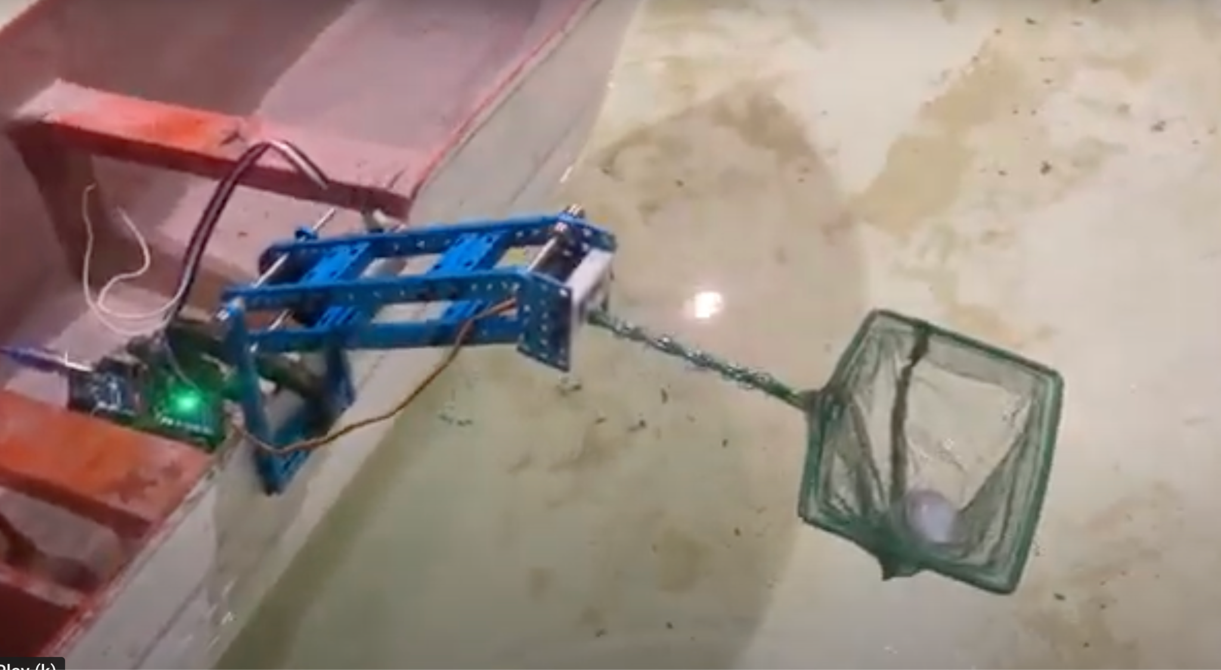
Figure 12: Garbage Collector in Action
Waste Disposal Methods Using Multi-Criteria Analysis
As the Consistency Index (CI) is less than 0.1, the matrix is said to be considerably consistent. The calculated weights are displayed in Figure 13. As mentioned before, it first determines the relative importance of each alternative and then computes their weighted scores considering all criteria.

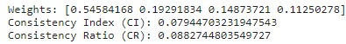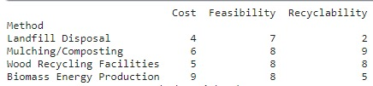
Figure 13: Weights and assigned values for methods

For plastics, priority is given to mechanical recycling (13.64) as shown in Figure 14. Mechanical recycling physically processes wastes to reclaim raw materials or produce a new product. It may be cost-effective, but it is often frequently limited by contamination in the waste stream. In comparison with methods such as chemical recycling (12.28), which could involve complex processes with higher costs, mechanical recycling offers a relatively less complex and more cost-effective approach.

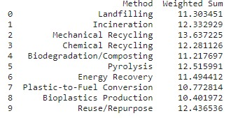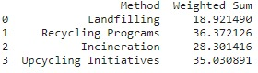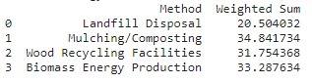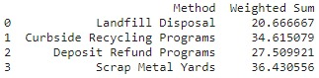
Figure 14: Weighted values for each method

For fishnets, its recycling programs (36.37). For instance, while a recycling program collects plastics and metals, mechanical recycling further processes these materials into pellets or melts them and manufactures new products like plastic bottles or aluminium cans. A compelling solution for waste management, boasting cost-effectiveness, feasibility, and high recyclability is offered by recycling programs.

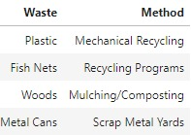
Figure 15: The most weighted method for each class of waste

For wood, the one is mulching/composting (34.84) which involves breaking down organic materials into nutrient-rich compost. This compost helps in enriching soil and promoting plant growth. Example Product: Compost (nutrient-rich soil conditioner), mulch. On the other hand, Biomass Energy Production (33.29) and Wood Recycling Facilities often require higher investments and specialized infrastructure. For metal cans Scrap metal yards (36.43) dispose of metal by collecting, sorting, and processing it from various sources like individuals and businesses.

Conclusion and Recommendation
For the detection and collection of marine floating debris, a marine garbage collector is built. Through the integration of hardware advancements with software technologies, this system offers a comprehensive solution for effectively collecting and mitigating marine debris accumulation in water bodies. It has sophisticated object detection capabilities with YOLOv8, which performs at a precision of 0.944, and Real-Time Detection Transformer, which performs at a precision of 0.972, for the detection and identification of marine litter such as plastic wastes, fishing nets, and ships to allow for targeted and effective cleaning operations.
Moreover, the system’s hardware components, including the robotic arm, rotating base, and net extension, have been meticulously designed and implemented to enhance movement and precision. The Arduino Mega controls the robotic arm with a DC motor to guide it in the vertical direction and the rotating base enables movement of the robotic arm in the horizontal plane. In combination with a servo motor and the net extension, it provides an environment for precise and efficient collection of floating marine debris. Furthermore, live video streaming capabilities enable real-time monitoring of collection activities, providing valuable insights and facilitating timely decision-making. The vessel design with fibreglass-reinforced plastic (FRP) for stability and manoeuvrability assures navigational safety in a variety of water conditions for operations to be carried out in a more efficient and safer way.
Based on the waste detected, the AHP algorithm is used to find the most suitable method based on features like cost, feasibility, recyclability and count. For instance, Mechanical Recycling for plastics, Recycling Programs for fish nets, Mulching/Composting for wood and Scrap Metal Yards for metal cans are identified as priority methods. The Consistency Index and the Consistency Ratios for this were 0.079 and 0.088 respectively.

References
Kannav, S., Karambelkar, S., Karanjkar, S., Katti, S., Khabiya, R., & Chavan, U. (2021). Surface water garbage collector. International Research Journal of Engineering and Technology (IRJET), 8(8), 2395-0072. https://www.irjet.net/archives/V8/i8/IRJET-V8I8401.pdf

Masood, M., & Seelam, K. (2022). Design and development of automated marine trash collector for trash-collecting applications. In 2022 2nd International Conference on Technological Advancements in Computational Sciences (ICTACS) (pp. 1-5). IEEE. https://doi.org/10.1109/ICTACS55593.2022.9988497

Parvez, S. M., Kumar, N. P. S., Salam, R. V. A., Rosemol, P. P., & Varun, P. N. (2022). Surface water garbage collector and quality monitoring system. International Journal of Innovative Research in Electrical, Electronics, Instrumentation and Control Engineering, 10(12), 1-4. https://doi.org/10.17148/IJIREEICE.2022.101206

Santos, M. R., Dias, L. C., Cunha, M. C., & Marques, J. R. (2022). Multicriteria decision analysis addressing marine and terrestrial plastic waste management: A review. Frontiers in Marine Science, 9, Article 747712. https://doi.org/10.3389/fmars.2021.747712

Shamsuddin, P. N. F. M., Mansor, M. A., Hadi, M. S. A., Abidin, N. Z., & Ibrahim, R. (2020). Development of water trash collector. Journal of Advanced Industrial Electronics Research and Applications, 1(1), 1-6. https://www.researchgate.net/publication/345132249_ARTICLE_DEVELOPMENT_OF_WATER_TRASH_COLLECTOR

Singh, V. R., & Kumar, C. (2020). Drone to collect and clean debris from canals and rivers. International Journal of Engineering Research & Technology (IJERT), 9(7), 1-4. https://doi.org/10.17577/IJERTV9IS070401

