**Spatial-Temporal Analysis of Urban Growth in the Suburban Area; Special Reference to the Homagama Divisional Secretariat Division from 1992 to 2023**

**Kavirathna G.E.**

**Department of Geography, Faculty of Arts, University of Colombo, Sri Lanka**

Email: [erangiguwani@gmail.com](mailto:erangiguwani@gmail.com)

**KEYWORDS:** *Geographic Information System, Remote Sensing, Spatial and Temporal, Suburban, Urban Growth*

**ABSTRACT**

Urban growth in suburban areas is characterized by expanding residential and commercial developments beyond city boundaries, often driven by the search for more affordable housing and better living conditions. Accordingly, this study aims to analyze the spatial and temporal urban growth in the Homagama Divisional Secretariat Division from 1992 to 2023. To achieve this, population density maps for 2000, 2007, 2017, and 2020 were downloaded from the "Worldpop" data source to analyze population density. Land use and land cover maps for 1992, 2008, 2015, and 2022 were collected from the Urban Development Authority (UDA) in Sri Lanka. Landsat images for the years 1992, 2007, 2017, and 2023 were downloaded from the United States Geological Survey (USGS) to analyze the Normalized Difference Building Index (NDBI) and Normalized Difference Vegetation Index (NDVI) based on ArcGIS 10.8 and Erdas-2014. The study found that population density is a primary driver of urban growth, with a notable increase in population primarily due to migration to this suburban area rather than natural growth. This migration is often driven by middle- and low-income individuals who cannot afford to settle near the Central Business District and instead opt for areas with somewhat developed infrastructure located further from the Central Business District. Although there has been a gradual increase in built-up areas during the study period according to the land use/land cover maps, indexes from the Normalized Difference Building Index analysis gradually declined from 1992 to 2023. On the other hand, the Normalized Difference Vegetation Index indicated a transformation from sparse vegetation cover to dense vegetation cover in the study area in the considered period. The reason for the above fluctuation is the adaptation of green building construction, the expansion of urban agriculture projects, and the proliferation of green infrastructures in the study area. Implementing a comprehensive sustainable urban development master plan is crucial to addressing the social, economic, and environmental challenges posed by high automobile dependency and land acquisition competition in suburban areas. This approach has improved living standards, ensured eco-system balanced and equitable growth, and provided valuable insights for future urban planning and policy-making.

**1. INTRODUCTION**

Industrialization since the 18th century has been a driving force behind urbanization, as economic development has transformed city patterns and structures. This transformation is a key indicator of the increase in the number of cities and population growth, a phenomenon described as urban growth (Ioannides and Rossi-Hansberg, 2005). Many urban areas have experienced dramatic growth due to rapid population increase and economic development (Cohen, 2006). In 2022, approximately 55% of the world's population resides in urban areas, and this figure is projected to rise to approximately 68% by 2050 according to UN projections (UNCTAD, 2022). On the other hand, developing countries have played a crucial role in urban growth over the past 30 years compared to developed countries. Around 400 cities now have populations exceeding one million, with approximately 70% of these urban residents living in developing countries. In Particular, Asia and Africa have seen significant increases in urban populations, with urban growth rates of 1.5 and 1.1, respectively, in 2014 (United Nations, 2018; World Urbanization Prospects, 2014).

In the Sri Lankan context, urban growth rates in 1963, 2001, and 2012 were 6.2%, 1.0%, and 1.36%, respectively. The above downward trends were attributed to the introduction of a new administrative unit, the Pradeshiya Sabha, and the impact of the civil war in 2001 (Masakorala and Dayawansa, 2015; Department of Census and Statistics, 2012). Despite this, the Colombo Metropolitan Area (CMA) is one of the fastest-growing cities in South Asia and serves as the main Central Business District (CBD) due to its socio-economic development (World Bank, 2013). Moreover, migration and settlement in urban areas are the primary factors driving urban growth in Colombo (Perera, 2020). Consequently, high population pressure has led to expansion beyond the administrative boundaries, with people settling in adjacent areas of the Central Business District. This expansion highlights the importance of suburban areas, which are gradually developing into cities due to improved infrastructure and socio-economic opportunities (Harris, 2015).

Geographic Information Systems (GIS) and Remote Sensing (RS) are modern technologies used to understand urban growth in suburban areas by monitoring land use and land cover changes spatially and temporally (Masakorala and Dayawansa, 2015; Herold *et* *al*., 2002; Usher, 2000). This study employed the Normalized Difference Vegetation Index (NDVI) and Normalized Difference Building Index (NDBI) to accurately represent land use and land cover changes (Masakorala and Dayawansa, 2015). In addition to that, population density was also considered in assessing urban growth in suburban areas.

The Homagama Divisional Secretariat Division, a suburban area in the Colombo district, offers favorable infrastructure, such as road networks, apartments, and communication systems, facilitating a consistent relationship with the Central Business District (CBD) (Weerakon, 2019; Zhang *et al*., 2017). For instance, a technical corridor was established along Mahenawatta and Meegoda in 2017 to promote technical and economic development in the area (Urban Development Authority, 2019). In particular, the population growth in this area is significant, with figures rising from approximately 252,469 in 2012 to 282,668 in 2016. By 2030, the population is predicted to reach about 687,717 (Department of Census and Statistics, 2012). Moreover, the Homagama Divisional Secretariat Division has seen a growing demand for residential purposes, with a population growth rate of 2.4% between 2001 and 2012. On that case, this study area is the third most populated area in the Colombo District, with 11% of the district's population residing there (Urban Development Authority, 2019; Department of Census and Statistics, 2012).

This context forms the foundation for the study's objective. Accordingly, this study aims to analyze the spatial and temporal urban growth in the Homagama Divisional Secretariat Division from 1992 to 2023.

**2. LITERATURE REVIEW**

Urbanization is a primary driver of urban growth. In developed countries such as the USA, Germany, the UK, and Australia, urbanization has reached its peak, resulting in a stable and low rate of urban growth. Conversely, developing countries are still experiencing high-intensity urbanization, making urban growth a more pertinent topic in these regions (Masakorala & Dayawansa, 2015; Cohen, 2006).

In particular, suburbanization has played a significant role in urban growth over the past two centuries. Moreover, the intense urbanization and technical development in cities have rendered them unhealthy environments (Harris, 2015). Limited vacant lands in the Central Business District (CBD) have prompted migration to nearby suburban areas, particularly among middle- and low-income populations, due to the affordability and availability of fragmented lands that can be chosen based on individual preferences and economic capability (Harris, 2015; Phelps *et al*., 2010). Accordingly, migration, rather than natural growth, is the primary phenomenon driving urban growth in suburban areas, especially in developing countries.

Urban growth manifests in three forms: infill, edge expansion, and outlying growth. Infill growth occurs within built-up areas, edge expansion contributes to suburban growth, and outlying growth happens in open and environmentally sensitive areas (Wilson *et al*., 2003). Additionally, Angel et al. introduced another three basic forms of urban growth. They are, secondary urban center development, ribbon development, and scattered development (Angel *et al*., 2007). These types are crucial for urban development planning and policy formulation.

Empirical studies on urban growth in Sri Lanka have primarily focused on main cities like the Colombo Metropolitan Area and Kandy City (Hettiarachchi et al., 2014; Divigalpitiya *et al*., 2007). For example, Subasinghe et al. analyzed urban growth in the Colombo Metropolitan Area using GIS-integrated urban gradient analysis and land change intensity analysis. They identified edge expansion along transportation networks as a significant urban growth type, indicating a gradual conversion of the urban fringe into urban areas (Subasinghe *et al*., 2016). In Kandy City, rapid urban growth has been driven by increased population density and rising land surface temperatures due to shrinking vegetation areas, pushing urban growth beyond administrative boundaries (Masakorala & Dayawansa, 2015).

Geographic Information Systems (GIS) and Remote Sensing (RS) are powerful tools for analyzing urban growth patterns spatially and temporally. Most studies have utilized GIS-integrated analyses such as urban gradient analysis and landscape metrics to quantify urban growth (Liu *et al*., 2010). For instance, Weerakoon (2017) identified landscape fragmentation and infill urban growth patterns in the Colombo district through gradient analysis. However, few studies in Sri Lanka have used GIS and remote sensing with vegetation and building indices to analyze urban growth (Jayasinghe et al., 2019).

While empirical studies on urban growth and its spatial and temporal changes in Sri Lanka have predominantly focused on major cities, there is a significant gap in the literature concerning suburban areas. This study addresses this gap by examining urban growth in the Homagama Divisional Secretariat Division, a suburban area that has received less scholarly attention. Unlike previous research that primarily utilized urban gradient analysis and spatial metrics, this study introduces a novel approach by employing GIS and remote sensing (RS) integrated applications, including the Normalized Difference Vegetation Index (NDVI) and Normalized Difference Building Index (NDBI) analyses, to comprehensively analyze urban growth both spatially and temporally in the suburban context.

**3. STUDY AREA**

Homagama Divisional Secretariat Division, located in the Colombo District of Western Province (Figure 01), has been selected as the study area for analyzing urban growth spatially and temporally. Covering an area of 121.0 km², Homagama Divisional Secretariat Division is one of the rapidly changing suburban areas and includes 81 Grama Niladhari Divisions (GNDs).

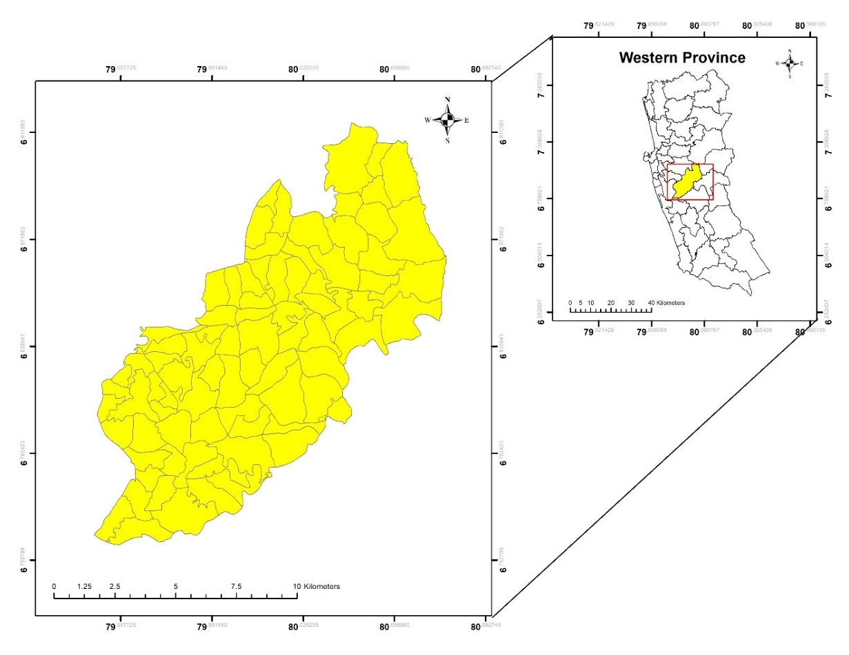

Figure 01: Location of the Study area

**4. METHODOLOGY**

**4.1 Data Sources**

This study utilizes population data, land use/land cover data, and satellite images obtained from secondary data sources. Specifically, population density maps for the years 2000, 2007, 2017, and 2020 were sourced from the "WorldPop" database. Land use/land cover data were provided by the Urban Development Authority (UDA) of Sri Lanka; however, the available data did not precisely correspond to the target years. Consequently, the closest available data for the years 1992, 2008, 2015, and 2022 were used.

Additionally, satellite images were downloaded from the United States Geological Survey (USGS). The details of these satellite images are presented in Table 01, and Figure 02 illustrates the extracted satellite images for the study area utilizing the composited images. The primary limitations identified in the satellite images include spatial resolution, spectral resolution, radiometric resolution, and cloud cover. However, techniques such as cloud cover removal, and pan-sharpening were employed to mitigate these limitations. Additionally, Google Earth Pro was utilized for the verification of the land use/land cover in the study area.

Table 01: Details of Downloaded satellite images.

|  |  |  |  |
| --- | --- | --- | --- |
| **Sensor** | **Resolution** | **Projection** | **Data Acquired** |
| Landsat 4-5 TM C2 L2 | 30*30 m | UTM WGS_1984 | 1/25/1992 |
| Landsat 4-5 TM C2 L2 | 30*30 m | UTM WGS_1984 | 1/2/2007 |
| Landsat 8-9 OLI/TIRS C2 L2 | 30*30 m | UTM WGS_1984 | 12/31/2017 |
| Landsat 8-9 OLI/TIRS C2 L2 | 30*30 m | UTM WGS_1984 | 4/12/2023 |

*Source: United States Geological Survey (USGS), 2024.*

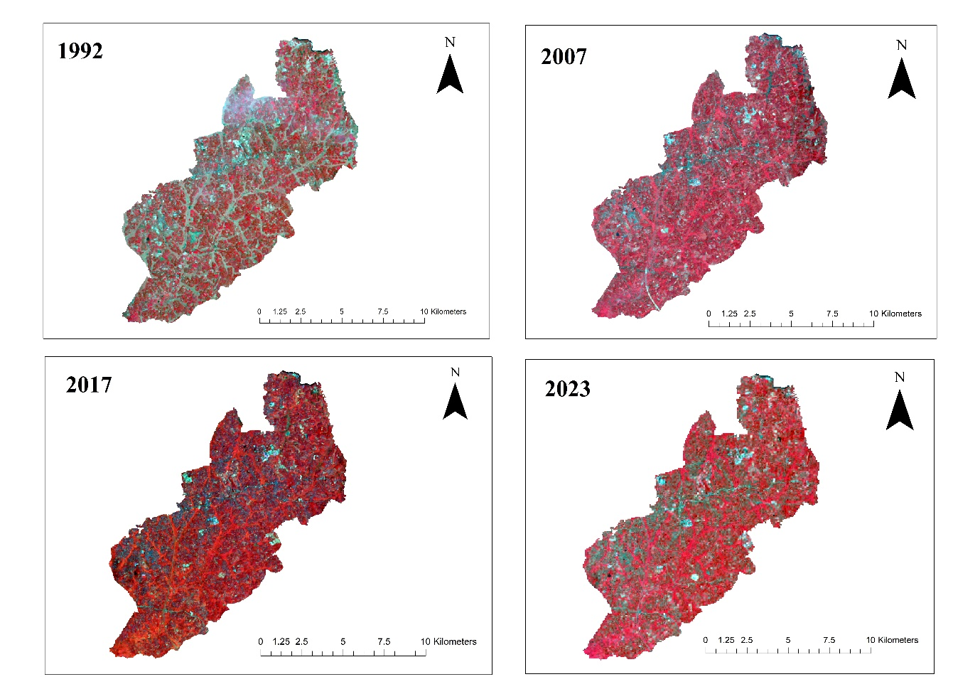

Figure 02: False color composites extracted from Landsat images

**4.2 Data Analysis**

**4.2.1 Population Density**

Examining population density is crucial for understanding urban growth (Wei *et al*., 2023). Population density maps for 2000, 2007, 2017, and 2020 were extracted for the study area using ArcGIS 10.8. The maps had a spatial resolution of 1 km, which caused some discrepancies in overlaying smoothly with the study area’s boundary. Nonetheless, these maps effectively represented population density growth.

**4.2.2 Land Use/Land Cover**

Land use/land cover maps for the years 1992, 2008, 2015, and 2022 were reclassified into four categories to delineate the spatial and temporal growth of the built-up area. Accordingly, the categories are built-up area, vegetation, road network, and water body. Table 02 illustrates these main categories along with their major attributes.

Table 02: Land use/ land cover categories in the study.

|  |  |
| --- | --- |
| **Land Use / Land Cover** | **Major Attributes** |
| Build-up Area | Commercial, Residential, Religious, Institutions, Industry, Schools |
| Vegetation | Paddy, Coconut, Rubber, Other Cultivations, Forest, Scrubs |
| Road Network | Primary Roads, Secondary Roads, Jeep and Cart Tracks |
| Water Body | River, Cannel, Water Hole |

*Source: Own compilation based on land use/ land cover data in the study area, 2024.*

Moreover, the areas of the built-up regions were calculated using the calculation geometry tool in ArcGIS 10.8 to assess urban growth in the study area.

**4.2.3 Normalized Difference Building Index (NDBI)**

The NDBI quantifies built-up areas by comparing short-wave infrared (SWIR) and near-infrared (NIR) values, as outlined in Equation 01. NDBI values range from -1 to 1, with negative values indicating water bodies and high values indicating built-up areas. Vegetation typically has low NDBI values (Kshetri, 2018). To analyze urban growth in the study area, NDBI values were calculated using the downloaded Landsat images in ArcGIS 10.8 and Erdas-2014 software. In particular, the calculation of NDBI varied depending on the data sensor, employing different bands as specified in Table 03.

(01)

$$NDBI= \frac{(SWIR-NIR)}{(SWIR+NIR)}$$

Table 03: Formular of NDBI according to Data Sensor.

|  |  |
| --- | --- |
| **Data Sensor** | **Formula** |
| Landsat 4-7, | NDBI = (Band 5 – Band 4) / (Band 5 + Band 4) |
| Landsat 8-9, | NDBI = (Band 6 – Band 5) / (Band 6 + Band 5) |

*Source: USGS, 2024.*

**4.2.4 Normalized Difference Vegetation Index (NDVI)**

The NDVI measures the vegetation index by comparing near-infrared and red radiance. NDVI values range from -1 to 1, with values closer to 1 indicating dense, healthy vegetation, and those closer to -1 indicating sparse or unhealthy vegetation (USGS, 2024). The NDVI analysis was conducted using the appropriate bands from Landsat images (Table 01) based on Equation 02, obtained from USGS, to detect changes in land cover and land use for the years 1992, 2007, 2017, and 2022. This analysis was performed using ArcGIS 10.8 and Erdas-2014 software. The specific bands utilized from the Landsat images were determined according to sensor data (Table 04).

(02)

$$NDVI= \frac{(NIR-RED)}{(NIR+RED)}$$

Table 04: Formular of NDVI according to Data Sensor.

|  |  |
| --- | --- |
| **Data Sensor** | **Formula** |
| Landsat 4-7, | NDVI = (Band 4 – Band 3) / (Band 4 + Band 3) |
| Landsat 8-9, | NDVI = (Band 5 – Band 4) / (Band 5 + Band 4) |

*Source: USGS, 2024.*

**5. RESULTS AND DISCUSSION**

**5.1 Population Growth and Infrastructure Development**

Population growth serves as the principal catalyst for urban expansion in developing countries. Specifically, rural-to-urban migration plays a more pivotal role than natural population increase in driving urban growth in suburban regions (Taubenbock *et al*., 2012). Consequently, population densities within the study area have shown a consistent upward trend over the years, as illustrated in Figure 03, with notable increments recorded in 2000, 2007, 2017, and 2020.

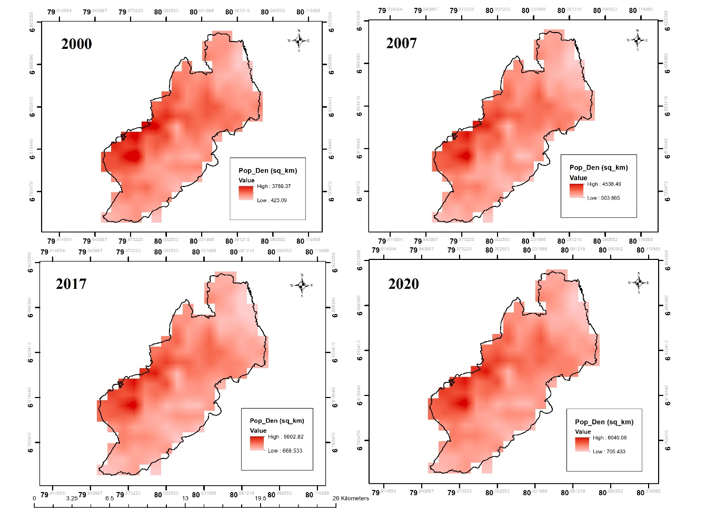

*Source: Own compilation used the “worldpop” data source, 2024.*

Figure 03: Population densities in the study area.

In 2000, the region exhibited the lowest population density at 423.09 km2, which subsequently increased to 705.433 km2 by 2020. This period saw approximately 60% of the population growth occurring in areas with initially low population density. Examining the areas with the highest population densities over the same timeframe reveals a notable upward trend in population growth. Specifically, the highest population densities recorded were approximately 3789.37 km2, 4538.49 km2, 5602.82 km2, and 6040.08 km2 for the years 2000, 2007, 2017, and 2020, respectively. This indicates a significant population density growth of approximately 63% between 2000 and 2020.

However, the most substantial increase in population density occurred between 2007 and 2017, with an approximate growth of 75% and 81% for low and high population density areas, respectively. On the other hand, the highest population densities were predominantly clustered around specific Grama Niladhari Divisions (GNDs), including Mattegoda East, Mattegoda West, Mattegoda Central "A", Mattegoda Central "B", and Brahmanagama. These Grama Niladhari Divisions are strategically located with feasible accessibility to the Central Business District (CBD) and offer land fragmentations suitable for purchasing, making them attractive for permanent settlements. Table 05 illustrates the increase in the number of families in these Grama Niladhari Divisions, providing key evidence of population aggregation in the study area driven by the demand for permanent housing solutions.

Table 05: Number of families in 2017 and 2020.

|  |  |  |
| --- | --- | --- |
| **GNDs** | **Number of Families** | |
| **2017** | **2020** |
| Mattegoda East | 966 | 1,005 |
| Mattegoda West | 1,343 | 1,690 |
| Mattegoda Central “A” | 492 | 660 |
| Mateegoda Central “B” | 910 | 943 |
| Brahmanagama | 1,426 | 1,452 |

*Source: Divisional Secretariant-Homagama, 2020.*

In this context, population migration predominantly occurred within the aforementioned Grama Niladhari Divisions (GNDs). The distribution of infrastructure facilities played a pivotal role in directing population movements towards the north and northwest. In particular, road networks significantly influence urban growth in specific areas, fostering ribbon-type urban development patterns by maintaining consistent accessibility and connectivity with the Central Business District (CBD) (Subasinghe *et al*., 2016). Consequently, GNDs such as Galavilawatta, Hiripitiya, Homagama Town, and Henawatta, located to the north and northwest, experienced a gradual increase in population densities from 2007 to 2020.

Additionally, the Urban Development Authority (UDA) and the Road Development Authority (RDA) in Sri Lanka have launched several projects to improve infrastructure facilities. For instance, the Homagama new township development project in 2019 led to the establishment of the Homagama Railway Station, the Homagama-Galavila-Kottawa roads, and luxury commercial center developments in Homagama Town (Road Development Authority, 2021; Urban Development Authority, 2019). Furthermore, the Sri Lankan government launched the "Mega Development Projects in Homagama," which aimed to create eight cities within the Homagama Divisional Secretariat Division (DSD). These projects include a wholesale exchange center in Meegoda, a granary in Godagama, a sports city in Diyagama, a knowledge city in Homagama, a biodiversity city in Barawa, a mega supermarket in Homagama, an apparel town in Ingiriya-Godagama, and an export city in Kahathuduwa (Daily News, 2021). Therefore, population growth serves as the primary impetus for the establishment of various advanced infrastructure facilities in the study area. Conversely, the development of these infrastructure facilities significantly influences population migration towards this suburban area, contributing to urban growth.

**5.2 Land Use / Land Cover Changes**

Consequently, urban growth in the study area can be identified through changes in land use and land cover (Figures 04 and 05). According to these maps, built-up areas have gradually expanded throughout the study area from 1992 to 2022, accompanied by a decline in vegetation areas. Moreover, Table 06 illustrates the expansion of built-up areas throughout the study area, providing further evidence of urban growth.

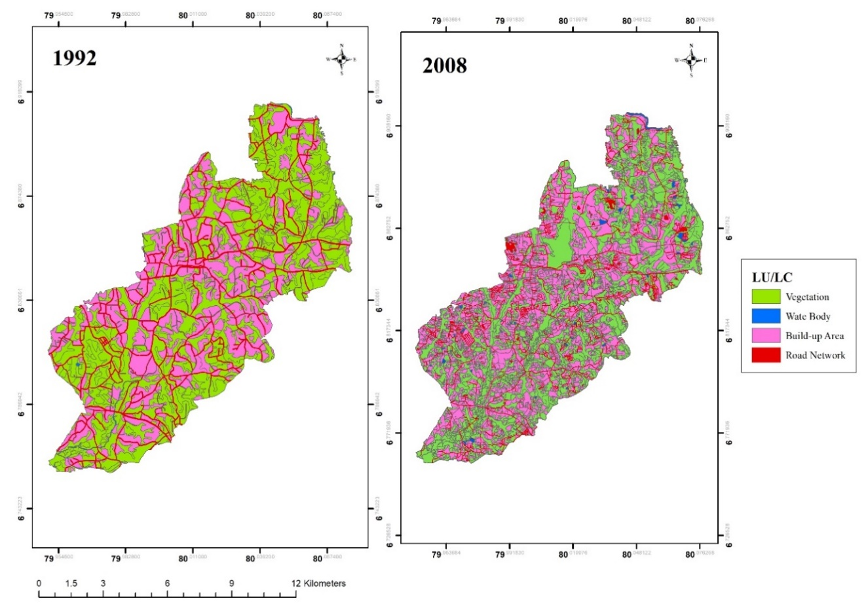

Figure 04: Land use/land cover in the study area

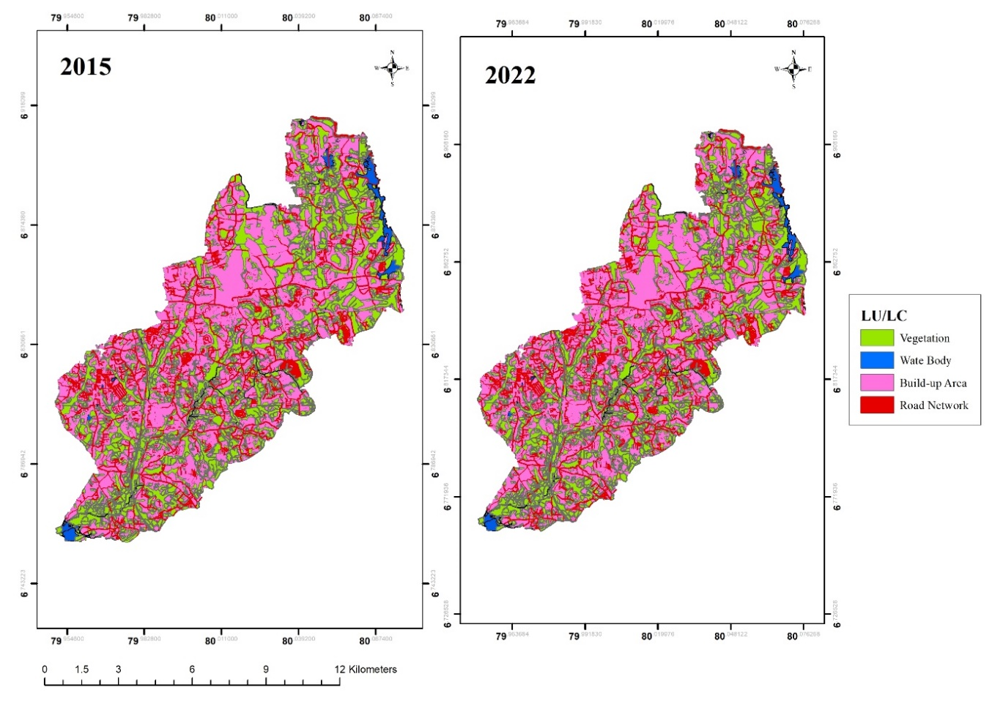

Figure 05: Land use/land cover in the study area

Table 06: Areas of Build-up Areas.

|  |  |
| --- | --- |
| **Year** | **Area (square km)** |
| 1992 | 43.94 |
| 2008 | 59.33 |
| 2015 | 70.40 |
| 2022 | 70.54 |

*Source: Own compilation by calculation of the areas of build-up area, 2024.*

According to Table 06, the extent of built-up areas has progressively increased over the years, with approximate measurements of 43.94 km² in 1992, 59.33 km² in 2008, 70.40 km² in 2015, and 70.54 km² in 2022. This data reveals a notable upward trend in built-up areas, with a total increase of approximately 26.6 km² from 1992 to 2022, primarily attributed to rapid suburbanization.

In particular, apartment complexes have proliferated in the study area, notably in Panagoda, Homagama, and Kahathuduwa GNDs. This expansion is largely driven by the Urban Development Authority's implementation of various housing plans. For instance, the “ Middle Income Housing Program” targets middle- and low-income individuals who are unable to afford land in the Central Business District (CBD). Due to concerns about housing affordability, many individuals prefer purchasing apartments rather than constructing individual houses to accommodate their budgets (Urban Development Authority, 2023). Additionally, other housing projects are aimed at upper-middle-income individuals. Consequently, the Homagama Divisional Secretariat Division has become a prime location for these housing projects due to its well-developed infrastructure and high accessibility to the Central Business District. Moreover, this condition has encouraged the migration of middle-income individuals to this suburban area. Furthermore, the availability of land fragments with affordable purchasing options in areas such as Mattegoda, Niyangala, Henawatta, and Siddamulla GNDs also contributes to the expansion of built-up areas and further urban growth in the study area.

**5.3 Environmental Impacts of Urban Growth**

The NDBI analysis (Figure 06) indicates a decline in NDBI values from 1992 to 2023. In 1992, an NDBI index value exceeding 0.4, represented in dark green color, signifies an increase in built-up areas. However, the NDBI indices in 2007, 2017, and 2023 exhibit a slight downward trend, with values of 0.20, 0.198, and 0.188, respectively. Conversely, negative values increased between 1992 and 2007, from -0.27 to -0.34, indicating the presence of water bodies in the study area. A minor reduction in negative values, approximately 0.05, can be observed between 2017 and 2023, suggesting a decline in built-up areas. Nonetheless, the actual reason for the reduction in NDBI indices is the initial utilization of green infrastructure through the adoption of green concepts in the study area. This is further corroborated by the NDVI analysis (Figure 07).

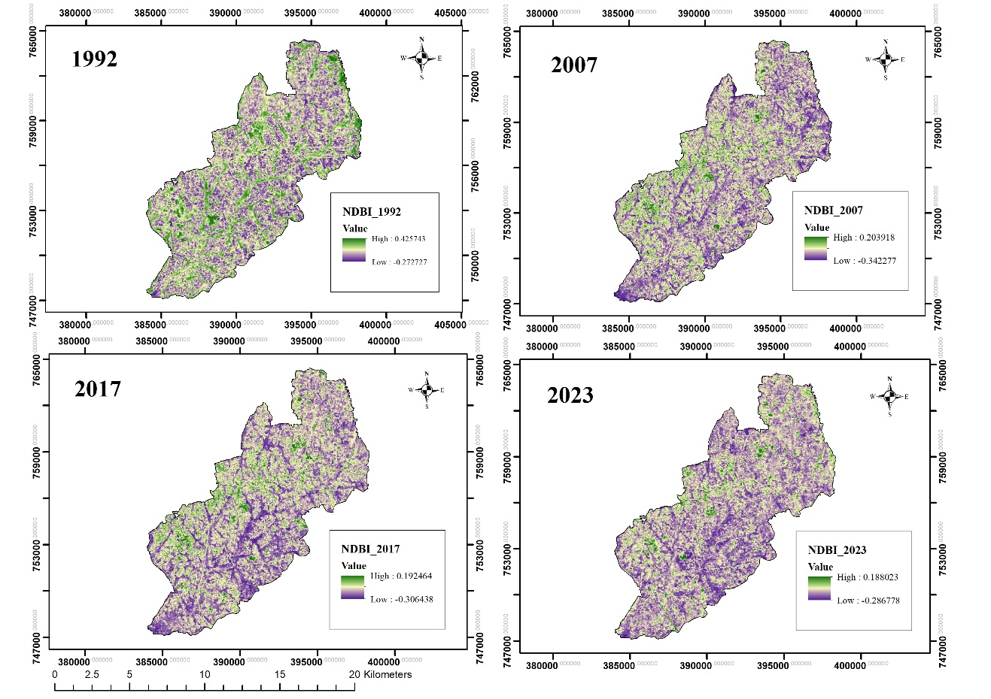

Figure 06: NDBI analysis in the study area.

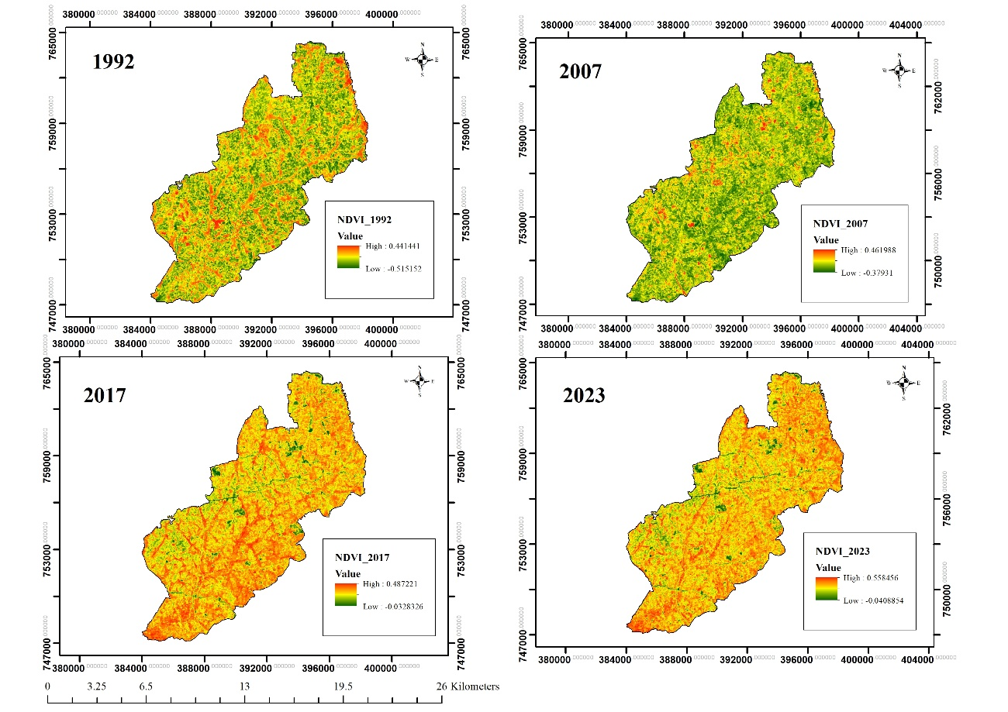

Figure 07: NDVI analysis in the study area.

The NDVI analysis for the study area reveals a progressive increase in vegetation index values over time, with recorded values of 0.44 in 1992, 0.46 in 2007, 0.48 in 2017, and 0.55 in 2023. This upward trajectory indicates a notable enhancement in vegetation density. Specifically, the index increased by 0.07 from 2017 to 2023, highlighting a transition from sparse to denser vegetation cover within the area. This trend signifies the successful adaptation and implementation of green infrastructure initiatives.

When looking at the above context from the Remote Sensing characteristics, spectral resolution was the main barrier to detect the build-up areas. Accordingly, NDVI is calculated using the red and near-infrared (NIR) bands, which are sensitive to vegetation health and density. On the other hand, NDBI uses the shortwave infrared (SWIR) and NIR bands to detect built-up areas. The clear distinction in these spectral responses explains why areas with dense vegetation can show a higher NDVI and lower NDBI, as they predominantly reflect more in the NIR band due to healthy vegetation and less in the SWIR band due to the cover of built-up structures from the green infrastructures which was verified using Google Earth Pro.

Moreover, the study area demonstrates a commitment to sustainable urban development, as evidenced by the Urban Development Authority's strategic planning. A significant portion of the land 25%, according to the 2016 land use plan is designated for green area development. Key projects driving this green transformation include the Kahathhuduwa and Godagama Town Development Projects, and the Barawa Wetland Development Project, all focused on creating a greener urban environment (Urban Development Authority, 2019). In addition to that, the eight previously discussed projects further support urban agriculture in the region. The establishment of NSBM Green University, the first green university in South Asia, is a testament to the area's commitment to sustainable development. This institution features advanced blue-green infrastructure and eco-friendly design principles (NSBM Green University, 2022). On the other hand, the increase in green spaces is also attributed to urban agricultural programs, such as the king coconut cultivation village in Homagama, and green residential complex projects like the "Supasan Purawara Program" in 2016, sponsored by the Urban Development Authority, and Agriculture Department in (Urban Development Authority, 2016).

**6. CONCLUSION**

The analysis of urban growth within the Homagama Divisional Secretariat Division (DSD) from 1992 to 2023 reveals a complex and dynamic interaction among population growth, land use transformation, and infrastructural development. Over this period, both areas with low and high population densities experienced substantial growth, propelled by enhanced accessibility and extensive infrastructure initiatives. Specifically, population density in areas with initially low density increased by 60% between 2000 and 2020, while regions with high population densities saw a 63% rise.

The expansion of built-up areas, which grew by approximately 26.6 km² from 1992 to 2022, underscores this urban growth. This expansion correlates with various housing projects targeting diverse income groups, indicative of pronounced suburbanization and urbanization trends.

Environmental sustainability has been a pivotal aspect of this growth trajectory. Positive trends in the Normalized Difference Vegetation Index (NDVI) values reflect an increase in vegetation cover. The shift towards sustainable urban development, emphasizing green and blue infrastructure, has contributed to improved environmental health and quality of life in the region.

In summary, the urban growth in the Homagama DSD is characterized by notable increases in population, extensive infrastructural advancements, and a strong focus on sustainability. This transformation has elevated living standards and ensured balanced and equitable growth, offering valuable insights for future urban planning and policy formulation.

**7. ACKNOWLEDGEMENTS**

I would like to extend my sincere gratitude to the GIS Division of the Urban Development Authority (UDA) of Sri Lanka for providing the essential data layers that facilitated this study as well as the reviewers for the valuable comments.

**8. REFERENCES**

Cohen, B. (2006). Urbanization in developing countries: Current trends, future projections, and key challenges for sustainability. Technology in Society, 28(1-2), 63–80. Science Direction. <https://doi.org/10.1016/j.techsoc.2005.10.005>

‌Daily News. (2021). Mega development projects for Homagama. Retrieved July 31, 2024, from <https://archives1.dailynews.lk/2021/02/22/local/242214/mega-development-projects-homagama#:~:text=A%20wholesale%20exchange%20centre%20in%20Meegoda%2C%20granary%20in>

Department of Census and Statistics (2020). Grama Niladhari Division Statistics - 2020. [online] “Colombo: Department of the census and statistics”, Retrieved July 30, 2024, from <https://www.colombo.pdf>.

‌Department of Census and Statistics. (2012). *Population Census and statistic* (Vol. 5, pp. 116–226) Department of census and statistics. ISBN : 978 – 955 – 577 – 940 – 1

Divigalpitiya, P., Ohgai, A., Tani, T., Watanabe, K., & Gohnai, Y. (2007). Modeling Land Conversion in the Colombo Metropolitan Area Using Cellular Automata. Journal of Asian Architecture and Building Engineering, 6(2), 291–298. <https://doi.org/10.3130/jaabe.6.291>

Divisional Secretariant-Homagama (2020). statistics. [online] “Colombo DS Divisions”. Retrieved July 24, 2024, from <https://www.colombo.ds.gov.lk/index.php/en/administrative-structure/gndivisions.html#information-on-roads-and-estates-of-gs-divisions-in-colombo-divisional-secretary-division>

Harris, R., 2015. Suburbanization and Suburbanism. International Encyclopedia of the Social & Behavioral Sciences, 2nd edition, Vol 23. Oxford: Elsevier. <https://doi.org/10.1016/9780080970868>

Herold, M., Goldstein, N. C., & Clarke, K. C. (2003). The spatiotemporal form of urban growth: measurement, analysis and modeling. Remote Sensing of Environment, 86(3), 286–302. <https://doi.org/10.1016/s0034-4257(03)00075-0>

Hettiarachchi, M., Morrison, T. H., Wickramsinghe, D., Mapa, R., De Alwis, A., & McAlpine, C. A. (2014). The eco-social transformation of urban wetlands: A case study of Colombo, Sri Lanka. Landscape and Urban Planning, 132, 55–68. <https://doi.org/10.1016/j.landurbplan.2014.08.006>

Ionnides, Y. M., & Rossi-Hansberg, E. (2005). Urban Growth. Department of Economic Working Paper, 1(2), 12–20.

Jayasinghe, P., Raghavan, V., Sanjaya, N., & Yonezawa, G. (2019). Spatio-temporal growth pattern analysis and urban simulation in Colombo city using open source software tools - application of futures simulation model. *The 40th Asian Conference on Remote Sensing (ACRS 2019), 14–18.*

Kshetri, T. B. (2018). NDVI, NDBI and NDWI calculation using Landsat 7 and 8*4*(1), 3. <https://doi.org/10.3895/rbgeo.v4n1.5462>

‌Liu, X., Li, X., Chen, Y., Tan, Z., Li, S., & Ai, B. (2010). A new landscape index for quantifying urban expansion using multi-temporal remotely sensed data. *Landscape Ecology*, *25*(5), 671–682. <https://doi.org/10.1007/s10980-010-9454-5>

Masakorala, P. P., and Dayawansa, N. D. K. (2015). Spatio-temporal Analysis of Urbanization, Urban Growth and Urban Sprawl Since 1976-2011 in Kandy City and Surrounding Area using GIS and Remote Sensing. Bhumi, the Planning Research Journal, 4(2), 26. <https://doi.org/10.4038/bhumi.v4i2.8>

‌NSBM Green University. (2022). Story of NSBM. Retrieved July 24, 2024, from <https://www.nsbm.ac.lk/story-of-nsbm/>

Perera, J. (2020). Internal Migration in Sri Lanka. Springer EBooks, 269–294. <https://doi.org/10.1007/978-3-030-44010-7_14>

Phelps, N.A., Wood, A.M., Valler, D.C., 2010. A post-suburban world? An outline of a research agenda. Environment and Planning A 42, 366–383.

Road Development Authority. (2021). National Road Development Master Plan (2021-2030) Road Development Authority (Second Edition).

Subasinghe, S., Estoque, R., & Murayama, Y. (2016). Spatiotemporal Analysis of Urban Growth Using GIS and Remote Sensing: A Case Study of the Colombo Metropolitan Area, Sri Lanka. ISPRS International Journal of Geo-Information, 5(11), 197. <https://doi.org/10.3390/ijgi5110197>

Taubenböck, H.; Esch, T.; Felbier, A.; Wiesner, M.; Roth, A.; Dech, S. Monitoring urbanization in mega cities from space. Remote Sens. Environ. 117. <https://doi.org/10.1016/j.rse.2011.09.015>

The Urban Development Authority. (2023). UDA. Retrieved July 24, 2024, from <https://www.uda.gov.lk/middle-income-housing.html>

The World Bank. (2013). Colombo: The Heartbeat of Sri Lanka. 2013. Retrieved July 30, 2024, from <http://www.worldbank.org/en/news/feature/2013/03/21/colombo-heartbeat-sri-lanka>

United Nations. (2018). 68% of the World Population Projected to Live in Urban Areas by 2050, UN. United Nations Department of Economic and Social Affairs; United Nations. Retrieved July 25, 2024, from <https://www.un.org/development/desa/en/news/population/2018-revision-of-world-urbanization-prospects.html>

Urban Development Authority. (2016). Supasan Purawara Program. The Urban Development Authority. Retrieved July 24, 2024, from: <https://www.uda.gov.lk/sukitha-purawara.html>

‌

Urban Development Authority. (2019). Homagama Development Plan 2019 -2030. Vol.12.

USGS (2024). Landsat Normalized Difference Vegetation Index | *U.S. Geological Survey*. Retrieved July 24, 2024, from: <https://www.usgs.gov/landsat-missions/landsat-normalized-difference-vegetation-index>

Usher, J.M., 2000. Remote sensing applications in transportation modeling, remote sensing technology centers final report, Retrieved July 24, 2024, from <http://www.rstc.msstate.edu/publications/proposal1999-2001.html>.

Weerakon, K.G.P.K. (2019). GIS-assisted land use structure change analysis in the Colombo district, Sri Lanka. *The 40th Asian Conference on Remote Sensing (ACRS 2019) October 14-18, 2019 / Daejeon Convention Center(DCC), Daejeon, Korea.*

Wei, Yehua.Dennis., Xiong, Ning. and Carlston, K. (2023). Urban space, sprawl, and intergenerational mobility. Applied Geography, 156, 102991–102991. <https://doi.org/10.1016/j.apgeog.2023.102991>

Wilson, E. H., Hurd, J. D., Civco, D. L., Prisloe, M. P., & Arnold, C. (2003). Development of a geospatial model to quantify, describe and map urban growth. *Remote Sensing of Environment*, *86*(3), 275–285. <https://doi.org/10.1016/s0034-4257(03)00074-9>

‌Zhang, X., Warner, M.E. and Homsy, G.C. (2017). Environment, Equity, and Economic Development Goals: Understanding Differences in Local Economic Development Strategies. Economic Development Quarterly, 1(3). <https://doi.org/10.1177/0891242417712003>