**Remote Sensing-Based Risk Assessment Indexing of Potential Threats to Drinking Water Sources**

Sourav Kumar N.R.S. 1*, Agilan B.1, Mithulesh P.1 and Dr Vani K.1

*1Department of Information Science and Technology, College of Engineering Guindy, Anna University, India.*

[*souravkumarofficial8@gmail.com](mailto:*souravkumarofficial8@gmail.com)

***Abstract:*** *Drinking water sources may encompass several potential hazards originating from urban locales, industrial zones and commercial districts. This study presents a comprehensive approach for assessing and identifying the potential risk sources of freshwater in the vicinity of drinking water sources. Leveraging high-resolution satellite imagery, water bodies and their proximal surroundings are precisely mapped utilizing semantic segmentation methodology. An open-source dataset comprising high-fidelity images paired to corresponding label masks is employed for training endeavors. The dataset is transmuted into Torch format to adapt it for training. The custom dataset is then employed to train pre-trained PyTorch models, including DeepLabV3+ and PSPNet, which are specifically designed for semantic segmentation tasks. The efficiency of the trained models is assessed through Dice Coefficient yielding a metric of 0.68, indicating promising efficacy in delineating water bodies and their surroundings. The segmented image is subjected to object optimization through the application of the Region Line Primitive Association Framework. The weights of risk sources are ascertained through Analytic Hierarchy Process. Thereupon Risk Assessment Index is computed through allocation of scores and weights to various identified risk sources in segmented image. This method allows for a thorough assessment of the safety of the drinking water source and its surrounding environment. Hence by leveraging satellite imagery and image processing techniques a systematic method is created to identify the risk sources around the water body thus promoting environmental sustainability.*

*Keywords: Analytic Hierarchy Process, Drinking water safety, Risk assessment, Satellite imagery, Semantic segmentation.*

Introduction

The area around the water body which have the potential to compromise the potability of the water. They are recognized as risk sources, these areas could be residential, industrial, Traffic, agricultural lands etc. Since they carry a potential threat to the water body vigilant monitoring of these sources is essential for assessing and managing ecological impacts on the drinking water quality. This research introduces a robust method to identify and evaluate risk sources encompassed by water bodies by enhancing the Object Based Image Analysis process coupled with Deep learning, incorporating additional risk factors, and employing advanced semantic segmentation and object optimization techniques to efficiently assess the level of threat posed by these risk sources. It ensures long-term access to safe drinking water, supporting public health and environmental sustainability for future generations.

Literature Review

The risk sources refer to human activity areas or target which may significantly impact the ecological security of water. Thus, identification of risk factors was done through object extraction adopting a two-level strategy combining object-based image analysis (OBIA) and deep learning (Yalan Zheng et al 2020). It involved U-Net semantic segmentation model to extract artificial risk sources and Object based classification for natural risk sources. The weights of different risk sources are calculated through Analytic Hierarchy process (AHP). Risk posed by each one of the risk sources is calculated as a product of score of degree of influence degree of each risk source and corresponding weights of the risk source. Then all risks added together form Risk Assessment Index (RAI). However, the weights of risk sources are calculated covering only few factors, making the work less generic in-turn addition of more risk sources would alter the weight distribution among different risk sources. The accuracy metrics of U-Net segmentation were missing not giving proper insights about performance of finding an efficient land-cover classification with high-resolution and heterogeneous remote sensing is quite unknown since the study was confined to a single target site.

Semantic Segmentation is a very important domain of research in the field of computer vision. Deep convolutional neural networks have been shown to make a substantial improvement over hand-crafted feature-based systems in benchmark tests; one example is the Fully Convolutional Neural Network. Liang-Chieh Chen et al (2018) developed DeepLabV3+, which uses spatial pyramid pooling and an encoder-decoder structure in segmenting images semantically. Spatial pyramid pooling collects contextual information by pooling features at multiple resolutions, and an encoder-decoder architecture can provide better delineation of sharp object boundaries. DeepLabV3+ extends DeepLabV3 by incorporating parallel atrous spatial pyramid pooling with various rates. Though it was able to capture a large amount of semantic information in the final feature map, It was still hard to preserve detailed object boundaries—partly due to the network backbone's many pooling operations. Here, it extracts denser feature maps using atrous convolution, which can be computationally expensive. DeepLabV3+ is an improvement over DeepLabV3, and introduces a simple, still effective, decoder module that enables the recovery of object boundaries. It accomplishes this design to have high semantic information at the output layer and accurate delineation of object boundaries. It achieved competitive performance without any post-processing, such as 89.0% and 82.1% accuracy on Cityscapes.

As a result, most existing state-of-the-art frameworks for scene parsing are based on allow networks. A major drawback for FCN-based models in scene parsing has been an unsatisfactory approach to effectively utilizing the global scene information in semantic segmentation. Filling this gap, Hengshuang Zhao et al (2017) proposed the Pyramid Scene Parsing Network. This new framework embeds a pyramid pooling module that allows for efficient aggregation of global context information at different scales by partitioning the feature map differently. It describes the contextual information for different receptive fields which will further help the model learn complex scenes, and hence it will predict pixels in the next layer. PSPNet was the top system in the ImageNet Scene Parsing Challenge 2016, with an 80.2% accuracy of Cityscapes.

Image segmentation is thus inherent to the OBIA technique, which produces accurate segment generation for further analysis. Conventional methods of OBIA usually suffered from errors in over-segmentation, particularly when dealing with the identification of objects of similar material compositions. Indeed, they were also inadequate to handle the high curvature and complex geometry characteristics of the irregularly shaped objects. To this, Min Wang et al (2016) proposed a very novel framework called the Region Line Primitive Association Framework, RLPAF. The approach combines the two primitives, region and line, within one concept concretely throughout the process of image analysis in capturing their complementary information to enhance spatial analysis capabilities to a great extent. RLPAF excels at refining shape analysis and spatial relationship reasoning with advanced models of region-line associations. It offers an integrated way to delve deeper into the spatial constraints and relationships within images. Long story short, very good performance in extracting road networks from HSR remote sensing image tasks has been depicted with the application of RLPAF. Validation studies underscore RLPAF's superiority over OBIA methods reliant solely on regions, achieving heightened accuracy in identifying and delineating objects, particularly those with intricate shapes or closely resembling surrounding features.

Weight assignment with respect to the influence of the segments on each other in a semantically segmented image around a water body is very important for accurate analysis. Analytic Hierarchy Process (AHP) is frequently utilized in scenarios involving multiple criteria because of its efficiency in handling complex decision-making. It involves pairwise comparisons of all the classes present in the segmented mask with respect to one another based on their influence, in order to establish their priorities on a nine-point scale and thus maintain consistency in weight assignment. However, the study from Yalan Zheng and Qian Shen indicated that the existing method only considers the percentage of impervious cover in each segment and ignores some other relevant factors: distance of segments from the water sources and their respective areas. These two elements are crucial in altering the influence of each segment on the water body and are therefore not taken into account while estimating their RAI. It is suggested that an influence score for each segment be calculated by the integration of its area and its distance from the water sources, regardless of class labels. In this approach, segments closer to the water body and those which are larger in area are weighted by the RAI calculus properly to reflect the real effect. The distance and area in the influence score estimation make the analysis comprehensive and give subtle insights into how different segments affect the water body. Therefore, enhancing this technique by considering such spatial factors is likely to provide more accurate and actionable results in the risk assessment for water bodies using semantic image segmentation.

Methodology

In this section, a step-by-step process on the analysis of satellite images with respect to risk levels of a water body is explained, as illustrated in Figure 1 for clarity and reference throughout the study.

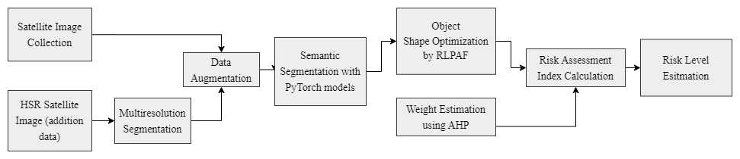

Figure 1: Overall architecture of the study

**Data Collection:** The risk factor semantic segmentation dataset around water bodies has been collated from several sources and pre-processed in order to be useful for developing models. First, satellite images along with their corresponding labels are obtained from an open repository: https://captain-whu.github.io/GID15/. Complementing this, HSRS imagery over different regions was gotten through SASPlanet, specifically Maxar imagery with very high resolution of 30cm. MRS was used to create further data in the dataset concerning semantic segmentation tasks. MRS segments images into segments based on spectral and spatial characteristics; this ensures that most varieties of environmental features surrounding the water bodies will be captured in the dataset. Each of these segments is carefully classified and added to the dataset to make it completer and more diverse. The images were standardized by being resized to 368x368 pixels so that a dataset and deep learning frameworks like PyTorch are consistent. Converting the dataset into torch format fostered seamless integration with PyTorch, hence seamless and efficient handling, pre-processing, and training of semantic segmentation models. This is a standardized approach that not only puts consistency into the input to models but also assures performance in risk factor identification and mapping around water bodies, an important component in effective environmental management and assessment. Further, PyTorch data augmentation techniques such as FiveCrop, Scaling, and Rotate, were applied to the training set. Such techniques introduce variations to the images without actually modifying the semantic content of those images and thus are very useful in improving the models' robustness and generalization ability.

**Model Development and Semantic Segmentation:** In this study, two PyTorch semantic segmentation models, DeepLabv3+ and PSPNet, are employed to train a custom dataset. DeepLabv3+ uses Atrous Spatial Pyramid Pooling for effective capturing of multi-scale features necessary in delineating precise objects occurring in complex scenes. On the other hand, PSPNet concatenates multiscale contexts using a Pyramid Pooling Module to improve semantic segmentation accuracy at varied scales. These improvements enable the two models to be at par with the conventional segmentation methods in many applications.

Both models use "Resnet101" as the encoder with pretrained weights from "ImageNet". The Adam optimizer is used, and CrossEntropyLoss acts as the loss function since it is suitable for multi-class classification problems such as semantic segmentation, and it embeds log-softmax activation together with negative log-likelihood. Finally, training is done in batches; when possible, this project utilizes acceleration by a GPU, and it uses automatic mixed precision for better computational performance. Model segmentation is typically evaluated by the F1 score (Dice coefficient) and pixel accuracy, two common metrics quantifying the similarity between predicted and ground-truth segmentations. This will ensure that for tasks requiring accurate delineation of objects or regions in images, quality in segmentation is robustly assessed.

F1 score is given by

F1 score = $\frac{\text{2 * Area of Intersection}}{\text{Area of Image + Area of Label}}$

Pixel accuracy is given by,

Pixel Accuracy = $\frac{\text{Number of Correctly Classified Pixels}}{\text{Total Number of Pixels}}$

In the case of multi-class segmentation, this idea can be expressed in the form,

Pixel Accuracy = $\frac{\sum_{i=1}^{k}{n_{ii}}}{\sum_{i=1}^{k}{\sum_{j=1}^{k}{n_{ij}}}}$

The classes present in the dataset are listed in the Table 1.

Table 1. List of classes

|  |  |
| --- | --- |
| List of classes | Industrial Land, Urban Residential, Rural Residential, Traffic Land, Paddy field, Irrigated land, Dry Cropland, Garden land, Arbor Forest, Shrub land, Natural Grassland, Artificial Grassland, River, Lake and Pond |

RLPAF algorithm: RLPAF makes use of several Python modules in its enhancement: computer vision tools, numerical operations, and scientific computing. It substantially increases the accuracy of the segmented areas by fusion of region-based and line-based data. The algorithm represents that the segmented regions are closely aligned with lines detected within the specified proximity threshold. Edge detection forms a very important basis that helps in segmentation. The Canny edge detector, provided by OpenCV, is commonly used to detect large pixel intensity changes that are crucial in effectively and accurately detecting object boundaries. It is created with a multistep algorithm that includes steps in noise reduction, gradient calculation, non-maximum suppression, and hysteresis thresholding, which finally results in robust edge maps.

The other one is the Hough Transform, complementing the Canny technique by transforming points to parameter space and effectively detecting lines or any other shapes. This approach is embedded into the RLPAF algorithm and refines segmentation by associating segmented regions with the lines detected within predefined distances. Optimizing these associations, it adjusts the parameters iteratively using the Nelder-Mead method—a versatile optimization technique that iteratively adjusts parameters to minimize a specified cost function. In essence, semantic segmentation combined with Canny edge detection and shape detection through Hough Transform provides the RLPAF algorithm with refined risk segmentation of water bodies. In this way, it is not only accurate but more robust in identifying and marking out various sources of risk associated with any environmental monitoring and management applications.

Weight assignment: In evaluating the risk associated with the water body, segmented image classes are assigned predefined weights using the AHP. Hence, each class is arranged hierarchically and subjected to pairwise comparisons, with their relative importance rated from 1 to 9. Hence, a matrix of pairwise comparisons is drawn up, and the consistency of these comparisons is checked based on metrics, including the Consistency Index and the Consistency Ratio. These measures ensure that the judgments recorded in the pairwise comparisons are consistent and reliable and therefore provide a structured approach for weighting the classes with respect to their relative importance within the context of the risk assessment of water bodies. Here classes such as pond, lake and river are not assigned with weights. Consistency Index and Consistency Ratio is given as follows

$$\text{Consistency Index = }\frac{{\text{λ}}_{\text{m}}\text{-n}}{\text{n-1}}$$

$\text{Consistency Ratio = }\frac{\text{Consistency Index}}{\text{Random Index}}$

Risk Assessment Index (RAI): The risk assessment index for each of the water bodies is calculated according to the formula:

RAI = $\text{Σ}{\text{ S}}_{\text{i}}{ \text{* W}}_{\text{i}}$

Here the Si denotes the Score of Influence and Wi denotes the weight of each class. The Si is determined by computing the Manhattan distance of each cluster of the identified class, along with the cluster area which collectively influences the degree of impact caused by that specific class on the water body. There is a positive correlation between scale and risk: larger projects amplify risk. Distance inversely correlates with risk, in that greater separation would reduce potential impacts and reduce risk exposure. RAI is calculated and the safety of the drinking water source based on the standards outlined by Zheng and Yalan et al (2020). RAI range and their corresponding safety levels are given in Table 2.

Table 2. RAI Ranges and the Safety Levels

|  |  |  |  |  |  |
| --- | --- | --- | --- | --- | --- |
| RAI | [0-5] | [5-10] | [10-15] | [15-25] | [25-40] |
| Safety Levels | Very High | High | Medium | General | Low |

Results and Discussion

Final dataset used in this research contained 145,378 images, properly divided into totally different training and validation sets. Out of those, there are 102,832 images used for training. The remaining subset is used to validate the data. Two segmentation models, DeepLabV3+ and PSPNet, compared for different learning rates. Comparison is based on F1 score and pixel accuracy. In all experiments, DeepLabV3+ performed better than PSPNet in terms of F1 score and pixel accuracy. Table 3 summarizes all maximum values reached for every model, manifestly and doubtlessly showing DeepLabV3+'s supremacy in the comparative analysis. Very clearly from these results is how DeepLabV3+ may actually be very powerful at semantic segmentation tasks and really be at its best in contexts that require highly accurate image analysis and processing.

Table 3: Performance of Semantic Segmentation Models

|  |  |  |
| --- | --- | --- |
| **Models** | **F1 score** | **Pixel accuracy** |
| DeepLabV3+ | 0.68 | 0.82 |
| PSPNet | 0.53 | 0.74 |

The performance difference margin that was witnessed in this case between DeepLabV3+ and PSPNet reaffirms the advantages accruable to the former in availing sophisticated segmentation techniques to applications. This may prove pivotal in situations where intricate image understanding is very important. Better F1 scores and pixel accuracy with DeepLabV3+ do not underline technical superiority but also enhance the reliability and efficiency for semantic segmentation workflows.

Three test sites considered in this study are the ICF Lake, Perungudi Lake, and Kattukalli Lake. All these places vary in their characteristics; each is represented with an input image of dimension 368 x 368 pixels, consisting of both water and the corresponding land nearby. This input image was passed to the best model obtained in the experiment, and an output was generated based on the segmentation into distinct classes. Figure 2 shows the input image and the segmented mask image of the ICF Lake. Figure 3: Original image and its corresponding mask image for the case of Kattukalli Lake, and Figure 4: the same in the case of Perungudi Lake. The same colormap scheme is applied for different classes distinguished in all the segmented images. This segmentation makes the model classify different habitat features in each lake site, such as water and land areas.

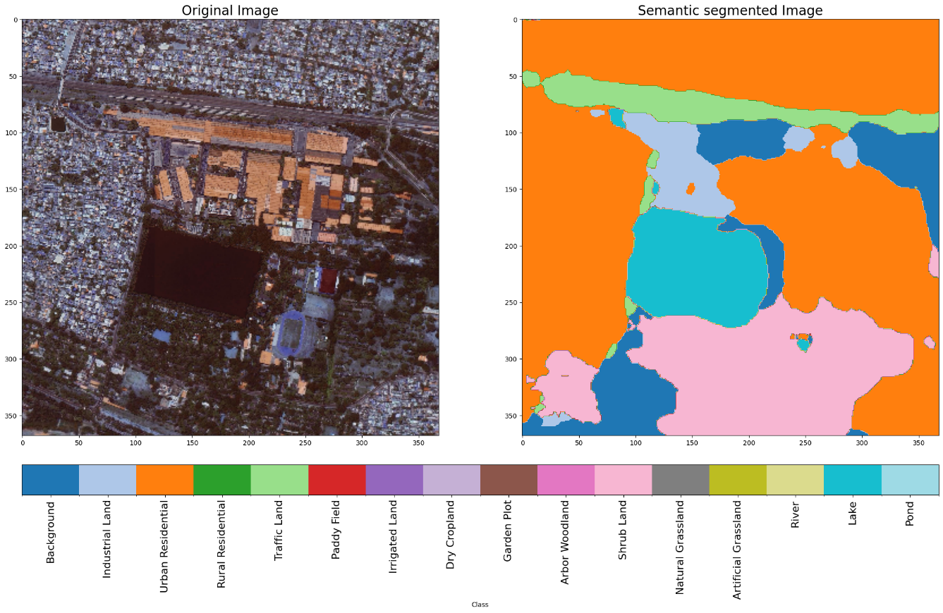Figure 2: Original and Segmented Image of ICF lake

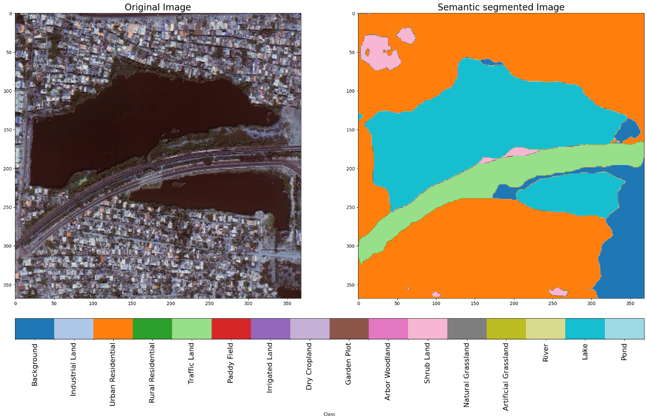

Figure 3: Original and Segmented Image of Kattukalli lake

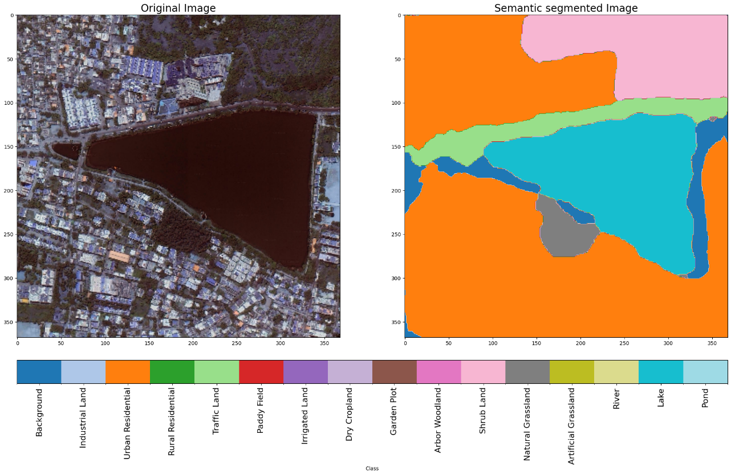

Figure 4: Original and Segmented Image of Perungudi lake

In the second step, the RLPAF algorithm is executed with the images generated from these two steps, which refines the region geometries. Figures 5, 6, and 7 show examples of lines kitting into their corresponding regions after the execution of the RLPAF algorithm on each of the lake scenarios. This process is iterative, meaning it provides a very fine estimation of the extent to which sources of risk are influential by further refining their shapes and borders in the image data. Using RLPAF, the contours and configurations of the regions adapt to be more harmonious with the underlying identified risk factors, ensuring the accurate and full quantification of the effects on the environment or system under study of the latter.

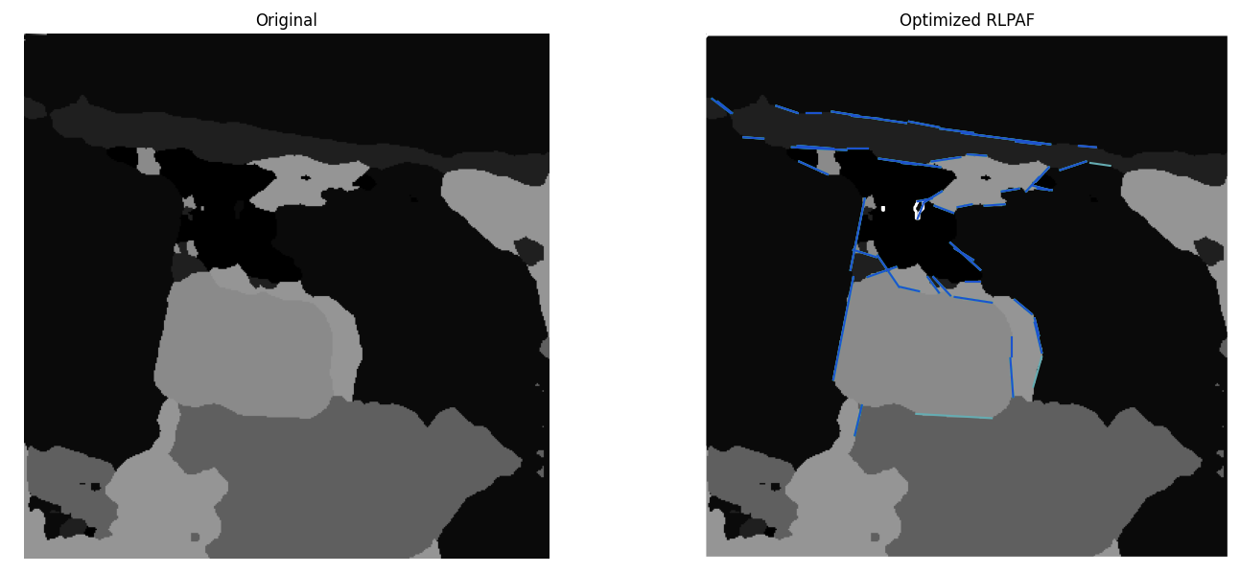

Figure 5: RLPAF optimization in ICF lake segmented image.

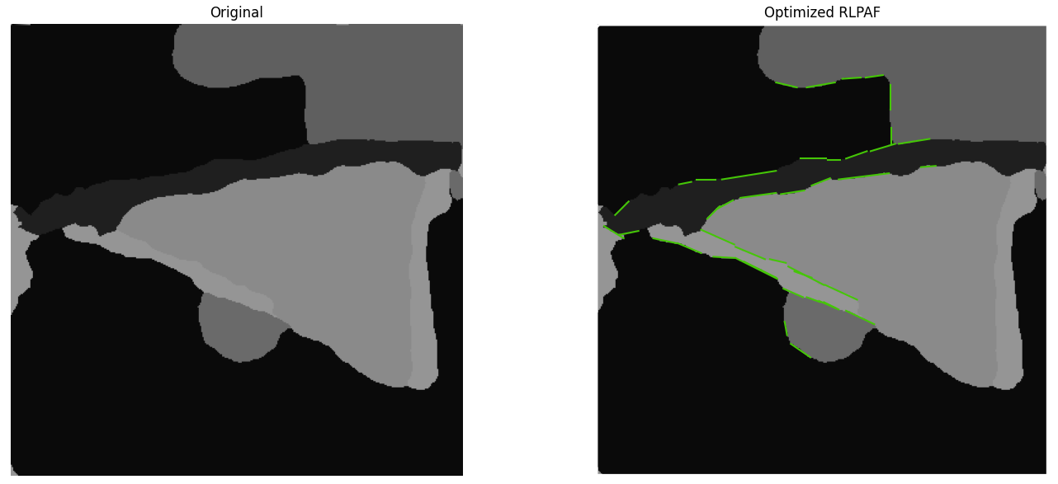

Figure 6: RLPAF optimization in Perungudi lake segmented image.

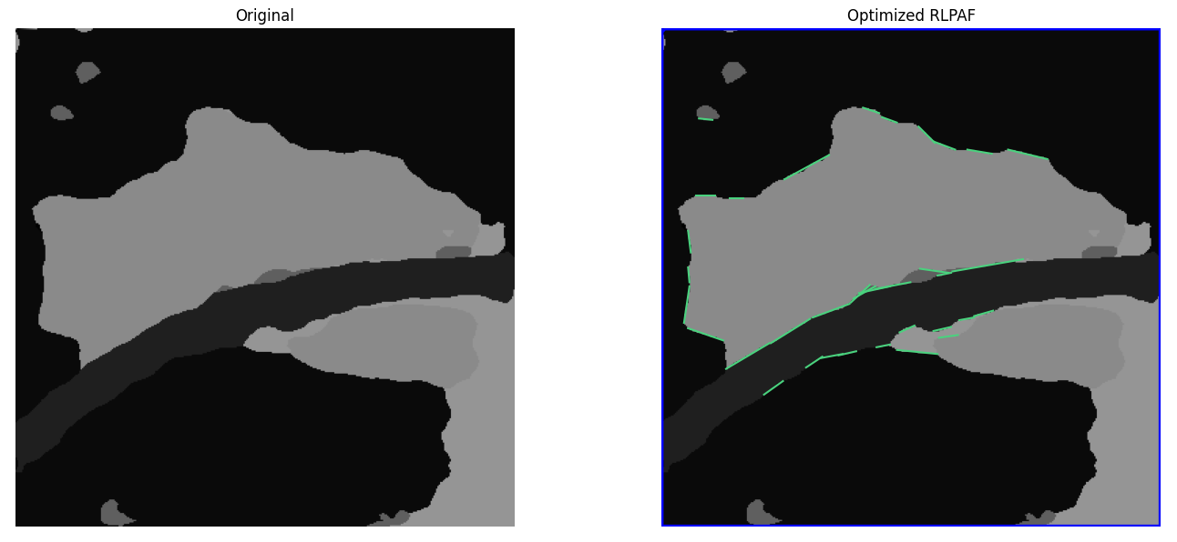

Figure 7: RLPAF optimization in Kattukalli lake segmented image.

The weights for each class are determined by using the AHP, which involves mathematical methods such as the eigenvector approach. The algorithm provides that all priorities between classes shall be carefully considered. Noticeably, the Consistency Index and the Consistency Ratio of the derived weights compute to be 0.136 and 0.09 respectively, thus indicating a satisfactory consistency check in the decision-making process. Table 4 presents the detailed list of classes with their weights, indicating their relative importance as assigned to them by the AHP calculus in the hierarchy under consideration. This methodology improves the accuracy and reliability of the decisions made at complex hierarchical systems.

Table 4. List of classes and their corresponding weights calculated from AHP

|  |  |  |  |
| --- | --- | --- | --- |
| Industrial Land | 0.232 | Dry Cropland | 0.061 |
| Urban Residential | 0.165 | Garden land | 0.055 |
| Rural Residential | 0.102 | Arbor forest | 0.040 |
| Traffic Land | 0.128 | Shrub land | 0.033 |
| Paddy field | 0.071 | Natural Grassland | 0.033 |
| Irrigated land | 0.085 | Artificial Grassland | 0.023 |

The RAI becomes an extremely important tool when analysing water bodies against identified sources of risk. In each water body, the risk index becomes score- and weight-based on the various sources of risk, with the application of metrics such as Manhattan distance and cluster area assessments. An example of this assessment is ICF Lake, with a risk assessment index value of 27.13 and in the rating "Low" safety level. It belongs to this designation because it is close to industrial zones, a large urban area, and busy roads, thus increasing the perceived risks. On the other hand, Perungudi Lake acquires an estimate of 15.54 in terms of risk, classifying it under the "General" band of safety levels. This way, it characterizes with medium risks, under the influence of the surroundings and the sources of this kind of risk identified. The estimated risk for Kattukalli Lake is therefore 12.68, once more in the range of "Medium" safety levels. In that respect, it is classified as a place with a moderate level of risk factors affecting the lake, although it differs in specifics compared to other lakes due to the local conditions found there. The overall Risk Assessment Index provides a step-by-step procedure for comparing the relative safety of different water bodies and thus informing decisions regarding mitigating strategies, based on risk factors identified for management.

**Conclusion and Recommendation**

The following research work is an innovative approach toward risk assessment near water bodies using HSR imagery. Deep learning state-of-the-art models—DeepLabV3+ and PSPNet—are used with the semantic segmentation method to classify different land-use types in Water Body Regions. DeepLabV3+ is presented, which shows the better performance by yielding a higher F1 score of 0.68 compared to PSPNet whose F1 score is 0.53. Additionally in terms of pixel accuracy, DeepLabV3+ achieves 0.82 outperforming PSPNet's score of 0.74. The shapes of the refined segmented regions were improved by the RLPAF algorithm. Such refinement raises the accuracy of risk assessment to a great extent. Weights are then assigned to different land use classes based on their relative importance regarding the risk associated with the same using AHP. The weights are then combined with the influencing scores derived from factors such as proximity and area, which finally leads to the RAI. In doing so, the approach will not only identify risks holistically but also quantify them comprehensively, allowing useful insights into the problems. The methodology is oriented toward the sustainable development goals by facilitating better water resource management and environmental protection. It provides a strong set of tools that will enable policy decisions concerning the long-term protection of water resources. Already integrated advanced semantic segmentation models in this study, further development of algorithms for RLPAF, and a potential ability to extend the dataset globally strengthen this commitment to continuous improvement and applicability. Future directions would be the scaling up of datasets at a global level; the use of more advanced semantic segmentation models; refining RLPAF for better performance; and by rigorous field studies, validation of the assessments. Efforts along these lines would provide further strength to the reliability of the methodology and its applicability across a wide array of geographical and environmental contexts, hence entrenching its role in sustainable development initiatives worldwide.

References

Baatz, M., & Schäpe, A. (2000). Multiresolution segmentation: An optimization approach for high quality multi-scale image segmentation. In J. Strobl, T. Blaschke, & G. Griesbner (Eds.), *Angewandte Geographische Informations-Verarbeitung XII* (pp. 12-23). Wichmann Verlag.

Chen, L.-C., Zhu, Y., Papandreou, G., Schroff, F., & Adam, H. (2018). Encoder-decoder with atrous separable convolution for semantic image segmentation. *arXiv*. <https://doi.org/10.48550/arXiv.1802.02611>

Happ, P. N., Ferreira, R. S., Bentes, C., Costa, G. A. O. P., & Feitosa, R. Q. (2010). Multiresolution segmentation: A parallel approach for high resolution image segmentation in multicore architectures. In E. A. Addink & F. M. B. Van Coillie (Eds.), *GEOBIA 2010: Geographic Object-Based Image Analysis* (pp. 580-585).

Saaty, R. W. (1987). The analytic hierarchy process—What it is and how it is used. *Mathematical Modelling, 9*(3-5), 161-176. https://doi.org/10.1016/0270-0255(87)90473-8

Wang, M., & Wang, J. (2016). A region-line primitive association framework for object-based remote sensing image analysis. *Photogrammetric Engineering & Remote Sensing, 82*(2), 149-159. <https://doi.org/10.14358/PERS.82.2.149>

Zhao, H., Shi, J., Qi, X., Wang, X., & Jia, J. (2017). Pyramid scene parsing network. *arXiv*. <https://doi.org/10.48550/arXiv.1612.01105>

Zheng, Y., Shen, Q., Tao, S., Cao, Q., Feng, C., & Wang, M. (2020). Risk assessment of drinking water source based on high spatial resolution remote sensing. In *IGARSS 2020 - 2020 IEEE International Geoscience and Remote Sensing Symposium* (pp. 2197-2200). IEEE. <https://doi.org/10.1109/IGARSS39084.2020.9324456>