**Satellite-based Investigation of Urban Heat Island (UHI): Industrial Hotspot Study**

Saurav Kumar1, Anjani R.N1, Santhoshi T1, Kalyan Deep K1, Dr. S.S.Rao1

1National Remote Sensing Centre (NRSC), ISRO, Hyderabad, Telangana

[saurav_kumar@nrsc.gov.in](mailto:saurav_kumar@nrsc.gov.in)

***Abstract*:** *India's rapid urbanization and industrialization have significantly impacted land surface temperature (LST), intensifying the urban heat island (UHI) effect. This study delves into LST patterns in Vishakhapatnam's industrial zones, examining their relationship with land use, vegetation cover, and urban configuration. Key metrics—Spectral Radiance, Top of Atmosphere Brightness Temperature (TOA BT), Normalized Difference Vegetation Index (NDVI), Vegetation Proportion (Pv), Land Surface Emissivity (LSE), and LST—were computed to provide a comprehensive analysis. Statistical analysis of LST indicated a μ±2σ UHI threshold of 36.50°C, with additional thresholds of 31°C and 34°C identified using μ±1σ and Gaussian Mixture Model (GMM), respectively. The findings highlight a significant and persistent UHI effect in Vishakhapatnam, underscoring the critical need for targeted urban planning and sustainable development initiatives. The study also tracked LST variations from 2014 to 2023, revealing a concerning decline in peak NDVI values from 0.338 to 0.207, which suggests a decrease in vegetation cover and its cooling effects. These insights stress the importance of integrating green spaces and efficient land use strategies to mitigate the adverse impacts of urbanization and industrial activities on LST and overall urban climate. The results provide a crucial basis for policymakers to develop interventions aimed at enhancing urban resilience and promoting environmental sustainability in rapidly growing industrial cities like Vishakhapatnam.*

*Keywords: GMM, Landsat-8, LST, Standard Deviation, UHI*

Introduction

The rapid urbanization and industrialization in India have led to significant LST changes, impacting local climates and exacerbating the UHI effect. The UHI phenomenon, characterized by higher temperatures in urban areas than their surroundings, poses substantial challenges to urban planning and environmental sustainability. Addressing these challenges requires a comprehensive understanding of the spatio-temporal distribution of LST in industrial hotspots and its correlation with factors such as land use, vegetation, and urban geometry. Satellite remote sensing has become an effective method for tracking land surface temperatures with high detail and frequency (Li et al., 2023). It enables the investigation of LST variations over extended regions, providing essential insights into the dynamics of urban climates. As a result, there has been a growing interest in developing methods to retrieve accurate LST information from satellite thermal infrared data.

However, the intricate geometric structure and material characteristics of urban areas require specialized LST retrieval methods that account for the complexities of the urban environment. The strong heterogeneity of urban land cover, including various types of building artificial objects, and vegetation, leads to significant spatial variations in LST. The interaction between urban geometry and thermal radiation introduces complexities in LST retrieval, such as multiple scattering and the effect of adjacent pixels (Chen et al., 2021). Our study focuses on investigating the phenomenon of UHI in Vishakhapatnam (Urban), a major industrial city in India. With the help of Landsat 8 Operational Land Imager (OLI) and Thermal Infrared Sensor (TIRS) bands, the project aims to retrieve accurate LST values using a specific method. We compare LST with other environmental indices like the Normalized Difference Vegetation Index (NDVI) and the Normalized Difference Built-Up Index (NDBI). Furthermore, the plots visually present the temperature of the land surface, allowing intuitive interpretation. Data spanning ten years has been downloaded from USGS Earth Explorer to examine the formation of UHIs in March month of each year, enabling year-on-year comparisons.

Literature Review

Landsat 8 carries the OLI and TIRS instruments, which provide crucial data for various applications, including land cover mapping, environmental monitoring, and UHI studies. Landsat 8 OLI and TIRS images include nine spectral bands, with Bands 1 to 7 and 9 having a spatial resolution of 30 meters. Band 1 (ultra-blue) is specifically designed for coastal and aerosol analysis, while Band 9 assists in detecting cirrus clouds. Band 8, the panchromatic band, has a finer resolution of 15 meters. Thermal Bands 10 and 11, captured at a 100-meter resolution, are used to determine more accurate surface temperatures. Each image covers an area approximately 170 km by 183 km. The band details are summarized in Table 1.

Landsat 8 satellite data was acquired from the USGS Earth Explorer platform for the period 2014 to 2023. The dataset includes multiple scenes captured by the Landsat 8 OLI and TIRS. The choice of March for most years was made to ensure uniformity in data collection and to minimize the influence of seasonal variations. However, some years' data were acquired in April or May due to factors like heavy cloud cover or data unavailability (Survey & Interior, 2017).

Table 1: Landsat 8 OLI and TIRS Bands

|  |  |  |
| --- | --- | --- |
| **Band** | **Wavelength Range (µm)** | **Resolution (m)** |
| OLI Band 1 | 0.43 - 0.45 | 30 |
| OLI Band 2 | 0.45 - 0.51 | 30 |
| OLI Band 3 | 0.53 - 0.59 | 30 |
| OLI Band 4 | 0.64 - 0.67 | 30 |
| OLI Band 5 | 0.85 - 0.88 | 30 |
| OLI Band 6 | 1.57 - 1.65 | 30 |
| OLI Band 7 | 2.11 - 2.29 | 30 |
| OLI Band 8 | 0.50 - 0.68 | 15 |
| OLI Band 9 | 1.36 - 1.39 | 30 |
| TIRS Band 10 | 10.60 - 11.19 | 100 |
| TIRS Band 11 | 11.50 - 12.51 | 100 |

Urbanization plays a key role in influencing city climates, primarily through the UHI effect, which is intensified by alterations in land use and land cover (LULC). Sarkar (2022) explored this phenomenon in Bhubaneswar Metropolitan Area, India, revealing how the growth of impervious surfaces and alterations in LULC contributed to rising surface temperatures. By analyzing Landsat imagery, the study demonstrated that areas with dry, bare, and built-up surfaces exhibited notably higher temperatures. Mathematical models using indices such as the NDVI, NDBI, Normalized Difference Water Index (NDWI), and Normalized Difference Bareness Index (NDBaI) further illustrated these trends. Sarkar’s work found a positive correlation between LST and NDBI, while NDVI, NDWI, and NDBaI exhibited negative correlations, showing how built-up areas, in particular, drive the UHI effect.

Similarly, the UHI effect is not limited to Indian cities alone. Yu et al. (2014) examined the Surface Urban Heat Island (SUHI) phenomenon in major Greek cities, including Athens, Thessaloniki, Patra, Volos, and Heraklion, using Landsat 7 ETM+ imagery. Their research focused on mapping the heat distribution during daytime and warmer periods when the SUHI effect is most intense. They observed that the hottest surfaces were closely linked to urban land uses and surface characteristics, highlighting the role of built-up areas in intensifying the UHI effect. By utilizing the Corine Land Cover (CLC) database, Yu and colleagues provided insight into the relationship between land surface emissivity, temperatures, and land cover patterns.

Xu and Chen (2004) further contributed to understanding the UHI effect by investigating the phenomenon in Xiamen, China. Using Landsat TM and ETM+ thermal infrared imagery from 1989 and 2000, they processed thermal infrared bands to create 3D-perspective images, providing a visual representation of UHI spatial distribution. Their introduction of the Urban-Heat-Island Ratio Index (URI) quantified the UHI intensity and indicated a reduction in the UHI-to-urban area ratio due to localized cooling in certain areas, such as Gulangyu Island.

Gartland (2012) offers a comprehensive exploration of the Urban Heat Island (UHI) effect, attributing rising urban temperatures to traditional construction materials and inadequate landscaping. The book highlights the growing consequences of UHIs, such as increased energy demand, poor air quality, and negative health outcomes, particularly as urbanization accelerates.

Expanding on this, Morabito et al. (2021) examined 10 Italian cities and found that impervious surfaces and low tree cover significantly increased summer daytime SUHI intensity, with Turin experiencing the highest impact. A 10% rise in impervious surfaces with low tree density led to a 4.0°C increase in SUHI. This underscores the critical role of green infrastructure, aligning with Gartland’s emphasis on urban greening as an essential UHI mitigation strategy.

Pawe (2019) turned attention to Srinagar, a rapidly growing city in the Himalayas, where multi-temporal Landsat images from 1992 to 2013 revealed a 228.6% increase in built-up land, leading to a significant loss of vegetation and agricultural areas. The research found that this rapid urban growth intensified the UHI effect, raising concerns about the city’s sustainable development.

Hu et al. (2019) explored UHI variations across three major Chinese cities—Beijing, Shanghai, and Guangzhou—each in different climate zones. The study found that SUHI effects were generally more intense than Canopy Urban Heat Island (CUHI) effects, with Beijing showing the highest UHI intensity. Drier climates, such as Beijing’s, exhibited stronger UHI effects, particularly in spring and summer. The study also noted that daytime SUHI was more intense than nighttime SUHI, especially in southern cities like Guangzhou. These findings highlight the influence of climate on UHI intensity and the need for region-specific mitigation strategies.

Dutta et al. (2021) analyzed UHI patterns in a tropical megacity and its satellite towns over a 20-year period (1999–2019), observing that reduced vegetation and expanded impervious surfaces led to increased surface temperatures. However, the study also found significant cooling effects near green parks, reinforcing the importance of green spaces in mitigating UHI. This echoes earlier studies that call for sustainable urban planning and increased vegetation to address rising temperatures.

Kaur and Pandey (2021) investigated the surface UHI effect in Bathinda District, Punjab, over five years using Landsat 8 OLI/TIRS data. The study found that vegetated and water surfaces had lower temperatures, while built-up areas experienced significantly higher temperatures, reaching up to 44.01°C. Using statistical analysis like Moran’s Index and Getis-Ord Gi* statistics, they confirmed that high-temperature areas clustered around urban zones, intensifying the UHI effect. The study emphasized the importance of urban greening and smart urban planning to mitigate UHI and achieve sustainable development goals. Similarly, Malik et al. (2019) demonstrated that Land Surface Temperature (LST) was strongly correlated with the NDBI, while having a negative correlation with the NDVI, further illustrating the relationship between the built environment and UHI intensity. Saqib et al. (2024) also focused on the UHI effect in Srinagar Municipal Corporation, India, analyzing Landsat data over two decades. Their findings revealed a significant increase in LST, driven by rapid urban growth, and a strong correlation between LST and NDBI, underscoring the critical role of sustainable urban planning in mitigating UHI and protecting environmental and public health in rapidly urbanizing regions.

These studies collectively underscore the intricate relationship between urbanization and the UHI effect.

Methodology

The study area for this project is focused on the Vishakhapatnam (Urban) region, located in the Vishakhapatnam-Guntur industrial belt. Vishakhapatnam Urban, commonly known as Vizag, is a coastal city in southern India. Geographically, Vishakhapatnam is located within the coordinates of 83.11° E to 83.40° E longitude and 17.54° N to 17.87° N latitude. Figure 1 shows the map for Andhra Pradesh and Vishakhapatnam (Urban) respectively. Its topography features a combination of coastal plains and hilly terrain. The Eastern Ghats mountain range is located west of the city, providing a scenic landscape and contributing to the biodiversity of the region. The choice of Vishakhapatnam as the study area is driven by its relevance in representing the phenomenon of UHI in industrial regions. Its location in the industrial belt makes it an ideal case for investigating the interactions between industrial activities, land use changes, and UHI effects. The economic importance of the area and the rapid urbanization contribute to the increased potential of the UHI, making it a critical area for research and analysis. Table 2 refers to the acquisition properties of Landsat-8 data for the Visakhapatnam (Urban) region.

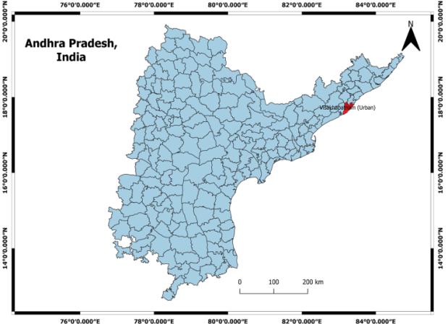 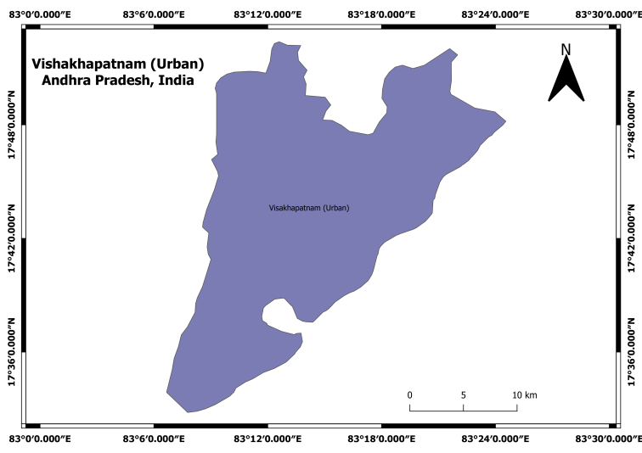

Figure 1: Map of Our Study Area: Vishakhapatnam (Urban)

Table 2: Landsat 8 Dataset Description

|  |  |  |  |
| --- | --- | --- | --- |
| **S.N.** | **Acquisition Year** | **Month** | **Cloud Coverage (%)** |
| 1 | 2013 | March | 2.18 |
| 2 | 2014 | March | 0.13 |
| 3 | 2015 | March | 0.29 |
| 4 | 2016 | March | 0.61 |
| 5 | 2017 | March | 1.44 |
| 6 | 2018 | March | 0.24 |
| 7 | 2019 | March | 0.40 |
| 8 | 2020 | April | 2.72 |
| 9 | 2021 | April | 0.07 |
| 10 | 2022 | May | 0.12 |

The study relies on Landsat 8 Collection 2 Level 1 data, a critical resource for Earth observation. These data, originally initiated by NASA and the United States Geological Survey (USGS), have proven invaluable for monitoring Earth’s surface. Landsat 8, also known as the Landsat Data Continuity Mission (LDCM) stands out due to its ability to capture high-quality multispectral and thermal infrared imagery, making it the ideal candidate for tracking LST and UHI.

**a. Methodology for Estimating UHI:**

This section outlines the approach used to measure and analyze the UHI effect. To prepare the data for analysis, we first acquired Landsat 8 Collection 2 Level 1 data for our study area, meticulously selecting scenes with minimal cloud cover. Next, we performed radiometric calibration and atmospheric correction to transform the digital numbers (DN) into top-of-atmosphere (TOA) reflectance values. Images are handled as units of absolute radiance, processed through 32-bit floating-point computations. Following this initial processing step, these values are converted into 16-bit integer values as part of the finalization of the Level 1 product. The conversion of these integer values to spectral radiance is carried out using the radiance scaling factors, which are thoughtfully provided in the metadata file. This transformation is achieved using Equation (1) (Solangi et al., 2019).

 (1)

Where:

*Lλ*: Top of Atmosphere (TOA) Spectral Radiance (*Wm−2sr−1µm−1*).

*ML*: The Radiance multiplicative scaling factor for the band.

*AL*: The Radiance additive scaling factor for the band.

*Qcal*: The Level 1 pixel value in DN.

Before the early 2014 update, researchers had been counseled to apply corrections to the calibrated radiance values from Landsat 8's TIRS thermal bands (Band 10 and Band 11) to improve their accuracy. These corrections are vital to bringing the radiance values toward the actual radiance tiers (Solangi et al., 2019).

For data collected prior to 2014, specific corrections need to be made to the calibrated radiance values to ensure accuracy:

For TIRS Band 10:

CodeCogsEqn (4)

For TIRS Band 11:



The corrections were based on comparisons with surface water temperatures, resulting in a -2.1 K adjustment for Band 10 and a -4.4 K (Kelvin) adjustment for Band 11, assuming a brightness temperature of 295 K. The rms variability in the required adjustment was approximately 0.12 (*Wm−2sr−1µm−1*) (0.8 K) for Band 10 and 0.2 (*Wm−2sr−1µm−1*) (1.75 K) for band 11. Notably, these adjustments are scene-dependent and likely related to out-of-field responses in the TIRS instrument (Solangi et al., 2019).

As calibration issues were addressed, these adjustments are no longer necessary for data acquired after the early 2014 update. Since we have taken the data from 2014 to 2023 here, we have used Equation (1) for the LST calculation.

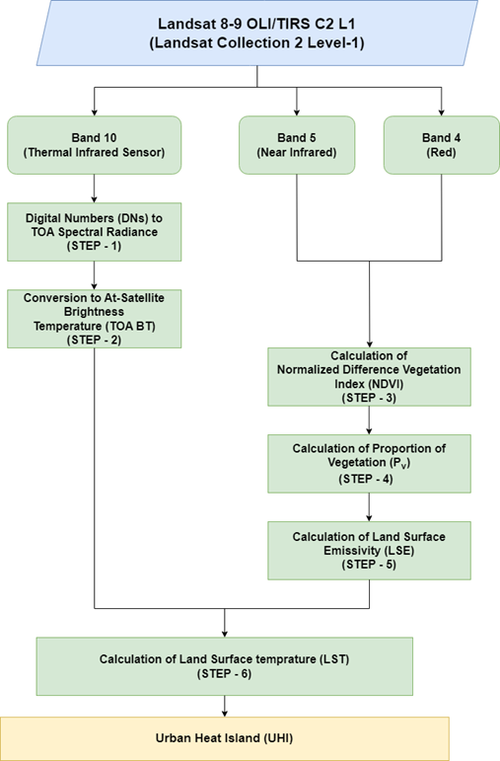

Figure 2: Flowchart Illustrating the Stepwise Methodology for UHI Estimation.

**b. Top of Atmosphere Brightness Temperature (*TOA_BT*) Calculation:**

*TOA_BT* is the temperature of an object as viewed from a satellite, assuming it has a surface that radiates heat effectively at all wavelengths. This temperature can be calculated using the *Lλ* (Ndossi & Avdan, 2016).

*TOA_BT = $\frac{K2}{ln⁡(\frac{K1}{L_{λ}}+1)}$*  (2)

Where:

*K1, K2* = Band-specific thermal conversion constant.

*TOA_BT* = Brightness temperature in Kelvin (K).

The thermal constants, K1 and K2, necessary for calculating TOA BT, are available in the corresponding metadata file. Equation (2) provides the brightness temperature in Kelvin (K). To convert it to degrees Celsius, you can use the following formula:

*TOA_BT°C = TOA_BT − 273.15* (3)

Where:

*TOA_BT°C*: Brightness temperature in degrees Celsius (°C).

From now on, in the following sections, TOA_BT will refer to the temperature in degrees Celsius. Equation (3) allows us to calculate the TOA brightness temperature, which is crucial for further thermal analysis.

**c. Calculating NDVI:**

Here, we discuss the methodology for NDVI calculation and its relevance to our analysis. NDVI can be calculated at different spatial scales: scene-wise (entire Landsat image) and region-wise (smaller subareas within the image). The choice of scale depends on the re-search objectives and the detail required for the analysis (Zhang et al., 2006), (Kalpoma & Rahman, 2021).

Our research has adopted a region-wise approach to calculate NDVI. This approach will help us identify areas most affected and develop effective mitigation strategies to address the problem. The NDVI is calculated using the formula:

NDVI = $\frac{NIR-RED}{NIR+RED}$ (4)

Where:

NIR represents the near-infrared band,

RED represents the red band.

**d. Calculating the Proportion of Vegetation (*Pv)*:**

The *Pv*, often referred to as the Vegetation Fraction, is a crucial parameter to understand the impact of vegetation on the local environment. It indicates the proportion of ground area covered by vegetation in the vertical view (Neinavaz et al., 2020). In the context of our study, *Pv* plays a central role in assessing its influence on LST and UHI formation. Our study estimates *Pv* using a methodology based on NDVI values as in Equation (5). NDVI provides a reliable measure of vegetation density, making it a suitable proxy for calculating *Pv*.

*Pv* = *(NDVI – NDVImin / NDVImax − NDVImin) 2*  (5)

Here, NDVI is the actual NDVI value calculated from Equation (4). NDVImin and NDVImax refer to the minimum and maximum NDVI values, respectively.

**e. Land Surface Emissivity (*LSE*) Calculation:**

In the context of remote sensing and satellite data, emissivity is a crucial parameter for estimating LST. To obtain the LST from TOA brightness temperature, we need to account for LSE. LSE represents the emissivity of various land surface materials, such as soil, vegetation, and water (Dash, 2005). LSE can be estimated using the NDVI, as it reflects the greenness of land surfaces and helps identify the materials making up those surfaces (Nse et al., 2020). For NDVI values below 0.2, which indicate bare soil, emissivity can be calculated from reflectivity in the red band. When NDVI exceeds 0.5, indicating a surface mostly covered by vegetation, a constant emissivity value, often 0.99, is typically used (Yu et al., 2014). For NDVI values between 0.2 and 0.5, LSE can be linked to NDVI and the vegetation fraction (*Pv*) as described by (Sobrino et al. 2004).

**f. LST Calculation:**

As we move forward, we will focus on the pivotal step of LST calculation. LST, which represents the temperature of the Earth’s surface, is a fundamental parameter for assessing

UHI effect. It provides insights into the thermal characteristics of the land, which is critical for understanding temperature variations in urban environments. We have already gone through the data preprocessing and emissivity calculation steps. Now, here, we will focus on the final step - calculating LST using the provided *TOA_BT* and *LSE* values. The calculation of LST is based on the Stefan-Boltzmann law. It involves the use of at-sensor brightness temperature TOA BT), wavelength (λ) of emitted radiance, and *LSE* values. The formula for LST in Equation (6) is given by (Stathopoulou & Cartalis, 2007), (Azua et al., 2020).

*LST* = $\frac{TOA_BT}{1+ \frac{λ*TOA BT*ln⁡(LSE) }{ρ}}$ (6)

Where:

λ: Wavelength of emitted radiance (typically λ = 10.895 [20])

The constant ρ is calculated as:

ρ = hc/σ = 1.438 × 10−2 m · K

Where:

σ: Boltzmann constant (1.38 × 10−23 J/K)

h: Planck’s constant (6.626 × 10−34 J s)

c: Speed of light (2.998 × 108 m/s)

These constants are fundamental in the calculation of ρ and play a crucial role in determining LST.

**g. Quantifying the Urban Heat Island Effect:**

We use several statistical and machine learning techniques to figure out the UHI effect. These include the 1-Sigma and 2-Sigma deviation methods as well as the Gaussian Mixture Model (GMM). These methods help us understand how big the UHI is by looking at LST data. They also help us spot urban areas that are much hotter than the rural or less-developed areas around them.

In the 1-Sigma method (LST > mean + 1σ), we identify areas where the LST exceeds one standard deviation above the mean. To find more extreme UHI effects, we use the 2-sigma method (LST > mean + 2σ), which pinpoints regions where the LST exceeds two standard deviations above the mean. The 2-sigma method helps to identify the heart of the UHI where temperature differences stand out the most due to things like packed buildings few plants and high energy use. Besides 1-Sigma and 2-Sigma, we've applied the Gaussian Mixture Model (GMM). This method is a bit fancier and sees the LST data as a mix of several Gaussian distributions. It helps to tell apart different heat patterns in the area we're studying, like city centers, suburbs, and countryside. The intersection of the two Gaussian components helps in accurately dividing the study area into two distinct zones areas with lower temperatures and areas with higher temperatures, which are typically urban zones with a strong UHI effect. The GMM assigns each pixel a probability of belonging to either the lower or higher temperature regime based on the fitted Gaussian distributions. The threshold where these two distributions intersect is used as the boundary between areas dominated by urban heat and cooler rural surroundings, effectively dividing the landscape into UHI and non-UHI regions.

Results and Discussion

This section explores the LST and Urban UHI effects in the Vishakhapatnam urban area between 2014 and 2023. Our analysis focuses on several important aspects, beginning with year-by-year changes in LST during this period. We’ve gathered data for specific dates, mostly in March, but when cloud cover or other issues made that difficult, we extended the collection to April and May. We’ll also look at the NDVI, a key measure of vegetation health. By analyzing trends in NDVI over the same timeframe, we can better understand how vegetation has fluctuated in the area. We also use the Normalized Difference Built-up Index (NDBI) to monitor changes in built-up areas. We examine how the NDBI trends reflect regional shifts in land cover and how these relate to urban expansion and other factors. Together, these insights will provide a comprehensive picture of how Vishakhapatnam's landscape has evolved over the last decade. Please note that all the graphs and maps presented in this chapter use the Coordinate Reference System (CRS): EPSG:4326 - WGS 84 - Geographic coordinate system. For generating the maps, we utilized the QGIS software tool.

Table 3: Estimated LST Variation for Vishakhapatnam Urban Area

|  |  |  |  |  |
| --- | --- | --- | --- | --- |
| Date | Min. LST (°C) | Max. LST(°C) | Mean LST (°C) | Std. Dev. |
| 26-03-2014 | 24.01 | 38.41 | 31.61 | 2.45 |
| 13-03-2015 | 24.31 | 40.45 | 32.30 | 2.61 |
| 16-04-2016 | 24.62 | 38.82 | 33.51 | 2.29 |
| 05-05-2017 | 22.65 | 37.26 | 31.30 | 2.31 |
| 05-03-2018 | 24.40 | 42.77 | 33.41 | 2.63 |
| 25-04-2019 | 25.14 | 41.95 | 32.57 | 2.35 |
| 26-03-2020 | 24.76 | 39.55 | 31.05 | 2.37 |
| 29-03-2021 | 25.36 | 37.81 | 31.36 | 1.98 |
| 16-03-2022 | 25.83 | 44.74 | 33.43 | 2.65 |
| 03-03-2023 | 24.39 | 38.50 | 30.11 | 2.08 |

Table 3 provides a summary of LST statistics, including the minimum, maximum, mean, and standard deviation of LST for each year. These statistics offer insight into the temperature dynamics experienced by the urban area over the years.

Figure 3 presents a candlestick graph that visualizes the variation in LST and identifies UHI hotspots. In this graph, each candlestick represents a specific year, showing the min- imum, maximum, and mean LST values. The height of the candlestick body represents the range between the minimum and maximum LST, while the vertical lines (whiskers) extend from the body to show variability. Additionally, we present year-wise LST plots in Figure 4 to provide a detailed view of LST patterns over time. Figure 4(a) to 4(j) comprises ten subplots arranged in a grid, each showing the LST for a specific year and date combination. We have divided the LST into five categories as presented in the legend of each LST plot. LST ranges are: 20.00 °C – 25.00 °C, 25.00 °C – 30.00 °C, 30.00 °C – 35.00 °C, 35.00 °C – 40.00 °C, and 40.00 °C – 45.00 °C.

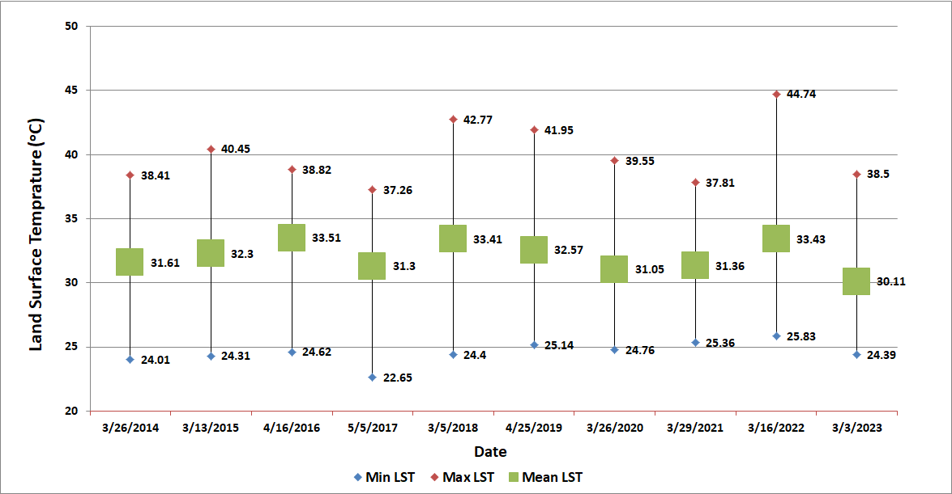

Figure 3: Land Surface Temperature Variation of Vishakhapatnam (Urban): 2014-2023.

An UHI refers to a region within a city or metropolitan area where temperatures are notably higher compared to the surrounding rural or less developed areas. The Urban Heat Island Intensity (UHII) is a localized warming phenomenon observed in urban areas, primarily attributed to several factors. These include radiative trapping, increased heat retention, reduced vegetation cover, minimal surface permeability, and concentrated heat generated by human activities. In our investigation, we performed stack profiling for validation on LST for our study area to identify and analyze UHI. Stack profiling allows us to assess how LST varies within specific zones compared to their surrounding perimeter areas.

We used the 1-Sigma analysis to identify areas in Vishakhapatnam where temperatures were significantly higher than average, specifically focusing on regions where the LST was more than one standard deviation above the city's mean. The 1-Sigma statistics has been shown in Table 4. This approach helped us track how the UHI effect changed over the years from 2014 to 2023.

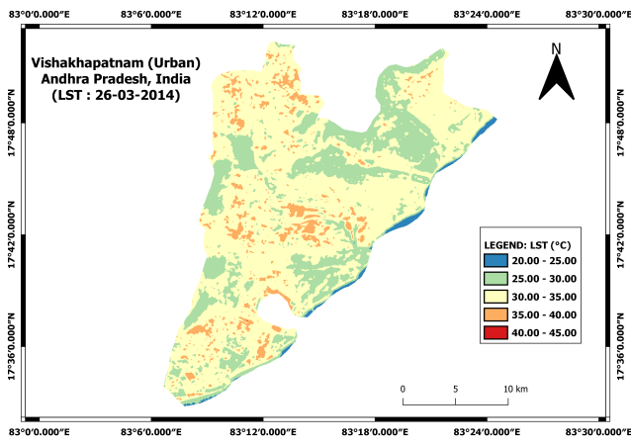 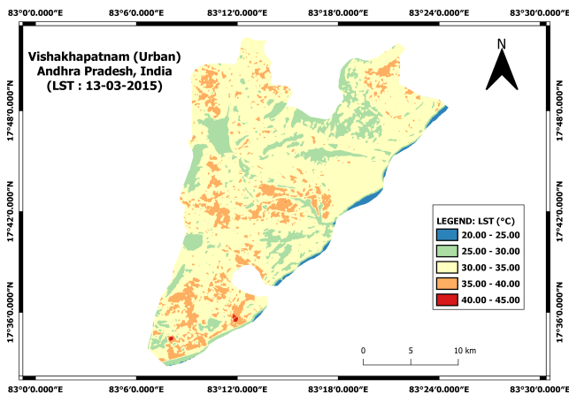

(a) LST: 26-03-2014 (b) LST: 13-03-2015

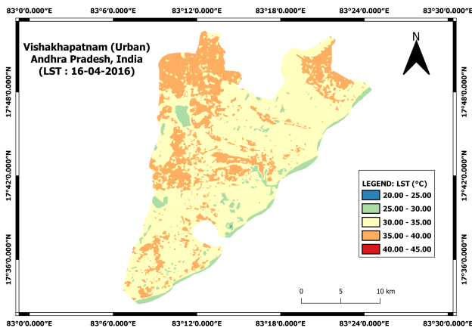 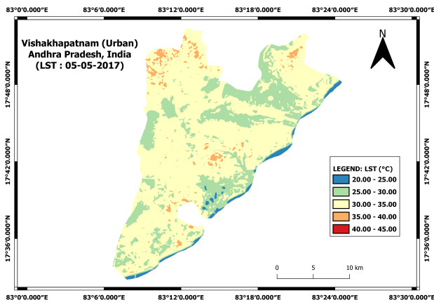

(c) LST: 16-04-2016 (d) LST: 05-05-2017

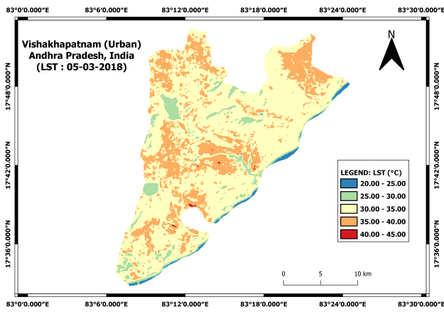 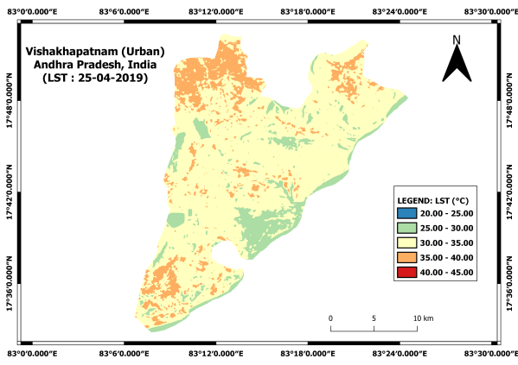

(e) LST: 05-03-2018 (f) LST: 25-04-2019

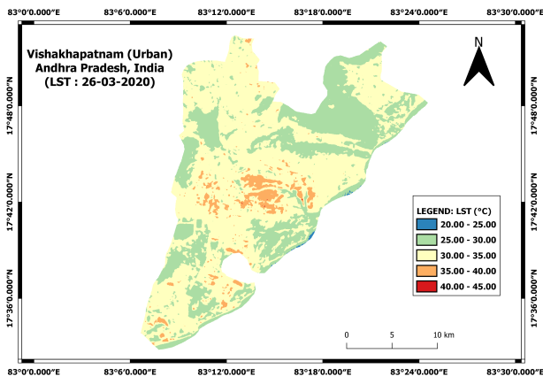 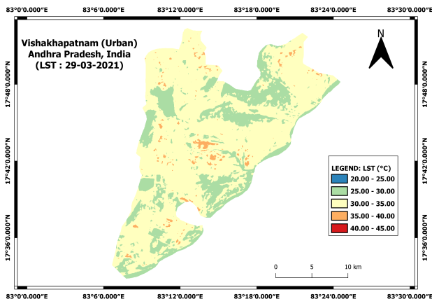

(g) LST: 26-03-2020 (h) LST: 29-03-2021

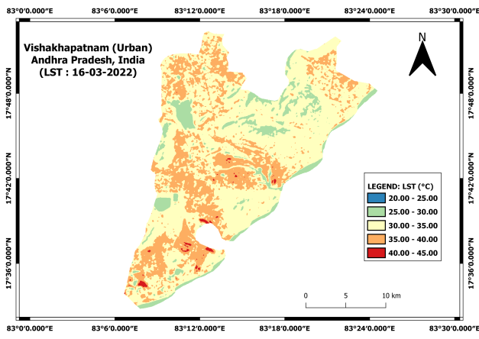 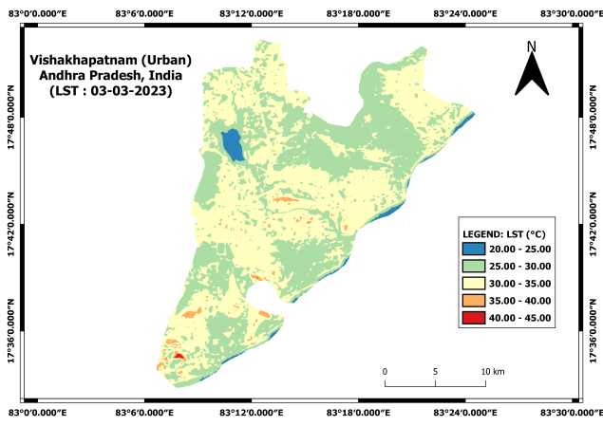

(i) LST: 16-03-2022 (j) LST: 03-03-2023

Figure 4: LST of Vishakhapatnam (Urban) Area for Selected Dates

During this period, the 1-Sigma threshold, which marks elevated temperatures, varied between 32.21°C in 2023 and 36.14°C in 2022. The size of the affected areas also shifted, ranging from 75.34 sq. km in 2023 to 88.64 sq. km in 2014. Although the threshold temperature generally increased, showing rising heat levels, the size of the UHI-affected areas fluctuated, likely due to changes in urban growth, vegetation, and surface characteristics. For instance, in 2015, even though the threshold rose to 34.91°C, the UHI-affected area shrank to 77.38 sq. km, indicating fewer regions experienced extreme heat. Figures 5 illustrate the distribution of GMM and 1-Sigma methods. We can see how 1–Sigma threshold separates these zones, clearly marking the boundary between areas with cooler and warmer temperatures. This distinction aligns with variations in urban structures, such as dense built-up areas and vegetated regions.

Table 4: Decadal 1-Sigma Statistics for the Study Area.

|  |  |  |
| --- | --- | --- |
| Year | **1-Sigma Threshold (°C)** | **1-Sigma Area (sq. km)** |
| 26-03-2014 | 34.068 | 88.636 |
| 13-03-2015 | 34.909 | 77.384 |
| 16-04-2016 | 35.805 | 77.845 |
| 05-05-2017 | 33.609 | 79.43 |
| 05-03-2018 | 36.027 | 76.354 |
| 25-04-2019 | 34.953 | 84.01 |
| 26-03-2020 | 33.443 | 83.188 |
| 29-03-2021 | 33.361 | 82.388 |
| 16-03-2022 | 36.142 | 76.645 |
| 03-03-2023 | 32.209 | 75.34 |

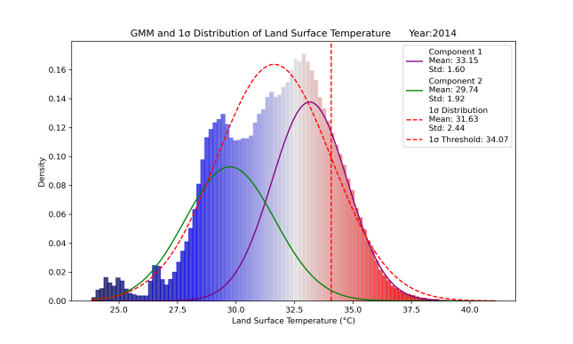 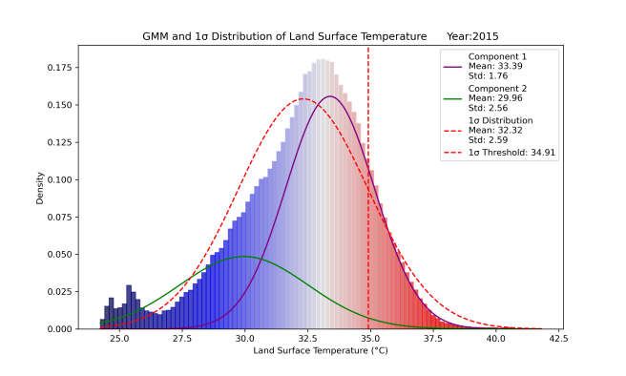

(a) 1-Sigma Threshold: 26-03-2014 (b) 1-Sigma Threshold: 13-03-2015

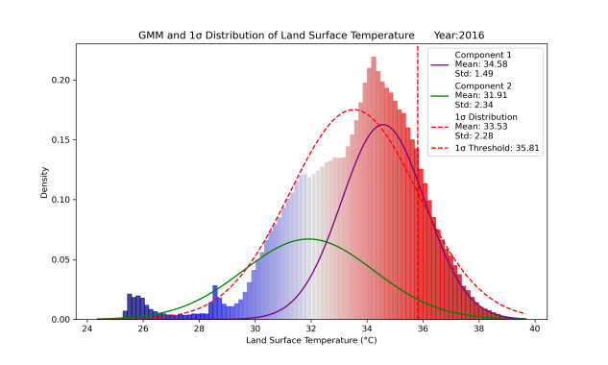 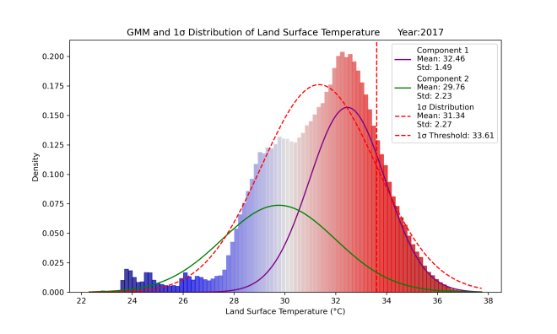

(c) 1-Sigma Threshold: 16-04-2016 (d) 1-Sigma Threshold: 05-05-2017

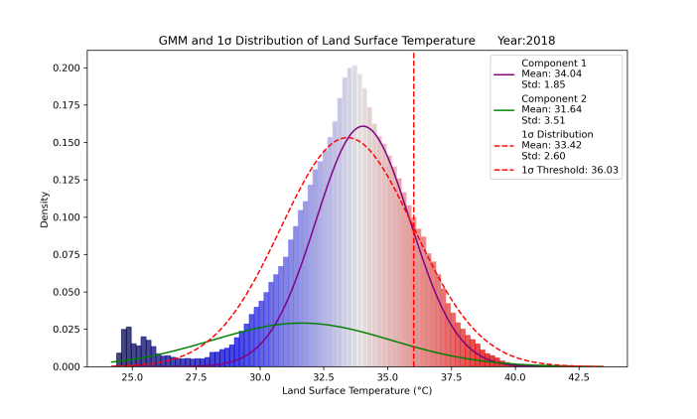 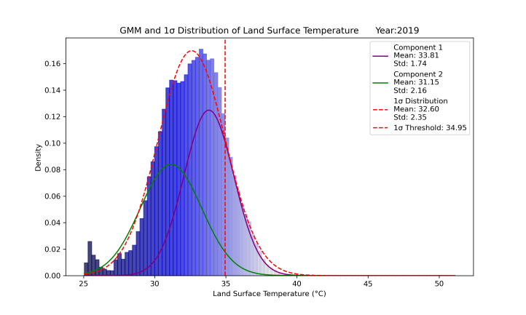

(e) 1-Sigma Threshold: 05-03-2018 (f) 1-Sigma Threshold: 25-04-2019

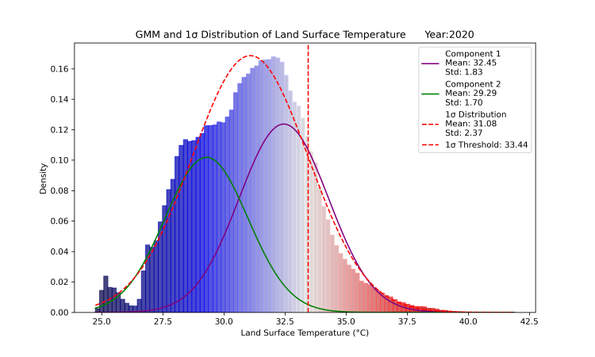 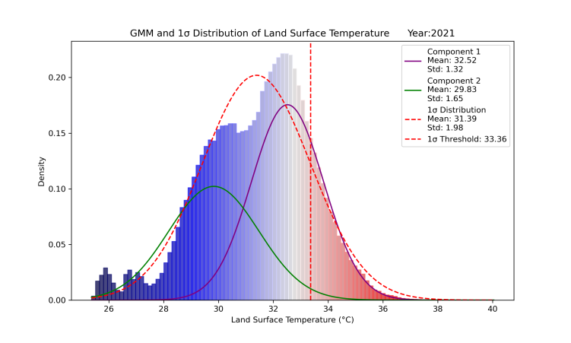

(g) 1-Sigma Threshold: 26-03-2020 (h) 1-Sigma Threshold: 29-03-2021

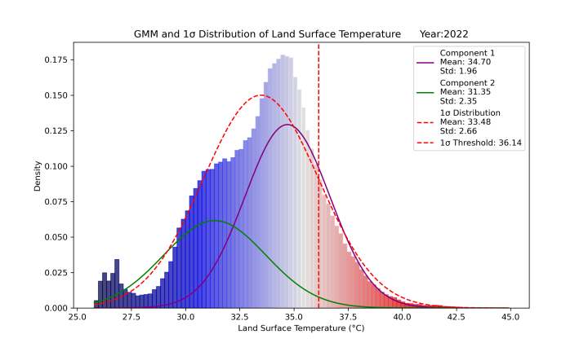 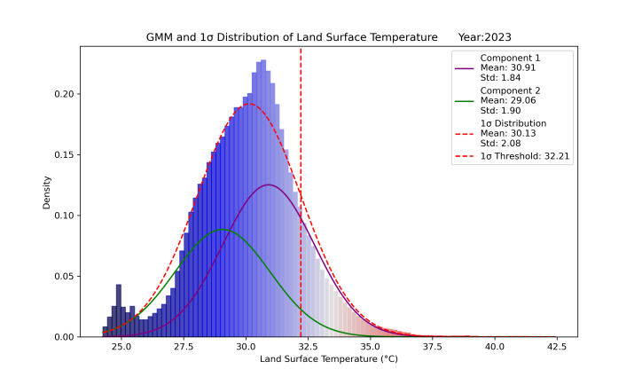

(i) 1-Sigma Threshold: 16-03-2022 (j) 1-Sigma Threshold: 03-03-2022

Figure 5: 1-Sigma and GMM threshold plots for the Study Area.

Figures 6 illustrate the UHI effect in the study area using the 1-Sigma threshold. The red spots on the maps represent the hottest regions, or "heat islands," showing how these high-temperature zones have changed over time. These maps highlight areas where temperatures are significantly higher than the surrounding landscape. By focusing on this temperature distribution, we were able to clearly distinguish between areas with lower and higher temperatures, helping us better understand how different urban characteristics—such as dense buildings and green spaces—contribute to these variations.

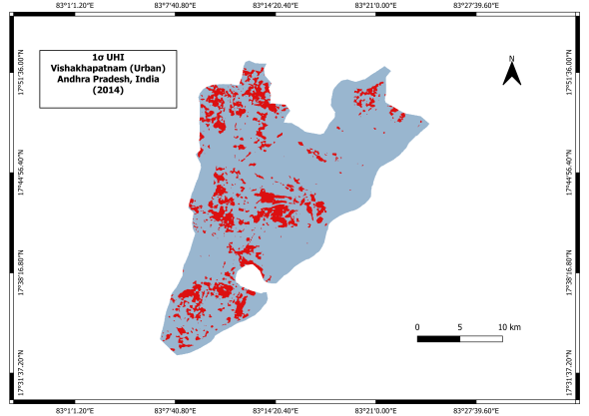 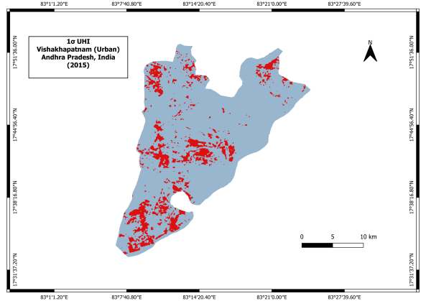

(a) 1-Sigma UHI: 26-03-2014 (b) 1-Sigma UHI: 13-03-2015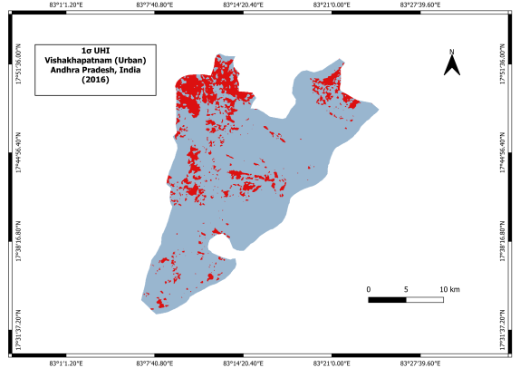 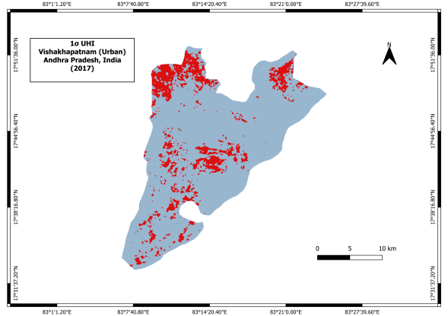

(c) 1-Sigma UHI: 16-04-2016 (d) 1-Sigma UHI: 05-05-2017

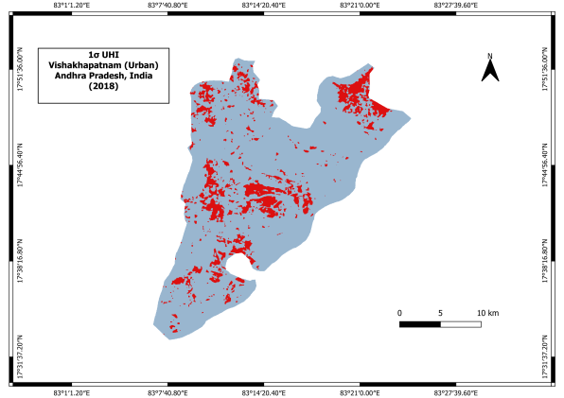 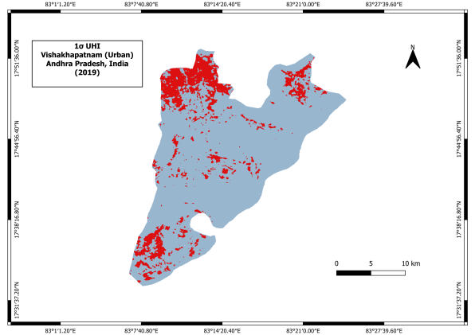

(e) 1-Sigma UHI: 05-03-2018 (f) 1-Sigma UHI: 25-04-2019

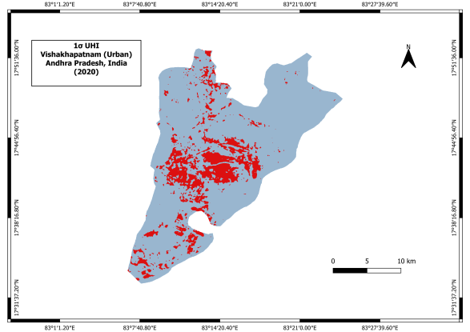 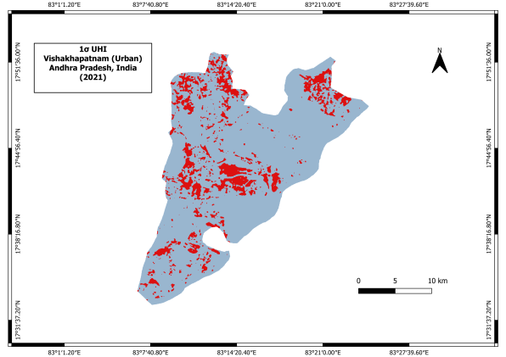

(g) 1-Sigma UHI: 26-03-2020 (h) 1-Sigma UHI: 29-03-2021

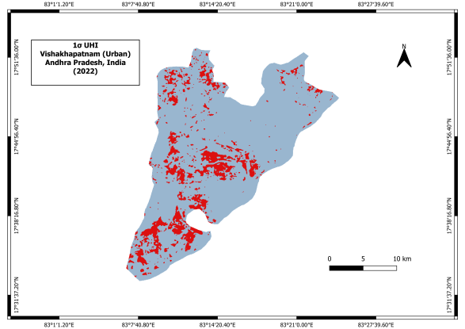 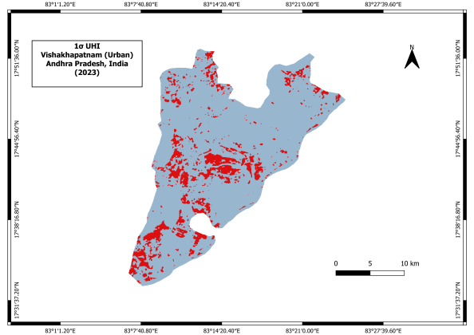

(i) 1-Sigma UHI: 16-03-2022 (j) 1-Sigma UHI: 03-03-2023

Figure 6: 1-Sigma UHI for the Study Area.

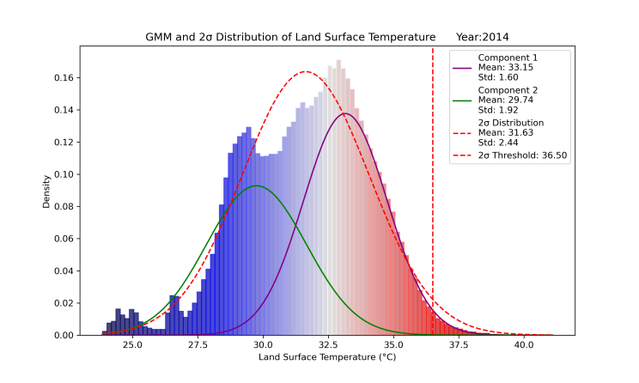 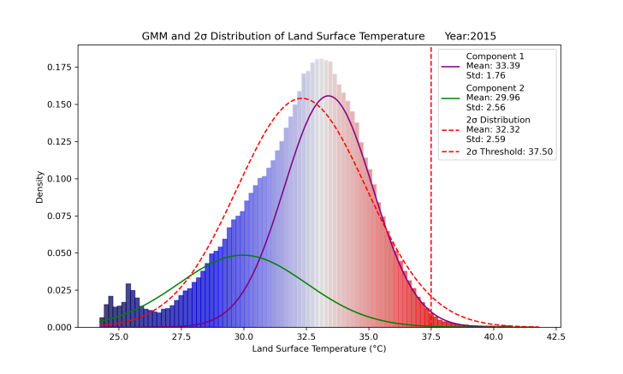

(a) 2-Sigma Threshold: 26-03-2014 (b) 2-Sigma Threshold: 13-03-2015

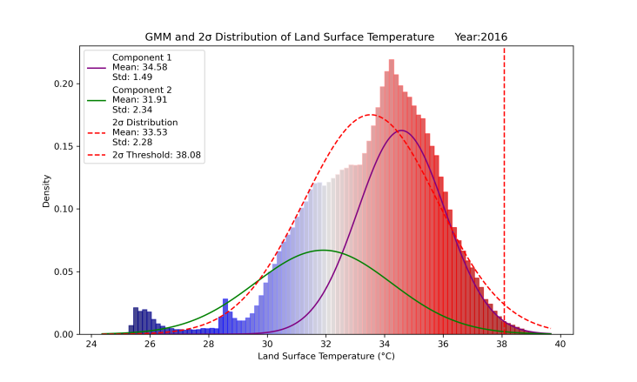 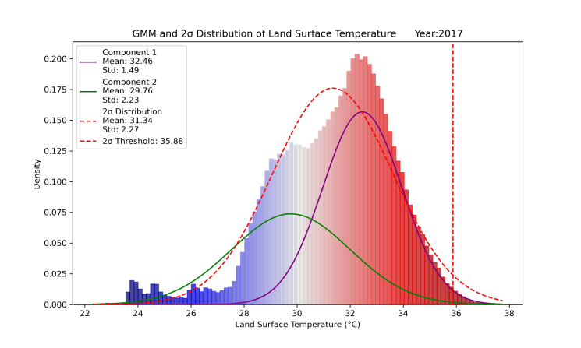

(c) 2-Sigma Threshold: 16-04-2016 (d) 2-Sigma Threshold: 05-05-2017

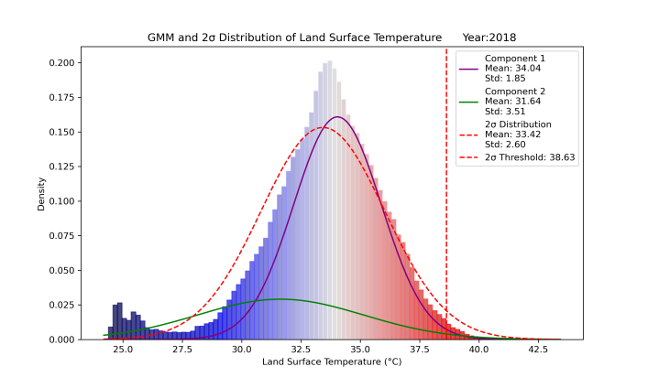 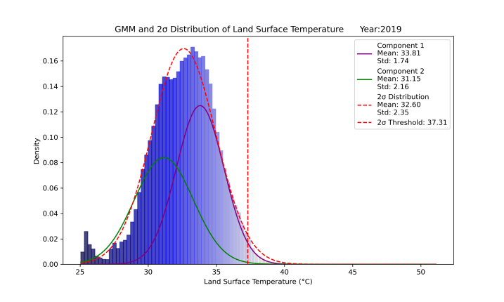

(e) 2-Sigma Threshold: 05-03-2018 (f) 2-Sigma Threshold: 25-04-2019

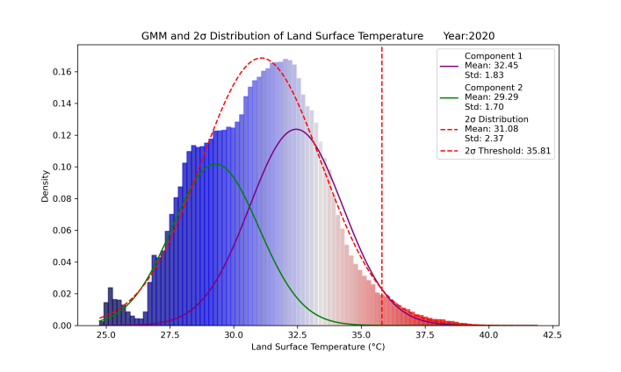 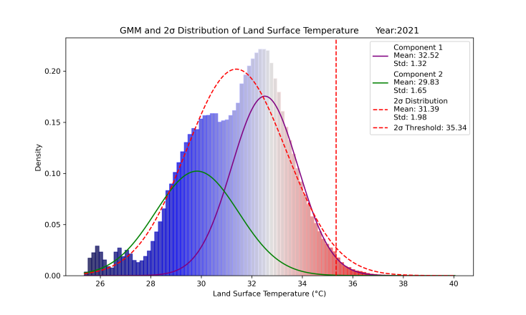

(g) 2-Sigma Threshold: 26-03-2020 (h) 2-Sigma Threshold: 29-03-2021

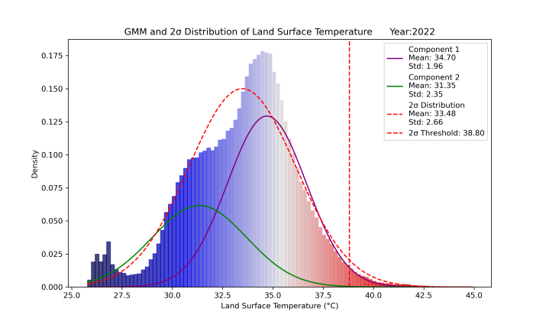 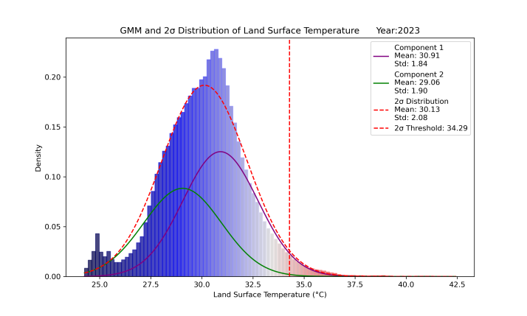

(i) 2-Sigma Threshold: 16-03-2022 (j) 2-Sigma Threshold: 03-03-2023

Figure 7: 2-Sigma and GMM threshold plots for the Study Area.

Furthermore, our 2-Sigma analysis on LST reveals the most intense heat zones in Vishakhapatnam from 2014 to 2023. The 2-Sigma thresholds ranged from 34.29°C in 2023 to 38.80°C in 2022, with extreme heat areas varying between 3.03 sq. km and 13.91 sq. km. The 2-Sigma statistics has been shown in Table 5. These extreme zones are smaller but highlight areas with the highest temperatures. As we have seen that 1-Sigma identifies broader regions with elevated temperatures, with thresholds from 32.21°C to 36.14°C and coverage between 75.34 sq. km and 88.64 sq. km.

Figure 7 shows 2-Sigma distribution from 2014 to 2023 and corresponding 2-Sigma statistics has been shown in Table 5. It illustrates how these extreme heat areas have evolved over time. For instance, the 2020 plot highlights a significant increase in the 2-Sigma area to 13.91 sq. km, despite a relatively lower threshold. This is visualized in the corresponding UHI in Figure 8, which shows how the most heat-affected regions align with changes in urban development and land cover.

Table 5: Decadal 2-Sigma Statistics for the Study Area.

|  |  |  |
| --- | --- | --- |
| Year | **2-Sigma Threshold (°C)** | **2-Sigma Area (sq. km)** |
| 26-03-2014 | 36.504 | 5.728 |
| 13-03-2015 | 37.499 | 3.960 |
| 16-04-2016 | 38.083 | 3.030 |
| 05-05-2017 | 35.875 | 3.293 |
| 05-03-2018 | 38.631 | 4.919 |
| 25-04-2019 | 37.305 | 7.759 |
| 26-03-2020 | 35.810 | 13.906 |
| 29-03-2021 | 35.336 | 6.078 |
| 16-03-2022 | 38.801 | 8.850 |
| 03-03-2023 | 34.288 | 13.54 |

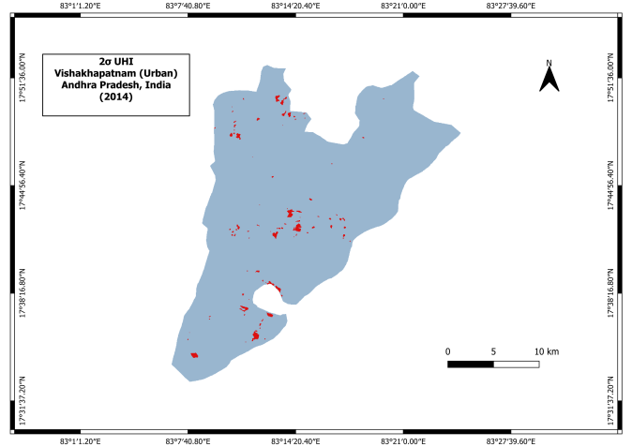 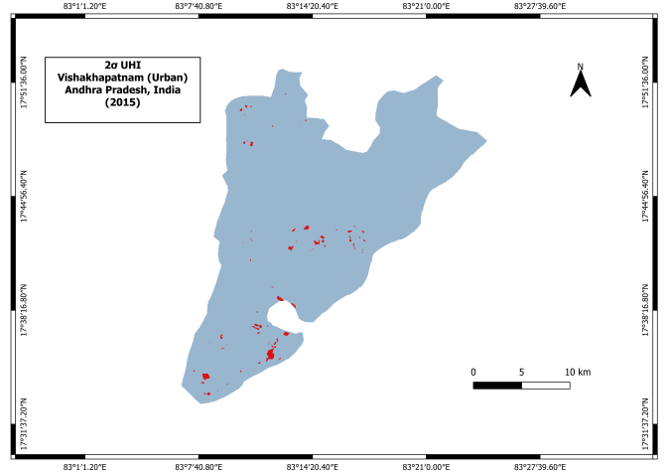

(a) 2-Sigma UHI: 16-03-2022 (b) 2-Sigma UHI: 03-03-2022

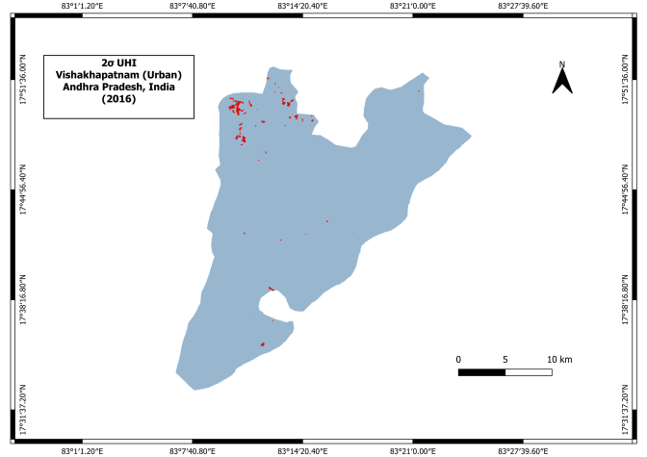 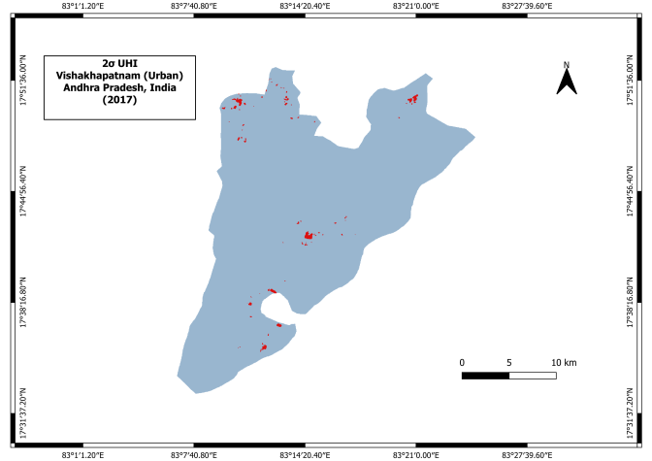

(c) 2-Sigma UHI: 16-04-2016 (d) 2-Sigma UHI: 05-05-2017

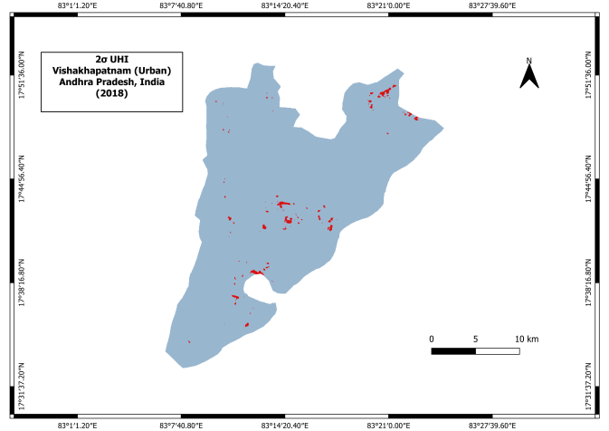 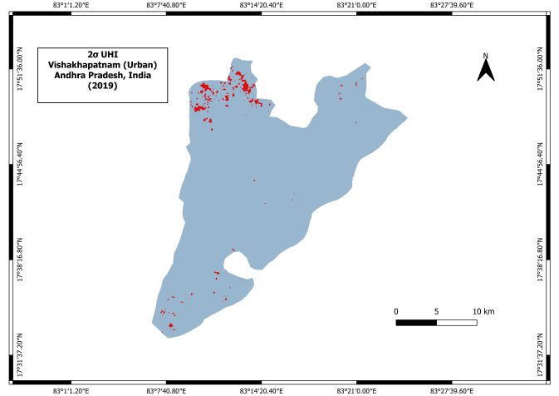

(e) 2-Sigma UHI: 05-03-2018 (f) 2-Sigma UHI: 25-04-2019

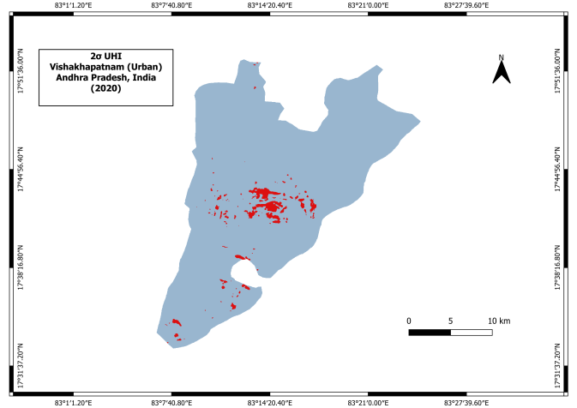 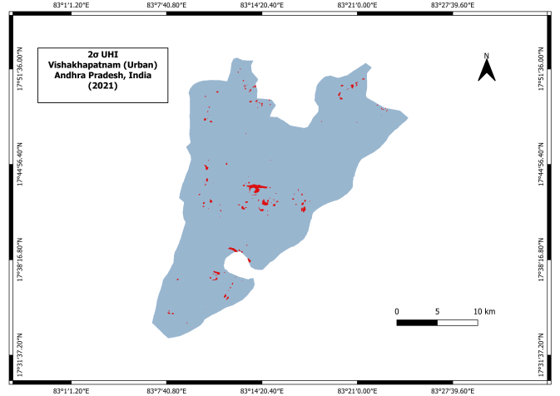

(g) 2-Sigma UHI: 26-03-2020 (h) 2-Sigma UHI: 29-03-2021

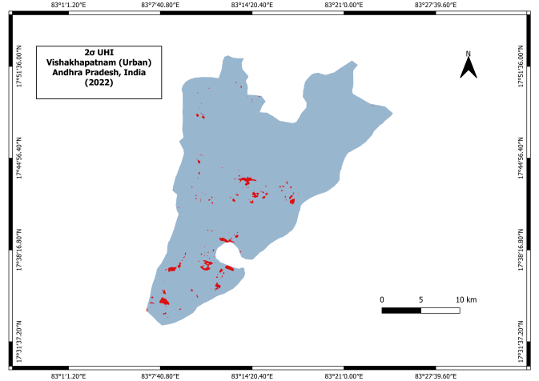 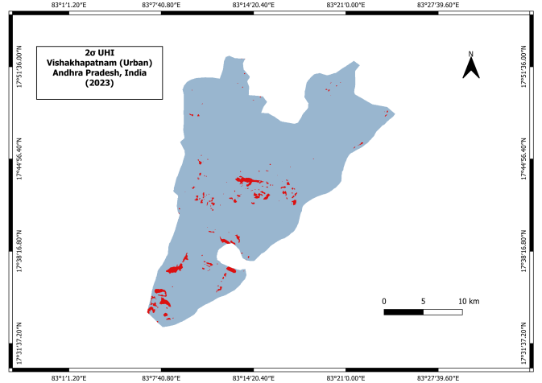

(i) 2-Sigma UHI: 16-03-2022 (j) 2-Sigma UHI: 03-03-2023

Figure 8: 2-Sigma UHI for the Study Area.

We further validated the 1-Sigma, 2-Sigma, and GMM UHI results by conducting stack profiling on 2022 LST data, in specific heat island zones within Vishakhapatnam's urban area. This method allowed us to visualize how LST varied within selected regions compared to their surroundings, helping us clearly identify UHIs — areas with noticeably higher temperatures.

As shown in Figure 9, we selected eight lines across the city for profiling, marked 1 to 8. These lines intersect potential UHI zones, identified through 1-Sigma, 2-Sigma, and GMM analysis, with the red line highlighting the most prominent heat island effects. Through this profiling, we observed temperature spikes ranging from 2°C to 3°C higher than the adjacent areas, confirming the presence of UHIs . These temperature anomalies are primarily linked to urban infrastructure, buildings, roads, and reduced greenery, which trap more heat.

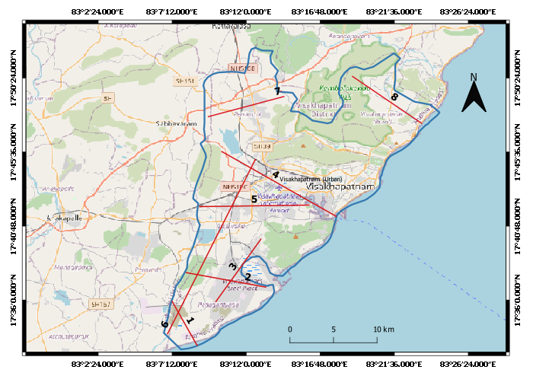

*Source: OpenStreet Basemap*

Figure 9: Selected eight Candidate lines in potential UHI zone identified by 1-Sigma, 2-Sigma and GMM.

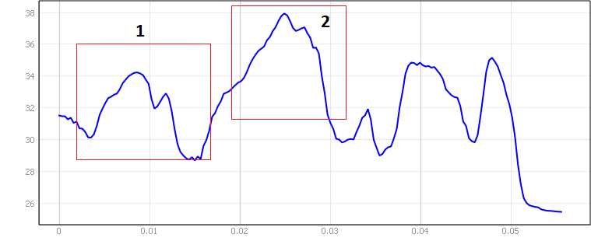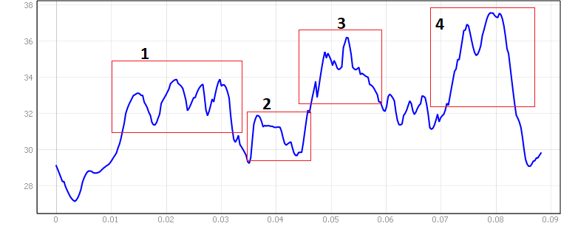

(a) Stack Profile for Line 1. (b) Stack Profile for Line 1.

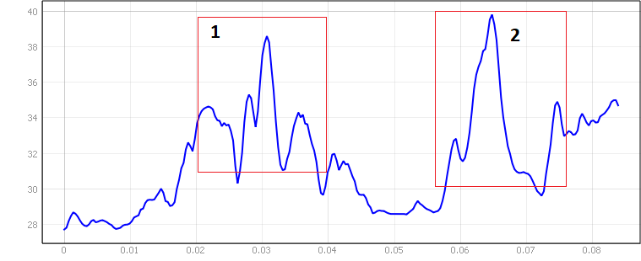 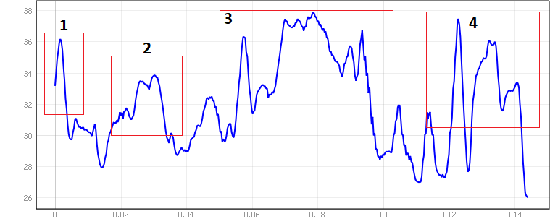

(c) Stack Profile for Line 3. (d) Stack Profile for Line 4.

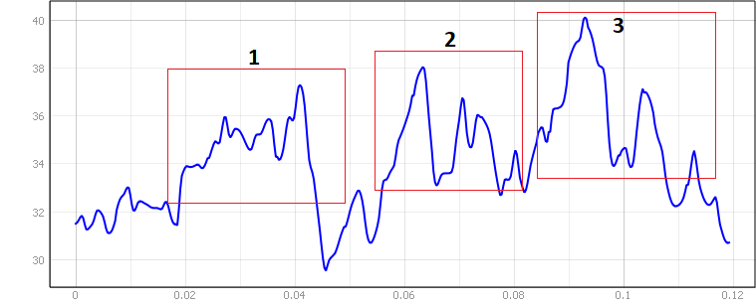 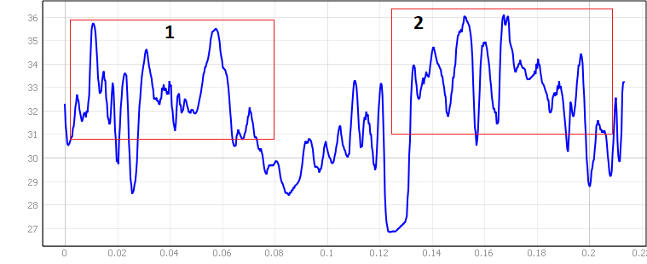

(e) Stack Profile for Line 5. (f) Stack Profile for Line 6.

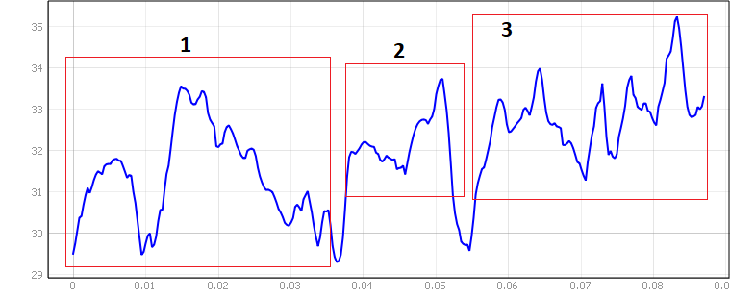 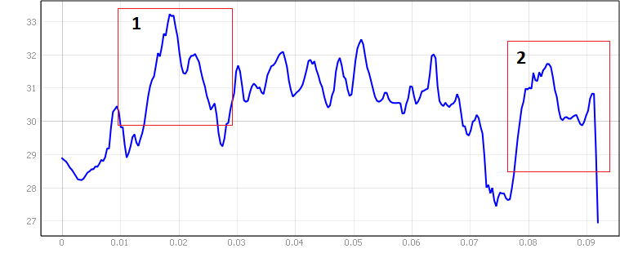

(g) Stack Profile for Line 7. (h) Stack Profile for Line 8.

Figure 10: Stack Profiling on potential UHI zones, Identified through 1-Sigma, 2-Sigma, and GMM Analysis.

Figure 10 presents the stack profiling results, with the Y-axis representing LST in °C and the X-axis corresponding to longitude. To further validate these findings, we cross-referenced with Google Earth imagery in Figure 11, which showed that most of the UHI hotspots are near industrial zones and areas characterized by large concrete surfaces and limited vegetation.

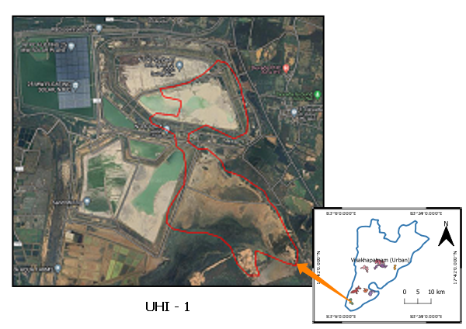 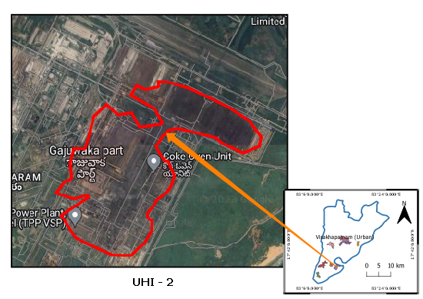

(a) Identified UHI 1. (b) Identified UHI 2.

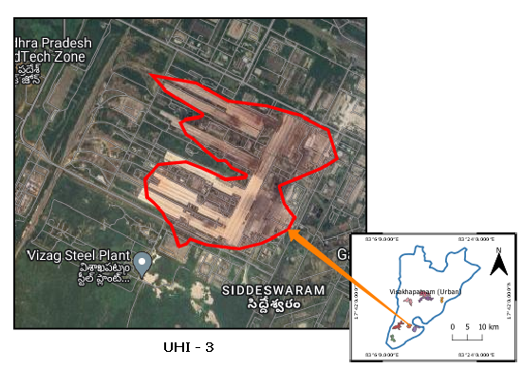 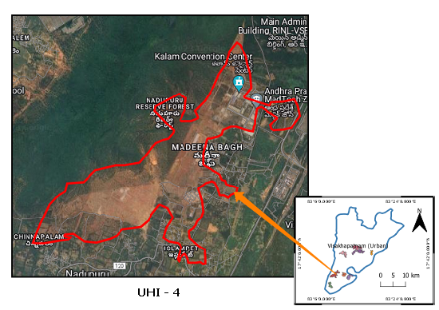

(c) Identified UHI 3. (d) Identified UHI 4.

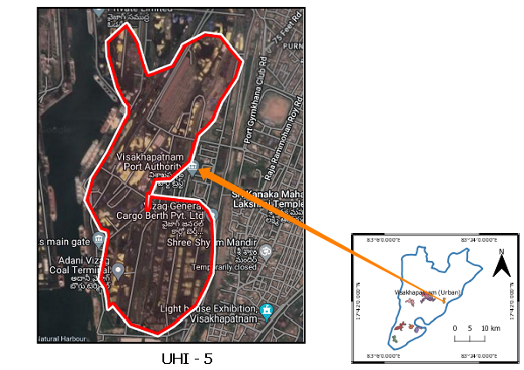 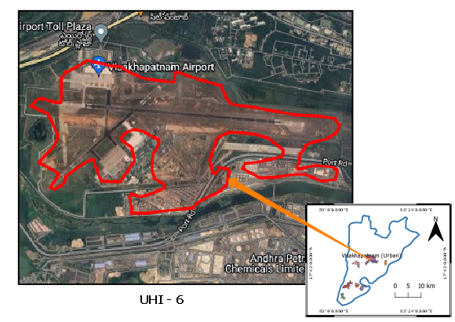

(e) Identified UHI 5. (f) Identified UHI 6.

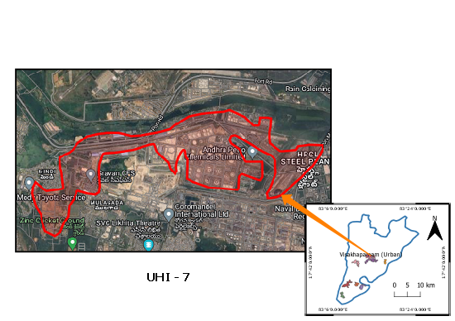 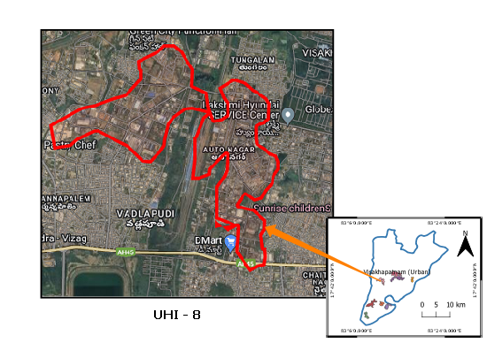

(g) Identified UHI 7. (h) Identified UHI 8.

*Source: Google Earth Imagery.*

Figure 11: Validation of UHI Hotspots Using Google Earth Imagery.

Now we turn our focus to NDVI analysis, which highlights how vegetation impacts temperature patterns in urban areas. Healthy vegetation is known to have a cooling effect, helping to mitigate the UHI effect by lowering surface temperatures. In contrast, areas with lower NDVI values, indicating sparse or degraded vegetation, tend to experience higher temperatures, thereby contributing to UHI.

To assess changes in NDVI within our study area, we utilized Landsat 8 OLI data, specifically Bands 4 (Red) and 5 (NIR), to calculate NDVI values for the years 2014, 2019, and 2023. Our analysis focused on the UHI hotspots identified earlier through 1-Sigma, 2-Sigma, and GMM models. These NDVI values helped us track vegetation changes within these hotspots over the years. As illustrated in Figure 12: Mean NDVI Comparison (2014, 2019, 2023), there is a noticeable decline in NDVI values across all UHI hotspots, indicating a reduction in vegetation from 2014 to 2023.

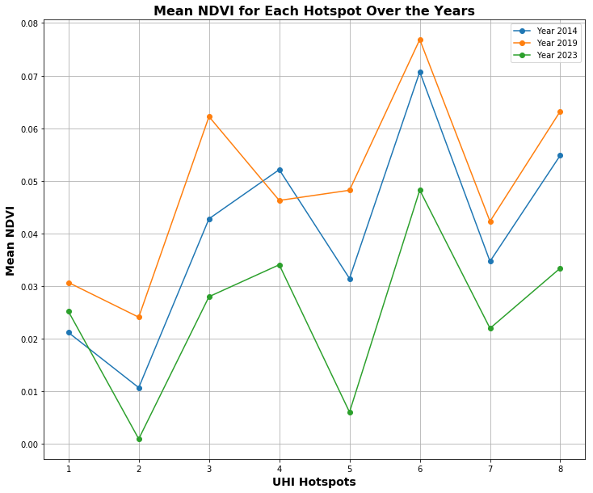

Figure 12: Mean NDVI Comparison (2014, 2019, 2023).

We also explore the relationship between the NDBI and LST to better understand the impact of urbanization on heat distribution in Vishakhapatnam. NDBI, which is a key indicator for identifying built-up areas, helps us measure the extent of urbanization by analyzing the reflectance of different surfaces. It is calculated using Near Infrared (NIR) and Middle Infrared (MIR) reflectance values. The formula for the NDBI is:

NDBI = (NIR - MIR) / (NIR + MIR)

Higher NDBI values indicate areas with more built-up structures, which are known to absorb and retain heat, contributing to increased surface temperatures. To quantify this relationship, we calculated the R-squared values and Pearson’s correlation between NDBI and LST for the years 2014 to 2023. As shown in Table 6, both the slope and intercept of the linear regression model are positive each year, indicating that as NDBI increases. This supports the notion that urbanized areas with more built-up surfaces experience higher temperatures. The R-squared values in Table 6 range from 0.30 to 0.57, meaning that between 30% and 57% of the variation in LST can be explained by changes in NDBI. The Pearson’s correlation values, which range from 0.55 to 0.75, indicate a moderate to strong positive relationship between urban growth (NDBI) and increased temperatures (LST). This correlation, visualized in Figure 12, highlights the consistent trend of urban expansion driving higher heat retention, particularly in areas with limited vegetation and increasing built-up infrastructure.

Table 6: NDBI and Its Correlation with LST: 2014 - 2023.

|  |  |  |  |  |
| --- | --- | --- | --- | --- |
| **Year** | **Slope** | **Intercept** | **R-Squared** | **Pearson’s Corr.** |
| 26-03-2014 | 23.39 | 32.56 | 0.49 | 0.70 |
| 13-03-2015 | 30.17 | 32.71 | 0.56 | 0.75 |
| 16-04-2016 | 20.91 | 34.06 | 0.35 | 0.59 |
| 05-05-2017 | 20.17 | 31.85 | 0.30 | 0.55 |
| 05-03-2018 | 28.41 | 33.86 | 0.45 | 0.67 |
| 25-04-2019 | 21.75 | 33.45 | 0.35 | 0.59 |
| 26-03-2020 | 21.19 | 32.40 | 0.44 | 0.67 |
| 29-03-2021 | 25.30 | 32.33 | 0.54 | 0.74 |
| 16-03-2022 | 27.00 | 34.88 | 0.48 | 0.69 |
| 03-03-2023 | 25.32 | 31.24 | 0.57 | 0.75 |

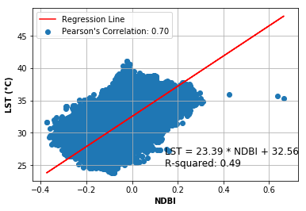 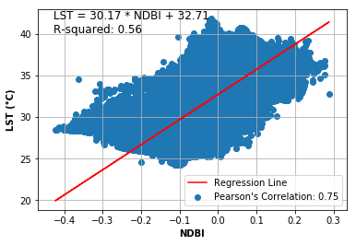

(a) Correlation: NDBI and LST for 2014. (b) Correlation: NDBI and LST for 2015.

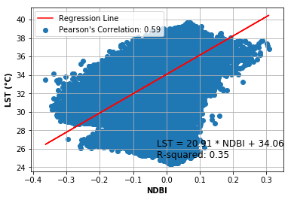 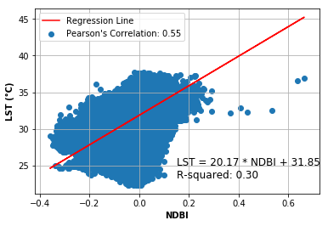

(c) Correlation: NDBI and LST for 2016. (d) Correlation: NDBI and LST for 2017.

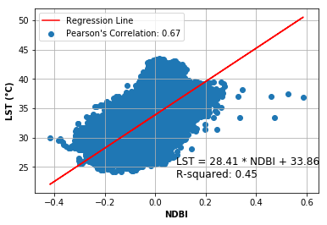 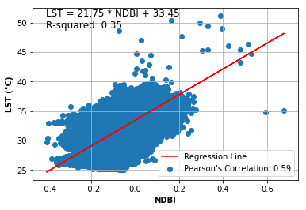

(e) Correlation: NDBI and LST for 2018. (f) Correlation: NDBI and LST for 2019.

 

(g) Correlation: NDBI and LST for 2020. (h) Correlation: NDBI and LST for 2021.

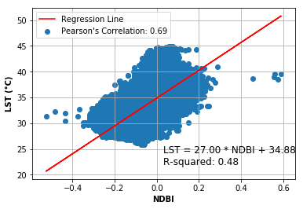 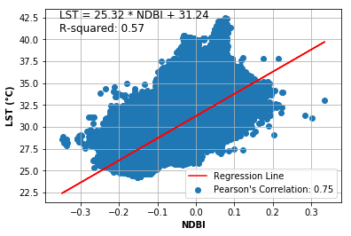

(i) Correlation: NDBI and LST for 2022. (j) Correlation: NDBI and LST for 2023.

Figure 12: Correlation between NDBI and LST from 2014 to 2023.

**Conclusion and Recommendation**

This study examines how urbanization has affected the Urban Heat Island (UHI) effect in Vishakhapatnam between 2014 and 2023, with a focus on changes in land surface temperature (LST), vegetation (NDVI), and built-up areas (NDBI). Using statistical models like 1-Sigma, 2-Sigma, and the Gaussian Mixture Model (GMM), we identified UHI hotspots and validated our results through stack profiling, along with ground verification using Google Earth imagery. Our analysis showed a clear pattern of rising temperatures in the city, with certain regions consistently standing out as UHI hotspots. These hotspots, primarily found in industrial and densely built-up areas, recorded temperature increases of 2-3°C compared to their surroundings. The 1-Sigma and 2-Sigma thresholds helped delineate these areas, while the GMM further distinguished zones with higher and lower temperatures, enhancing the clarity of the findings. The NDVI analysis revealed a worrying trend of decreasing vegetation across all UHI zones, particularly in industrial areas. This decline in green cover, highlighted by significantly lower NDVI values in 2023 compared to 2014, correlates strongly with the intensifying UHI effect. The loss of vegetation not only removes natural cooling effects but also intensifies surface heat in urban areas. In addition, the NDBI analysis confirmed a positive correlation between LST and the built-up index, indicating that regions with more concrete structures and less green space experienced higher temperatures. Pearson’s correlation values ranged from 0.55 to 0.75, further emphasizing the strong link between urban developments and rising temperatures.

The temporal scope of this study spans from 2014 to 2023, providing valuable information on LST variations. However, this duration might not capture long-term climate trends or account for possible climate change effects. A more extended temporal analysis could offer a more comprehensive understanding of evolving UHI dynamics over decades.

References

Azua, S., Nnah, S., & Ikwueze, H. (2020). Spatio-temporal Variability of Landuse Landcover and its Impact on Land Surface Temperature in Zaria Metropolis, Nigeria. *FUTY Journal of the Environment*, *14*(1), 1–11. <https://www.ajol.info/index.php/fje/article/view/201353>

Chen, S., Ren, H., Ye, X., Dong, J., & Zheng, Y. (2021). Geometry and adjacency effects in urban land surface temperature retrieval from high-spatial-resolution thermal infrared images. *Remote Sensing of Environment*, *262*, 112518. <https://doi.org/10.1016/j.rse.2021.112518>

Dash, P. (2005). Land surface temperature and emissivity retrieval from satellite measurements. *Wissenschaftliche Berichte FZKA*, *7095*. <https://doi.org/10.5445/ir/1000001413>

Dutta, K., Basu, D., & Agrawal, S. (2021). Synergetic interaction between spatial land cover dynamics and expanding urban heat islands. *Environmental Monitoring and Assessment*, *193*(4). <https://doi.org/10.1007/s10661-021-08969-4>

Gartland, L. M. (2012). Heat Islands. In *Routledge eBooks*. <https://doi.org/10.4324/9781849771559>

Hu, Y., Hou, M., Jia, G., Zhao, C., Zhen, X., & Xu, Y. (2019). Comparison of surface and canopy urban heat islands within megacities of eastern China. *ISPRS Journal of Photogrammetry and Remote Sensing*, *156*, 160–168. <https://doi.org/10.1016/j.isprsjprs.2019.08.012>

Kalpoma, K. A., & Rahman, A. (2021). *Web-Based monitoring of boro rice production using improvised NDVI threshold of MODIS MOD13Q1 and MYD13Q1 images*. <https://doi.org/10.1109/igarss47720.2021.9553881>

Kaur, R., & Pandey, P. (2021). Spatial trends of surface urban heat island in Bathinda: a semiarid city of northwestern India. *International Journal of Environmental Science and Technology*, *19*(11), 10911–10932. <https://doi.org/10.1007/s13762-021-03742-z>

Li, Z., Wu, H., Duan, S., Zhao, W., Ren, H., Liu, X., Leng, P., Tang, R., Ye, X., Zhu, J., Sun, Y., Si, M., Liu, M., Li, J., Zhang, X., Shang, G., Tang, B., Yan, G., & Zhou, C. (2023). Satellite Remote sensing of global land surface temperature: definition, methods, products, and applications. *Reviews of Geophysics*, *61*(1). <https://doi.org/10.1029/2022rg000777>

Malik, M. S., Shukla, J. P., & Mishra, S. (2019). Relationship of LST, NDBI and NDVI using Landsat-8 data in Kandaihimmat Watershed, Hoshangabad, India. *Indian Journal of Marine Sciences/Indian Journal of Marine Sciences*, *48*(1), 25–31. <http://nopr.niscair.res.in/bitstream>

Morabito, M., Crisci, A., Guerri, G., Messeri, A., Congedo, L., & Munafò, M. (2021). Surface urban heat islands in Italian metropolitan cities: Tree cover and impervious surface influences. *The Science of the Total Environment*, *751*, 142334. <https://doi.org/10.1016/j.scitotenv.2020.142334>

Ndossi, M. I., & Avdan, U. (2016). Application of Open Source Coding Technologies in the Production of Land Surface Temperature (LST) Maps from Landsat: A PyQGIS Plugin. *Remote Sensing*, *8*(5), 413. <https://doi.org/10.3390/rs8050413>

Nse, O. U., Okolie, C. J., & Nse, V. O. (2020). Dynamics of land cover, land surface temperature and NDVI in Uyo City, Nigeria. *Scientific African*, *10*, e00599. <https://doi.org/10.1016/j.sciaf.2020.e00599>

Pawe, C. K. (2019). The Heat is on in the Himalayas: Assessing Srinagar’s Urban Heat Island Effect. In *Springer eBooks* (pp. 157–171). <https://doi.org/10.1007/978-3-030-03362-0_8>

Saqib, M., Jamal, S., Ahmad, M., Ali, M. A., Mir, A. Y., & Ali, M. B. (2024b). Determining the impact of land use and land cover on microclimate with reference to thermal variability in Srinagar Municipal Corporation: Understanding and addressing threats with insights for policy and practice. In *Climate Change, Vulnerabilities and Adaptation* (pp. 115–139). <https://doi.org/10.1007/978-3-031-49642-4_7>

Sarkar, A. A. (2022). Remote-Sensing-Based analysis of relationship between Urban Heat Island and Land Use/Cover Type in Bhubaneswar Metropolitan Area, India. In *Advances in geographical and environmental sciences* (pp. 39–60). <https://doi.org/10.1007/978-981-16-6966-8_3>

Solangi, G. S., Siyal, A. A., & Siyal, P. (2019). Spatiotemporal dynamics of land surface temperature and its impact on the vegetation. *Civil Engineering Journal*, *5*(8), 1753–1763. <https://doi.org/10.28991/cej-2019-03091368>

Sobrino, J. A., Jiménez-Muñoz, J. C., & Paolini, L. (2004). Land surface temperature retrieval from LANDSAT TM 5. *Remote Sensing of Environment*, *90*(4), 434–440. <https://doi.org/10.1016/j.rse.2004.02.003>

Stathopoulou, M., & Cartalis, C. (2007). Daytime urban heat islands from Landsat ETM+ and Corine land cover data: An application to major cities in Greece. *Solar Energy*, *81*(3), 358–368. <https://doi.org/10.1016/j.solener.2006.06.014>

Survey, U. S. G., & Interior, D. O. T. (2017). *Landsat L8 Data Users Handbook: Version 2.0 - March 29, 2016*. Createspace Independent Publishing Platform.

Xu, H., & Chen, B. (2004). Remote sensing of the urban heat island and its changes in Xiamen City of SE China. *PubMed*, *16*(2), 276–281. <https://pubmed.ncbi.nlm.nih.gov/15137654>

Yu, X., Guo, X., & Wu, Z. (2014). Land Surface Temperature Retrieval from Landsat 8 TIRS—Comparison between Radiative Transfer Equation-Based Method, Split Window Algorithm and Single Channel Method. *Remote Sensing*, *6*(10), 9829–9852. <https://doi.org/10.3390/rs6109829>

Zhang, X., Yan, G., Li, Q., Li, Z., Wan, H., & Guo, Z. (2006). Evaluating the fraction of vegetation cover based on NDVI spatial scale correction model. *International Journal of Remote Sensing*, *27*(24), 5359–5372. <https://doi.org/10.1080/01431160600658107>