**Mapping of Multiple Hazards Using Remote Sensing and GIS in Gandaki Province, Nepal**

Krishna Prasad Bhandari1*1, Bikash Sherchan2, Nabaraj Neupane3, Sujan Subedi 1

*1Center for Space Science and Geomatics Studies, Pashchimanchal Campus, Tribhuvan University

2Department of Geomatics Engineering, Pashchimanchal Campus, Tribhuvan University

3Department of Civil Engineering, Pashchimanchal Campus, Tribhuvan University

1Center for Space Science and Geomatics Studies, Pashchimanchal Campus, Tribhuvan University

[*bhandarikrishna@wrc.edu.np.](mailto:*bhandarikrishna@wrc.edu.np.)

***ABSTRACT***

Nepal is a country with a diverse geography ranging from the majestic Himalayas to the fertile plains in the Terai and this varied topography makes it susceptible to different hazards. This study analyzed the most destructive natural disasters, i.e.; landslides and floods, and the results have been presented using a Geographic Information System (GIS) based on hazard risk zonation applying Analytical Hierarchy Process (AHP) techniques in Gandaki Province, Nepal. Hazard risk mapping was performed based on 12 conditioning parameters under four groups mainly topographic factors (Elevation, Slope, Land Use Land Cover, and Profile curvature), hydrological factors (Proximity to stream, Precipitation, Flow Accumulation, Drainage Density, and Topographic Wetness Index), geological factors (Geology and Fault lines) and infrastructure factor (Proximity to road). These hazard risk maps were produced and were classified into five classes: very low, low, moderate, high, and very high risks. The validity and accuracy were tested by calculating the Areas Under the Curve (AUC) value of the receiver operating characteristic (ROC) curve. The AUC values of landslide and flood were found to be 0.792 and 0.855 respectively indicating good performance. The final risk maps can be used for disaster risk reduction, land use planning, and early warning systems.

**Keywords:** Geographic Information System, Remote Sensing, Analytical Hierarchy Process ( AHP), Hazards, Risk Zone

1. **Introduction**

Natural hazards pose a major threat to property and human lives around the world. The frequency of these events are increasing worldwide (Fuchs et al., 2015). Many parts of the globe face numerous natural calamities including terrible earthquakes, landslides, epidemics, droughts, floodings, forest fires, etc. The frequency and severity of these geohazards on a worldwide scale are significantly impacted by the growing trend of climate change (Haque et al., 2019).

Floods and landslides are two most destructive natural hazards that affect communities and infrastructure world-wide (Salvati et al., 2014). Landslides pose a serious threat to human life, property, built infrastructure and the environment in the majority of mountainous and hilly locations of the world. The main causes of the observed rise in landslide disasters are increased vulnerability of the exposed population due to growing urbanization and uncontrolled land use, as well as increased susceptibility of surface soil to instability as a result of overexploitation of natural resources and deforestation (Sassa et al., 2013). Floods are a result of significant precipitation, prolonged precipitation or snowmelt combined with unfavorable weather conditions where communities and infrastructure near rivers are the ones which are most vulnerable to the consequences of flooding (Nachappa et al., 2020).

The increasing frequency and magnitude of these disasters have become a major concern for many countries, particularly those with mountainous terrain. Understanding the magnitude of loss experienced by the built environment as a result of a natural disaster requires conducting a vulnerability assessment beforehand, so that preventive measures can be adopted before such hazards occur (Bhatt et al., 2013). The aim of this study is to analyze the most destructive natural disasters, i.e.; landslides and floods, and to present the results using a Geographic Information System (GIS) based on hazard risk zonation applying Analytical Hierarchy Process (AHP) techniques in Gandaki Province, Nepal.

1. **Methodology**

The study incorporates datasets from several sources. Meteorological data (Rainfall) was extracted from Department of Hydrology and meteorology (DHM), Nepal. Historical data (Past incident of landslide, fire and flood) was downloaded from BIPAD Portal which is initiated by ministry of home affairs for disaster risk reduction. Geological data (fault lines and geology) were obtained from Department of Mines and Geology. Infrastructure data were obtained from OSM platform and RS data were extracted from Google earth engine (GEE). The multiple hazard risk conditioning factor or triggering factors are crucial component used to model the multiple hazard risk zone mapping. Multiple Hazard Risk was analsyzed and Hazard risk mapping was performed based on 12 conditioning parameters under four groups mainly topographic factors (Elevation, Slope, Land Use Land Cover, and Profile curvature), hydrological factors (Proximity to stream, Precipitation, Flow Accumulation, Drainage Density, and Topographic Wetness Index), geological factors (Geology and Fault lines) and infrastructure factor (Proximity to road). Analytical Hierarchy Process (AHP).

AHP is a mathematical method that is applied to resolve highly complex decision-making problem involving scenarios, criteria and factors. It represents an accurate approach to quantifying the weights of decision criteria. Experts compare the importance of criteria, two at a time through pair-wise comparisons. AHP converts these evaluations into numbers, which can be compared to all of the possible criteria. This quantifying capability distinguishes the AHP from other decision-making techniques.

The AHP method looks at the problem in three parts. The first part is the issue that needs to be resolved, the second part are the alternate solutions that are available to solve the problem. The third and the most important part as far as the AHP method is concerned is the criteria used to evaluate the alternative.

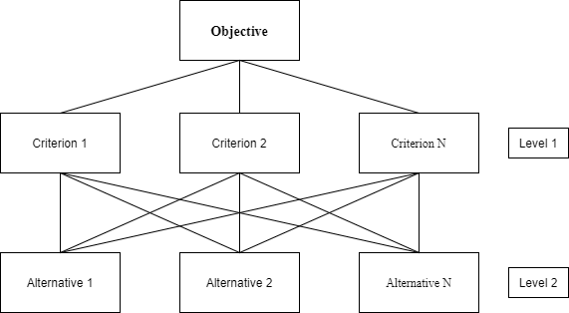

Figure 2.1: Example of Hierarchy in AHP

AHP method mainly consists of 4 major steps:

1. The first stage is to create a hierarchical problem model from which to make a choice. As illustrated in the diagram below, the aim or goal is at the top of the hierarchy, followed by criteria and sub-criteria and finally alternatives.
2. The pair-wise comparison of the criteria is performed at each level of the hierarchy, with relative importance assigned using the Saaty’s scale. The intensity is described by the scale's five levels and four sub-levels of relevance. As shown in the Table 2.1, the scale spans from 1 to 9.

Table 2.1: Saaty’s scale and their numerical ratings

|  |  |  |
| --- | --- | --- |
| **Importance** | **Definition** | **Explanation** |
| 1 | Equally important | Both elements have equal contributions to the objective. |
| 3 | Moderately important | Moderate advantage of the one element compared to other |
| 5 | Strong importance | Strong favoring of one element compared to the other |
| 7 | Very strong and proven importance | One element is strongly favored and has domination in practice, compared to the other element. |
| 9 | Extreme importance | One element is favored in comparison with the other based on strongly proved evidence and facts. |
| 2,4,6,8 | Intermediate values |  |

1. Then, it is used to calculate local criteria, sub-criteria, and alternatives after an assessment of the relative relevance of items at each level of the hierarchical structure. Following that, a summary of the option’s general priorities is created. The sum of local priorities that are weighted with weights of parts from higher levels is used to compute the total priority of each choice.
2. Finally, a sensitivity analysis is performed.
3. **Result**

## **3.1 Landslide Risk Map**

Landslide Risk Map was calculated based on the equation (2) on ArcGIS platform. The risk map was reclassified into five classes using natural breaks method. Moderate risk class has largest area (44.78%) followed by low (39.68%), very low (7.74%), high (7.50%) and very high (0.30%) classes. The details are shown in the Figure 3.1 and Table 3.1.

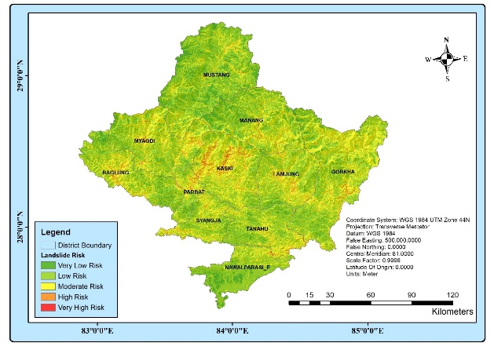Table 3.1: Landslide risk zone class with area

|  |  |  |  |
| --- | --- | --- | --- |
| **S. No.** | **Landslide Risk** | **Area in sq. km.** | **Percentage** |
| 1. | Very Low Risk | 1,703.60 | 7.74 |
| 2. | Low Risk | 8,735.97 | 39.68 |
| 3. | Moderate Risk | 9,858.28 | 44.78 |
| 4. | High Risk | 1,650.96 | 7.50 |
| 5. | Very High Risk | 65.81 | 0.30 |
| **Total** | | **22,014.62** | **100.00** |

Figure 3.1: Landslide Risk Zone Map

In the above map, we can see that the hills of Kaski district are found more prone to landslide as they possessed very steep slope, very weak geology and receive very high rainfall which are the most influencing factors and gained more weightage in AHP calculation.

The Kaski distrct is followed by Baglung, Myagdi, Lamjung, Gorkha, Parbat and Syangja district interms of vulnerability to landslide. Two districts across the Himalayas, Manang and Mustang are found less susceptible to landslide as they receive less rainfall throughout the year and have very strong geology.

## **3.2 Flood Risk Map**

Flood Risk Map was calculated based on the equation (3) on ArcGIS platform. The risk map was reclassified into five classes using natural breaks method. Very low risk class has largest area (48.20%) followed by low (36.66%), moderate (10.83%), high (3.32%) and very high (0.98%) classes. The details are shown in the Figure 3.2 and Table 3.2 below:

|  |  |  |  |
| --- | --- | --- | --- |
| **S. No.** | **Flood Risk** | **Area in sq. km.** | **Percentage** |
| 1. | Very Low Risk | 10,610.18 | 48.20 |
| 2. | Low Risk | 8,071.60 | 36.66 |
| 3. | Moderate Risk | 2,385.00 | 10.83 |
| 4. | High Risk | 731.03 | 3.32 |
| 5. | Very High Risk | 216.81 | 0.98 |
| **Total** | | **22,014.62** | **100.00** |

Table3. 2: Flood risk zone class with area

As displayed in the map above, we can see Nawalpur District is highly prone to flood as most of the area is plain land and this district is bordered by deepest river of Nepal (Saptagandaki also known as Narayani). It also consists many other rivers that can cause flash floods which makes it most vulnerable district in case of flooding in the Gandaki Province. Nawalpur is followed by Kaski District as this district receives more rainfall throughout the year and contains many rivers and other water bodies as compared to other districts in Nepal which can cause severe flooding in the region. Apart from these, Lamjung, Syangja and Tanahu districts are also at the high risk of flooding.

1. **Discussion**

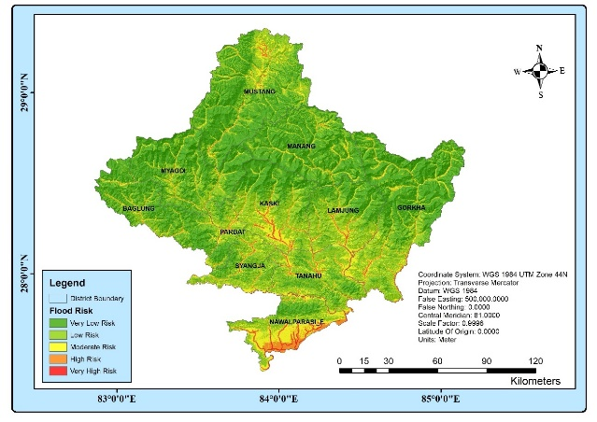

Figure 3. 2: Flood Risk Zone Map

Two significant hazard maps were prepared following AHP process. The result of these maps show that Gandaki Province is highly prone to natural hazards. Different districts are vulnerable to different hazards. Middle and Western hills of Kaski district is found to be highly subjected to landslide due to weak geology, heavy rainfall and steep slope. Also, Baglung and Myagdi districts are determined to be highly susceptible to landslides whose main cause are found as steep slope and haphazardly constructed earthen roads without any engineering designs and knowledge. The areas around the Pokhara valley are also found to be highly prone to flood due to of heavy rainfall and a greater number of streams and other water bodies. The southern and eastern part of the Nawalpur District is determined to be highly vulnerable to flood due to gentle slope and high drainage density. The existing data were digitized manually using the Google Earth Pro whereas the historical data were obtained from the BIPAD Portal. The results showed that both the existing as well as historical data had good correlation with the risk rasters that we obtained after the weighted overlay. The AUC value of flood risk model was better as compared to landslide and forest fire. This may be due to the reason that flooding generally occur in the areas that are very near to the water bodies and perceive heavy rainfall which mostly matched our output raster.

1. **Conclusion**

These hazard risk maps were produced and were classified into five classes: very low, low, moderate, high, and very high risks.by using the factors such as elevation, rainfall, proximity to streams , geology etc. This study also analyzed the most destructive natural disasters, i.e.; landslides and floods, and the results have been presented using a Geographic Information System (GIS) based on hazard risk zonation applying Analytical Hierarchy Process (AHP) techniques in Gandaki Province, Nepal. The historical date of landslide and flod were validate by overlaying to the hazard risk map. The results showed that both the existing as well as historical data had good correlation with the risk rasters that we obtained after the weighted overlay. The AUC value of flood risk model was better as compared to landslide and forest fire. Kaski, Baglung and Myagdi districts are seen most vulnerable to landslide whereas Nawalpur, Kaski and Tanahun districts are determined to be most vulnerable to flood. While, two districts across the the Himalayas: Manang and Mustang are found to be mostly at low risk from these hazards. The validity and accuracy were tested by calculating the Areas Under the Curve (AUC) value of the receiver operating characteristic (ROC) curve. The AUC values of landslide and flood were found to be 0.792 and 0.855 respectively indicating good performance. The final risk maps can be used for disaster risk reduction, land use planning, and early warning systems.

**References**

Fuchs, S., Keiler, M., & Zischg, A. (2015). A spatiotemporal multi-hazard exposure assessment based on property data. *Natural Hazards and Earth System Sciences*, *15*(9), 2127–2142. https://doi.org/10.5194/nhess-15-2127-2015

Gudiyangada Nachappa, T., Tavakkoli Piralilou, S., Gholamnia, K., Ghorbanzadeh, O., Rahmati, O., & Blaschke, T. (2020). Flood susceptibility mapping with machine learning, multi-criteria decision analysis and ensemble using Dempster Shafer Theory. *Journal of Hydrology*, *590*, 125275. https://doi.org/10.1016/j.jhydrol.2020.125275

Haque, U., da Silva, P. F., Devoli, G., Pilz, J., Zhao, B., Khaloua, A., Wilopo, W., Andersen, P., Lu, P., Lee, J., Yamamoto, T., Keellings, D., Jian-Hong, W., & Glass, G. E. (2019). The human cost of global warming: Deadly landslides and their triggers (1995–2014). *Science of the Total Environment*, *682*, 673–684. https://doi.org/10.1016/j.scitotenv.2019.03.415

Prashad Bhatt, B., Datt Awasthi, K., Prasad Heyojoo, B., Silwal, T., & Kafle, G. (2013). Using Geographic Information System and Analytical Hierarchy Process in Landslide Hazard Zonation. *Applied Ecology and Environmental Sciences*, *1*(2), 14–22. https://doi.org/10.12691/aees-1-2-1

Salvati, P., Bianchi, C., Fiorucci, F., Giostrella, P., Marchesini, I., & Guzzetti, F. (2014). Perception of flood and landslide risk in Italy: A preliminary analysis. *Natural Hazards and Earth System Sciences*, *14*(9), 2589–2603. https://doi.org/10.5194/nhess-14-2589-2014

Sassa, K., Rouhban, B., Briceño, S., McSaveney, M., & He, B. (2013). Landslides: Global risk preparedness. *Landslides: Global Risk Preparedness*, 1–385. https://doi.org/10.1007/978-3-642-22087-6