**Extracting Wood Point Cloud from Terrestrial Laser Scanner Data of a Giant Tree**

Ryadi M.V.I.1, Setiawan M.B.1, Lee C.C.1, Wang C.K.1*, Hsu R.C.C.2

1 Department of Geomatics, National Cheng Kung University, University Road no. 1, Tainan 70101, Taiwan,

2 Taiwan Forestry Research Institute, Forest Ecology Division, No. 67, Sanyuan St., Taipei 100, Taiwan

* chikuei@ncku.edu.tw (*Corresponding author’s email only)

***Abstract*** *An accurate 3D quantification of giant tree is necessary for estimating the tree part size and carbon estimation. Terrestrial Laser Scanner (TLS) has become a potential instrument supporting the non-destructive study of giant tree with the detailed tree point cloud. The extraction of wood points from tree point cloud has become a challenging task due to the overlapping condition and occlusion from leaves and branches. In this study, we evaluate five machine learning models to classify the wood and leaf from the Tao tree point cloud. A total of 46 features including radiometric and geometric features were used to develop the models. 4.4% of the tree point cloud was selected as the training data. The classification result of all machine learning models ranged from 0.688 to 0.801. The calculation result from feature importance indicates that the percentage of 3rd eigenvalue turns to be an important feature affecting the classification accuracy.*

*Keywords: Giant Tree, Terrestrial Laser Scanner, Wood Point Cloud*

Introduction

Giant tree as one of the largest and longest living organism on the earth plays an important role in ecological and ecosystem (Lindenmayer & Laurance, 2016). An accurate 3D quantification of giant tree is necessary for estimating the tree part size and carbon estimation. Terrestrial Laser Scanner offers a possibility to capture high-detailed of the tree (Guo et al., 2021).

Extracting the wood from tree point cloud has become a challenging task due to the overlapping condition and occlusion from leaves and branches. A machine learning based classification has been proposed to perform the leaf-wood classification (Krishna Moorthy et al., 2020). The challenge when performing leaf-wood classification using a machine learning model are the chosen of machine learning techniques (Xi et al., 2020) and predictor features used for model development (Zhu et al., 2018). In order to assess the performance of leaf-wood classification, we evaluate five machine learning models to extract wood points of a giant tree. A computation of feature importance was computed to evaluate the features significance to the classification.

Study Area

The study was performed on the Tao tree (*Taiwania cryptomerioides*) with the tree height of 79.1 m. The tree is located at 121o18’07.75” E, 24o27’21.89” N in Hsinchu, Taiwan with area elevation of 2,312 m. A TLS RIEGL VZ-400 was used to scan the tree from 22 number of scanning on October 8th 2022. The challenge of performing a scanning on the giant tree is to capture the tree part on the high elevation due to the limited vertical field of view from TLS. Therefore, the TLS was scanned with a tilted condition (Figure 1b) on 8 scanning positions and one of the scanning positions was scanned at 105 m away from the tree. All the scanning was performed with an angular resolution of 0.04 for the non-tilted condition, 0.02 for the tilted condition and 0.01 for the furthest scanning positions. During the measurement, several checkerboard-patterned balloons were placed and used to assist the point cloud registration. The point cloud registration is performed on RiSCAN Pro v.2.9.

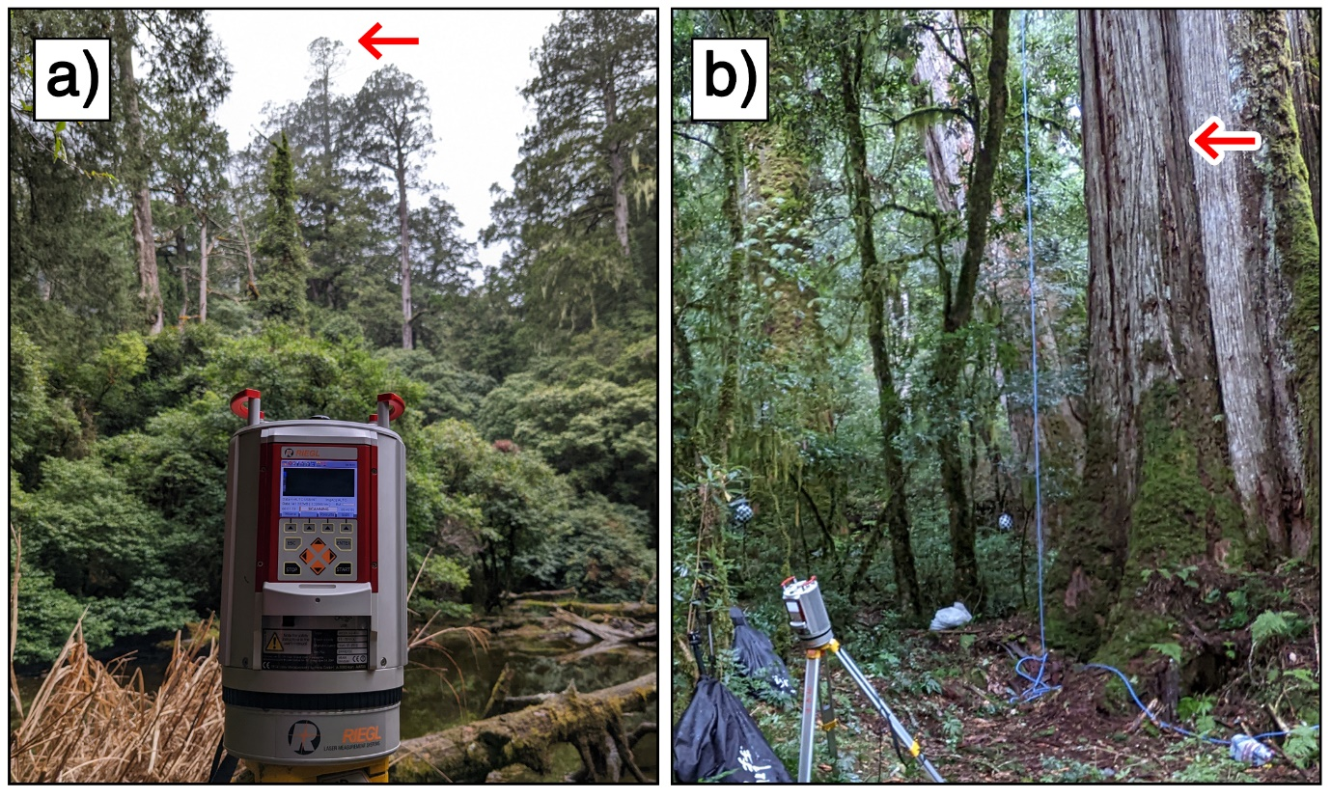

Figure 1: The TLS scanning from the furthest distance from tree (a) and TLS scanning with tilted condition (b)

After the point cloud registration, the Tao tree was manually segmented from the surrounding tree using CloudCompare. A ground classification was conducted on the segmented Tao tree point cloud using Cloth Simulation Filter (Zhang et al., 2016). Then, the point cloud was down sampled with a sampling distance of 0.02 m. The number of Tao tree point cloud after the down sampling process was 1,754,441 points. As the comparison of the automatic wood point extraction method, a manual classification was performed on the Tao tree point cloud. The manual classification was done in CloudCompare with a total processing time about 70 person-hours.

Methodology

The wood point extraction was performed based on 46 features including radiometric and geometric feature computed on each points. The radiometric feature used is the original intensity value from TLS measurement. The geometric feature used is derived from eigenvalue of Principal Component Analysis (PCA) computation on sphere-shaped local neighborhood. The eigenvalue can be used to present the different point cloud arrangement of object (Vicari et al., 2019). Equation (1) were used to compute the geometric feature using eigenvalue from PCA computation.

$PC1= \left(\frac{λ_{1}}{λ_{1}+λ_{2}+λ_{3}}\right)$, $PC2= \left(\frac{λ_{2}}{λ_{1}+λ_{2}+λ_{3}}\right)$, $PC3= \left(\frac{λ_{3}}{λ_{1}+λ_{2}+λ_{3}}\right)$ (1)

Where, $λ_{1}, λ_{2}, and λ_{3}$ are the first, second and third eigenvalue from PCA computation. In this study, the sphere local neighborhood examined were from 0.2 m up to 3 m with step of 0.2 m (Figure 2). The consideration of using sphere neighboord size of 0.2 m assuming that the small branches could be classed correctly, and 3 m were aiming to help on classifying the main tree trunk. The geometric feature was computed using CloudCompare.

Figure 2: Illustration of computed geometric feature based on different sphere radius

A total of 4.4% from Tao tree point cloud was selected as the training dataset. The training data was manually chosen in CloudCompare. Five supervised machine learning method were evaluated in this study: Random Forest (RF), Linear Disciminant Analysis (LDA), Naïve Bayes (NB), K-Nearest Neighbours (KNN), and Support Vector Machines (SVM). The learning phase was conducted in MATLAB with most of processing parameter setting as default. The number of K of KNN was set to 10 and the number of bagged tree for the RF was 100.

For the quantification of wood point extraction, three indexes were computed based on the automatic and manual classification result. The indexes are precision, recall, and accuracy were computed using equation (2).

$Precision= \left(\frac{TP}{TP+FP}\right)$, $Recall= \left(\frac{TP}{TP+FN}\right)$, $Accuracy= \left(\frac{TP+TN}{TP+FP+TN+FN}\right)$ (2)

The features used in the computation are manually designated without knowing their usefulness. The computation of feature importance could identify the less significant feature or redundant and also help to guide the learning process (Xi et al., 2020). Classification and Regression Tree (CART) was used to calculate the importance of 46 features for wood point extraction. The computation was performed in Python.

Results and Discussion

Quantitative assessment result of wood point extraction is summarized in Table 1. By using the machine learning models, the wood point of giant tree can be extracted with accuracy range from 0.688 to 0.801. Within the five machine learning models, SVM has the highest accuracy (0.801) and precision (0.711) but with longest training time (25 min). The visualization of classification result can be seen in Figure 3.

Table 1: Summary of machine learning classification results

|  |  |  |  |  |
| --- | --- | --- | --- | --- |
|  | **Precision** | **Recall** | **Accuracy** | **Training time (s)** |
| RF | 0.675 | 0.738 | 0.747 | 1551.7 |
| LDA | 0.691 | 0.883 | 0.790 | 31.6 |
| NB | 0.644 | 0.818 | 0.740 | 48.6 |
| KNN | 0.603 | 0.701 | 0.688 | 428.2 |
| SVM | 0.711 | 0.865 | 0.801 | 1582.3 |

Figure 3: Classification result of the Tao tree using manual classification and machine learning model. Leaf point was represented with green point and woody point was represented with brown point

The result of feature importance calculation using the Classification and Regression Tree (CART) is shown in Figure 4. Within these datasets, the PC3 of searching radius 0.4 m, 3.0 m and 0.2 m were the most important feature. As shown in Figure 2, the main tree trunk could be extracted from the leaf clump by using the PC3 value with neighborhood searching radius of 0.2 and 0.4 m. Contrast to the result by Xi et al. (2020), we found that the intensity value from LIDAR has a low feature importance value compared to the other feature. In this study, the intensity value that was used for developing the machine learning model is the original data from TLS measurement which still contain the distance effect (Tan et al., 2019; Tan & Cheng, 2020).

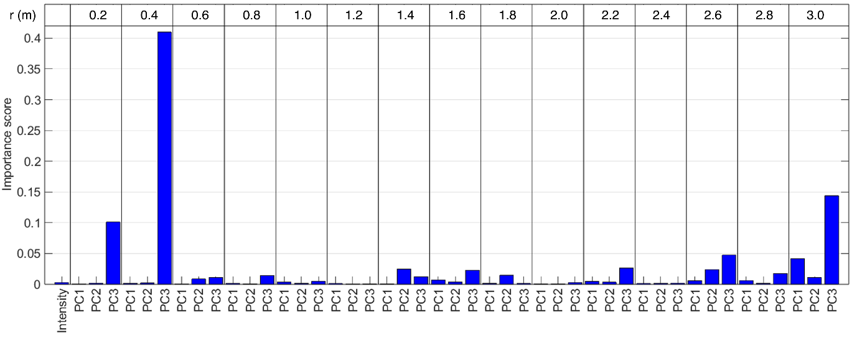

Figure 4: Feature importance calculation from the Classification and Regression Tree (CART) among the 46 features. The r refers to the sphere radius for local neighborhood

**Conclusion**

In this study, we extract the wood points from the giant tree point cloud by using the machine learning model. A combination of radiometric and geometric features were used to develop the machine learning model. Five machine learning models, namely Random Forest, Linear Discriminant Analysis, Naïve Bayes, K-nearest Neighbor and Support Vector Machine were evaluated in this study. The overall accuracy of all machine learning model for wood point extraction were range from 0.688 to 0.801. SVM turns out to have the highest accuracy (0.801) and precision (0.711). Among the 46 features, the PC3 computed with sphere radius of 0.4 m, 3 m and 0.2 m were the most significant.

References

Guo, Q., Su, Y., Hu, T., Guan, H., Jin, S., Zhang, J., Zhao, X., Xu, K., Wei, D., Kelly, M., & Coops, N. C. (2021). Lidar Boosts 3D Ecological Observations and Modelings: A Review and Perspective. *IEEE Geoscience and Remote Sensing Magazine*, *9*(1), 232–257. https://doi.org/10.1109/MGRS.2020.3032713

Krishna Moorthy, S. M., Calders, K., Vicari, M. B., & Verbeeck, H. (2020). Improved supervised learning-based approach for leaf and wood classification from LiDAR point clouds of forests. *IEEE Transactions on Geoscience and Remote Sensing*, *58*(5), 3057–3070. https://doi.org/10.1109/TGRS.2019.2947198

Lindenmayer, D. B., & Laurance, W. F. (2016). The Unique Challenges of Conserving Large Old Trees. *Trends in Ecology & Evolution*, *31*(6), 416–418. https://doi.org/10.1016/j.tree.2016.03.003

Tan, K., Chen, J., Qian, W., Zhang, W., Shen, F., & Cheng, X. (2019). Intensity Data Correction for Long-Range Terrestrial Laser Scanners: A Case Study of Target Differentiation in an Intertidal Zone. *Remote Sensing*, *11*(3), 331. https://doi.org/10.3390/rs11030331

Tan, K., & Cheng, X. (2020). Distance Effect Correction on TLS Intensity Data Using Naturally Homogeneous Targets. *IEEE Geoscience and Remote Sensing Letters*, *17*(3), 499–503. https://doi.org/10.1109/LGRS.2019.2922226

Vicari, M. B., Disney, M., Wilkes, P., Burt, A., Calders, K., & Woodgate, W. (2019). Leaf and wood classification framework for terrestrial LiDAR point clouds. *Methods in Ecology and Evolution*, *10*(5), 680–694. https://doi.org/10.1111/2041-210X.13144

Xi, Z., Hopkinson, C., Rood, S. B., & Peddle, D. R. (2020). See the forest and the trees: Effective machine and deep learning algorithms for wood filtering and tree species classification from terrestrial laser scanning. *ISPRS Journal of Photogrammetry and Remote Sensing*, *168*(August), 1–16. https://doi.org/10.1016/j.isprsjprs.2020.08.001

Zhang, W., Qi, J., Wan, P., Wang, H., Xie, D., Wang, X., & Yan, G. (2016). An easy-to-use airborne LiDAR data filtering method based on cloth simulation. *Remote Sensing*, *8*(6), 1–22. https://doi.org/10.3390/rs8060501

Zhu, X., Skidmore, A. K., Darvishzadeh, R., Niemann, K. O., Liu, J., Shi, Y., & Wang, T. (2018). Foliar and woody materials discriminated using terrestrial LiDAR in a mixed natural forest. *International Journal of Applied Earth Observation and Geoinformation*, *64*(September 2017), 43–50. https://doi.org/10.1016/j.jag.2017.09.004