**Sugar Apple Fruit Bags Detection using Geometric Feature in   
MLS Point Cloud Data**

Setiawan M.B.1, Lee C.C.1, and Wang C.K.1*

1 Department of Geomatics, National Cheng Kung University, Taiwan

[*chikuei@ncku.edu.tw](mailto:*chikuei@ncku.edu.tw%20)

***Abstract*** *Sugar apple is an important agricultural product with a high market value in Taiwan. Taiwanese farmers have implemented diverse methods to improve the quantity and quality of sugar apples, including the utilization of fruit bags. Fruit bags serve multiple purposes, such as protecting the fruits and avoiding defects. Point cloud data acquired by mobile laser scanning (MLS) provides precise spatial information for distinguishing fruit bags from other objects including plants. The purpose of this study is to detect fruit bags on point cloud by using random forest algorithm. A total of 39 geometric features and intensity derived from point cloud serves as the parameter for random forest computation. The segmentation result demonstrates an acceptable performance with 0.57 F1 score by using 39 geometric features and 0.55 F1 score by using only 15 features. In addition, PC3,* *Sphericity, Planarity, Dip, Number of Points, and intensity are some significant features that can be utilized to distinguish the fruit bags. Finally, by accounting for a few geometric features, the proposed workflow produces an accurate Sugar Apple fruit bags detection result.*

*Keywords: Sugar Apple, fruit bags detection, point cloud, geometric features, mobile laser scanner (MLS)*

Introduction

Taiwan is one of the countries that have a very big agricultural production value. The production value of the agricultural products in Taiwan was exceed US$ 9 billion in 2021 (Yan et al., 2023). Sugar apple is the top four commodity with a high market value in Taiwan (Yan et al., 2023). Taiwanese farmers have tried diverse methods to increase fruit production, especially sugar apples including pruning the tree (Varu et al., 2023), cultivating new varieties (Lee et al., 2017), and the utilization of fruit bags (Tsai et al., 2013). Fruit bags serve multiple purposes such as protecting the fruits and avoiding defects.

Nowadays, there is a technology called mobile laser scanning (MLS) which can provide precise spatial information of farming areas, including the sugar apple field. MLS produces precise point cloud data that can be very useful for many purposes, for example to rock and soil layers identification, water content extraction, road traffic marking identification (Xu et al., 2017), and distinguishing one object from other objects including the fruit and plants (Li et al., 2022; Yu et al., 2022). Several studies have been done for detecting fruit from its tree. Yu et al. (2022) and Li et al. (2022) used a point cloud produced from RGB-D images to detect a mature pomegranate and apple fruits. However, by using 2D images, it takes more time to produce point cloud data. Therefore, we can obtain the point cloud directly by using MLS. This study proposes a workflow to detect fruit bags by using MLS point cloud data based on several geometric features and intensity derived from the point cloud. This study utilizes a Random Forest algorithm with its ability to handle several features followed by DBSCAN clustering algorithm in order to detect the Sugar Apple fruit bags. Finally, we evaluate the number of Sugar Apple fruit bags based on the reference position and calculating the commission and omission error of the detected results.

Methodology

In this chapter, we explain about the methodology and workflow for Sugar Apple fruit bags detection which shown in Figure 1.

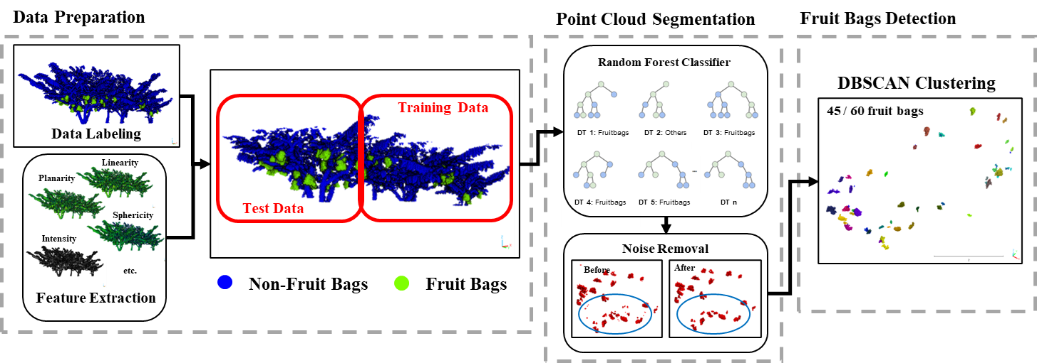

Figure 1: Sugar Apple Fruit Bags Detection Workflow

**a. Data Preparation**

The mobile laser scanner (MLS) dataset was measured in Taitung Sugar Apple field in Taiwan. The field area is 150 meters x 105 meters with a total of 387 million points (Figure 2a). The point cloud used in this study was the subset dataset including three trees with only 500 thousand points (Figure 2b). After the data was subset into smaller area, it was labeled into two classes which are the fruit bags and non-fruit bags (Figure 2c). The appearance of Taiwan Sugar Apple fruit bags is shown in Figure 2d. Then we computed all features for the classification.

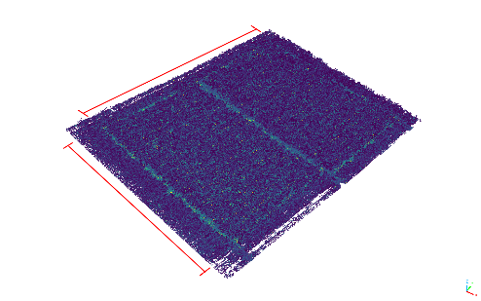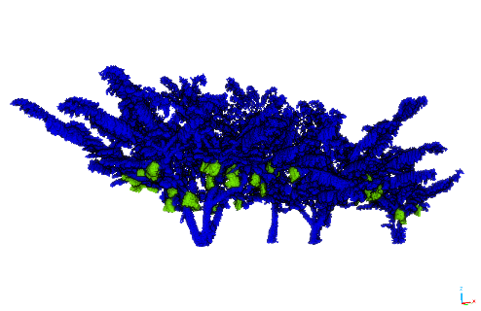

b

a

c

105 m

150 m

d

Figure 2: (a) Point cloud colorized by the intensity of the sites (b) subsets point cloud  
(c) labeled point cloud (d) Sugar Apple fruit bags

There are three types of features (Letard et al., 2024). The first type of the feature is called point features. Point features are the original information which comes from each point cloud such as intensity, RGB channel, 3D positions (X, Y, and Z), etc. The second feature is the neighborhood features which calculated based on the neighboring point clouds such as PCA1, PCA2, PCA3, Sphericity, Linearity, Planarity, Dip, Dip Direction, Roughness, Number of points, Curvature, Z-range, Z-max, Z-min, Anisotropy, and First order moment.

The third feature type is the context-based features such as mean vertical distance to k-nearest neighbor (DZx) and mean horizontal distance to k-nearest neighbor (DHy). In this study, we chose only the point feature and the 13 neighborhood features which were calculated from several radiuses. The neighborhood features computed using the equations in Table 1 (Letard et al., 2024).

Three radiuses were used in this study which are 0.25, 0.5, and 0.75. The radiuses were used to define the spherical neighborhoods of each point. The point neighbors then used for calculating each geometric feature in Table 1. The purpose of using several radiuses was to get more features in order to represent the characteristics of each point. Then, the tree point clouds were pruned based on the height. After the features are computed and the tree point clouds are pruned, the point clouds are separated into training and testing data as the input for the Random Forest algorithm.

Table 1: Features used

| **Dimensionality-based features** | |
| --- | --- |
| **Features** | **Formulation from eigenvalues** |
| PCA1 | $$\frac{λ_{1}}{(λ_{1}+ λ_{2}+ λ_{3})}$$ |
| PCA2 | $$\frac{λ_{2}}{(λ_{1}+ λ_{2}+ λ_{3})}$$ |
| PCA3 | $$\frac{λ_{3}}{(λ_{1}+ λ_{2}+ λ_{3})}$$ |
| Sphericity | $$\frac{λ_{3}}{λ_{1}}$$ |
| Linearity | $$\frac{(λ_{1}- λ_{2})}{λ_{1}}$$ |
| Planarity | $$\frac{(λ_{2}- λ_{3})}{λ_{1}}$$ |
| **Geometry-based features** | |
| **Features** | **Information** |
| Dip* | Angle between surface normal and best fitting plane |
| Roughness | Standard deviation of distance between points and best fitting plane |
| Number of points | Number of points in each neighborhood |
| Anisotropy | Ratio of distance to center of mass and radius of sphere |
| **Height-based metrics** | |
| **Features** | **Formulation** |
| Z-range | $$(z_{max}- z_{min})$$ |
| Z-max | $$(z_{max}- z)$$ |
| Z-min | $$(z- z_{min})$$ |

$λ_{1}$*, $λ_{2}$, and $λ_{3}$ are first, second, and third eigenvalues, respectively.*

*z is the point elevation, zmax and zmin are the maximum and minimum elevation in the spherical neighbourhood, respectively.*

**b. Point Cloud Segmentation**

The second step is the point cloud segmentation. The point cloud segmentation process was done using a plugin in CloudCompare software which called 3DMASC: Accessible, explainable 3D point clouds classification (Letard et al., 2024). This plugin uses a Random Forest algorithm to accommodate all features used in the classification. We tested four feature selection scenarios to segment the point cloud of the fruit bags. The first and second scenarios used a total of 39 features which are PCA1, PCA2, PCA3, Sphericity, Linearity, Planarity, Dip, Roughness, Number of Points, Z-range, Z-max, Z-min, and Anisotropy within three different radiuses which are 0.25, 0.5, and 0.75. The third and fourth scenarios were conducted using a total of 18 features which are PCA3, Sphericity, Planarity, Dip, and Number of Points in 0.25, 0.5, and 0.75 radiuses.

Additionally, the third and fourth scenarios were added with the radiometric information from the point (point features) which is intensity. The third and fourth scenarios were implemented to understand the usage of intensity in the fruit bags detection. After the point cloud was segmented, the fruit bags points were extracted. The extracted fruit bags point will still have some noise. In order to remove the noise, we implemented Statistical Outlier Removal (SOR) filtering algorithm. This algorithm calculates a set of statistics for points within the neighborhood radius and identifying all points within one standard deviation (1σ) distance from the mean distance (µ) as the inlier (Rusu & Cousins, 2011).

**c. Fruit Bags Detection**

The location of the fruit bags was determined based on the filtered points. The points were grouped using Density-Based Spatial Clustering of Applications with Noise (DBSCAN) clustering algorithm. This algorithm estimates a minimum density level on a threshold for the number of neighbors within a specific radius. The points that have more neighbors than the threshold of the number of point neighbors within the given radius are considered as a core point. Then all neighbors within the radius of a core point are considered as the same cluster as the core point (Schubert et al., 2017).

The clustered point cloud then was used to estimate the number of fruit bags. To count the number, we extracted the center point position of each clustered point cloud. Then we counted how many points were extracted. After the location of the detected fruit bags were acquired, we compared it with the reference fruit bags position and calculated the commission and omission error to estimate the accuracy of our proposed method.

Results and Discussion

a. Fruit bags point cloud segmentation

The first result is the Sugar Apple fruit bags segmentation. On four segmentation scenarios using Random Forest algorithm, the Sugar Apple fruit bags point cloud could be segmented with segmentation performances as shown in Figure 1.

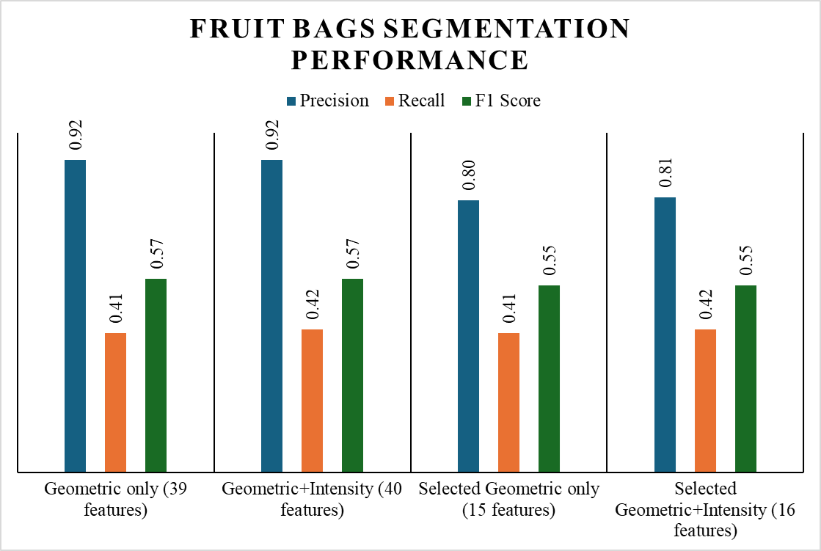

Figure 3: The performance of Random Forest algorithm to segment the fruit bags point cloud

Figure 1 shows that the performance of the Sugar Apple fruit bags point cloud segmentation was given almost a similar value on each scenario on the F1 score. The first and second segmentation scenarios give 0.57 F1 scores and the third and fourth segmentation scenarios give 0.55 F1 scores. It means that the models could give an acceptable Sugar Apple point cloud segmentation results for all scenarios. The best precision score was obtained by using 39 features with and without intensity. It means that the more features we have, the more positive prediction of Sugar Apple fruit bags points obtained. The best recall score was obtained by adding the intensity value. It indicates that the intensity can improve the number of correct prediction Sugar Apple fruit bags points.

Furthermore, we can also obtain the importance of the features by using Random Forest algorithm. It can be used to choose which features are more reliable to segment the Sugar Apple fruit bags from MLS point cloud data. Based on the feature importance from the first scenario (Figure 4), we kept the features that provide 80% cumulative importance and removed the feature after 80% cumulative importance. The removed features were Roughness, Linearity, Z-max, PCA2, PCA1, Anisotropy, Z-range, and Z-min. Then we kept PCA3, Sphericity, Planarity, Dip, and Number of Points as the important geometric features. Figure 3 proved that the performance of the segmentation is the same as using only the selected features by keeping only five features.

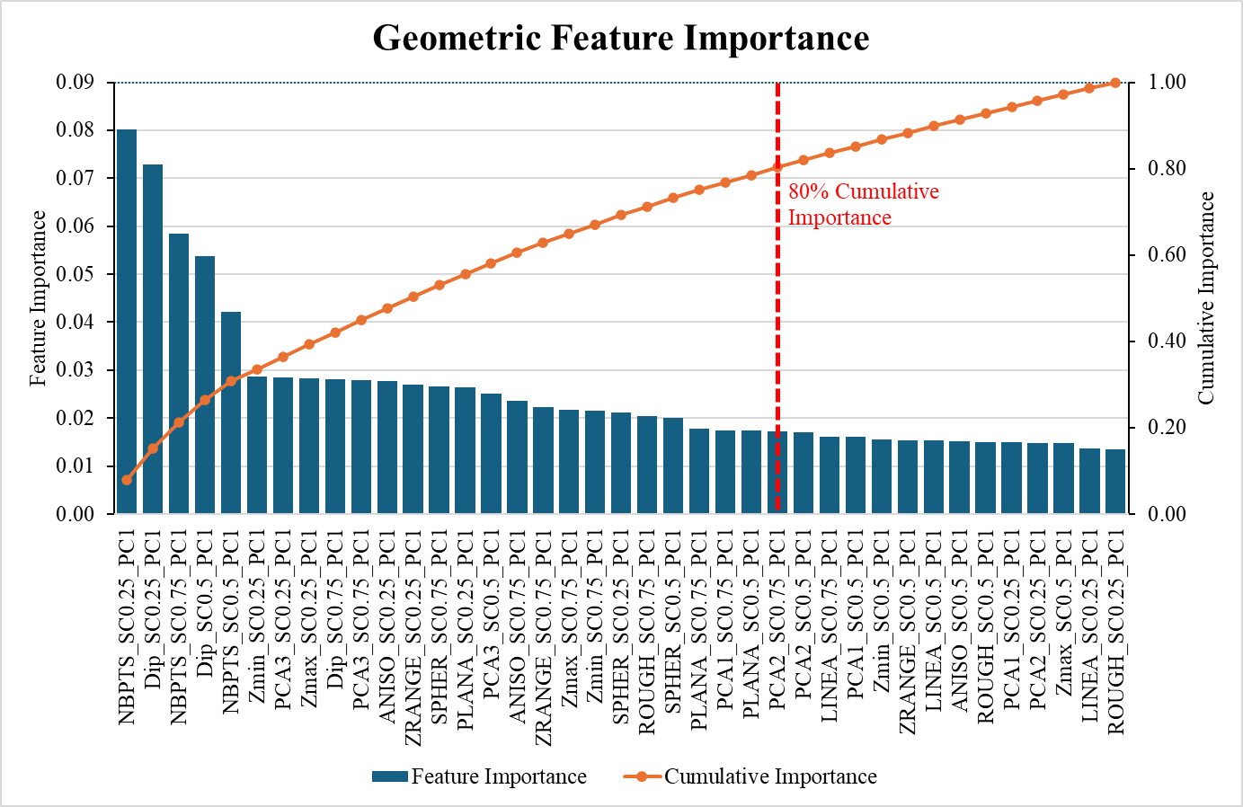

Figure 4: Geometric features importance

b. Detection results

The main result of this study is the Sugar Apple fruit bags detection result. We obtained four different detection results from four scenarios. The detection results are shown in Figure 5 and Table 2.

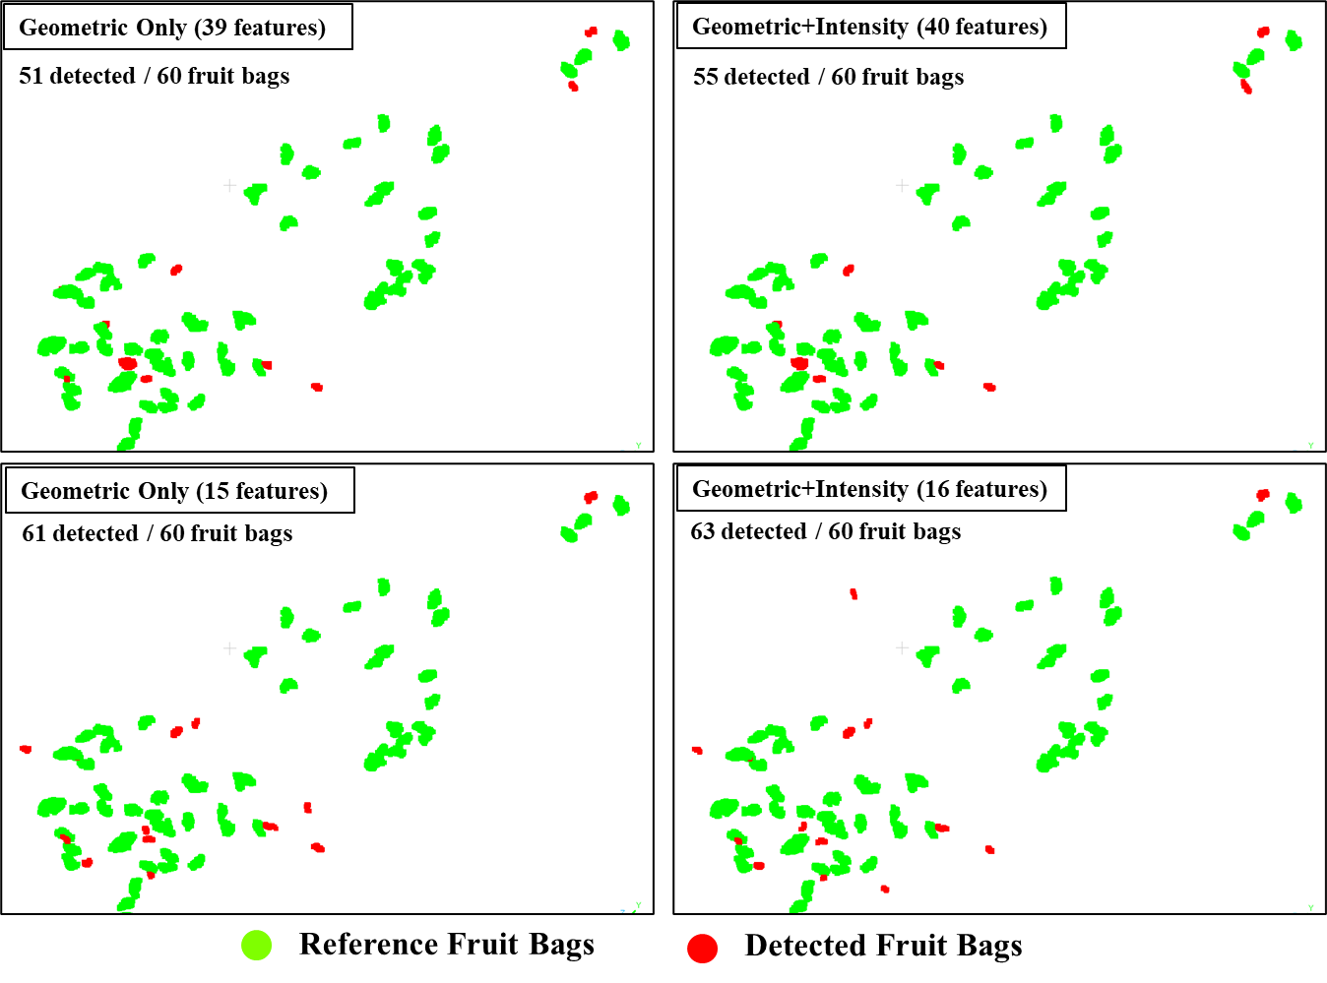

Figure 5: Clustered fruit bags point cloud

According to Figure 5, the red color shows the detected Sugar Apple fruit bags while the green color shows the reference. The red dots outside the green dots in Figure 5 indicating the missed classification Sugar Apple fruit bags. The missed classification results are less by using more geometric features. However, the number of fruit bags detected are increase after decreasing the number of geometric features. Table 2 shows the number of fruit bags detected and matched and showing the commission and omission errors.

Table 2: Number of fruit bags detected and matched

|  |  |  |  |  |
| --- | --- | --- | --- | --- |
| **Scenario** | **Detected Fruit Bags** | **Matched Fruit Bags** | **Commission Error** | **Omission Error** |
| Geometric only  (39 features) | 55 | 41 | 14 | 19 |
| Geometric+Intensity (40 features) | 52 | 42 | **10** | 18 |
| Geometric only  (15 features) | 65 | 44 | 21 | 16 |
| Geometric+Intensity (16 features) | **65** | **45** | 20 | **15** |

By looking at Table 2, we can see that by using less geometric features the detected fruit bags will increase, but the number of incorrect fruit bags also increase as shown from the commission error results. However, the number of matched fruit bags increases when the detected fruit bags are increased which make the omission error is getting smaller. Based on Table 2 we also know that adding the intensity can increase the number of matched fruit bags.

**Conclusion**

This study successfully introduced a workflow to detect the Sugar Apple fruit bags using point cloud measured by MLS. The Random Forest algorithm was used to extract the fruit bags point cloud with slightly the same accuracy for all scenarios. However, the best detection scenario is using 18 geometric features combined with intensity which can achieved 45 matched fruit bags from total 60 fruit bags (75% fruit bags correctly detected). Furthermore, the intensity value is also important to improve the accuracy of fruit bags detection algorithm.

References

Lee, W.-L., Huang, C. C., Kuan, C. S., Jiang, S. W., & Hsieh, H. Y. (2017). Development of GA3 tropical fruit varieties and cultivation techniques in Taiwan. *Acta Horticulturae*, *1166*, 47–54. https://doi.org/10.17660/ActaHortic.2017.1166.7

Letard, M., Lague, D., Le Guennec, A., Lefèvre, S., Feldmann, B., Leroy, P., Girardeau-Montaut, D., Corpetti, T., & Lefevre, S. (2024). 3DMASC: Accessible, explainable 3D point clouds classification. Application to Bi-spectral Topo-bathymetric lidar data. *ISPRS Journal of Photogrammetry and Remote Sensing*, *207*, 175–197. https://doi.org/10.1016/j.isprsjprs.2023.11.022ï

Li, T., Feng, Q., Qiu, Q., Xie, F., & Zhao, C. (2022). Occluded Apple Fruit Detection and Localization with a Frustum-Based Point-Cloud-Processing Approach for Robotic Harvesting. *Remote Sensing*, *14*(3), 482. https://doi.org/10.3390/rs14030482

Rusu, R. B., & Cousins, S. (2011). 3D is here: Point Cloud Library (PCL). *2011 IEEE International Conference on Robotics and Automation*, 1–4. https://doi.org/10.1109/ICRA.2011.5980567

Schubert, E., Sander, J., Ester, M., Kriegel, H. P., & Xu, X. (2017). DBSCAN revisited, revisited: Why and how you should (still) use DBSCAN. *ACM Transactions on Database Systems*, *42*(3). https://doi.org/10.1145/3068335

Tsai, M.-S., Lee, T.-C., & Chang, P.-T. (2013). Comparison of Paper Bags, Calcium Carbonate, and Shade Nets for Sunscald Protection in ‘Murcott’ Tangor Fruit. *HortTechnology*, *23*(5), 659–667. https://doi.org/10.21273/HORTTECH.23.5.659

Varu, D. K., Parmar, V. M., Patel, S., Parsana, J. S., Varu, D. K., Kanzaria, D. R., & Mishra, S. (2023). *Influence of Pruning and Integrated Nutrient Management on Custard Apple (Annona Squamosa L.)* (Vol. 54). https://www.researchgate.net/publication/370731447

Xu, T., Xu, L., Yang, B., Li, X., & Yao, J. (2017). Terrestrial laser scanning intensity correction by piecewise fitting and overlap-driven adjustment. *Remote Sensing*, *9*(11). https://doi.org/10.3390/rs9111090

Yan, Y. J., Wong, W. K., Chen, C. J., Huang, C. C., Chien, J. T., & Ou-Yang, M. (2023). Hyperspectral signature-band extraction and learning: an example of sugar content prediction of Syzygium samarangense. *Scientific Reports*, *13*(1). https://doi.org/10.1038/s41598-023-41603-6

Yu, T., Hu, C., Xie, Y., Liu, J., & Li, P. (2022). Mature pomegranate fruit detection and location combining improved F-PointNet with 3D point cloud clustering in orchard. *Computers and Electronics in Agriculture*, *200*. https://doi.org/10.1016/j.compag.2022.107233