**Geology of Iron Ores in Arabic Countries and importance its study by Remote Sensing Techniques**

Mohamad Rukieh

*Damascus University, Geographic Faculty, Syria –Damascus- Mazzeh- P.O.Box 9916,*

Email: rukiehm@gmail.com

Key words: *Exploration, Sedimentary, Magmatic , Maps, Metamorphic*

**Abstract**

The iron ore deposits are present in many of the Arab countries, in particular Mauritania, Algeria, Egypt, Morocco, Tunisia, Saudi Arabia, Libya, Yemen, Syria and Lebanon. With reserve more than 14 Billion tons . This study indicate to the main Ore characteristics and importance investigate by R.S .techniques. The Ores in Arabic Countries Returning to the three main origins: Magmatic ,Metamorphic , and Sedimentary .The subject of this research is the use of satellite images in studying, the formation of hydrothermal iron deposits in the Zabadani Area in Syria as an example of the possibility of using it in other regions of the Arab countries. The following methodology was adopted: 1-Collec data, maps and ASTER satellite images available for the region. 2-Geographic and radiometric correction and image processing, 3- Field check .4- Determining the most effective spectral ranges for detecting iron minerals.5- Relying on the spectral library in the comparison.The following results were obtained: The 14-band ASTER satellite images are useful for detecting both metallic and non-metallic minerals, compared to other satellite images.The evidence we have adopted is effective in detecting iron oxides, carbonate, Clay and siliceous minerals. The VNIR is useful in detecting hematite, the SWIR 5 is useful in identifying goethite, hydrogothite and magnetite, the range 8 is useful in identifying calcite and siderite. The study showed that spectral bands 12 and 13 in ASTER images( TIR ) contribute to the detection of siliceous minerals associated with hydrothermal iron deposits. Benefits of Remote Sensing data for Iron Ore Exploration , Cost-Effectiveness, Large areas Coverage, Speed, accuracy, studying areas that are difficult to reach using traditional methods such as deserts, high mountains and dense forests, Non-Destructive

1. **Introduction**

The iron ores are the raw materials of the iron and steel industry, which is one of the strategic industries and plays a basic role in the economic and industrial development of any society. Statistics indicate that there is a diametrical relation between the consumption quantity of steel products and the economic growth of the state. The modern civilization, closely linked to iron, which has become a major enters in all fields of economic activity. Iron is the fourth element in the earth's crust,. Human needs, has doubled several times in the second half of the twentieth century. The Arab world Characterized by the presence of large quantities of iron ore of different grades of quality. And exceed / 14 / billion tons. Most of iron mines concentrated in the Arab African countries from Egypt to the east, and even Mauritania in the west through Libya, Algeria, Tunisia and Morocco. Also there are in Saudi Arabia, Yemen, Syria, Lebanon, etc. They differ in the conditions of formation ,by the composition and the degree of richness in iron and proportions of impurities in it.(.Rukieh M. 2011)

The Objective of this research indicate to the main Ore characteristics and the use of satellite images in studying, the formation of hydrothermal iron deposits in the Zabadani Area in Syria as an example of the possibility of using it in other regions of the Arab countries . The Ores in Arabic Countries Returning to the three main origins, Magmatic (Adsas In Saudi , Zwerat in Mauritania ) Metamorphic (East Desert in Egypt , Sawawen in Saudi Arabia, Kwaiat in Mauritania and Sedimentary ( Algeria , Syria Lebanon, Libya, Tunis, Morocco ,Albahria oasis in Egypt) .

The Magmatic and Metamorphic Ores mainly consist of hematite and magnetite, while sedimentary ores predominantly consist of Goethite , Hydro goethite , hematite and hydro hematite within the sedimentary rocks of the Paleozoic ( Devonian, Algeria Libya) Mesozoic ,(lower cretaceous Syria ,Lebanon, Egypt, Tunis,) and Cenozoic( Eocene ,Saudi Arabia).

Remote Sensing data through their distinguished properties and various kinds of survey systems ( multispectral, Hyper spectral ,thermal, LiDAR, Radar and Drone) and space images possessing , play important role in studying and exploring Iron ores, through preparing geospatial geological, mineral and structural tectonic maps. and, through using direct or indirect methods in the exploration processes. So, this technology has enabled Saudi Arabia ,(Wadi Sawawin iron ore, Hail Region , Al-Jalamid Iron Ore, Khnaiguiyah area. Jabal Idsas region. ). Egypt (Eastern Desert,). Oman (Semail Ophiolites , Dhofar Region) and Emirates (Hajar Mountains) ,Zabadani in Syria, to identify and develop new iron ore resources.

The main results of our study to Hydrothermal ore Deposits in Zabadani area were : 1- The 14-band ASTER satellite images are useful for detecting both metallic and non-metallic minerals, compared to other satellite images. 2- The evidence we have adopted is effective in detecting iron oxides, carbonate, Clay and siliceous minerals. 3-The VNIR is useful in detecting hematite, the SWIR 5 is useful in identifying goethite, hydrogothite and magnetite, the range 8 is useful in identifying calcite and siderite.4- The study showed that spectral bands 12 and 13 in ASTER images( TIR ) contribute to the detection of siliceous minerals associated with hydrothermal iron deposits. Benefits of Remote Sensing data for Iron Ore Exploration , Speed, accuracy, Large areas Coverage, studying areas that are difficult to reach using traditional methods such as deserts, high mountains and dense forests, Cost-Effectiveness, , Non-Destructive

**2-** **Results and Discussion**

**2-1 The main characteristics of Arabic Iron deposit**

**2-1-1 Iron ores in Egypt**

The iron ores forms one of the most important iron mineral deposit in Egypt which is found in three main areas (fig.1):

1 - Iron Ores east of Aswan, is the oldest mines exploited in Egypt, where he began in 1954 (in open way) to supply steel factory in Helwan, which began operating in 1958, The reserve estimated in (124 million tons) ..The iron deposits here located in more than 15 locations within the Nubian Sandstone formations belonging to the Cretaceous. It consists mainly of hematite and Goethite minerals.

2-ore deposits in Albahria Oasis. this deposits there are in four key areas, are Aljadedeh, Alhah, Nasser and Gebel Ghorabi. The average thickness of deposit is 11 m. Iron ores occurring mainly in lower Eocene limestone ,include an oolitic type consisting essentially of goethite, containing hematite with pyrolusite and psilomelane, of iron ore ratio ranging from 45% to 50%, Fe ,and Crude reserves of about 210 million tons (F.M.Nakhla, 2008) Advantage of these depositions at this time, with a feed iron and steel factory in Helwan. An annual production of about one million tons.

3-Iron ore deposits in East Desert .The iron ore deposits occur intercalated with volcano sedimentary units within the basement of the Egyptian Eastern Desert. These units, amalgamated during the Neoproterozoic Pan-African Orogeny, reveal a history that can be simplified into five distinct tectonic stages (Stern, R. J and others 2006,).These Deposits are located near the coast of the Red Sea, to the south of Algosair. Its were originally sedimentary deposits, and then became metamorphic by the high Temperature and extreme pressure. it has 13 sites, The most important of them: Iron Mountain, the Kareem Valley, Aldbah, Om Annar , and Om Ghamis, Om Nar Gebel Semna, Hadrabia, - Diwan. The reserve is estimated at about 53 million tons. The Deposits are in the form of lenses or strips of magnetite and hematite and silicate which of up to 40%.fe the thickness ranges from a few centimeters to almost five meters(Khalil Isaa , El-Shazly, Aley K.2010 ) There are tens of millions tons in the newly discovered Owaynat Western Sahara

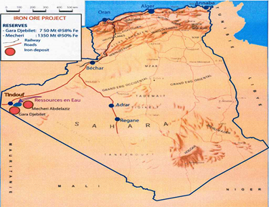 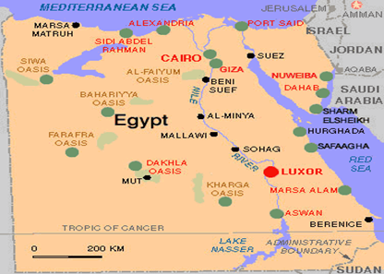

Fig (2 ) Location of Iron ore in Algeria Fig.1, Location of Iron ore in Egypt

**2-1-2 Iron ores in Algeria**

The main iron ore producing mines are the Quenza and Bou Khadra iron-ore mines near the Mediterranean coast, and boundary with Tunisia .whose produce about 80%, also at Gara Djebilet and Mecheri Abdul-Aziz in the west. (MBendi.com 2005) The main hematite-rich ore body at Quenza is estimated at 2 km in length and 500 m in width .the potential is valued at 72 million tons, grading 60% Fe Reserves. Big potential for iron ore mining is located in the South-west part of the country (fig2) and has 3.5 milliard tons of reserves grading 57% Fe. The deposits are Mecheri Abdul-Aziz and Gara Djebilet located at 1600 km south of the Mediterranean coast of Algeria.( Guerrak S, 1988 ).These deposits are hosted within the Early Devonian sediments of the Tindouf Basin in the Algerian Sahara of North Africa and is an important occurrence of the 'North African Paleozoic Ironstone Belt' extending from the Zemmour to Libya, and also includes ironstones of Ordovician, Silurian and Devonian age. (MBendi.com 2005) .At Gara Djebile, three large lenses form three individual deposits, extending east-west for about 60 km. The mineralization is interbedded with argillaceous to sandy sediments .(MBendi.com 2005) This is oolitic iron ore, which, a mineralogy marked mainly by magnetite, hematite, goethite, maghemite, chamosite siderite, apatite and quartz.

Chemical data for the whole field show a difference between the Lower non-magnetite ore (Fe=54.6%), the Magnetite ore (Fe=57.8%) and the Upper non-magnetite ore (Fe=53%).

**2-1-3 Iron deposits in Mauritania**

Mauritania occupies an area of more than 1 million square kilometers (km2) and has a population of 3.4 million. The country’s geology includes four major units: The first one, the Reguibat shield in the north, which includes the Archean rocks and the Paleoproterozoic Birimian succession that hosts major iron ore and gold deposits. (Mowafa Taib 2013)

In 2011, Mauritania was the second ranked producer of iron ore in Africa after South Africa. The company SNIM produced 11.2 Mt of iron ore in 2011.( Mowafa Taib 2013 )

Mauritania Iron is by far the most widespread metal in the country. Famous for Mauritania richness of iron Ore, composed of magnetite and hematite, It was found in three main areas northeast of the country,(fig.3) a Tiris, Sfariat and Tasiast near of Zouerate, which I visited it in 2003 . The mines are at Idjill Kédia, M’haoudat and Guelbs.. It occurs in several geological formations, particularly in the Precambrian crystalline Regueibat Shield. Some belong to Arcian and bermain, It is estimated reserves of about 300 million tons of hematite-rich by / 60-68% / Iron, and 531 Mt of magnetite ore ranging from 36% to 40% iron. Deposits in Kaouat and the Lebtheinia belong to Archean age (Bevis Yeo 2013).

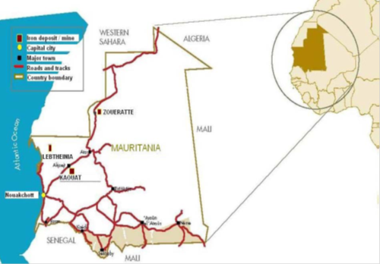

Fig 3, Locality map showing the major iron deposits in Mauritania

**2-1-4 Iron ores in Morocco and Tunisia**

Morocco produces Hematite iron ore extracted from Bouarfa, and Serwa in the south of Marocco, which produces 75% of the iron Morocco, which is estimated at more than 70 / / million tons. The Reserves of iron ore in the territory of Western Sahara, is about 700 million tons, the proportion of iron is estimated at about 65%. According to the geological surveys the potential my reach more reserves.

Tunisia, there are several sites of Iron deposit in the northern areas such as Jrisa and neck Mount near the borders of Algeria within Cretaceous rocks, consist of the hematite, and recognizes the reserve of approximately 60 / / million tons.

**2-1-5 Iron Deposits in Saudi Arabia**

Iron ore discovered in several areas in Saudi Arabia, Fig.4, including:

1-Wadi Sawawen . 900 km north of Jeddah and 60 km ;from the red Sea coast The largest known iron ore deposit in the Kingdom. The raw material is found in the form of magnetite within the Precambrian metamorphic rocks with a reserve of 390 million tons and an iron percentage of between 35.5 - 46.5%. (Rukieh M. 2011).This deposit extends over a belt measuring 15-20 by 25 Kilometers.

2 - Wadi Fatima, where the iron deposit here consist from Hematite in two layers within the sedimentary rocks of Eocene and estimated reserve of approximately 50 / / million tons of 46.2% iron.( - Ahmad M. S. Al-Shanti 2001 )

3-Adsas area in the west of country in the form of lenses high-quality magnetite by iron 65%, within the diorite igneous rocks belonging to the pre-Cambrian.

4-Aaddat Ash sham Iron deposit ,ADDAT Ash Sham area lies about 70km N to NE of Jeddah city, its belongs to the middle Cretaceous-Tertiary sedimentary Rocks. The Tertiary sequence is represented by the Haddat Ash Sham and Usfan Formation.( Rushdi J. Taj 2011 ). Usfan Formation lies conformably on Haddat Al-Sham Formation and it is characterized by its carbonate ledge.. Chamosite Ironstones, Oolitic Ironstones, and Silty Ironstones and Sandy Ironstones,( Rushdi J. Taj 2011) The main Iron minerals in these ores is Goethite ,Hematite, Chamosite.

In Yemen Discovered significant quantities of iron ore, its need further study.

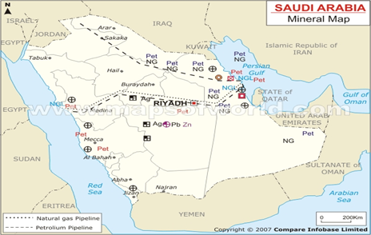

Fig 4, Locality map for the iron deposits in Saudi Arabia

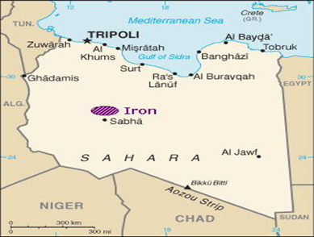

Fig 5, Locality map for the iron deposit in Libya

**2-1-6 Libyan Iron Deposit**

The Wadi ash Shati Iron-ore deposit, north of Sabha, 800 km south of the Mediterranean coast, is one of the largest iron deposits in Africa. Some years ago it was estimated to contain 1,600-20000 million tons of oolitic hematite, limonite, chamosite, and siderite with a grade range of 30%–48% iron. The deposit was discovered in (1943)

The deposit is suitable for open pit exploitation distributed over an area of 80 km2, and has a maximum thickness of 90 m. The deposit occurs within a Late Devonian formation exposed in the upper part of an essentially continuous Paleozoic detrital succession. (Amro F. ALAsta, 2011)

**2-1-7 Iron Ores in Syria**

Iron Syrian ore distributed in three key areas (Zabadani, 40 km northwest of Damascus, kadmouse 25 km to the west of Masyaf, and Kurd Dag, 80 km northwest of Aleppo)

The researches and studies that I conducted on these ores along 25 years ( 1980,1986, 1989, 1992, 1993,2003, 2011, 2012) confirmed the following facts:

- these ores are deposited within the sandy, clay, limestone Abtian sediments. Its positioned unconformable on the surface dolomite, limestone Jurassic rocks, and is composed of two main levels: the lower level is located in all of study areas in the bottom of the Abssian sediments with thickness / 0.5 to 25 m / while the upper level is in the Zabadani area only its thickness between / 7-25 m / and belong to the upper Abtian. (Fig 6)

- in the composition of these ores enters more than thirty minerals, representative in iron , Clay , carbonate , phosphates , Sulphed ,Ti,Mn minerals. The major Iron minerals are Goethite, Hydro goethite and hematite. The main non metallic minerals are quartz, kaolinite and calcite. I discovered more than eighteen new minerals in these ores for the first time (it has given a new vision for Mineralogical Composition of various types of Ores in various areas. Its Helping to know how to invest them.

-These ores Characterized by rising proportions of alumina in which (3.5 to 25%) and high rates of titanium (up 10%), phosphorus, especially in Kurd Dag ores ¸ also characterized by high proportions of following trace elements (V, Co, Zn, Mo, Ag, Ni, Cu, Cr, Pb),

- Ores are characterized by the presence of the following main types: Brown Oolitic Ores in Zabadani area, the proportion of iron (36-42%), green Oolitic ores in Zabadani area, the proportion of iron (31-33%), quartz Oolitic ores, iron proportion (28-32%), pyisolitic ores in the lower level, of Zabadani area, the proportion of iron (25-27%), and conglomerate ores in Kurd dag and Qadmous areas, the proportion of iron (28-35%), iron sandstone, increasing the percentage of quartz and is a sometimes interbedded layers, The iron ranging between (9-24%). The reserves of these ores in the mentioned areas reach up to more than / 300 / million tons,

finally pointed out that I discovered in 1989, in Zabadani area near of Serghaya Hydrothermal rich iron ores with a of zinc, copper, and lead, Sulphed ,(fig6 ),( Rukieh M 1989) which we study it by Remote Sensing techniques

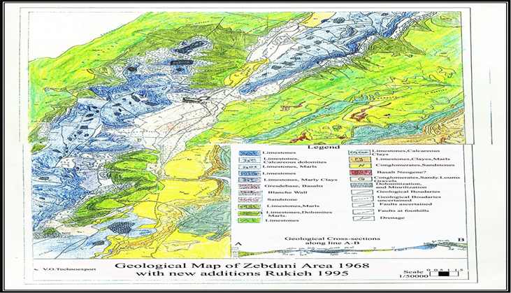

Fig.6, Geological map of Zabadani Area with location of Iron Ore deposit

**3**-  **Remote Sensing Procedure**

In our sensing research, we relied on the application of ASTR satellite images to detect and analyze the phenomena of dolomitization and silicification accompanying the rich hydrothermal iron deposits with their sulfide companions, which are spread in many locations in the Zabadani and Serghaya regions within the Jurassic limestone dolomitic rocks, The tectonic mosaic formed by the multiple faults in the Zabadani region, which extend from tens of meters to tens of kilometers, made it a complex structure and greatly helped in the penetration of hot solutions within its rocks, thus leading to the occurrence of dolomitization, silicification, iron and sulfide mineralization phenomena. The affected rocks appear in distinctive brown colors from their surroundings. The iron bodies resulting from these processes appear in various forms such as veins or in the form of crystals or crystal clusters or in the form of large metal masses in addition to copper, zinc, lead, and arsenic metals. Petrographic, mineralogical and structural studies of many rock sections showed the presence of minerals (goethite, hydrogoethite, hydrohematite, hematite) in addition to many other metallic and non-metallic minerals. These are hydrothermal mineralization associated with hot solutions coming from the depths

**3-1-Materials and methods**

We used ASTER space images with 14 channels of different scales, of various spectral channels with different resolution as follows:

- Visible Near Infrared (VNIR) consists of three bands with a spatial resolution of 15 m.

- Short Infrared (SWIR) consists of 6 bands with a spatial resolution of 30 m.

- Thermal Infrared (TIR) consists of 5 bands with a spatial resolution of 90 m.

We also used geological maps, Topographic maps ,Tectonic maps: with resent tectonic map of Syria, tectonic map of Zabadani area, scale 1/50000,

We used followed Methodology in detecting iron and associated sulfides mineralization:

1: collect of Information and entering it into the computer. After collecting information in various forms, it is verified and ensured that it covers the study area, and the maps are numbered after entering them into the computer using a scanner, in addition to the space images whose data has been verified and uploaded to the computer.

2: Image processing, analysis and interpretation. Its include:

2-1: Geometric correction.

-2-2: Radiometric correction.

-2-3: Space images analysis.

-2-4: Space images interpretation.

3- Use USGS Spectral libraries , so, Fig. 7 shows the reflectance spectral curves of iron oxides and Fig. 8 shows the spectral curves of carbonates (calcite, dolomite, siderite).

4-: Derivation of spectral evidence indicating rock changes phenomena associated with iron and other sulfides mineralization and their application to space images.

5- Selecting the best spectral evidence indicating the phenomena of rock changes associated with mineralization.

6-: Comparing the results of the analysis on space images with the results of radiometric measurements and the spectral library.

7- Adopting specific indicators to be used in detecting similar deposits and indicators in other areas.

8- Developing Thematic maps of rock changes associated with iron and other sulfides mineralization in Zabadani area at appropriate scales.

**3-2 Matching spectra from the spectral library to Space image spectra**

This method is used for spectral matching between reference spectra extracted from the spectral library or from radiometric spectral measurements, with radiometrically and geometrically corrected satellite image spectra.

This method is done in two stages, the first stage is the Matched Filtering (MF) stage, which is used to identify and determine the categories (elements) to be matched using the process of partial unmixing between the components of the space image, which works to increase the response of the known final element (reference spectrum) and suppress the response of the unknown composite background, thus matching the known spectral reflectance (reference spectrum).

This technique can use several types of files to compare them with the space visual spectra, where in this research, ASCII files extracted from the spectral library were used as a reference spectrum, to determine the spectral match between the original space visual spectra and the reference spectrum extracted from the USGS spectral library, for the required metallic and non-metallic minerals.

The second stage is Mixture Tuned Matched Filtering (MTMF) which is used to add infeasibility data to the results which is used to reduce the false positives that are sometimes found when using the first stage. Image elements that are classified as infeasibility are likely to be false positives in the first stage. Therefore, correctly assigned image elements will have a higher MF score than the background distribution around zero, and a lower infeasibility score.( . (Almarrani, M. Fawal A. Rukieh M. 2023)

**3-3 Comparison of the results of the spectral evidence with the results of the MTMF spectral matching**.

After applying the spectral matching process using MTMF based on the reference spectra extracted from the spectral library, which were for the iron oxides group within the VNIR spectral range, the carbonate group, within the SWIR spectral range and siliceous (quartz) within the TIR spectral range, the results of the spectral evidence were compared with the results of MTMF in each spectral range (VNIR – SWIR – TIR), with the aim of determining the best evidence for each group of metals and in each spectral range separately

- It turned out that the highest matching percentage was found for the 2/1 index in (hematite. - Followed by the 5/3 index in (goethite fig. 9 and hydrogothite Fig.10). We notice in the figure 9 that the highest percentage of goethite is found within the Callovian rocks of the Upper Jurassic and reaches 27 percent. Also, the percentage of hydrogothite in the Callovian and Kembridgian Rocks of the Upper Jurassic, reaching 29 percent and 11 percent, respectively, as shown in Figure 10. The highest percentage of conformity is for the 5 /8 index in (calcite and siderite). Followed by the (9+6) /(8+7) index in (dolomite). The 12/13 index was adopted within the thermal infrared range (TIR) ​​to detect Quartz )Sio2.( . (Almarrani, M. Fawal A. Rukieh M. 2023).

**4- Results**

The Research indicate to the next main results:

1- The Iron Ores in Arabic Countries Returning to the three main origins, Magmatic (Adsas In Saudi , Zwerat in Mauritania ) Metamorphic (East Desert in Egypt , Sawawen in Saudi Arabia, Kuwait in Mauritania and Sedimentary ( Algeria , Syria Lebanon, Libya, Tunis, Morocco ,Albahria oasis in Egypt)

2-The Magmatic and Metamorphic Ores mainly consist of hematite and magnetite, Chamosite minerals within the igneous and metamorphic rocks at the pre-Cambrian crystalline base, while sedimentary ores predominantly consist of Goethite , Hydro goethite , hematite and hydro hematite within the sedimentary rocks of the Paleozoic ( Devonian, Algeria Libya) Mesozoic ,(lower cretaceous Syria ,Lebanon, Egypt, Tunis,) and Cenozoic( Eocene ,Saudi Arabia)

3-The Magmatic ores usually rich in iron ( (52 -68 %) while the sedimentary rich, medium and poor in iron (55-25%) and increasing the proportion of Ti, P, Al, Si, as in Syrian ores . sometimes with high Mg , Zn , as in Bahariya Oasis ores in Egypt. But the Metamorphic Ores its medium (47-30%) in iron consist with usually increasing the proportion of silica.

4- The research showed that the space images taken by the ASTER scanner with its wide spectral ranges consisting of 14 spectral bands are useful in detecting metallic and non-metallic minerals, compared to other space images with limited spectral ranges.

5-The research confirmed that the MTMF mixture-tuned matching filtering method is effective in the matching process between the spectra of the spectral library and the spectra of the space image. It can be adopted in subsequent studies.

6- The research showed that the following indicators: 2/1, 5/3, 5/8, (9+6) /(8+7), 12/13 ,are effective in detecting iron oxides, carbonate and siliceous minerals, , and can be adopted in subsequent studies,

7 The research showed that the first spectral range (0.52 – 0.60 μm) and the second spectral range (0.63 – 0.69 μm) located within the visible and near infrared (VNIR) spectral range of the ASTER scanner are useful in detecting hematite, and the third spectral range (0.78 – 0.86 μm) within the VNIR spectral range, and the fifth spectral range (2.145 – 2.185 μm) located within the short infrared (SWIR) range of the ASTER scanner are useful in detecting goethite and hydrogothite.

8-The ASTER SWIR spectral range is useful for detecting carbonate minerals, especially spectral ranges 5 (2.145 – 2.185 μm) and 8 (2.295 – 2.365 μm) for detecting calcite and siderite, spectral ranges 6 (2.185 – 2.225 μm), 7 (2.235 – 2.285 μm) and 9 (2.360 – 2.430 μm) for detecting dolomite , and the twelfth spectral range (8.925 – 9.275 μm) and the thirteenth (10.25 – 10.95 μm) in the ASTER scanner, which belongs to the thermal infrared TIR range, can be relied upon to detect siliceous.

**5- Conclusion**

Iron ores exploited in a number of Arab countries constitute a solid foundation for establishing an advanced Arab iron industry that keeps pace with the advanced world. They must be developed by searching for new ores suitable for complex exploitation, not only for iron, but also for alumina, titanium and other industries. Here comes the role of remote sensing technologies to take the leading role in investigation and exploration operations due to their unique characteristics that are not available in other means, the most important of which are speed, accuracy, covering large areas, studying areas that are difficult to reach and implementing them using traditional methods such as deserts, high mountains and dense forests, reducing the cost to about 50 percent and preserving the environment.

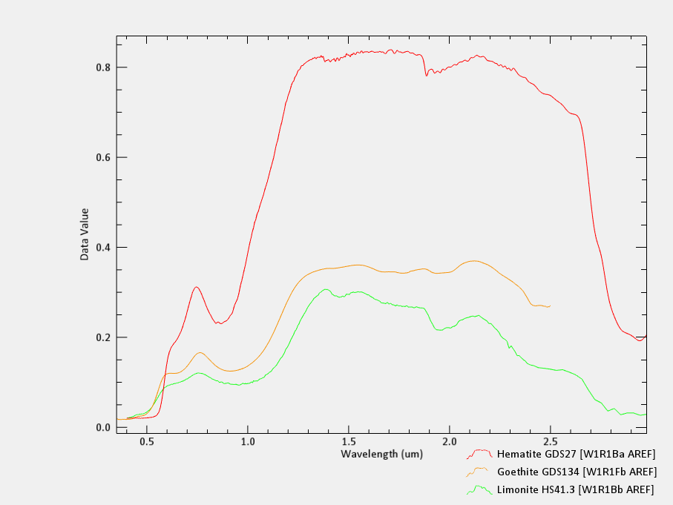

**Fig. (7): Reflection spectral curves of iron oxides from the spectral library**

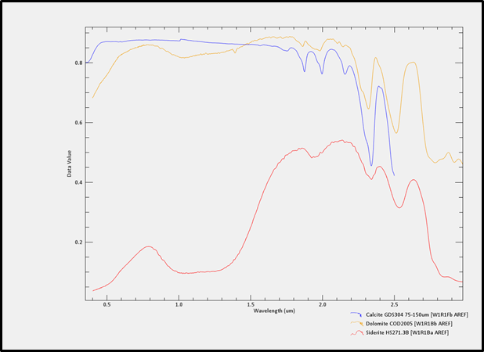

**Fig. (8): Reflection spectral curves of carbonates from the spectral library**

Fig. 9 A graph showing the percentages of goethite according to geological ages in the study area. . (Almarrani, M. Fawal A. Rukieh M. 2023)

Fig. 10, A graph showing the percentages of hydrogothite according to geological ages in the study area. (Almarrani, M. Fawal A. Rukieh M. 2023)

**6- References**

1- Ahmad M. S. Al-Shanti. OOLITIC Iron Ore Deposits In Wadi Fatima ,Saudi Arabia,2001,www.sciencedirect.com/science/article/pii/0301751684900024

-2Almarrani, M. Fawal A. Rukieh M. 2023, Using remote sensing technologies and supporting systems to detect dolomitization and mineralization phenomena in Zabadani area( Syria) Master's thesis , Damascus University

3- Amro F. ALAsta, 2011,Using Remote Sensing data to identify iron deposits in central western Libya, International Conference on Emerging Trends in Computer and Image Processing (ICETCIP'2011) Bangkok Dec., 2011

4-Bevis Yeo 2013 Charter Pacific's Mauritania iron ore project ranked against Sphere Minerals

5-Guerrak S, 1988 - Geology of the Early Devonian oolitic iron ore of the Gara Djebilet Field, Saharan Platform, Algeria in Ore Geology Reviews : v3,Issue 4, pp 333 -358

6-Iron ore mining in Algeria – Overview-MBendi.com 2005. Exploitation of iron ore deposit "Gara Djebilet and Abdul-Aziz Mecheri,

7- Khalil Isaa , El-Shazly, Aley K.2010,Banded Iron Formations from the Eastern Desert of Egypt: A new type of Ore? Session 02d (Poster): Precambrian sediments as records of early earth tectonics and ocean-atmosphere-biosphere interactions Poster # 24

8-Mowafa Taib, the Mineral Industry of Mauritania 2013, USGS ,Science for a changing world Mauritania(Advance Release ) 2011 Minerals Yearbook:/

9- Nakhla, F.M., 2008, the iron ore deposits of El-Bahariya oasis, Egypt Economic Geology; 56(6):1103-1111.

10-Stern, R. J., Avigad, D., Miller, N.R., and Beyth, M., 2006. Journal of African Earth Sciences, 44: 1-20.

.11- Rukieh M.1980, “The Syrian Iron Ore Occurrences” , Book of Geology and Mineral Resources in the countries of Asia, Africa and Latin America”. Moscow 1980, (pp 191-198)( In Russian )

12- Rukieh M. 1980 ,Mineralogical composition of Iron ores in Zabadani area–Syria. Geology and Exploration Journal, Moscow, October 1980, no: 7, pp37-41.( in Russian )

13— Rukieh M. 1986, Mineralogical and chemical composition, structural characteristics and main types of the sedimentary Iron Ores in Al-Qadmous area, the Syrian Geological Journal, March 1986, no.10, pp 45-57 ( in Arabic)

14- Rukieh M. 1989 "A report on the discovery of potential deposits of rich iron ores and mineral sulphides in the Zabadani area", in 1989, a report issued by the General organization of Remote Sensing, Damascus, Syria. ( in Arabic)

15—Rukieh M. 1992, Geological characteristics and mineralogical structure of Iron Ores in Al Kurdagh area , Arab Steel Journal, July/August 1992, no: 210, pp35-55.( in Arabic)

16- Rukieh M. 1993, Structural and Chemical characteristics of Iron Ores in Al-Kurdagh Area and their main kind, Arab steel Journal –Algeria ,feb.1993.no.216,pp 12-23

17—Rukieh M. 2003,The Tectonic Position, Mineralogical Composition and Geochemical Characteristics for Iron and Sulphed Deposits Discovered in AlKota, Dahr Alkhanzeer and Toufahta Sites in Sirghaya Area- Syria, Remote Sensing Journal, No.15, December 2003,pp 1-50, Damascus. .( in Arabic)

Rukieh M.2012, Using Space Imagery in the Exploration of Useful Raw Materials, Proceedings of (ACRS 33, 2012) –November 2012, Pattaya –Thailand, 1624-1637 p

18- Rushdi J. Taj 2011, Stratigraphic Setting, Facies Types and Depositional Environments of Haddat Ash Sham Ironstones, Western Arabian Shield, Saudi Arabia. (Asian Transactions on Basic & Applied Sciences (ATBAS ISSN: 2221-4293) Volume 01 ttp