**Castle Investigation Using UAV LiDAR Surveying**

Hideyuki Haijima 1*, Takuya Okamoto. 1, and Hajime Nakasha 1

1 Nakanihon Air Co., Ltd. Japan

[*haijima@nnk.co.jp](mailto:*haijima@nnk.co.jp)

***Abstract***

*Yatsushiro Castle was built in Kumamoto Prefecture, Japan, about 400 years ago. Over the years, it suffered various damages such as fires and the collapse of stone walls, and by the time of the Meiji Restoration, only the stone walls of the main tower foundation and the inner moat remained. The existing stone walls also damaged during the earthquake that occurred on April 16, 2016. During an inspection after the earthquake, it was pointed out that there might be a distortion in the northern stone wall of the main tower foundation. However, conventional land survey methods could not accurately capture the three-dimensional shape of the stone wall, making it difficult to confirm the presence of any distortion. Therefore, in this project, a high-performance LiDAR scanner was mounted on a UAV to acquire high-density and high-precision 3D point cloud data from the air, with the aim of three-dimensionally capturing the shape of the stone wall. As a result of detailed analysis of the acquired data, the detailed shape of the stone wall, which could not be understood from land surveys, became clear. This achievement is significantly beneficial in the protection and restore of cultural properties.*

*Keywords:　UAV, LiDAR, 3D point cloud, Stone wall, Archaeological Survey*

Introduction

**a. Yatsushiro Castle:**

Yatsushiro Castle was relocated and rebuilt in Matsue Village, on the opposite side of Tokubuchi's port, following the collapse of the original Yatsushiro Castle (current Mugishima Castle ruins) due to an earthquake in 1619. The main tower, surrounded by stone walls, consisted of “hon-maru (main enclosure)”, “ni-no-maru (2nd enclosure)”, “san-no-maru (3rd enclosure)”, “kita-no-maru (northern enclosure)”, and “de-maru (outside enclosure)” and was encircled by Mae River as an outer moat. The main tower and some others were lost by fire caused by lightning in 1672. Reconstruction began the following year, but the main tower was not rebuilt. Instead, the smaller tower, “tojin-yagura (attached tower)”, and “uzumi-go-mon (gate house)” were reconstructed. In course of time, the castle caught multiple fires and the stone walls collapsed. The smaller tower and the hon-maru palace were lost again in a fire in 1797, and reconstruction efforts began in 1799. The castle was decommissioned in 1870 during the Meiji Restoration. In 1871, this castle ruin became a military site, and later that year, Yatsushiro Prefecture Office was established with its government office in the hon-maru ruins. The Taiyo school, the predecessor of the Taiyo elementary school, was established in the other part of hon-maru ruins in 1873. In 1884, the Yatsushiro Shrine, was established, and a grand festival for the enshrinement was held. The guest space left at hon-maru ruins were relocated twice between 1939 and 1959, but it was lost by fire in February 1986.

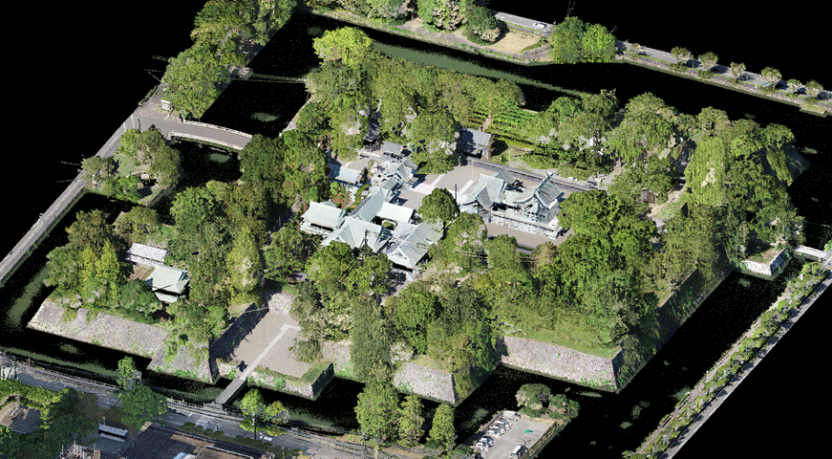

N

Figure 1: Aerial view of Hon-maru (main enclosure) in Yatsushiro Castle Ruins

(UAV LiDAR point cloud)

**b. The Kumamoto Earthquake:**

On April 14, 2016, at 11:26 PM, a foreshock with a 6.5 on richter scale struck Kumamoto Prefecture. The main shock with a 7.3 on richter scale followed on April 16 at 1:25 AM, causing significant damage throughout Kumamoto Prefecture, including Yatsushiro City, which recorded a seismic intensity of 5+ on the Japanese Seven Stage Seismic scale during the foreshock and 6- during the main shock. Aftershocks of 5+ intensity were repeatedly recorded. While Kumamoto Castle's damage was widely reported, in Yatsushiro Castle ruins, northern stone walls at the bridge gate also collapsed and necessitated preservation and restoration efforts.

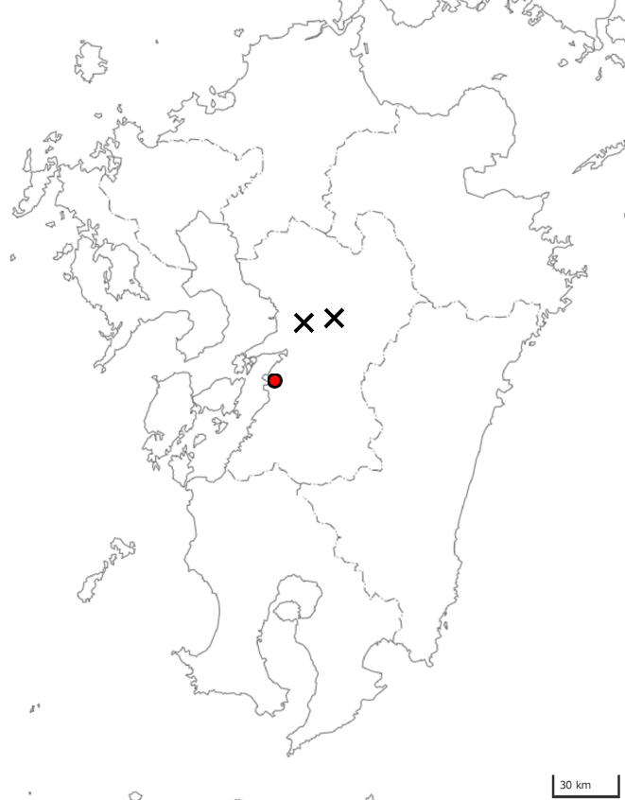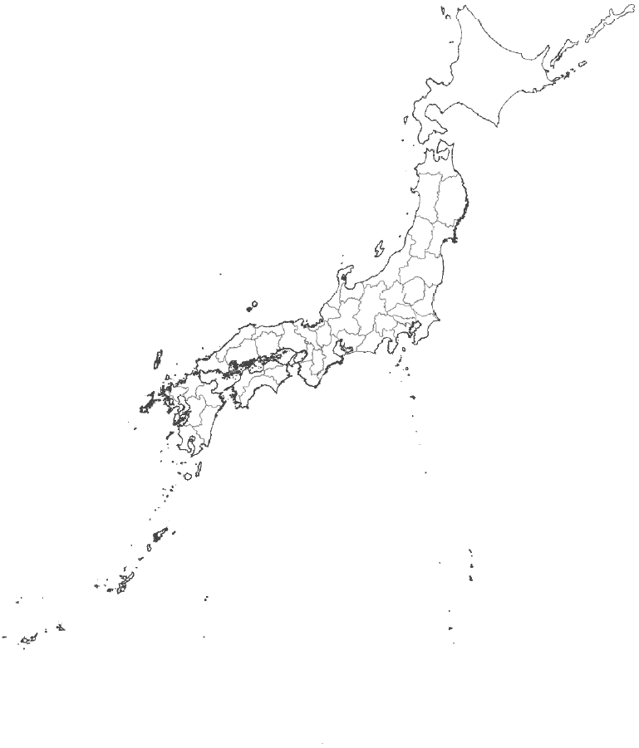

**Kumamoto Pref.**

**Yatsushiro Castle**

**The Epicenter Apr 14, 2016**

**The Epicenter Apr 16, 2016**

30 km

GSI Blank Map: Geospatial Information Authority of Japan (GSI)

Figure 2: Location Map

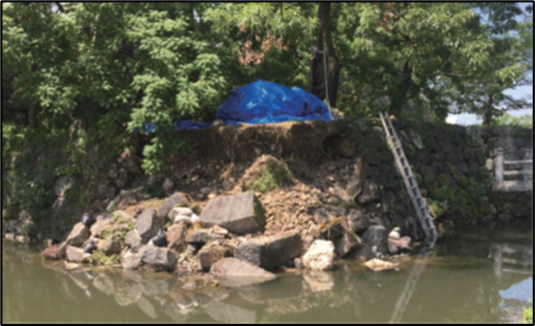

*Source: Yatsushiro Castle Ruins Conservation and Restoration Report*

Figure 3: condition of the collapsed stone wall at the bridge gate

During post-earthquake inspections, it was pointed out that there were bulges in the northern stone walls of the main tower foundation. Although the post-earthquake plan views, elevation drawings, and sectional drawings of the stone walls did not confirm any clear bulges, the expected curvature of the stone walls was not observed on the east side of the northern stone walls. Therefore, UAV laser surveying was conducted to obtain high-density and high-precision 3D point cloud data from the air in an attempt to understand the 3D shape of the stone walls.

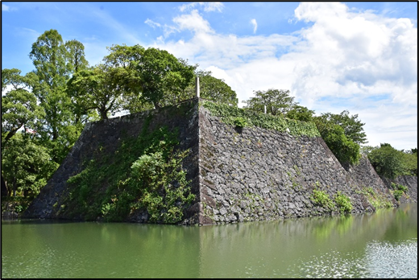

**Western stone walls**

**Northern stone walls**

Figure 4: Stone walls at the Main tower foundation

UAV Laser Surveying

The UAV laser surveying was conducted using a high-performance LiDAR scanner, "RIEGL VUX1-UAV," mounted on a large UAV. The laser scanner emits laser beams towards the ground and measures the time for the reflections, thereby determining the precise distance to the target objects. By combining this distance data with the UAV's position and orientation information, the shapes of the terrain and objects can be measured as 3D point cloud data. The system used in this project enables high-density scanning of over 400 points/m², allowing for precise measurements of the terrain and object shapes.

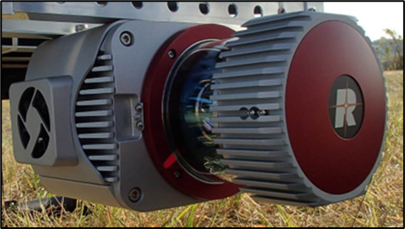　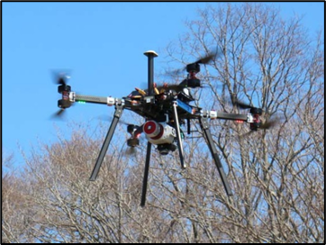

Figure 5: LiDAR scanner and UAV

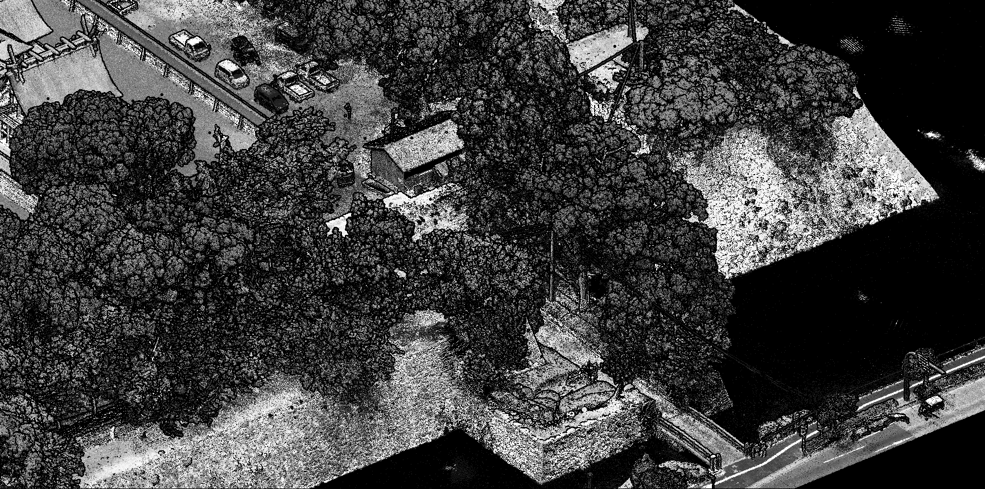

**Bridge gate**

**Northern stone walls**

Figure 6: Example of Acquired Data (Bridge gate and Main tower foundation)

Analysis of the Main Tower foundation's Stone Walls

**a. Northern Stone Walls:**

Using UAV laser data and elevation/sectional drawings, the post-earthquake shape of the northern stone walls of the main tower foundation was analyzed. The shapes from the measured cross-sections surveying by hand and UAV laser data matched well (elevated areas in the laser data were affected by vegetation).

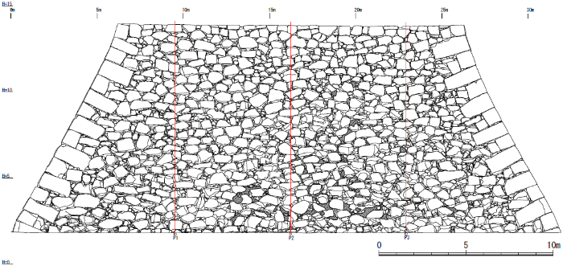

P1　　　　　 P2　　　　　　 P3

Figure 7: Elevation of the Northern Stone Walls of the Main tower foundation

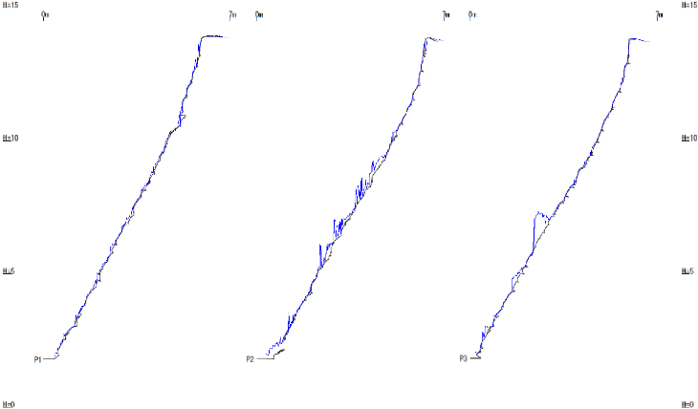

Surveying by hand Surveying UAV laser

**P1 P2　　　　　　 P3**

vegetation

vegetation

Less curvature

Figure 8: Sectional Drawings of the Northern Stone Walls of the Main tower foundation

Cross-sections were created from the UAV laser data at fine intervals (2m). In Figure 9, the color of the cross-section lines indicates that white and warm colors are on the east side (P1 side), and cool colors are on the west side (P3 side). When overlaying the cross-sections, it was observed that the slope is gentler on the west side (cool colors) and becomes steeper towards the east side (white and warm colors).

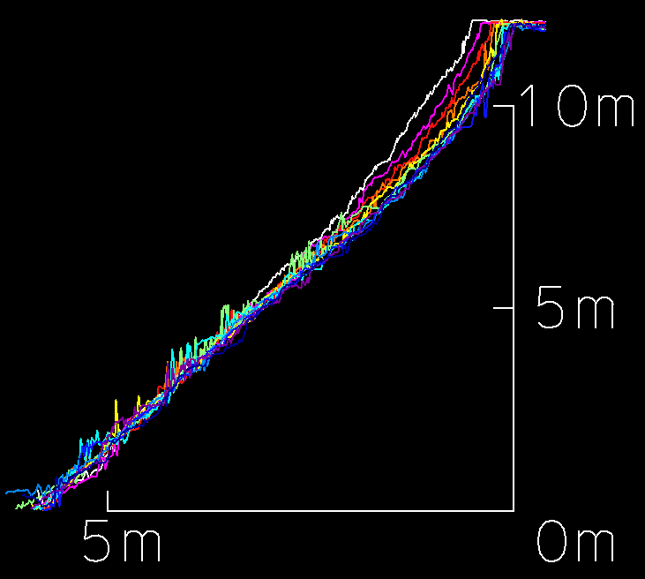

Figure 9: Overlay of laser Cross-Sections of the northern wall of the Main tower foundation

(Horizontally Exaggerated 2x)

Reviewing the drawings in Figure10, it was confirmed that the capstones and base stones are tilted approximately 1.6 degrees from parallel, narrowing towards the east side (P1 side). Since the height of the stone walls remains almost constant, the slope becomes steeper as the width narrows towards the east side.

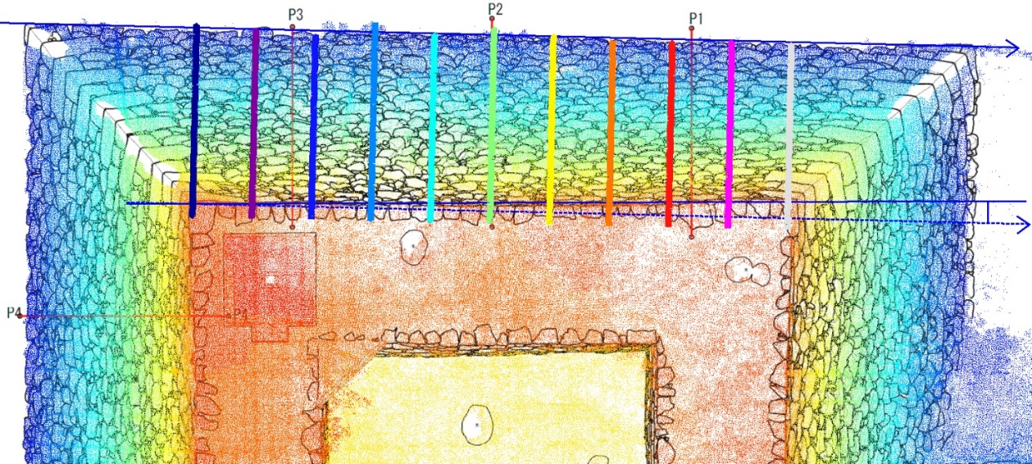

The colors of the cross-section lines are the same as in Figure 9

approx. 1.6°

Figure 10: Floor plan of the Northern wall of the Main tower foundation

**b. Western Stone Walls:**

No significant distortions like those in the northern stone walls were observed in the plan of the western stone walls. The sectional drawings showed relatively uniform slopes, though the central slope was slightly gentler compared to the sides. Therefore, a more detailed analysis was conducted focusing on minor bumps (bulges) in the western stone walls.

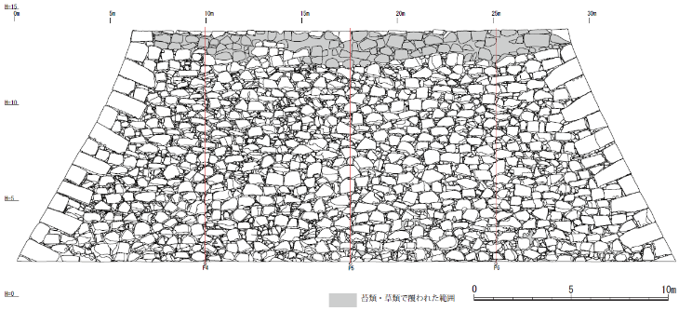

P4　　　　　 P5　　　　　　 P6

Figure 11: Elevation of the Western Stone Walls of the Main tower foundation

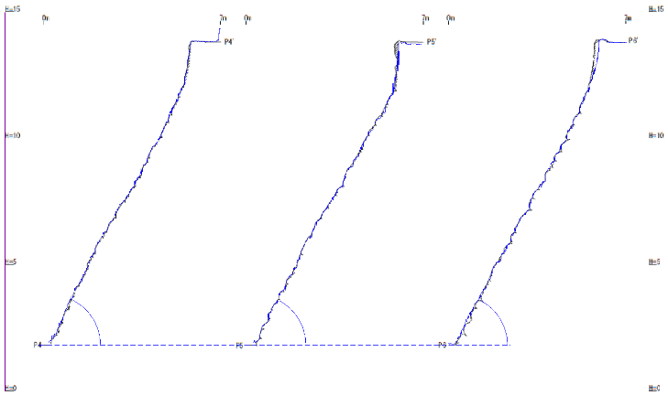

Surveying by hand Surveying UAV laser

approx. 61.5°

approx. 62.1°

approx. 62.0°

**P4 P5　　　　　　 P6**

Figure 12: Sectional Drawings of the Western Stone Walls of the Main tower foundation

Figure 13 represents the bumps of the western stone walls. The average slope is shown in green, convex areas in warm colors (red: convex by 20cm or more), and concave areas in cool colors (blue: concave by 20cm or more). Viewed as a whole, the lower part of the western stone walls shows a slight bulging. Although this may not be easily discernible from the cross-sectional drawings alone, comparing the cross-sectional drawings in Figure 12 with those in Figure 13 reveals that the lower part also shows bulging in the P4 and P5 cross-sectional drawings.

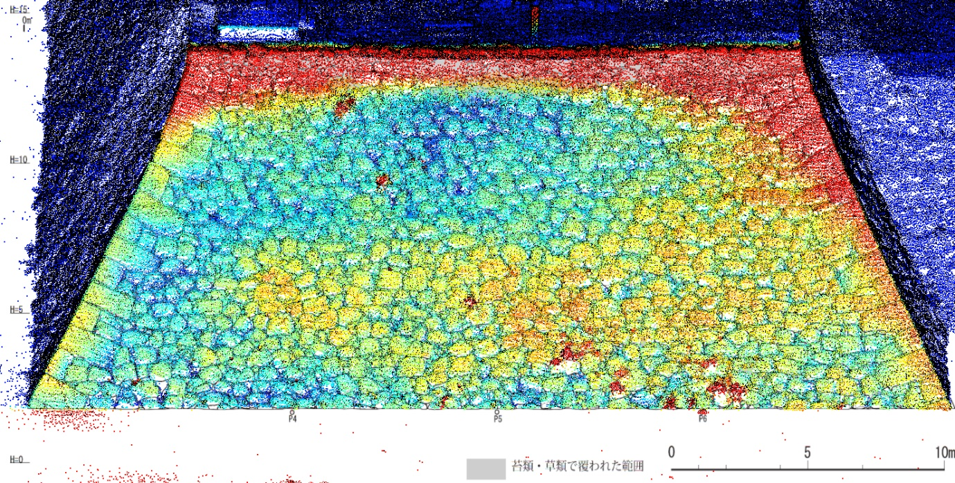

Bulging

P4　　　　　　　 P5　　　　　　　 P6

20cm

0cm

-20cm



Figure 13: Bumps Plan of the Western of the Main tower foundation

Utilization of High-Density UAV Laser

UAV laser scanning can capture point data more densely than Airborne laser scanning. Unlike Terrestrial Laser scanning, it can acquire data uniformly over areas, allowing for a comprehensive understanding of the overall structure of fortifications and detailed examination of individual structures using high-density data. Once captured, the UAV laser data can be utilized in various applications.

Conclusion

While the distortions in the northern stone walls and bulges in the western stone walls of the main tower foundation are newly confirmed this time by high-density data from UAV laser scanner, it is unclear whether they were caused by the 2016 Kumamoto Earthquake. However, detail studies of their shapes help for the preservation of cultural properties and the formulation of restore plans as needed. Although this analysis focused on the stone walls of the main tower foundation, the data was collected comprehensively, and further analysis might reveal new findings in other areas.

Acknowledgments

We deeply appreciate the cooperation and advice provided by Mr. Junji Yamauchi of the Yatsushiro City Board of Education and Mr. Kazuhisa Ishibashi of Kyushu Research Institute for Cultural Properties Inc.

References

Yatsushiro City & Yatsushiro City Board of Education (2018). Preservation and Repair Report of Yatsushiro Castle Ruins Post-2016 Kumamoto Earthquake. *Yatsushiro City Cultural Property Survey Report No. 49*

Yatsushiro City & Yatsushiro City Board of Education (2020). The 2nd Enclosure of Yatsushiro Castle - Excavation Report on the Relocation of Yatsushiro City Hall Damaged by the 2016 Kumamoto Earthquake. Yatsushiro *City Cultural Property Survey Report No. 51*