**Developing an Ecotourism Master Plan for Udawattakele Forest: Integrating Remote Sensing, GIS, and Community Insights**

W.S. Aluwihare 1, A.R. Gunawardena * 2 and T.T. Fernando 2

1Forest Department of Sri Lanka

2Central Environmental Authority of Sri Lanka

ajithr@cea.lk

***Abstract***: Udawattakele Forest, designated as a nature reserve in 1856 and a sanctuary in 1938 by the Forest Department of Sri Lanka, spans 102.8 hectares. This forest, located in the heart of Kandy—a major tourist destination—hosts diverse vegetation and numerous fauna species, generating an annual income of Rs. 7.2 million approximately. Despite its potential, the forest lacks a proper ecotourism plan. This study aimed to develop an ecotourism master plan using remote sensing, GIS, questionnaire survey together with expert opinions.

Spatial distribution of vegetation density and different habitat mapping were implemented utilizing high-resolution satellite images. Slope maps were developed using the SRTM DEM and verified with 10m contour vector data. Water bodies and streams were demarcated using available vector data and updated with GPS data. Biodiversity and flora, fauna primary data were collected through field sampling and included into the spatial database. These methodologies facilitated to create an eco-zone map encompassing all ecosystems within the forest reserve.

Based on the eco-zone map, nature trails, signboards, and footpaths were accurately demarcated and significant locations were enhanced with QR codes. Additionally, data on visitor popularity, lodging options and local community insights were collected from a questionnaire survey.

Ultimately, an ecotourism master plan for Udawattakele Forest was developed as a combination of remote sensing, GIS, community feedback and expert recommendations.

Keywords: Forest, Remote Sensing, Ecotourism

**Introduction**

Sri Lanka, known for its rich cultural and natural heritage, attracts a wide range of tourists, making tourism a key industry that contributed USD 4.4 billion to the economy in 2019 (Sri Lanka Tourism Development Authority, 2021). Ecotourism, a subset of tourism, focuses on responsible travel to natural areas, conserving the environment and supporting local communities. It has grown in popularity, with the government promoting sustainable practices and partnering with communities. Sri Lanka’s diverse ecosystems, including forests, beaches, and wetlands, offer high potential for ecotourism (Arachchi, 2012). Activities such as wildlife safaris, bird watching, and trekking are popular. Famous destinations include Sinharaja, Kanneliya, and Knuckles, with Udawattakele Forest Reserve in Kandy also being a key site. Udawattakele, managed by the Forest Department (FD), became a nature reserve in 1856 and a sanctuary in 1938. Covering 102.8 ha, it hosts 460 plant species and diverse fauna. Ecotourism in the area supports conservation, local communities, and cultural preservation. Although underutilized, Udawattakele generates around Rs. 7.2 million annually (FD Performance Report, 2019). This study explores the potential, challenges, and guidelines for developing Udawattakele as an ecotourism destination, benefiting stakeholders and promoting sustainable conservation practices.

Ecotourism is a sustainable form of tourism that focuses on preserving natural environments while offering educational and recreational experiences for visitors (Arachchi, 2012). Sri Lanka, with its diverse flora, fauna, and rich cultural heritage, is an ideal ecotourism destination. The country has been identified as one of the fastest-growing ecotourism destinations globally (World Tourism Organization, 2019; Sri Lanka Tourist Board, 2003, Nisthar, et.al, 2016). Ecotourism is defined as "responsible travel to natural areas that conserves the environment, sustains the well-being of local people, and involves interpretation and education" (TIES, 2015). Sri Lanka, with its diverse forests, wildlife, and cultural heritage, has significant potential to develop ecotourism further” (TIES, 2015). The government's efforts in promoting sustainable tourism have led to the growth of ecotourism activities like wildlife safaris, bird watching, and trekking, providing positive experiences for visitors and supporting local communities (World Tourism Organization (2019).

Sri Lanka's National Ecotourism Policy emphasizes the need for tourism development that promotes the conservation of natural environments, enhances the country’s cultural and historic attractions, and ensures economic benefits for local communities. This policy also aims to mitigate the negative impacts of nature tourism by promoting responsible tourism practices and supporting conservation efforts (Gunasinghe, 2011).

Ecotourism extends beyond typical tourism by focusing on conservation, community involvement, and education (Silva, 2004). Its success relies on implementing sustainable practices, minimizing environmental and social impacts, and generating financial benefits for both conservation and local communities (Kulatunga, 2019). Forest-based ecotourism, in particular, has gained attention due to its potential to support conservation efforts and improve local livelihoods. Activities such as nature walks, wildlife safaris, and camping contribute to forest conservation through park entry fees and provide employment for local communities (Pathmasiri, 2017). In places like the Sinharaja Forest Reserve, ecotourism has positively impacted local communities by generating income and reducing illegal activities like logging. As a non-consumptive, market-based approach to forest use, ecotourism supports sustainable forest management, helping to conserve biodiversity and protect natural resources (De Zoysa, 2021; De Zoysa, 2022).

**Udawattakele Forest Reserve**

Udawattakele Forest Reserve, located in Kandy, holds significant potential for ecotourism due to its rich biodiversity and cultural heritage. Situated within walking distance from Kandy town, the reserve offers well-maintained, accessible paths that attract school groups, university students, and foreign tourists, especially bird watchers, due to its diverse bird species (Bhikkhu Nyanatusita, 2014). The forest is also a research hub for scientists and students, with studies focusing on its flora and fauna. Managed by the Forest Department, Udawattakele became a nature reserve in 1856 and a sanctuary in 1938 (Karunaratna, 1986). Spanning 102.8 hectares, the forest boasts diverse vegetation and provides critical habitats for numerous species (Weerakoon, 2015). It supports over 460 plant species, including rare and endemic varieties like Diospyros ebanjamina and Cinnamomum zeylanicum. The forest is home to over 90 bird species, 40 butterfly species, 12 mammal species, and various reptiles and amphibians, including endangered species like the Sri Lanka Spurfowl and Purple-faced Langur (Dahanayaka, 2017). Historically, Udawattakele served as a royal forest during the Kandyan Kingdom (14th–16th centuries) and later became a sanctuary for monks during the colonial era (Perera, 2006). During British rule, the forest spanned over 400 hectares but has since been reduced to its current size of 104 hectares. Cultural landmarks such as ancient caves, meditation centers, and Buddhist monasteries add to its spiritual and historical significance.

**Strengths and Opportunities for Ecotourism**

Udawattakele's rich biodiversity, cultural heritage, and natural beauty make it an ideal ecotourism destination. The forest supports numerous endemic species and offers opportunities for scientific research, education, and conservation efforts. Ecotourism here can also boost local economies through sustainable development, promoting public-private partnerships and involving local communities.

**Weaknesses and Challenges**

Challenges include limited community involvement in conservation and the threat of urban encroachment due to its proximity to Kandy. Uncontrolled development and insufficient public awareness about the forest’s ecological value could undermine conservation efforts. Addressing these challenges is crucial for sustainable ecotourism development in Udawattakele.

**Objectives**

This study utilizes Remote Sensing and GIS to assess the potential for ecotourism in Udawattakele Forest Reserve and gather opinions via a questionnaire survey. It identifies key challenges, including limited community involvement, urban encroachment, and low public awareness of the forest's ecological value. Based on these findings, guidelines will be developed to enhance ecotourism, focusing on sustainability, conservation, and community engagement.

**Methodology**

**Study Area**

The Udawattakele Forest Reserve is located in the Kandy Municipal Council Area of Kandy District of Sri Lanka (Figure 1). This Forest located in Gangawata Korale Divisional Secretariat Division and boundary to the Gagawara Korale Grama Niladhari Division (figure 1). The forest reserve is located at an elevation range from 520-645msl. It is categorizes as a tropical rainforest but mixed with some introduced plant species. The annual average rainfall in Udawattakele Forest reserve is about 1773 mm and the average temperature 23.5°C. Reddish brown Latasolic is the major soil type represented the area.

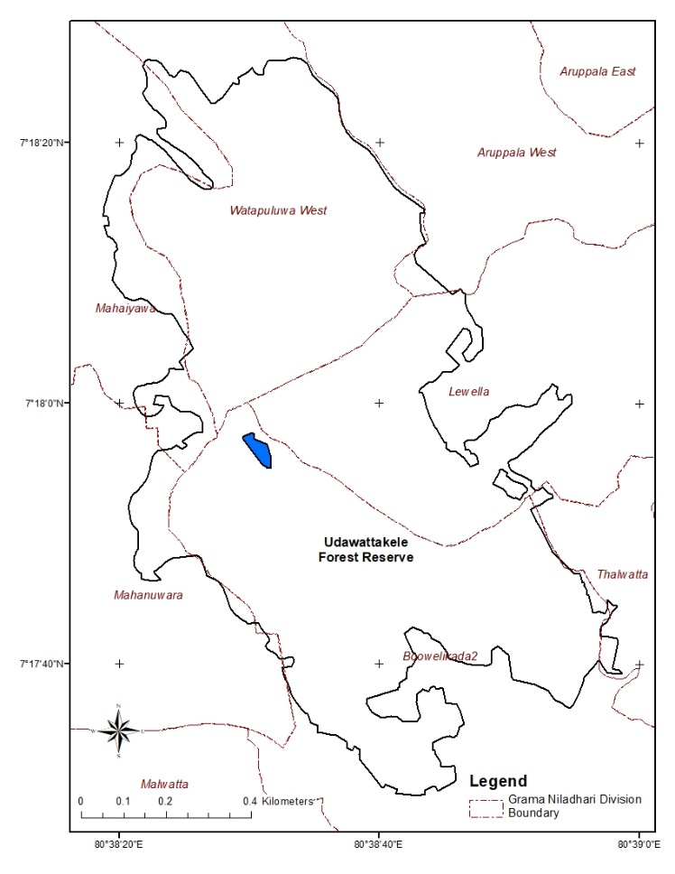

Figure 1: Distribution of Grama Niladhari Divisions in Udawattakele

A vegetation density map of Udawattakele Forest Reserve was developed using remotely sensed data to analyze the spatial distribution of vegetation. The Normalized Difference Vegetation Index (NDVI) was generated from Landsat 8 multispectral satellite images, which revealed the variation in vegetation density across the reserve. Areas with the highest NDVI values, indicating dense and healthy vegetation, were observed in regions dominated by Mesua species, while lower NDVI values were found in disturbed or degraded areas.

Additionally, a terrain map was produced using data from the Shuttle Radar Topography Mission (SRTM), allowing for the creation of a detailed slope map of the forest. This topographical data helps understand the forest's elevation changes, which is crucial for planning sustainable tourism activities. Existing nature trails, cycling paths, and hiking routes were demarcated using GPS tracking, and new potential pathways were identified to promote future ecotourism development while ensuring minimal impact on the ecosystem. This data-driven approach enhances the reserve’s ecotourism potential by balancing accessibility with environmental conservation.

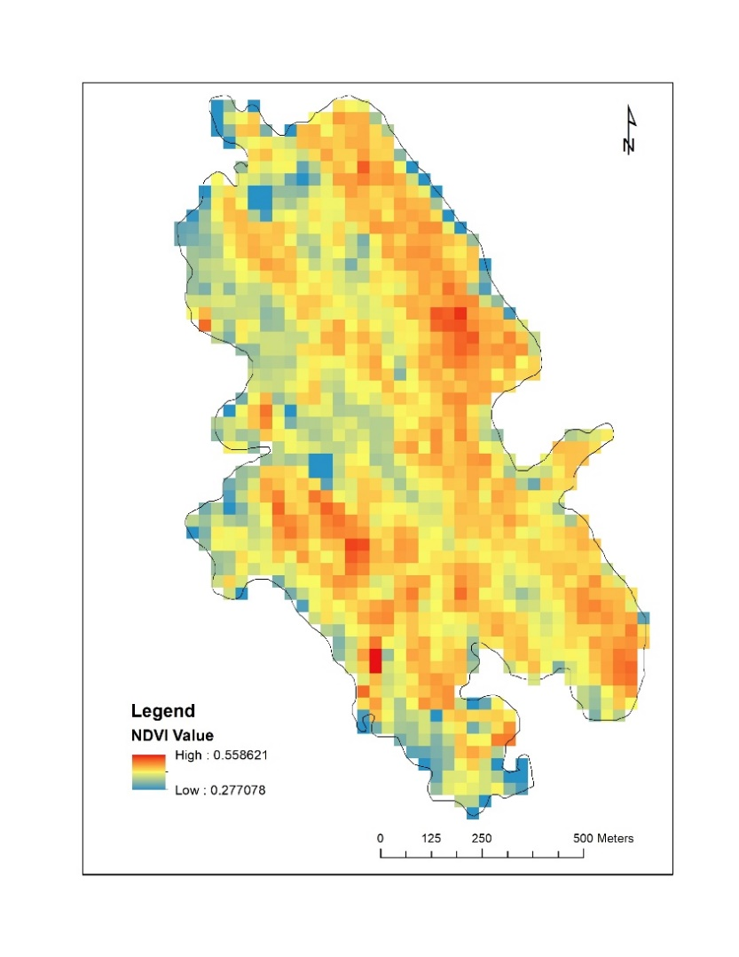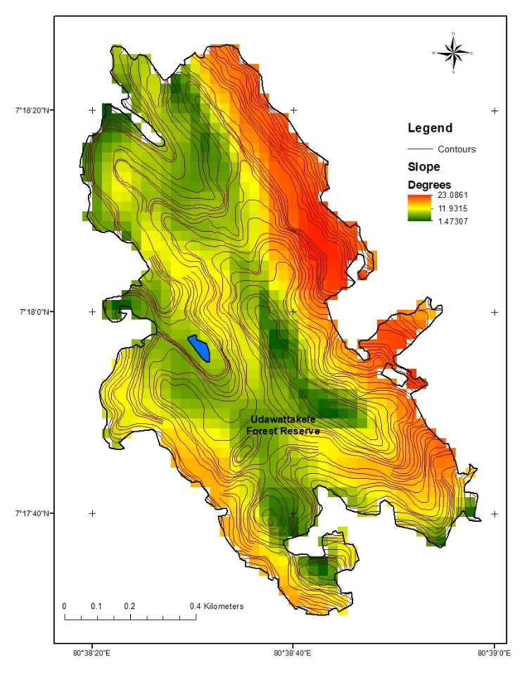.

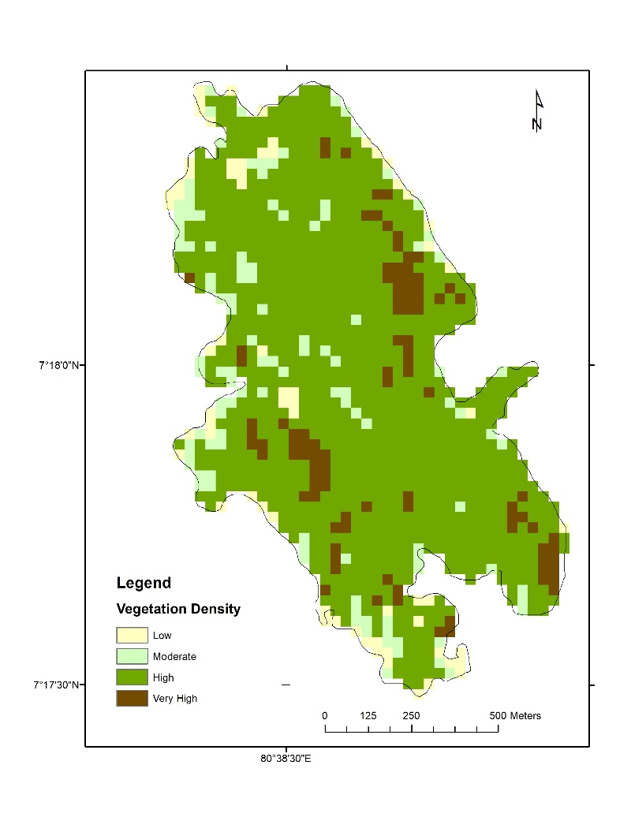Figure 3. (a) Slope map from SRTM DEM and (b) NDVI Map from Landsat 8 satellite image

Figure 4. Spatial distribution of vegetation density in Udawattakele

**Questionnaire survey for identification of ecotourism potentials**

A questionnaire survey was conducted to gather opinions, issues, and challenges regarding ecotourism development in Udawattakele Forest Reserve. The survey featured both closed and open-ended questions, designed to be clear and easy to understand. It was pre-tested on a small sample to ensure clarity and refine the questionnaire. Participants could complete the survey either on paper or online, based on their preference.

**Sample Size and Selection**: The survey included 50 participants, selected through stratified random sampling. The sample comprised: 10 students from nearby schools and universities, 10 tour operators and guides, 10 hoteliers and businesspeople near the reserve, 10 local residents, and 10 visitors to the destination.

**Data Collection**: The survey was administered in Sinhala and English, with responses recorded in Google Sheets. Data collection occurred over two months, ensuring non-bias, voluntary participation, and participant consent. The collected data was then statistically analyzed.

**Expert Group Discussion**: An expert team was selected for discussions, comprising professionals in ecology, ecotourism, forestry, environment, GIS, and ecosystem services. Selection criteria included both research and practical experience, along with availability during the research period for active involvement.

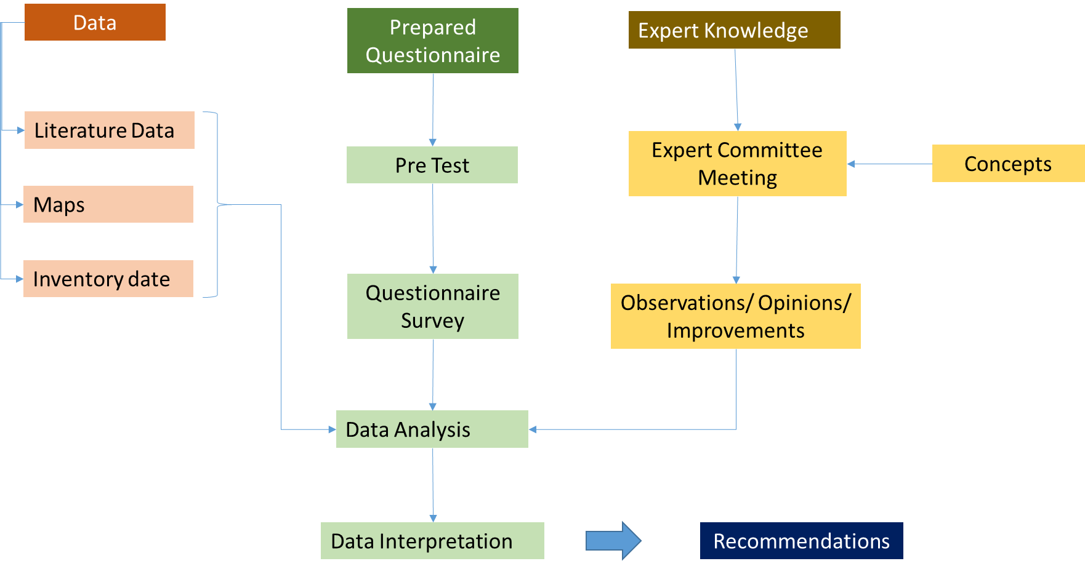

Figure 5: Flow Diagram of the Questionnaire survey Methodology

A total of 50 participants were surveyed, gathering demographic data such as gender, age, visit frequency, and reasons for visiting Udawattakele Forest Reserve. The majority of participants (60%) were male, and most were between 31-40 years old. In terms of visit frequency, 60% had visited the forest once, 5% had visited twice, 5% had visited three times, and 30% had visited more than three times. Most participants visited the forest for entertainment, with others visiting for education, exploration, research, and other reasons.

The study found that 90% of participants were familiar with the concept of ecotourism, while 10% were not. Most participants (84%) believed Udawattakele has potential for ecotourism development, with 14% disagreeing. Additionally, 60% of participants reported gaining good knowledge from their visit, while 40% felt they did not acquire sufficient information.

**Discussion**

The research study on Udawattakele Forest Reserve revealed that most participants were familiar with ecotourism and believed the reserve had potential as an ecotourism destination. However, while 60% reported gaining knowledge from their visit, many identified only a few features, such as native trees and animals, with limited recognition of the forest's historical, religious, and cultural significance. The primary source of information was the few existing signboards, indicating a need for improved knowledge dissemination through updated boards, QR codes, brochures, and modern technologies.

The Conservation Centre, despite being equipped with resources, was underutilized, suggesting a need for better promotion and enhanced training for staff. The study also identified a gap in collaboration between the Forest Department and local communities, who are eager to benefit from tourism but lack resources. Recommendations include involving local businesses, establishing a market for traditional products, and employing local guides with indigenous knowledge.

To boost ecotourism, the expert group proposed creating an eco-cultural park, adding bird-watching towers, improving facilities for visitors, and enhancing biodiversity. These guidelines aim to promote responsible, sustainable tourism that benefits both the environment and local communities while improving visitor experience.

Guidelines to improve ecotourism in Udawattakele Forest reserve was developed based on the results and obtained from the survey. Guidelines developed from the research was further advanced through expert group opinions.

In conclusion, the research on Udawattakele Forest Reserve underscores both the potential and challenges of ecotourism development. Visitors showed strong interest in learning more about the forest's history, biodiversity, and conservation efforts. To enhance this, improvements in information boards, maps, and audio-visual tools at the conservation center are recommended, along with the establishment of a marketplace for local businesses, the development of an eco-cultural park, and increased biodiversity conservation efforts.

Using satellite imagery, vegetation density maps and terrain models were created to identify potential ecotourism pathways within the reserve.

The study also identified challenges, including limited awareness and opportunities for local businesses, insufficient conservation efforts, a lack of trained guides, and inadequate visitor facilities. Additionally, communication gaps between the forest department and the local community hinder collaboration.

To address these issues, incorporating local businesses in ecotourism, establishing a Udawattakele protection group, improving facilities, and creating bird-watching towers are recommended. Clear guidelines and regulations are needed to ensure ecotourism is environmentally friendly and socially responsible. Action plans for these recommendations should be developed in collaboration with local communities, tour operators, visitors, and the forest department to promote sustainable ecotourism practices benefiting all stakeholders.

**References**

Arachchi, R. S. S. W., (2012). Perception of the Eco Tourism Concepts and its Practices in the Hotel Industry: The Case in Eco Resorts in Sri Lanka. Department of Tourism Management.

De Zoysa, M. ,(2022). Ecotourism Development and Biodiversity Conservation in Sri Lanka: Objectives, Conflicts and Resolutions. Department of Agricultural Economics, University of Ruhuna. DOI: 10.4236/oje.2022.1210037.

De Zoysa, M., (2021). Forest-Based Ecotourism in Sri Lanka: A Review on State of Governance, Livelihoods, and Forest Conservation Outcomes. Journal of Sustainable Forestry, 41(1), 1-27. DOI: 10.1080/10549811.2021.1943450

Dahanayaka, D. D. G. N. K., et al., (2017). Biodiversity of Udawatta Kele Forest Reserve, Sri Lanka. Biodiversity Conservation, 26(1), 123-145. DOI: 10.1007/s10531-016-1224-4.

Kulatunga, S., (2019). Community-based ecotourism in Sri Lanka: opportunities and challenges. Tourism Geographies, 21(2), 258-280.

Nisthar, S., Vijayakumar, S., & Nufile, A. A. M.,(2016). Assessment of Potentiality of Ecotourism in Sri Lankan Context: An Analytical Study of Econometric Basis. KALAM -International Research Journal, Faculty of Arts and Culture, South Eastern University of Sri Lanka, Volume X Issue 2.

Nyanatusita, B., & Dissanayake, R. ,(2014). Udawattakele: A Sanctuary Destroyed From Within. Forest Hermitage, Udawattakele, Kandy, Sri Lanka & Birkbeck College, University of London, London, Journal of the Wildlife and Nature Protection Society of Sri Lanka, Vol. 26, Issue 5 & 6, 2013, pp. 38–47. ISSN 0024-6514.

Pathmasiri, E. H. G. C., (2017). A Retrospective Study on the Ecotourism Practices in Sri Lanka in terms of Sustainable Rural Development. International Journal of Scientific & Engineering Research, Volume 8, Issue 9, September-2017, ISSN 2229-5518.

Perera, M. R., (2006). History of Kandyan Kingdom. Godage International Publishers University of Ruhuna.

Silva, D. C., (2004). Ecotourism: Sri Lanka’s potential. Journal of Ecotourism, 1(2).

Sri Lanka Tourist Board., (2003). Ecotourism, development strategy of Sri Lanka. Retrieved from http-- dl.nsf.ac.lk-bitstream-handle-1-14197-ER36(11-12)_27.pdf-sequence-2.

Sri Lanka Tourism Development Authority, (2021). Annual Statistical Report 2020. Retrieved from https://www.sltda.gov.lk.

Forest Department, (2017). Forest Department Performance Report 2019. Retrieved from <https://www.forestdept.gov.lk/images/docs/annual_reports/2019.pdf>

Forest Department, (2018). Forest Department Performance Report 2019. Retrieved from <https://www.forestdept.gov.lk/images/docs/annual_reports/2019.pdf>

Forest Department, (2019). Forest Department Performance Report 2019. Retrieved from <https://www.forestdept.gov.lk/images/docs/annual_reports/2019.pdf>

Forest Department, (2020). Forest Department Performance Report 2019. Retrieved from <https://www.forestdept.gov.lk/images/docs/annual_reports/2019.pdf>

World Tourism Organization, (2019). International Tourism Highlights, 2019 Edition, UNWTO, Madrid, DOI: https://doi.org/10.18111/9789284421152.

The International Ecotourism Society (TIES). (2015). “What is Ecotourism?” Retrieved from http://www.ecotourism.org/what-is-ecotourism. Accessed June 21, 2016.

Gunasinghe, N., (2011). National Ecotourism Policy and Strategy for Sri Lanka. Retrieved from <https://www.unwto.org/sites/all/files/pdf/ecotourism_policy_sri_lanka.pdf>

Karunaratna, N., (1986). On the history and nature of the Udawattakele Forest Reserve, Kandy, Sri Lanka. Udawattakele: The Forbidden Forest of The Kings of Kandy.

Weerakoon,W. M. W., (2015). Avifaunal Diversity of Udawatta Kele: An Urban Forest Reserve in the Kandy District. https://api.semanticscholar.org/CorpusID:132718242